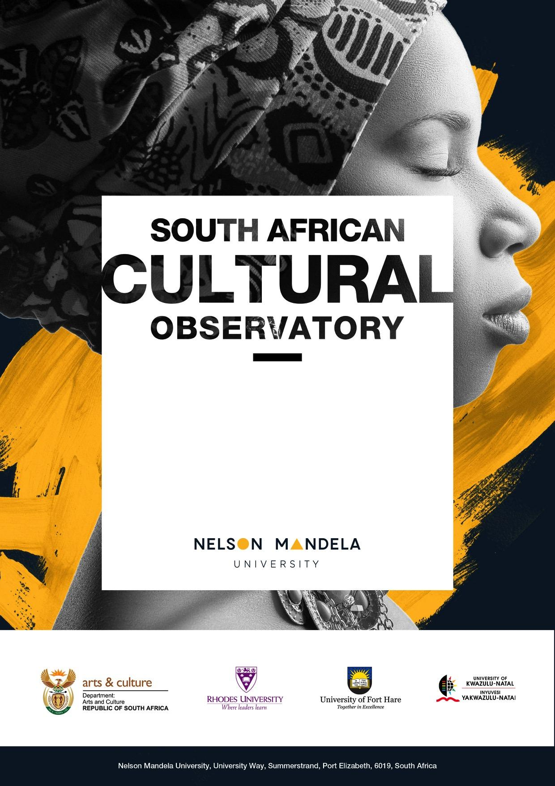
The macroeconomic impact of the Cultural and Creative Industries in South Africa
2022
Summary
Key Findings

- In 2020, the CCIs contributed R161 billion (3%) to the South African economy.
- The largest domain is Design and Creative Services: R51 billion in 2020, 32% of the CCI contribution to GDP.
- The second-largest domain is Audio-visual and Interactive Media: R48.4 billion in 2020, 30% of the CCI contribution to GDP.
- Visual Arts and Crafts made up 15% of the CCI contribution to GDP in 2020 but was one of the most negatively impacted because of COVID-19.
- Books and Press made up 13% of the CCI contribution to GDP in 2020, and also had a negative growth rate between 2019 and 2020.
- The CCIs have strong backward and forward linkages with the rest of the economy, resulting in strong multiplier effects.
- In 2020, CCI investment in capital stock declined for most domains, except Audio-visual and Interactive Media.
- Most domains were running down their inventories in 2020, but this is especially evident in Visual Arts and Crafts (-R114 million) and Books and Press (-R439 million).

This first chapter of the 2020 Cultural and Creative Industries Mapping Study estimates the macroeconomic contribution of the Cultural and Creative Industries (CCIs) to the gross domestic product (GDP) of the country, including the performance of the domains (using the UNESCO Framework for Cultural Statistics, 2009) over time. Information from official sources as well as reliable national databases was analysed using Input-Output modelling and a Social Accounting Matrix adapted for the CCIs.
Using the rebased 2015 GDP data, the total Gross Value Added (GVA) of the CCIs was R161 billion in 2020. This represents just under 3% of South Africa’s total economic production in 2020 and makes the sector approximately the same size as agriculture.
As found in previous mapping studies, the largest domains in terms of contribution to GDP are Design and Creative Services, and Audio-Visual and Interactive Media. The dominance of these domains is expected, since they create cultural and creative content used in film and television, video games, fashion design, architecture and advertising.
The next largest domains are Visual Arts and Crafts (R23.4 billion in 2020, 15% of the contribution to GDP), and Books and Press (R21.5 billion in 2020, 13% of the contribution to GDP). These are followed by the smaller domains of Performance and Celebration (6%) and Cultural and Natural Heritage (4%).
Looking at the growth rates between 2018 and 2020, the impact of the slowdown in the economy during 2019 and the COVID-19 lockdowns have resulted in all sectors showing some decline. The most negatively COVID-19 impacted domains are the Visual Arts and Crafts (-2.13%), and Books and Press (-1.81%), which together account for nearly a third of CCI output and employment.
As found in previous mapping studies, and in the international literature, the creative economy grows quickly when the economy as a whole is doing well but tends to decline more quickly than other sectors when economic growth slows. The CCIs generally performed better in 2017 than the South African economy as a whole. However, the growth rate for the sector slowed down relative to the South African economy from 2018.
Type II output multipliers show the backward and forward linkages of a sector to the rest of the economy. All the CCI multipliers are between 3.7 and 4.3, indicating that new spending in the sector can be expected to have large knock-on impacts in the rest of the economy.
An innovation of this report is the calculation of the Gini coefficient for each domain’s contribution to household income. The Gini coefficient is an indicator of inequality, where a higher coefficient indicates more inequality. The domain with the most unequal distribution of income is Visual Arts and Crafts. This domain includes both fine artists whose works sell internationally, often for very high prices, and crafters who may be operating informally on a small scale. Half of the poorest households in this domain earn only 8% of total income. Audio-visual and Interactive Media has one of the lower Gini coefficients in the sector. In general, however, the CCIs have a more equal distribution of income than for South Africa as a whole.

Table of Contents
1 Introduction and Background 1
1.1 Motivation and Context 1
1.2 Review of Studies on the Impact of COVID-19 on the Cultural and Creative Industries 2
2 The Macroeconomic Impact Modelling System 4
2.1 Toward a Cultural Satellite Account 5
2.2 Classification of CCIs 5
2.3 The South African Policy Environment and Rationale for a CSA 7
2.4 Methodologies to Develop Satellite Accounts 7
2.4.1 Structure of the System of National Accounts 7
2.4.2 Embedding the SNA into a CCI-Input-Output Model 8
2.4.3 Methodology 9
2.4.4 Disaggregating the SNA Data 9
2.4.5 Establishing the Magnitude of the Cultural and Creative Industries 9
2.4.6 Structure of the CCI Satellite Account for South Africa 10
2.4.7 Data 10
2.4.8 Caveats 11
2.5 A South African Cultural Satellite Account 11
2.5.1 Data Input and Report Generation 11
2.5.2 Social Accounting Matrix 12
2.6 Rebasing of the GDP 13
3 The Magnitude of the Cultural and Creative Industries 14
3.1 Gross Value Added 15
3.2 Size of the Domains 17
3.3 Growth Rates 18
3.4 Total Output or Sales (Intermediate Output plus Final Output) at Basic Prices 20
3.5 Multipliers 20
3.6 Factors of Production 21
3.6.1 Capital Stock 22
3.6.2 Capital Formation 22
3.6.3 Labour 23
3.7 Distribution of Income Within Each Domain 23
4 Consumption Expenditure on Recreation and Entertainment 25
5 Inflation 27
6 Critique of the System of National Accounts 30
7 Conclusion and Implications 30
8 References 34
Appendix 1. The UNESCO Mapping of SNA and Stats SA Classifications 39
Appendix 2. A Simple Input-Output Framework 59
Appendix 3. Available Data in South Africa 62
Appendix 4. Household Income Deciles 66

Tables
Table 1: Wages and employment numbers in 2020 at current prices 15
Table 2: CCI domain sizes and elements that contribute to their size 17
Table 3: South Africa’s GVA and GVA growth rate 2016-2020 18
Table 4: The Cultural and Creative Industries’ GVA and GVA growth rates 2016-2010 19
Table 5: GVA at basic prices per domain (Constant 2015 prices, R millions) 19
Table 6: GVA annual growth rates by domain 20
Table 7: Total output or sales (intermediate output and final output) 20
Table 8: CCI Type I output multipliers for 2019 21
Table 9: CCI Type II output multipliers for 2019 21
Table 10: CCI Capital Stock (R million 2015 constant prices) 22
Table 11: Gross fixed capital formation (GFCF) 2020 (R million 2015 constant prices) 22
Table 12: Labour skills levels by domain (derived from total compensation data) 23
Table 13: Gini coefficients per domain 24
Table 14: Basic IO Transactions Table 59
Table 15: A highly simplified IO accounting framework 59
Table 16: Technical coefficients of an IO table (Matrix A) 60
Table 17: Potential data sources that can be used in the CSA 62
Table 18: Differences in coding between SIC, ICNPO and ISIC 64
Table 19: Household Income Deciles 66

Figures
Figure 1: Summary of Research Reports included in the COVID-19 bibliographic database 2
Figure 2: Themes identified in COVID-19 and the creative economy bibliographic database 3
Figure 3: UNESCO’s cultural domains 6
Figure 4: Schematic of a CCI IO 12
Figure 5: Components of value added in 2015 base year 14
Figure 6: GVA Contribution per CCI Domain (at current 2020 prices) 16
Figure 7: GVA per Cultural Domain (Percentage) 2020 18
Figure 8: The Lorenz curve 24
Figure 9: Lorenz Curves by Domain 25
Figure 10: Consumption expenditure of Recreation and Entertainment goods and services 26
Figure 11: Index of consumption expenditure of Recreation and Entertainment goods and services 27
Figure 12: South Africa’s CPI and CPI of selected CCIs 28
Figure 13: CPI of books and newspapers and periodicals 29
Figure 14: CPI of Cinema and TV 29
Figure 15: CPI of musical instruments 30
Figure 16: The CCI Ecosystem 32
Figure 17: Tableau Économique 38
Figure 18: UNESCO mapping using ISIC 58

Table of Abbreviations

AFS Annual Financial Statistics
CAGR Compound Annual Growth rate
CCI Cultural and Creative Industries
COICOP Classification of Individual Consumption According to Purpose
CPI Consumer Price Index
CSA Cultural Satellite Account
DSAC Department of Sports, Arts and Culture
EBPM Evidence-based policy making
FAANGs Facebook, Amazon, Apple, Netflix and Google
GDP Gross domestic product
GFCF Gross Fixed Capital Formation
GVA Gross Value Added
IMF International Monetary Fund
IO Input-Output
ISIC International Standard Industrial Classification
IT income tax
ITC International Trade Centre
NDP National Development Plan
NGO Non-governmental organisation
OECD Organisation for Economic Co-operation and Development
OTT Over-The-Top
PPI Producer Price index
SACO South African Cultural Observatory
SAM Social Accounting Matrix
SARS South African Revenue Services
SIC Standard Industrial Classification
SNA System of National Accounts
UN United Nations
UNESCO United Nations Educational, Scientific and Cultural Organization
UNSC United Nations Statistical Commission
VAT value added tax

Introduction and Background
South Africa’s Culture and Creativity are important to the nation. Culture comprises society’s social behaviour, norms, knowledge, beliefs, arts, laws, customs, capabilities, and habits. Many of these are passed down from our ancestors and these alone are priceless in terms of their intrinsic value. Culture and Creativity have through the ages also had an economic value. As these developed, they have become distinct industries each with considerable economic value. This report covers the economic value that the Cultural and Creative Industries (CCI) bring to South Africa in terms of their contribution to Gross Domestic Product, Employment and Trade.

Motivation and Context
One of the flagship products of the South African Cultural Observatory (SACO) has been the mapping of the Cultural and Creative Industries on a national level (SACO, 2018; 2020). An essential part of this work is determining the macroeconomic contribution of the sector to the gross domestic product (GDP) of the country, including information on which domains (using the UNESCO Framework for Cultural Statistics, 2009) have increased or reduced in size and growth rate.
Currently, Statistics South Africa does not report on the CCIs as a separate industry in their System of National Accounts. By doing so, chapter 1 of the Mapping Study foregrounds the important role that the CCIs play in contributing to the National Development Plan (NDP) and their potential for post-COVID-19 recovery. Domain-level analysis also provides evidence on which to base sector-specific intervention policies that aim to foster recovery, growth and development.
This report looks at the Macroeconomic Impact of the CCIs in South Africa and forms Chapter 1 of the Cultural and Creative Industries Mapping Study (SACO, 2022). Other chapters give more detail on specific aspects, the methods and data used, and a national picture of the creative economy in South Africa, as follows:
Chapter 2: Cultural Employment and Transformation
Chapter 3: International Trade in Cultural Goods and Services
Chapter 4: Provincial Profiles
Chapter 5: The South African Creative Economy in Historical Context
The aims of this chapter are to provide information on:
- The direct overall contribution of the CCIs (as defined by the UNESCO FCS, 2009) to the GDP of South Africa;
- The direct contribution (relative size) of each of the Domains to the GDP contribution of South Africa;
- The growth rates of the CCIs overall, and per domain, in comparison to the findings of the previous mapping studies (2018; 2020);
- The forward and backward linkages (multiplier effects) that the CCIs have with the rest of the economy; and
- Interpretation and implications of the findings.
Macroeconomic data were sourced from Quantec, Statistics South Africa (Stats SA), South African Revenue Services (SARS), South African Reserve Bank (SARB), International Monetary Fund (IMF), World Bank, and the Organisation for Economic Co-operation and Development (OECD). Various models were developed to, firstly, disaggregate the relevant data, and secondly, ensure that the data are standardised. This is the first step to developing a South African CCI Satellite Account based on the UNESCO Framework for Cultural Statistics (2009).
This chapter includes a review of international literature on the impact of the COVID-19 pandemic on the creative economy. It is followed by a discussion of the South African System of National Accounts (SNA) and how it fits into the United Nations SNA, the weaknesses of the method, and how these are overcome. The report presents the Gross Value Added (GVA) of CCIs, the size of the individual CCI domains, and the historic performance of CCI domains. It reports the total output or sales (intermediate output plus final output) of CCIs at base year (2015) prices and also the factors of production (capital and labour). In addition, the CCI Gini Coefficient and the CCI multipliers are discussed. Aspects of CCI consumption patterns and inflation of some CCI components are also reported.

Review of Studies on the Impact of COVID-19 on the Cultural and Creative Industries
As part of the preparation for the Mapping Study, a review of publications about the impact of COVID-19 on the creative economy was conducted, and a bibliographic database of the sources was developed. The criteria for inclusion in the database were:
- That the focus of the work should be the impact of COVID-19 on the CCIs (as defined by UNESCO, 2009);
- That the author/s or institution should be identifiable; and
- That, wherever possible, the publications should be based on original research/data.

Figure 1: Summary of Research Reports included in the COVID-19 bibliographic database
While preference was given to published journal articles and book chapters, these take time to produce, and there is also some excellent research being done by industry organisations, NGOs, and some government departments. The decision was thus made to also include publicly available research reports produced by these institutions.
In all, 63 reports, articles and book chapters meeting the above criteria were selected for review: 45 of them were published in 2020, and 18 in 2021.
Many of the studies were international (29%), from Europe (17%), the UK (14%) and the US (10%). However, a number of developing country studies were also found: from Africa, including South Africa (11%), India (6%), China (3%), the Indo-Pacific (3%), Korea and the Middle East.
About half were published as a journal article or book chapter (49%), and the rest were produced as industry or government reports. The majority of the studies used qualitative analysis (60%), 21% were quantitative and 19% used mixed methods.
The reports provided coverage across the different sectors, or domains, except for domain F (Design and Creative Services). Other SACO research (2021) has shown that, while the activities of Domain F (which includes fashion, graphic, and interior design, advertising and architecture) were negatively impacted by the COVID-19 pandemic, it was not as vulnerable as the other domains, which tended to have higher levels of in-person production and consumption that could not be moved online, and more informal and freelance workers.
While space does not allow a detailed analysis of all the research, the annotated bibliographic database is available on the SACO website as an electronic appendix to the Mapping Study, and can be used as a resource by others researching this area. Some of the main themes, with examples of references in the database that relate to each topic, are briefly identified and discussed.

Economic Impact: Countries & Industries

Contribution to GDP & employment
Multiplier impacts
Revenue & Subsidy
Business Closures
Changing business models

Innovation & Digitisation

Live streaming
Online auctions
Rights (IP) online
Platforms (FAANGs)
OTT viewership

Audiences and online access

Growing audience reach
Potential for exclusion (digital divide)
Online fatigue

Communities & Cultural Diversity

Creatives supporting communities
Information access
Libraries & Heritage
Workforce diversity

Impact on Creatives

Business & Income sources
Wellbeing & mental health
Creative labour markets
Remote work
Networks

Cultural Tourism & Travel

Regional economic impact
Event organisers
Sector impact (museums; music; heritage sites; festivals)

Governance & Policy

Cities, Regions & Countries
Domain-specific support
Workforce vulnerability and support.
Figure 2: Themes identified in COVID-19 and the creative economy bibliographic database
A small number of quantitative studies discussed the economic impacts of the COVID-19 lockdowns and restrictions on the ability of the CCIs to contribute to economic growth and job creation. Some were at country level (Florida and Seman, 2020; Bunketi Buse, 2020), while others focused on specific domains (Rumney, 2020; UNESCO, 2021; Baur, 2020; Kim, 2021). Topics included the knock-on (multiplier) impacts on other industries as a result of falling sales and business closures in the creative economy (Khan, 2021; Wang, 2021).
Several reports focused on the speeded-up innovation and digitisation process in the creative economy in response to COVID-19 restrictions (Nobre, 2020). These included the use of live streaming (White, 2020; Johnson, 2021; Runde et al., 2020), e-books (International Publishers Association, 2020) and online art auctions (Citi GPS, 2020; Tunnikmah, 2021) as methods of maintaining business continuity. The research also noted the rise in market power and influence of large online platforms such as Facebook, Amazon, Apple, Netflix and Google (FAANGs) and the impact of Over-The-Top (OTT) and Video-on-Demand (VOD) viewership (Cunningham and Scarlata, 2020; Nijhawan and Dahiya, 2020).
Another important theme was audiences, and in particular, the impact of digitisation on audiences. Some studies found that the online environment helped to maintain contact with audiences and communities, and in some cases, extended the reach of cultural institutions and firms into other countries and amongst new audience types (Browne, 2021; Okoth, 2020; Feng, 2020). In developing country contexts, however, there was also some concern that lack of access to the internet is excluding poorer communities (Llorens, 2020; Kazim, 2020).
A few studies tracked ways in which the cultural and creative sector interacted with, and supported, their local communities (Peachey, 2020; Europa Nostra, 2020; Watling, 2020). Finding ways to continue serving their stakeholders was often a strong motivation for moving online. However, there was also concern that the online shift was reducing diversity – both in terms of the diversity of cultural offerings, and in terms of the diversity of the creative economy workforce itself (Federation of European Publishers, 2021; Eikhof, 2020).
There are a significant number of studies on the impact of COVID-19 on creatives, who are often more vulnerable than other workers because of freelance, or short-term contract working modes (Comunian and England, 2020). Research explored the impact of the crisis on income sources, wellbeing, and metal health (Amann and Heinsius, 2021; Khan, 2021), and creative labour markets. Adaptation and continuity strategies, such as remote and online working, and the importance of networks in this context were also explored (Asker, 2020; Buchholz et al., 2020; Greenhall, 2020; Spiro et al., 2021).
While tourism is a “related” domain in the UNESCO Framework for Cultural Statistics (2009), the sudden drop in cultural tourism and travel had immediate impacts on cultural domains that rely on tourists and events, including museums (Burke et al., 2020), live music and festivals (Davies, 2020), and heritage sites. The reduction in cultural tourism also had negative economic impacts on the cities and regions that used to attract visitors (Flew and Kirkwood, 2021; Disimulacion, 2020; Bartis, 2021), and on event organisers and management (Mohanty et al., 2020; Velu, 2021).
Several sources included considerations of what kinds of governance and support would help the creative economy to recover post-COVID-19, and to be generally less vulnerable to shocks in the future (OECD, 2020; Betzler, 2020). Some of the work is relative to sub-national levels of governance, such as cities and regions (Anheier et al., 2021). Domain-specific support is suggested in several works.

The Macroeconomic Impact Modelling System
The SNA 2008 is the latest version of the international statistical standard for the national accounts, adopted by the United Nations Statistical Commission (UNSC) and used by Statistics South Africa (Stats SA). The system does not make provision for CCIs in the same way that they have for other sectors and therefore Stats SA does not report on the CCIs as a separate industry or sector. Therefore, by implication, neither are the various CCI domains reported.
The sector does play a significant role in contributing to the NDP specifically and the economy in general. Their potential for post-COVID-19 recovery cannot be underestimated. Evidence-based policy making (EBPM) helps make better decisions and achieve better outcomes. EBPM is achieved by drawing on the best available evidence from research and evaluation and other sources. This research is based on data. Especially at domain-level, data provides the evidence on which to base sector-specific intervention policies that aim to foster recovery, growth and development.
A Satellite Account is a framework linked to the national accounts, which enables focused attention on a particular aspect of economic or social life (e.g. cultural and creative activity) by combining national accounts estimates with the findings of other surveys and statistics. Stats SA has developed satellite accounts such as tourism, non-profit institutions, and International Trade Centre (ITC).

Toward a Cultural Satellite Account
Before a mapping study of the CCIs or Cultural Satellite Account (CSA) can be developed, it is necessary that cultural products or services be defined, which is no easy task. Culture permeates society (of a country, a particular society, group, place or time) and includes its beliefs, customs, and arts. Cultural goods or services are derived from the society’s culture. In many cases, these goods and services have little or no commercial value, although they may have important social and cultural value. However, many cultural goods and services do have an economic value. The value of CCIs is often misrepresented and generally misunderstood. CCI goods and services are not only traded in their own right, but they are embodied as intermediate inputs into other goods and services.
There are several possible approaches to measuring the contribution of CCIs to the South African economy. One is to use the country’s national accounts. Unfortunately, components that make up CCIs are not included in the SNA. The national accounts divide economic activity into a number of industry categories. Statistics South Africa (Stats SA), the official statistics bureau, provides information about value, expressed in constant or current Rands. These sectors cumulatively make up South Africa’s GDP or total industry GVA. There is no specific sector that includes CCIs – these are embedded into other sectors.
South Africa’s national accounts are generally aligned to international statistical standards and are, by and large, consistent over time. Both trends and comparisons can be identified (domestic and international) that are useful for industry analysis and policy making. The SNA has changed over time as new industries emerge and develop (OECD, 2017).
Unfortunately, national accounts use rather broad headings. This suggests homogeneity of production and usage. As technology and consumption patterns have changed over time, these groupings that may be misleading. This is further complicated by which products and services are considered to be cultural or creative.

Classification of CCIs
The task of defining CCIs is complicated. A vigorous debate persists over the inclusion or exclusion of specific sectors in the classification of the cultural and creative industries. Galloway and Dunlop (2007) summarise the debate succinctly, stating that the “terminology currently used in creative industries policy lacks rigour and is frequently inconsistent and confusing. The terms ‘cultural industries’ and ‘creative industries’ are often used interchangeably; there is little clarity about these terms and little appreciation or official explanation of the difference between the two.” These problems are discussed below.
Broadly, CCIs are those activities (or branches of industries or sectors) that produce both tangible or intangible artistic and creative outputs using creativity, cultural knowledge, and intellectual property to produce products and services with social and cultural meaning. They have the potential for wealth creation and income generation through the exploitation of cultural assets and production of knowledge-based goods and services (both traditional and contemporary). However, when compiling a satellite account, a more precise definition is needed.
There are many different definitions of the cultural and creative industries. However, the UNESCO Framework for Cultural Statistics (2009) (Figure 3) is used for the development of the CSA. The choice of the UNESCO Framework is based on the fact that it is increasingly used in South African cultural policy documents (such as the Revised White Paper on Arts, Culture and Heritage), and that it was used in previous SACO mapping studies (2018; 2020). Using the UNESCO Framework thus allows international comparability as well as the ability to track changes in the South African economy over time.
UNESCO’s (2017) simplest definition of CCIs is those activities “whose principal purpose is production and reproduction, promotion, distribution or commercialisation of goods, services and activities of a cultural, artistic or heritage-related nature.” UNESCO (2005) more formally defines cultural industries as “those industries which produce tangible or intangible artistic and creative outputs, and which have a potential for wealth creation and income generation through the exploitation of cultural assets and production of knowledge-based goods and services (both traditional and contemporary).”
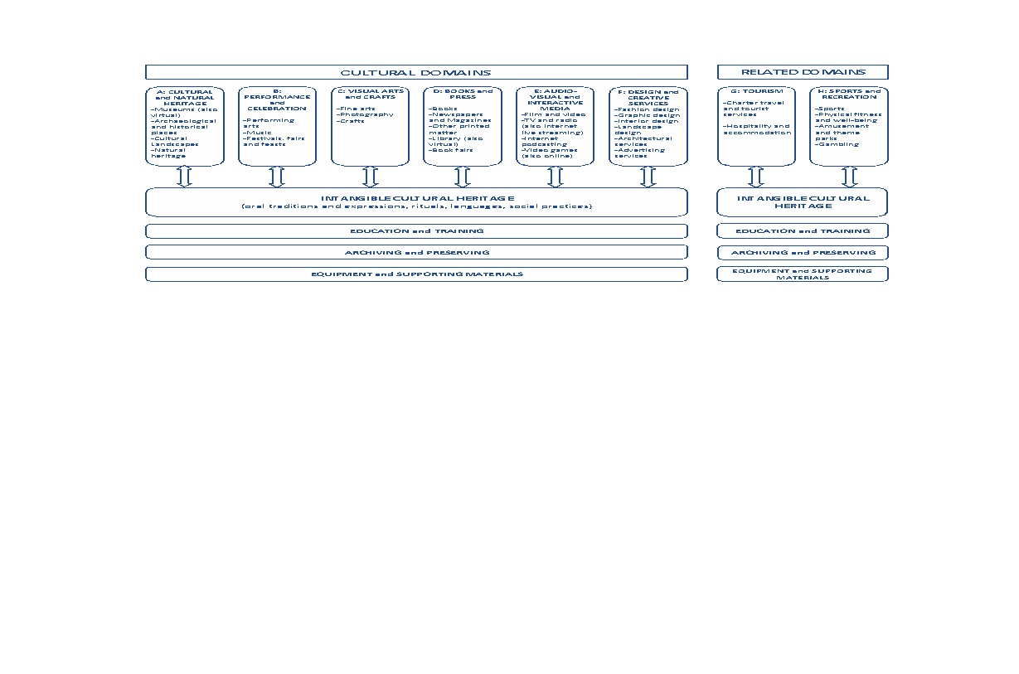
Figure 3: UNESCO’s cultural domains
Source: The UNESCO Framework for Cultural Statistics (2009, p. 24)
UNESCO (2005) includes advertising; architecture; crafts; designer furniture; fashion clothing; film, video and other audio-visual production; graphic design; educational and leisure software; live and recorded music; performing arts and entertainment; television, radio and internet broadcasting; visual arts and antiques; and writing and publishing into the definition of cultural industries. This led to the development of UNESCO’s Framework for Cultural Statistics (2009), which classifies cultural and creative activities into six domains, supported by and contributing to intangible cultural heritage, education and training, archiving and preserving, and equipment and supporting materials. South Africa, to a large degree, has incorporated this framework as the definitional starting point for categorising and understanding its CCIs, and also for analysis, with a view to ‘Africanising’ the framework over time.

The South African Policy Environment and Rationale for a CSA
The UNESCO Framework for Cultural Statistics, published in 2009, is intended to be an international guideline, used for international comparisons and providing a recognised framework for countries wishing to construct their own CSA. It is based on six cultural and two related domains.
The data required depends on the classification of what is included in the definition of cultural industries and CCIs. It will also depend on what the requirements are for both the Department of Sports, Arts and Culture (DSAC) and Statistics South Africa (Stats SA). Much, although not all, of the data are already being collected in by Stats SA. Unfortunately, the format in which it is being collected may not be aligned to the compiling of a CSA.
Government policy must contribute to the mandate given to it by the voters. In South Africa’s case, government policy must lead to a “better life for all”. Since democracy, macroeconomic policies and sectoral policies have been developed that are intended, either directly or indirectly, to fulfil the government’s mandate. These include the RDP, GEAR, the Accelerated and Shared Growth Initiative – South Africa (AsgiSA), and have led to the NDP.

Methodologies to Develop Satellite Accounts
The SNA 2008 defines two methodologies to develop satellite accounts:
- The first group involves a rearrangement of the central classifications with the possible introduction of additional elements. Although there are differences, they do not modify the SNA concepts significantly. The main reason for developing this type of account is to shed light on important social or economic areas of concern without overloading or unbalancing the standard system. Many components contained in these satellite accounts would be invisible in the central accounts and aggregates appearing in global variables. This type of account is used in areas of tourism, environmental protection expenditures, and culture, for example.
- The second type of satellite analysis is mainly based on alternative concepts to those used in the SNA. Therefore, alternative definitions of production, consumption, capital formation or asset item can be employed.
Satellite Accounts may include certain aspects of both types. In some of the areas mentioned above, there have been significant methodological advances.

Structure of the System of National Accounts
Mohr states (2005, p. 16) that the “National account constitutes the most important source of information about the state and the performance of the economy, in the same way as operating and financial accounts of an individual firm convey information about the condition and performance of its firm.” He explains that the task of preparing a set of national accounts is “anything but simple or straightforward”. The compilers of national accounts must contend with various conceptual problems, and the acquisition of accurate data also presents a problem.
The SNA is primarily an economic accounting structure that is derived from macroeconomic analysis. Its structure is based on many areas of macroeconomic study. National Accounts pre-date Smith (1776) and more recently to the seminal work by Meade and Stone (1954) and Stone et al (1972). This has led to the development of the concept of National Income which was the earliest aggregate measure at the root of the System of Accounts.
The United Nations’ SNAs were first developed in 1953 (although they have a longer history), with many subsequent revisions. This analysis studied the major decision centres and economic agents including households, businesses, governments and foreign economies and how they affect the economy through their propensities to consume, save or invest out of income which flows from the productive activity already articulated in the Production Account. Sometime in the late 1940s and early 1950s the idea of an integrated set of accounts pulling together these analytic underpinnings into a system of accounts became a focus of work at the international level. By 1968, the idea came together with the publication by the United Nations of the “System of Accounts”.
“… the compilation of national accounts involves liberal use of estimation and guesstimation, interpolation and extrapolation, and approximation and adjustment.”
(Mohr 2005, 31)
The United Nations’ SNA is a standard System of National Accounts accepted internationally. The first international standard was published in 1953 with revisions in 1968, 1993 and 2008. In 2009, the UNSC endorsed a revised set of international standards for the compilation of National Accounts, replacing the 1993 version of the SNA.
The SNA strives to provide a complete integrated system of accounts enabling international comparisons of significant economic activity. Individual countries use the SNA as a guide in constructing their national accounting system that promotes international comparability. Adherence to the SNA is not rigidly enforced, and some countries differ significantly. However, the system in each country provides sufficient data that is used to compile national accounts according to the United Nations standard.
The primary goal of national accounts is the compilation of macroeconomic aggregates that are consistent over time. For this reason, national accounts typically try to avoid the regular introduction of changes in standards, data sources and methodologies that would affect consistency over time. Newly developed source data and latest available methodologies are only introduced when compiling a new benchmark estimate. Past time-series are then backcast to arrive at a new consistent set of data.
They provide a comprehensive and detailed record of the complex economic activities taking place within an economy and of the interaction between the different economic agents (or groups of agents) that takes place in markets or elsewhere.
The accounts themselves present in a condensed way a great mass of detailed information, organised according to economic principles and perceptions, about the working of an economy. Although it is generally true that the SNA’s accounting framework allows economic data to be compiled and presented in a format that is useful for economic analysis, decision-taking and policy making, this is not always the case. “In some cases, working with the central framework, even in a flexible way, is not sufficient. Even when conceptually consistent, the central framework may become overburdened with details. Moreover, some requirements may conflict with the concepts and architecture of the central framework” (United Nations, 2009, p. 37).

Embedding the SNA into a CCI-Input-Output Model
An Input-Output (IO) model is essentially a matrix that represents the national (or regional) economic accounting in a way that shows how industries trade with one another and their production (in other words, the flow of goods and services). The IO analysis is the standard method for measuring the effects of changes in the final demand for a product of an industry or sector (Surugiu, 2009).
The complex economic structure of each sector of the economy has many dynamic variables, each of which is unique. Each sector has some impact on the economic performance of the CCIs as a whole. This relates to the inputs into CCIs (raw material, labour, technology and capital) and outputs of CCIs (such as inputs into other sectors that are used as intermediary products, trade and export). It is virtually impossible to determine these backward and forward linkages and their subsequent impacts using conventional cost and accounting systems. This is especially true when these are highly aggregated. The mass of data produced by these conventional systems is distilled into aggregated or averaged factors, upon which fundamentally important operational and investment decisions (both by private investors or firms and government) are based.
The way in which these IOs are compiled is influenced by history and convention. Frameworks and guidelines agreed to at various international I, including the OECD and United Nations (UN), are playing an increasingly important role in how IOs are compiled. These, together with the history of IOs, are discussed below. Further technical information on the IO framework can be found in Appendix 2.

Methodology
The IO tables in South Africa are based on the Standard Industrial Classification (SIC) system. The UN has developed the International Standard Industrial Classification (ISIC) that is used in the SNA. South Africa has adopted the SNA framework and is using an adapted version of the ISIC. Although the ISIC has modified over time and for various countries, CCIs are not specifically catered for. Fortunately, the SIC classification system is hierarchical. It is, therefore, possible to identify some CCI components within the broader SIC classifications. Unfortunately, it is not possible to identify all CCIs even at the most disaggregated levels. Therefore, even when a particular SIC classification is disaggregated to its lowest level, estimates have to be made regarding the proportion of CCI products and services that a particular industry produces or uses as inputs.
Although the most accurate way to determine the CCI composition of each industry would be to undertake a census of the industry (or even a large sample survey), the cost of such an undertaking would be prohibitive. Estimates, therefore, must be made using available information. Where CCIs are identified within each industry (in other words where a subcategory refers to a CCI) the turnover, the total output, the net final demand or the value-added components could be used to apportion each industry. Where there is no CCI sub-industry classified, the proportion of creative workers (or the share of total salaries paid to creative workers) can be used.

Disaggregating the SNA Data
In compiling the CSA, a bottom-up approach has been applied. The first step involves deriving the CCI activities out of the various SIC sectors where they have previously been accounted for, using both direct and indirect extraction methods.
The process of deriving the CCIs has two areas of focus:
- Firstly, establishing the Rand-value magnitudes of the CCIs in terms of variables such as production, capital and labour usage, etc.; and,
- Secondly, deriving the structures of the CCIs in terms of how they link backward and forward to other SIC sectors.

Establishing the Magnitude of the Cultural and Creative Industries
This section describes the methodology used for establishing the backward linkages that exist between the CCI activities and the upstream CCI activities and other non-CCI SIC sectors that supply intermediate inputs to them; and the forward linkages that exist between the CCI activities and the various downstream intermediate and end-users of the CCI products and services produced by them.
There are two methods for establishing the magnitude of the CCIs, namely
- Direct Method, and
- Indirect Method.
The Direct Method involves using the proportion of the production or turnover of each SIC sector as a measure of the magnitude of the CCIs. There are two approaches that can be used in applying the Direct Method. Firstly, where a CCI corresponds directly with a SIC sector, the full amount of the SIC sector’s production can be used as the CCI’s production. In cases where the CCI represents only a portion of the SIC’s production, it is necessary to derive an appropriate portion of the SIC sector’s production by making use of secondary data sources.
The Indirect Method is used in cases where it is difficult to establish the proportion that a specific CCI represents of a SIC sector. In these cases, it is necessary to establish where the output of the CCI is used as an input to the production process of a SIC sector. Appendix 3 indicates how the Direct and Indirect Methods have been applied in establishing the magnitude of the various CCIs included in the CSA compiled in this study.
These values are incorporated into an IO to estimate the backward and forward linkages of each sector and CCI domain, as well as their value-added components and expenditure.

Structure of the CCI Satellite Account for South Africa
This report does not include employment (discussed in Chapter 2) or trade (discussed in Chapter 3) (generally, a CSA is concerned mainly with the economic indicators). However, the CSA method generally focuses on:
- Output or production;
- Value added, including compensation of employees and gross operating surplus;
- Employment;
- Trade, both import and exports; and
- Expenditure.
Many governments across the world have adopted policies and programmes to support the cultural sector (including arts and cultural heritage). However, more governments are realising that to ensure cultural sustainability, projects must be economically viable and should generate economic outcomes such as the development of commercial markets, employment opportunities, and the creation of viable businesses in the broader economy (e.g. cultural tourism, design and advertising). The South African government has promoted culture not only for its own sake (or intrinsic value) but also as for its economic contribution. The Revised White Paper on Arts Cultural and Heritage acknowledges the role of the CCIs and their potential contribution to economic growth, transformation and job creation in South Africa.

Data
When compiling national accounts (including satellite accounts), it is necessary to understand the purpose for which the accounts are created. Therefore, the scope of the accounts must be clearly defined. The South African national accounts must also comply with the international 2008 SNA that was developed by the UNSC.
The quality of the data is critical. Much of the data used in the compilation of national accounts is collected from administrative sources such as SARS, which includes Customs and Excise. Other data are collected using surveys or censuses. A census is ideal because it collects information for the entire population. Undertaking censuses regularly is too expensive and impractical, therefore most national statistical offices use surveys. Surveys too are expensive and therefore cannot be done regularly.
The IO table used is generated by Quantec. This is done because it is based on Stats SA’s IO as well as updated using Stats SA’s Supply and Use Tables and other official data. The primary data sources used in developing the Quantec IO includes:
- The 2019 Annual Financial Statistics (AFS) report (Statistical Release P0021) published by Stats SA;
- The Supply and Use Tables, 2014 (Report 04-04-03) published by Stats SA;
- The Final Social Accounting Matrix, 2011 (Report 04-03-02) published by Stats SA;
- The Income and Expenditure of Households Survey, published by Stats SA;
- The Labour Market Dynamics 2021 (Report No. 02-11-02) published by Stats SA; and
- The September 2021 Quarterly Bulletin published by the South African Reserve Bank.
In all cases, data derived from these sources has been adjusted to 2015 prices.

Caveats
Tepper (2002) lists some issues which should be considered so as not to skew or impact the valuation of CCIs. These include:
- Accurately defining a cultural segment, to avoid double counting;
- Valuation methods should be constantly applied, so as to not capture the distortion between creation and repeated use; and
- Aggregation of sectors could hide sector-specific production activities.
Producing time-series results that are, at least potentially, internationally comparable, the CSA does not take into account the non-market or intrinsic value of culture.
One disadvantage of the new CCI IO table described below, is that it does not specifically make provision for the informal sector. Since many CCIs are in the informal sector, this could be a problem if they are substantially different from the CCIs in the formal sector. It could be possible for the current 85 x 85 South African CCI IO to be further split into small, medium, and large enterprises with data from the AFS. Unfortunately, the sectors are not disaggregated enough to do this meaningfully.

A South African Cultural Satellite Account
A new South African CCI IO table was derived using the methods described above giving an IO table comprising 85 industries with the additional six UNESCO CCI domains.

Data Input and Report Generation
The Macroeconomic Modelling System that was developed for this project includes using MATLAB vR2021a (a programming and numeric computing platform used to analyse data, develop algorithms, and create models) as well as Stata v15 (a general-purpose statistical software package for data manipulation, visualisation, statistics, and automated reporting) and MS Excel. This made it possible to capture project specific programme, construction and operational data. These programs generated the macroeconomic and socioeconomic performance reports. The software used could also undertake sensitivity analysis to ensure that the assumptions used were as accurate as possible.
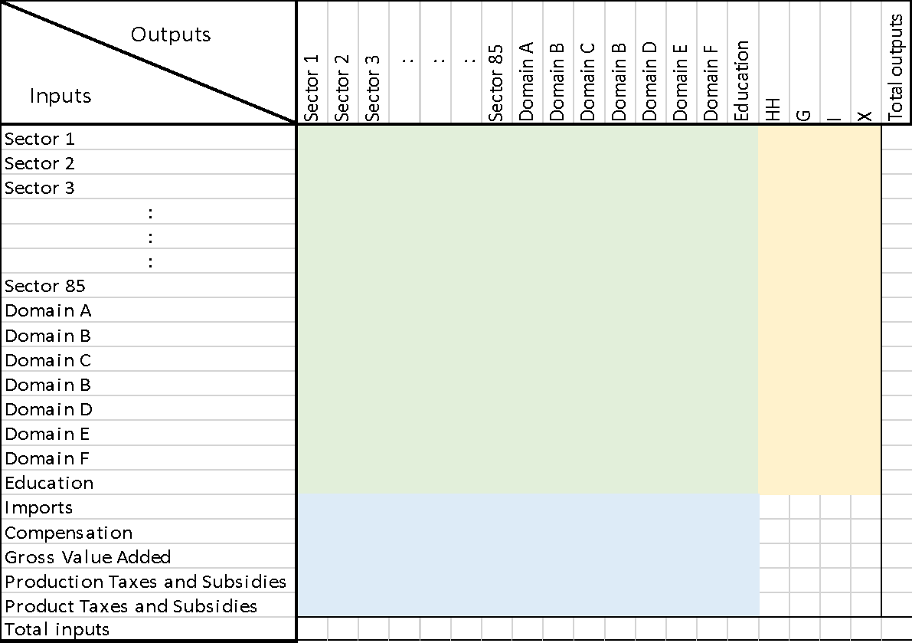
Figure 4: Schematic of a CCI IO
Where:
- HH Household Consumption;
- G Government Consumption;
- I Investment;
- X Exports
CCI-IOs were compiled for each year using the appropriate data for each year from 1993 where possible. Unfortunately, comparable data were not always available before 2010 and therefore the findings from the analysis of the new CCI-IOs are reported below.

Social Accounting Matrix
Stats SA (2009) contends that a Social Accounting Matrix (SAM) is one of the measurement tools that can be used in determining the success of government strategies and policies. A SAM represents flows of all economic transactions that take place within an economy. It can be extended to include other socioeconomic aspects as well. SAMs refer to a single period, usually a year, providing a static picture of the economy. Essentially, it is using the SNA in a matrix format, which elaborates on the linkages between Supply and Use tables (SU-tables) and institutional sector accounts. The SAM “reflects the economic relationship between the sectors of the economy by identifying monetary transactions (expenditure and receipts) between them.” It therefore allows for a study of vital issues that are of a particular interest to a country, such as “an analysis of interrelationships between structural features of an economy and the distribution of income and expenditure among household groups” (Stats SA, 2009, p. 1).

“Economies are dynamic, shifting and changing over time. New industries rise to dominance while others fade away, consumer tastes wax and wane, and new technologies replace the old. Rebasing and benchmarking exercises ensure that the tools used to measure the economy take these changes into account.”
Statistics South Africa¹
It plays an important role in linking data from both social and economic origins. Therefore, the interdependence between a wide spectrum of economic sectors and industries, as well as a wide variety of information about employment, capital, households and population groups is illustrated in the SAM.
In conclusion, a SAM is a square matrix that shows the linkages between the Supply and Use table and the institutional sectors in the economy. It states the circular flow in the economy from commodities produced by producers through their activities with the available production factors to the linkages with households, enterprises, the government and the rest of the world.
The SAM is inter alia updated using the following data sources:
- AFS (Stats SA)
- GDP for detailed industries (Annual; Stats SA)
- GDP / national accounts (Annual; Stats SA, SARB)
- GDP / national accounts (Quarterly; Stats SA, SARB)
- Quarterly Employment Statistics (Stats SA)
- Quarterly Financial Statistics (Stats SA)
- Quarterly Labour Force Survey (Stats SA)

Rebasing of the GDP
The GDP measures the aggregation of the market value of final goods and services produced within a geographic area in a specified period of time. The structure of economies changes over time. Governments validate GDP calculations by rebasing periodically, to reflect these structural changes. The change means that the weight of particular sectors changes in the measurement of GDP.
Generally, rebasing is the process of replacing the present price structure (base year) to compile volume measures of GDP with a new (more recent) base year. If general prices are increasing inflation has to be taken into account and fast technological progress affects prices and compensation. Prices also change because of changes in quality.
In line with international standards and best practice, Stats SA rebased and benchmarked the GDP in 2021, using 2015 as the base year, to ensure that the measurement of the GDP remains reflective of the South African economy and is relevant, given structural changes that occur in the economy over time. Before the latest rebasing, Stats SA and other agencies were using 2010 prices to get the real South African GDP.
The rebasing provided an opportunity to incorporate new data sources and to refine the methodologies used, including an improved method of classifying economic activity on both the production (supply) and expenditure (demand) sides of the economy. As a result of the rebasing, the revised GDP at current prices the economy is 11.0% larger in 2020 than previously estimated. In the 10 years between 2011 and 2020, the percentage difference between the previous and revised levels averaged 9.6%, and ranged between 8.6% in 2014 and 11.0% in 2020 (Stats SA, 2021). The annual growth rate for 2020 was revised from -7.0% to -6.4%.
As a result of the rebasing, Personal Services, that includes many CCI subsectors, has shown a dramatic increase as shown in Figure 5.
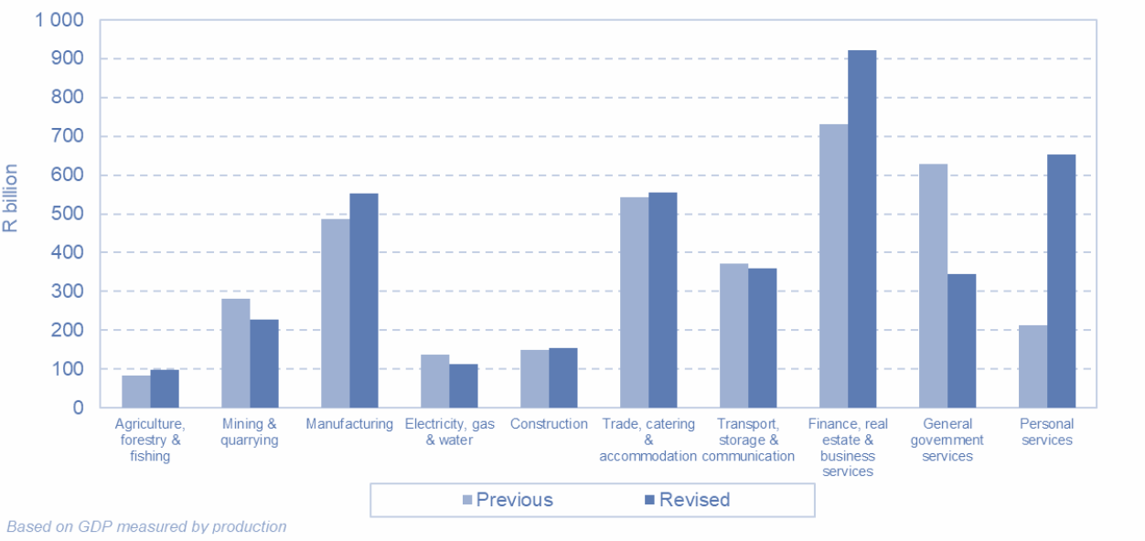
Figure 5: Components of value added in 2015 base year
Source: Stats SA (2021)
Clearly, the changes in the production of GDP expenditure on GDP (supply side) must reflect the expenditure (demand) side. The most noteworthy revision in the 2015 base year is household final consumption expenditure. Household final consumption expenditure is estimated to be 16% higher. According to Stats SA (2021) “[t]he three categories of household expenditure contributing the most to this increase are recreation and culture; restaurants and hotels; and miscellaneous goods and services.”

The Magnitude of the Cultural and Creative Industries
Using the SAM and CCI IO the following CCI variables were estimated:
- GVA of CCIs;
- Size of the CCI domains;
- Historic performance of CCI domains;
- Total output or sales (intermediate output + final output) of CCIs at basic prices;
- Factors of production – Capital;
- Factors of production – Labour;
- Gini Coefficient; and
- Multipliers.

Gross Value Added
This current study has determined that in 2020 (using the new 2015 rebasing prices discussed above), the total GVA at real (2015=100) Basic Prices of the CCI is R119 billion (or R161 billion if measured in nominal terms). This represents just under 3% of South Africa’s total GVA in 2020. This is approximately the same size as agriculture.
SACO’s 2020 Mapping Study estimated the CCI contribution to the South African economy at R74.4 billion (at 2018 prices). However, in 2021, Stats SA and the SARB rebased the economy from 2010 to 2015 prices (which is done every 5 years). During this exercise, not only was the economy estimated to be larger than previously thought (by 11%), but the size of the various sectors were re-estimated. The Personal Services Sector, which includes many of the CCI domains, grew by R439 billion. The recreation subsector grew by an additional R25 million. It is therefore not unexpected that the new estimates are substantially higher than those estimated in the previous studies.
Based on both the CCI SAM and the CCI IO, as well as using the average wages paid per sector per skill level, an estimated 573 000 people (including formal and informal jobs) were employed directly in the CCIs, constituting about 3.95% of total employment in South Africa in 2020. This does not include employees in creative occupations who work in other industries. The breakdown per skill level is included in Table 1.
Table 1: Wages and employment numbers in 2020 at current prices
 | Total CCI wages earned per skill level (Rand million: Current prices) | Estimated number of workers per skill level in CCI domains
High-skilled labour | R31 000 | 189 000
Skilled labour | R20 000 | 208 000
Low-skilled labour | R4 500 | 62 000
Informal labour | R4 000 | 114 000
 | R59 500 | 573 000
Highly skilled workers make up approximately a third of CCI employment. Although it is always difficult to estimate the number of informal workers, the CCI SAM and the CCI IO estimate that there were 14 000, which makes up approximately 20% of the CCI workforce.
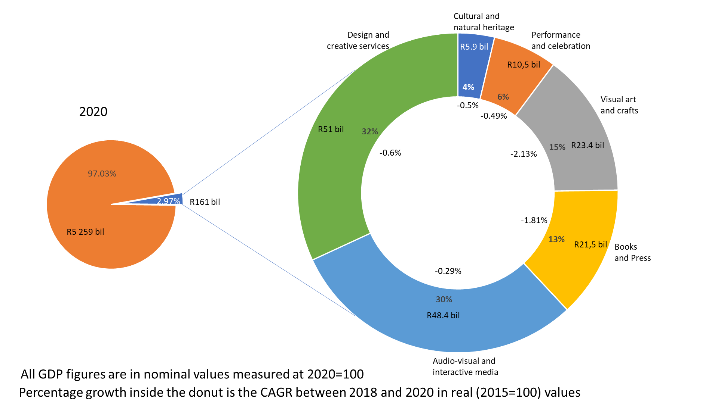
Figure 6: GVA Contribution per CCI Domain (at current 2020 prices)
As found in previous mapping studies, the largest domains in terms of contribution to GDP are Design and Creative Services (R51 billion in 2020, 32% of the contribution to GDP), and Audio-Visual and Interactive Media (R48.4 billion in 2020, 30% of the contribution to GDP). The dominance of these domains is expected, since they involve the commercial application of cultural and creative content, such as in film and television, video games, fashion design, architecture and advertising.
The next largest domain is Visual Arts and Crafts (R23.4 billion in 2020, 15% of the contribution to GDP), and Books and Press (R21.5 billion in 2020, 13% of the contribution to GDP). These are followed by the smaller domains of Performance and Celebration (6%) and Cultural and Natural Heritage (4%).
Looking at the growth rates between 2018 and 2020, the impact of the slowdown in the economy during 2019 and the COVID-19 lockdowns have resulted in all sectors showing some decline. Of concern is that the most negatively impacted are the Visual Arts and Crafts (-2.13%), and Books and Press (-1.81%) domains, which together account for nearly a third of CCI output.

Size of the Domains

Table 2: CCI domain sizes and elements that contribute to their size (Rm in base year (2015) prices)
 | A:  Cultural and natural heritage | B: Performance and celebration | C:  Visual art and crafts | D:  Books and Press | E:  Audio-visual and interactive media | F:  Design and creative services | Total CCI domains
Compensation of employees | R1 991 | R2 865 | R6 103 | R10 400 | R16 018 | R21 766
Gross operating surplus: Net operating surplus (NOS) | R2 084 | R3 208 | R7 463 | R4 181 | R13 754 | R12 945
Gross operating surplus: Consumption (depreciation) of fixed capital | R473 | R676 | R2 194 | R2 819 | R1 401 | R1 807
GVA at Factor Prices | R4 548 | R6 748 | R15 759 | R17 400 | R31 173 | R36 517 | R112 146
Other taxes on production | R77 | R120 | R104 | R262 | R373 | R387
Other subsidies on production | -R14 | -R25 | -R21 | -R46 | -R33 | -R79
GVA at Basic Prices | R4 612 | R6 843 | R15 842 | R17 616 | R31 512 | R36 826 | R113 250
Product taxes: Value added tax (VAT) | R145 | R233 | R530 | R1 181 | R1 263 | R1 471
Product taxes: Custom duties | R12 | R22 | R61 | R89 | R38 | R21
Product taxes: Excise duties | R8 | R13 | R5 | R8 | R18 | R1
Product taxes: Fuel levy | R8 | R9 | R54 | R48 | R31 | R148
Product taxes: Other taxes on products | R17 | R25 | R84 | R104 | R139 | R166
Subsidies on products | -R3 | -R5 | -R23 | -R60 | -R21 | -R31
GDP at Market Prices | R4 798 | R7 139 | R16 554 | R18 986 | R32 982 | R38 602 | R119 060

Table 2 shows the size of the various domains as GVA at factor prices, GVA at basic prices and GDP at market prices.
The table shows a detailed analysis of the compensation of employees (discussed in Table 1 above as well as in Chapter 2 of this report). It also shows the gross operating surplus (that corresponds indirectly to the returns on the investment in the sector). All taxes and subsidies paid or received by the various domains are included to derive the macroeconomic indicators discussed above. The table can be used to estimate the net taxes (that is, taxes paid minus subsidies received) from the economic activity of each domain.
Figure 7 shows the relative sizes of the domains during 2016 (the outer band of the donut), 2018 and 2020 (the inner band of the donut).

Figure 7: GVA per Cultural Domain (Percentage) 2020
The two commercial application domains that also have the greatest potential to benefit from digitisation, Design and Creative Services and Audio-visual and Interactive Media, have grown relative to the other domains. Books and Press, which has been suffering a steady downward trend over the past few years, shrank relative to the other domains from 17.7% in 2016 to just under 16% in 2020.
To understand these relative changes, it is useful to look at the South African economy as a whole to see how it is performing and then to compare the country’s economic performance to the various CCI domains. This is discussed below.

Growth Rates
South Africa has been experiencing very low growth rates in recent years. In 2020, with COVID-19, South Africa experienced a negative growth rate (Table 3).
Table 3: South Africa’s GVA and GVA growth rate 2016-2020
 | GVA at basic prices (Constant 2015 prices, R millions) | GVA at basic prices (Average of Quarterly Values, Year-on-Year per cent change)
2016 | R 4 014 646 | 0.83%
2017 | R 4 061 243 | 1.16%
2018 | R 4 121 231 | 1.48%
2019 | R 4 124 458 | 0.08%
2020 | R 3 879 360 | -5.94%
Source: South African Reserve Bank (2021)
The performance of the CCIs need to be measured against this background. Table 4 shows the contribution of CCIs to South Africa’s GVA at basic prices at constant 2015 prices in R millions and growth rates over time.
Table 4: The Cultural and Creative Industries’ GVA and GVA growth rates 2016-2010
 | Total CCI GVA at basic prices (Constant 2015 prices, R millions) | CCI Growth year-on-year growth rates
2016 | R 116 300 | 0.3%
2017 | R 120 233 | 3.4%
2018 | R 121 517 | 1.1%
2019 | R 120 134 | -1.1%
2020 | R 112 146 | -6.6%

As found in previous mapping studies, and in the international literature, the creative economy grows quickly when the economy as a whole is doing well, but tends to decline more quickly than other sectors when economic growth slows. The CCIs generally performed better in 2017 than the South African economy as a whole. However, the growth rate for the sector slowed down relative to the South African economy from 2018.
In 2019, the South African economy only managed a growth rate of 0.08% in real terms. To all intents and purposes there was no growth and there were signs that the economy was already heading for recession. The COVID-19 pandemic and subsequent lockdowns resulted in the economy shrinking by 6% in 2020. The COVID-19 pandemic hit South Africa hard but the CCIs were hit harder.
Table 5 shows the contribution of each domain to South Africa’s GVA at basic prices at constant 2015 prices in millions of Rands and Table 6 shows the growth rate by domain (as a year-on-year percentage change).
Table 5: GVA at basic prices per domain (Constant 2015 prices, R millions)
 | A:  Cultural and natural heritage | B: Performance and celebration | C:  Visual art and crafts | D:  Books and Press | E:  Audio-visual and interactive media | F:  Design and creative services | Transversal domain: Education and training
2016 | R 4 782 | R 8 419 | R 19 271 | R 17 692 | R 32 083 | R 38 791 | R 35 271
2017 | R 4 807 | R 8 430 | R 19 531 | R 17 754 | R 35 346 | R 39 333 | R 34 635
2018 | R 4 577 | R 7 926 | R 20 068 | R 17 231 | R 36 349 | R 40 374 | R 33 452
2019 | R 4 557 | R 7 857 | R 19 448 | R 16 728 | R 36 641 | R 39 900 | R 33 373
2020 | R 4 367 | R 7 561 | R 17 037 | R 14 420 | R 35 335 | R 38 246 | R 23 751

The Audio-visual and Interactive Media domain has performed the best of all domains in each year under study. It has consistently enjoyed a higher than national average growth rate in recent years and was also the only domain to maintain a positive growth rate in 2019. Books and Press has struggled most, declining in real terms for every year since 2016 except for 2017 when it managed a meagre 0.3% growth rate.
Table 6: GVA annual growth rates by domain
 | A:  Cultural and natural heritage | B: Performance and celebration | C:  Visual art and crafts | D:  Books and Press | E:  Audio-visual and interactive media | F:  Design and creative services | Transversal domain: Education and training
2016 | 3.3% | 3.2% | -0.8% | -1.7% | 0.4% | 0.9% | 0.9%
2017 | 0.5% | 0.1% | 1.3% | 0.3% | 10.2% | 1.4% | -1.8%
2018 | -4.8% | -6.0% | 2.7% | -2.9% | 2.8% | 2.6% | -3.4%
2019 | -0.4% | -0.9% | -3.1% | -2.9% | 0.8% | -1.2% | -0.2%
2020 | -4.2% | -3.8% | -12.4% | -13.8% | -3.6% | -4.1% | -28.8%

In 2019 most of the CCI domains shrank in real terms as South Africa’s economic growth slowed down. As found in other studies, the creative economy shrank faster than the South African economy as a whole. In 2020, the impact of COVID-19 was felt by all the domains.

Total Output or Sales (Intermediate Output plus Final Output) at Basic Prices
GDP is the total value of all final goods and services produced in a country in a particular period (usually a year). It must be stressed that the GDP consists of final goods and services. It is important that when the GDP is calculated that there is no double counting. Firms require raw materials or other intermediate goods to produce the products they sell, either to other firms (who use them to produce their products) or to final consumers. The final consumers are generally households, government, firms (who use the goods for investment) or the rest of the world. Table 7 below shows the total output of each of the domains. This includes both the intermediate output and the final output. While the figures give an indication of the backward and forward linkages in the economy, they do include double counting and are thus not as useful as indicators as the GVA discussed above, that excludes double counting.
Table 7: Total output or sales (intermediate output and final output) (R million 2015 constant prices)
 | A:  Cultural and natural heritage | B:  Performance and celebration | C:  Visual arts and crafts | D:  Books and Press | E:  Audio-visual and interactive media | F:  Design and creative services | Transversal domain: Education and training
2016 | 9 518 | 14 932 | 56 470 | 46 043 | 73 777 | 82 048 | 58 218
2017 | 9 701 | 15 195 | 57 364 | 46 477 | 78 384 | 83 439 | 58 130
2018 | 9 906 | 15 523 | 59 584 | 46 415 | 81 738 | 85 568 | 58 635
2019 | 10 154 | 15 881 | 56 034 | 44 795 | 83 890 | 86 614 | 58 074
2020 | 9 934 | 15 582 | 48 888 | 41 649 | 82 429 | 83 340 | 37 334

Multipliers
A multiplier is a factor that measures how much a monetary inflow that comes from outside a sector (exogenous variables) changes the endogenous variables (inside the sector itself). The affected variables could include output, GDP, GVA, income, employment, profit, taxes etc. In other words, it is the additional economic benefit that accrues to an area from money being spent (generally referred to as a shock) in the local economy. The size of the multiplier depends on the structure of the economy, including the degree of labour or capital intensity, the source of the raw material or other inputs and the propensity to spend or save.
The Type I output multiplier (or direct and indirect multipliers) for a particular industry is defined as the total of all outputs from each domestic industry required in order to produce one additional unit of output. This gives the direct and indirect (backward and forward linkages), as shown in Table 8.
Table 8: CCI Type I output multipliers for 2019
Cultural and natural heritage | Performance and celebration | Visual arts and crafts | Books and press | Audio-visual and interactive media | Design and creative services | Transversal domain: Education and training
1.850 | 1.894 | 2.092 | 1.903 | 1.891 | 1.881 | 1.763

For example, if foreign tourists come to South Africa and spend an additional R1 million on cultural and natural heritage products and services, the boost given to the economy in direct and indirect output impacts would be equal to R1m multiplied by 1.850 (the multiplier for this sector), which would be equal to R1.85 million (the total impact on the GDP of South Africa as a results of the original R1m increase in spending).
However, as the output increases, so do the number of workers required and the profits of the owners. These funds are saved, invested or spent in other sectors. This additional spending is referred to as the “induced impact.” The Type I multipliers plus the induced impact give theType II impact or total impact that can be expected from the additional turnover (Table 9).
Table 9: CCI Type II output multipliers for 2019
Cultural and natural heritage | Performance and celebration | Visual art and crafts | Books and press | Audio-visual and interactive media | Design and creative services | Transversal domain: Education and training
3.740 | 3.748 | 3.700 | 3.814 | 4.170 | 4.353 | 4.226

Using the same example given above, if foreign tourists come to South Africa and spend an additional R1 million on Cultural and Natural Heritage domain products and services, the boost given to the economy through the total output impacts (direct, indirect and induced) would equal R3.74 million.
The Design and Creative Services domain has the highest multipliers followed by Audio-visual and Interactive Media. Although the Transversal Education and Training domain does have a higher multiplier, the additional turnover is dependent on the growth of the other domains.
Multipliers could be improved if leakages, such as the importation of inputs required for the various domains, were reduced, and supplied by South African suppliers.

Factors of Production
Factors of production are the resources, or inputs, that are used in the production process together with raw material (or intermediary inputs) to produce output—that is, finished goods and services. This section will examine the capital (including capital stock) and the labour factors of production.

Capital Stock
The capital stock is the total value of the physical capital at any particular moment in time but is usually calculated and reported at the end of each year. Each year new capital stock is added but at the same time there is depreciation. The capital stock for the CCIs is based on the 2016 capital stock (SACO 2018) and then adjusted using figures from the CCI SAM and the AFS (capital formation). As with the GDP contributions, investment in capital stock is declining for most domains, with the exception of Audio-visual and Interactive Media (which also had the largest capital stock in 2020 (Table 10).
Table 10: CCI Capital Stock (R million 2015 constant prices)
 | 2014 | 2015 | 2 016 | 2017 | 2018 | 2019 | 2020
A. Cultural & Natural Heritage | R 5 362 | R 5 054 | R 4 474 | R 4 162 | R 3 850 | R 3 385 | R 2 919
B. Performance & Celebration | R 11 365 | R 10 804 | R 9 716 | R 9 176 | R 8 637 | R 7 858 | R 7 073
C. Visual Arts & Crafts | R 21 653 | R 21 036 | R 19 502 | R 19 511 | R 19 521 | R 18 317 | R 16 512
D. Books & Press | R 32 684 | R 30 785 | R 27 379 | R 26 183 | R 24 988 | R 23 623 | R 21 620
E. Audio-Visual & Interactive Media | R 18 225 | R 31 225 | R 42 961 | R 59 768 | R 74 315 | R 88 986 | R 105 679
F. Design & Creative Services | R 105 725 | R 105 121 | R 99 152 | R 98 382 | R 97 613 | R 97 161 | R 96 862
Transversal Domain: Education and Training | R 31 849 | R 30 190 | R 26 363 | R 24 329 | R 22 295 | R 19 307 | R 15 796
Total | R 226 861 | R 234 215 | R 241 626 | R 241 512 | R 251 218 | R 258 638 | R 266 461

Capital Formation
Table 11 shows the gross fixed capital formation for 2020. Buildings and construction works cannot be derived from the SAM. Nevertheless, as would be expected the audio-visual and interactive media domain invested in computers and related equipment as well as computer software. They also invested in R&D and transfer costs.
Table 11: Gross fixed capital formation (GFCF) 2020 (R million 2015 constant prices)
 | Transport equipment | Machinery and other equipment | Computers, related equipment Computer Software | Research and development, and Transfer costs | Change in inventories
A: Cultural and natural heritage | 13 | 38 | 4 | 4 | -1
B: Performance and celebration | 0 | 5 | 5 | 6 | 0
C: Visual art and crafts | 12 | 516 | 25 | 21 | -114
D: Books and Press | 12 | 36 | 1 542 | 1 276 | -439
E: Audio-visual and interactive media | 1 | 4 | 8 793 | 7 274 | -49
F: Design and creative services | 0 | 0 | 984 | 816 | -24
Transversal domain: Education and training | 0 | 0 | 4 | 5 | 31
H: Sports and recreation | 129 | 368 | 27 | 23 | -240

The change inventory shows how the various sectors have responded to COVID-19 and the subsequent recession. Typically, during the recession firms do not buy new stock but rather sell what they have until confidence in the economy returns and stock levels rise. Table 11 shows that most domains were running down their inventories in 2020, but this is especially evident in Visual Arts and Crafts (minus R114 million) and Books and Press (minus R439 million).
The Audio-visual and Interactive Media domain has acquired the most computers and related equipment and also software. They have also spent a great deal on research and development which includes the development of creative content. The Books and Press domain has also invested in computers and software and the development of creative content. It is encouraging that the domain is still investing even though it is a sector’s contribution to GDP has fallen.

Labour
Human capital is an essential ingredient in the production of any goods or services. For the sector to compete globally, firms require a highly skilled or skilled workforce. Nevertheless, the sector can also be an important entry point for low-skilled workers. Table 12 below shows the skills levels of the workers in each domain.
Table 12: Labour skills levels by domain (derived from total compensation data)
 | A:  Cultural and natural heritage | B: Performance and celebration | C:  Visual art and crafts | D:  Books and Press | E:  Audio-visual and interactive media | F:  Design and creative services
High-skilled labour | 47% | 52% | 36% | 39% | 61% | 58%
Skilled labour | 35% | 31% | 38% | 45% | 27% | 30%
Low-skilled labour | 10% | 9% | 17% | 8% | 6% | 5%
Informal labour | 8% | 7% | 9% | 7% | 6% | 7%

Most workers in the various CCI domains are highly skilled or skilled. Visual Arts and Crafts have the higher proportions of both low-skilled labour and informal labour. (Chapter 2 covers employment in greater detail.)

Distribution of Income Within Each Domain
The CCI SAM provides information on household income earned per industrial sector as well as per CCI domain. Although overall income is an important part of each domain’s contribution to the national GDP, this section analyses distribution of the income derived by households from each domain in which they work according to their decile. Income deciles are derived by ranking all households in an economy from poorest to wealthiest (in terms of their income) and then dividing them into 10 groups, with an equal number of households in each group. To examine the distribution of household income in each domain, the Gini coefficient is calculated for each domain according to the decile to which the household is included.
The Gini coefficient (also called the Gini index or Gini ratio) is a statistical measure of economic inequality in a population and can be used in the analysis of income distribution within a sector. The coefficient can take any values between 0 to 1 (or 0% to 100%). A coefficient of zero indicates a perfectly equal distribution of income. A coefficient of one represents perfect inequality when one household in a population receives all the income. The Gini coefficient is calculated from the Lorenz curve (Figure 8).
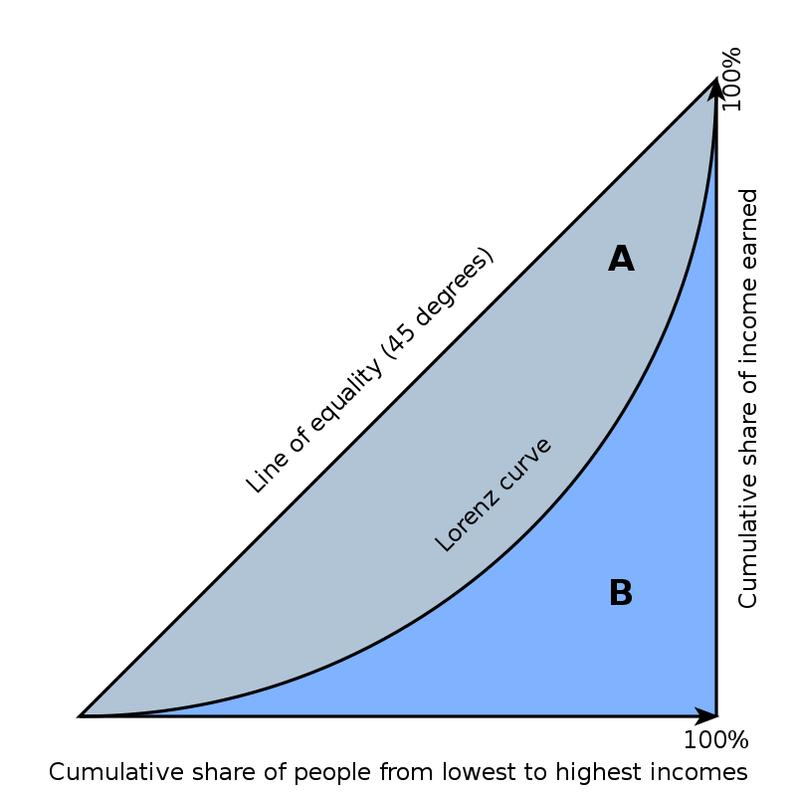
Figure 8: The Lorenz curve
The Gini coefficient is equal to the area marked A divided by the sum of the areas marked A and B, that is, Gini = A/(A + B). The Gini coefficient was calculated for each domain shown in Table 13. Table 19 (Appendix 4) shows household distribution by decile.
South Africa is acknowledged as having one of the most unequal distributions of household income in the world (of those countries which measure inequality in this way). In 2006 the country had a per capita expenditure Gini coefficient of 0.67, dropping to 0.65 in 2015. The top 10% of the population spent 8.6 times more than the bottom 40% in 2006 and 7.9 in 2015 (Stats SA, 2019). The origins of this inequality can be traced back to apartheid, but the current cause is the country’s high unemployment. Without the social grant system inequality would have been far worse. Increasing employment would have a positive impact. Nevertheless, even among employed South Africans the Gini coefficient is too high.
Using the CCI SAM it is possible to determine the Gini coefficients for each of the CCI domains (Table 13). The higher the ratio, the more unequal is the distribution of income in each domain.
Table 13: Gini coefficients per domain
Domain | Gini
A: Cultural and natural heritage | 0.60292
B: Performance and celebration | 0.63555
C: Visual art and crafts | 0.68988
D: Books and press | 0.60953
E: Audio-visual and interactive media | 0.57861
F: Design and creative services | 0.58431
Transversal Education and Training | 0.61708

The Lorenz curves for each domain have been plotted as well as the line of equality. These are shown and discussed below.
Figure 9: Lorenz Curves by Domain
Not surprisingly, the domain with the most unequally distributed income is Visual Arts and Crafts. This domain includes both fine artists whose works sell internationally, sometimes for very high prices, and crafters who may be operating informally on a small scale. 50% of the poorest households in this domain earn only 8% of the total income. Audio-visual and Interactive Media has one of the lowest Gini coefficients in the sector.

Consumption Expenditure on Recreation and Entertainment
Until now this chapter has focused on the supply side of the economy. However, the demand side is equally important. How consumers spend their income also affects which products and services are provided. Although most products and services are produced and consumed in South Africa, many of them are produced in foreign countries and imported into South Africa. South Africa also exports to foreign countries.
Consumers purchase goods and services for a variety of reasons. The types of products and services that they purchase also change over time. Figure 10 shows the value of recreational and entertainment goods and services bought by consumers in South Africa since 1970. Four categories are shown: durable goods, semi-durable goods, non-durable goods, and services. The largest category is “recreational, entertainment and educational services.” This category consists of spending at cinemas, parks, museums, and theatres. It also includes subscriptions to television services and licences and the hiring of equipment. This is the largest category, and it experienced rapid growth from 1997.
Durable recreational and entertainment goods (including audio-visual, photographic and communications equipment) have exhibited an increase since 2003. There has been no noticeable change in the consumption patterns of semi-durable (comprising sport and camping equipment, games, hobbies, toys, books and recorded media) and non-durable (consisting of newspapers, magazines, stationery, pets and related products as well as garden) recreational and entertainment goods.

Figure 10: Consumption expenditure of Recreation and Entertainment goods and services
Source: SARB (2021), Quantec (2021) and own calculations
With the first wave of the COVID-19 pandemic in early 2020, consumers changed, or were forced to change, their consumption patterns as business models changed and government regulations were implemented. There is a clear drop in the consumption, of particularly services, but also of non-durable and semi-durable recreational and entertainment goods. Durable recreational and entertainment goods, however, continued on an upward trajectory. This trend can be better seen when the figures have been converted to indices (2015 equals 100) in Figure 11.

Figure 11: Index of consumption expenditure of Recreation and Entertainment goods and services
Source: SARB (2015), Quantec (2005) and own calculations

Inflation
Inflation refers to a general progressive increase in prices of goods and services in an economy. With price level rises, each unit of currency buys fewer goods and services and leads to a reduction in the purchasing power of money. Inflation also influences the cost of manufacturing goods and services. There are several measures of the price level, including the Consumer Price Index (CPI), the Producer Price index (PPI) and the GDP deflator. These are broad or weighted average price indices.
Prices will not all increase at the same rates. Each component of the “basket” can have its own inflation. The amount of each product or service demanded depends on the various elasticities. (Elasticity measures the percentage change of one economic variable in response to a change in another.) If the price of a good or service rises (generally relative to other goods or services), the demand for that good or service would be expected to drop. How much demand drops (if at all) depends on its price elasticity of demand.
Graphical depictions of the CPI, used as a measure of price change over time, for a variety of cultural and creative industries in South Africa are shown in Figures 12 to 15 below. The prices of recreation and culture, and recreational equipment have generally risen slower than South Africa’s overall inflation rate. Similarly, the prices of books, newspapers and stationery have risen more slowly than for other goods and services, generally declining since 2002. This may in part be because of the way that digital online products are affecting this domain. When disaggregating books from newspapers and periodicals, the drop in price of books is a main contributor. The prices of cinemas, theatres, and concerts has increased approximately 35 basis points since 2017, while TV licences and similar subscriptions have only risen by five basis points over the same period.

Figure 12: South Africa’s CPI and CPI of selected CCIs
Source: Own calculations based on Stats SA (2021) and Quantec (2021)

Figure 13: CPI of books and newspapers and periodicals
Source: Own calculations based on Stats SA (2021) and Quantec (2021)

Figure 14: CPI of Cinema and TV
Source: Own calculations based on Stats SA (2021) and Quantec (2021)
The prices of musical instruments have been rather volatile. It is noteworthy to see a slight drop in prices at the beginning of 2020 with COVID-19. A SACO study of the impact of COVID-19 on the live music sector found that some musicians reported selling their equipment in order to survive.

Figure 15: CPI of musical instruments
Source: Own calculations based on Stats SA (2021) and Quantec (2021)

Critique of the System of National Accounts
The SNA 2008 (United Nations, 2009) is an update of previous versions devised by the UN that is based on internationally agreed concepts, definitions, classification and accounting rules (Mohr, 2005). It is a coherent and integrated set of accounts that allows for international comparison. It can be a powerful analytical tool containing a rich set of information. Unfortunately, this richness is not always apparent or sufficient (European Union, 2016). The SNA is based on historic practices and needs as well as the technology that prevailed in the past. The classifications are therefore not always suitable to meet the needs of policy-makers in an ever-changing technological landscape. The information from the SNA needs to be “further detailed, re-worked, re-packaged, or expanded in order to be effectively used to address more specific, policy questions” (Svirchevskyy, 2021).
Although the SNA and Stats SA data are generally very useful, South Africa faces the same problem as practically all countries in that there is a paucity of CCI-related data. Whatever data are available cannot always be standardised easily to make them comparable or even compatible. This report has used numerous econometric techniques to develop models that can be used to extract the CCI-related data.

Conclusion and Implications
Although the information provided in this chapter, which makes up Chapter 1 of the SACO 2022 Mapping Study, is economic in nature, it is important to note that cultural and creative activities have an intrinsic value that can contribute to areas such as nation building and social cohesion. Nevertheless, highlighting the size of the CCIs in terms of its contribution to GDP (larger than the agricultural sector) emphasises the importance of CCIs as a sector in its own right.
A particular challenge that was faced in the compilation of this chapter was the rebasing of economic statistics from the 2010 base year to 2015. This required the researchers to firstly wait for the new data to be published and then to re-estimate the various indicators. The data that is published in this chapter has been re-estimated to 1993 in some cases. This makes it possible to compare various years and see where progress has been made. Because of the rebasing, the data in this chapter is not always directly comparable to SACO’s previous mapping studies. However, because of the rebasing and additional data sources, the data presented is more representative and therefore more accurate. The findings justify the view that the creative economy can indeed be South Africa’s “new gold” as proposed with the publication of the Mzansi Golden Economy report (Gurney, 2012).
The chapter analysed both the supply and the demand sides of South Africa’s creative economy. The most important ingredient on the supply side is creativity. Although South Africa has an abundance of creativity, this component was not measured or given a monetary value. The study did, however, measure the inputs that are required to produce CCI products and services from other sectors of the economy.
Perhaps one of the important findings of this chapter is the unexpected size of the CCIs relative to the South African economy. The sector is relatively larger than previously estimated. Given its size, the importance of its inputs to other sectors, and its ability to provide jobs, the sector needs to be fostered and developed.
Analysis of CCI domains clearly showed there are three groups of CCI domains. The first group, Cultural and Natural Heritage and Performance and Celebration, are relatively small in terms of their contribution to GDP but have strong roots and assets that have been built up over the years. They are growing slowly and must be preserved and supported to continue this growth in the future.
The second group, Visual Arts and Crafts and Books and Press domains, are in the middle both in the size of their contribution to GDP and their growth potential. A concern is that the GDP contributions of both these domains have fallen in recent times, even before the COVID-19 pandemic of 2020.The third group, comprising Audio-visual and Interactive Media and Design and Creative Services domains, relies less on culture and more on creativity and technology. These are growing faster and are the two largest domains.
This chapter did not look at the importance of preserving South Africa’s cultural heritage but the country has assets that contribute to the CCI economy. Unfortunately, it can be clearly seen that the Cultural and Natural Heritage domain has been static for the past few years. Similarly, given South Africa’s rich heritage it is also surprising to see that the Performance and Celebration domain is both small and static. Both these domains need to be nurtured and efforts made to retain and grow the country’s talent as well as embarking on attracting more audiences to events and visitors to the cultural and natural heritage sites.
The Visual Arts and Crafts domain comprises just under 14% of South Africa’s CCI to the country’s GDP. However, the sector is shrinking, and the study found a drop from just over 15.4% in 2016 to 13.9% in 2020. Although part of the drop can be attributed to the COVID-19 induced recession, there are other factors. Crafts play a small role in the CCI economy and they may be underreported because of the informal nature of the subsector, but they do have an important role in providing an income for people with lower levels of formal education.
The Books and Press domain has also been shrinking over the past few years. Part of this can be attributed to the fact that there has been a shift to digital books that are currently being imported. However, reading competes with many other forms of entertainment and therefore the demand for books has decreased. South Africa needs to develop a reading culture, especially for South African stories.
The Audio-visual and Interactive Media domain has grown rapidly as CCI consumers’ tastes have changed and adapted to new technologies that are available. Design and Creative Services provides creative services mainly to the corporate sector.
The study also calculated the Gini coefficients (a measure of household income inequality) of the six main UNESCO domains, based on the Social Accounting Matrix (SAM). Unfortunately, there is a large discrepancy between the highest-paid creatives and the lowest. This is a common phenomenon across the world where a minority of creative “superstars” earn huge salaries while others in the sector, who play smaller but still important roles, earn barely enough to survive.
From the demand side various components could be measured and how these have changed over time. CCI services include spending at cinemas, parks, museums, and theatres but also subscriptions to television services and licences and the hiring of equipment. Although it was not the purpose of the study, with the advent of television services such as Netflix, the spending on these imported digital services has increased. Audience development and careful negotiation with online platforms needs to be undertaken to ensure that more South African content remains visible and is consumed.
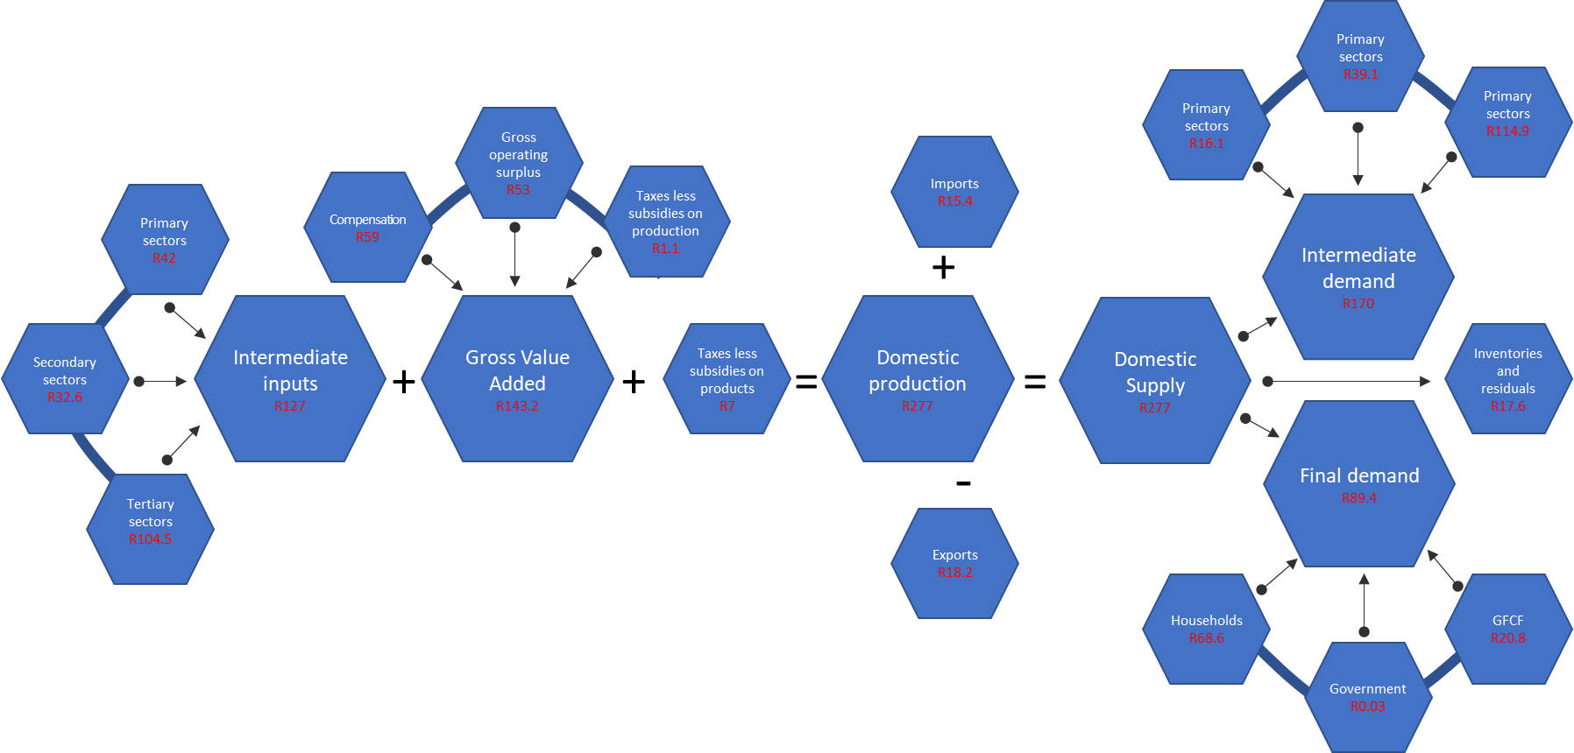
Note that the figure shows GVA in 2015 prices for the six main UNESCO domains.
Figure 16: The CCI Ecosystem
From the demand side, households are the largest consumers of CCI products and services. Government, in common with most governments in the world, does not consume a large proportion of South Africa’s CCI products or services.
Gross Fixed Capital Formation (GFCF) gives an indication of investment in productive capacity and is also an important contributor to final demand. Architectural and advertising services play an important role in the development of the country. However, GFCF in South African CCIs is volatile and depends on the state of the economy and especially the confidence that investors have in the future.
Figure 16 shows the CCI ecosystem. The components on the left-hand side generally indicate the contribution to the supply side of the CCI economy, while those on the right-hand side show the demand for CCI products and services. It is through such analysis that the South Africa’s creative economy can be mapped and understood in order to design effective evidence-based policy.
The second Chapter in this Mapping Study explores the recent trends and the impact of COVID-19 on employment and transformation in South Africa’s Cultural and Creative Industries.

References

Akser,M. (2020). Cinema, Life and Other Viruses: The Future of Filmmaking, Film Education and Film Studies in the Age of Covid-19 Pandemic. Cinej Cinema Journal. Volume 8.2(1): 1 - 13
Amann, S. and Heinsius, J. (2021). Research for CULT Committee – Cultural and creative sectors in post-Covid-19 Europe: crisis effects and policy recommendations. IDEA Consult, Goethe-Institut. European Parliament, Policy Department for Structural and Cohesion Policies: Brussels.
Anheier, H.K., Merkel, J. and Winkler, K. (2021). Culture, the Arts and the COVID-19 Pandemic: Five Cultural Capitals in Search of Solutions. Allianz Kulturstifund & Hertie School. Online. https://www.hertie-school.org/fileadmin/2_Research/5_Policy_Briefs/2021_January_Culture_and_Covid_Executive_Summary.pdf
Bartis, H. (2021). The Economic Impact of COVID-19 Pandemic on the Business Events Sub-Sector in South Africa: Mitigation Strategies and Innovations. African Journal of Hospitality, Tourism and Leisure, 10(1): 102–114.
Baur, P.W. (2020). An examination of the impact of COVID-19 on the financial markets and how this directs investments into the market for fine art. Journal of Economic and Financial Sciences, 12(1): 1–22.
Betzler, D., Loots, E., Prokůpek, M., Marques, L. and Grafenauer, P. (2020). COVID-19 and the arts and cultural sectors: investigating countries’ contextual factors and early policy measures. International Journal of Cultural Policy, 27(6): 796–814.
Browne, N. (2021). The IHS Library and Its Response to the COVID-19 Pandemic. In B. Holland (Ed.), Handbook of Research on Library Response to the COVID-19 Pandemic, IGI Global, pp. 298–320.
Buchholz, L., Fine, G.A. and Wohl, H. (2020). Art markets in crisis: how personal bonds and market subcultures mediate the effects of COVID-19. American Journal of Cultural Sociology, 8: 462–476.
Bunketi Buse, R.N. (2020). COVID-19 and Culture in Africa: A comparative analysis of economic impact studies. Online. https://www.artsmanagement.net/Articles/COVID-19-and-culture-in-Africa-A-comparative-analysis-of-economic-impact-studies, 4184
Burke, V., Jørgensen, D. and Jørgensen, F. (2020). Museums at Home: Digital Initiatives in Response to COVID-19. Norsk museumstidsskrift, 6, 117–123.
Citi GPS (2020). The Global Art Market and Covid-19. Citi Private Bank. Online. https://www.citivelocity.com/citigps/the-global-art-market-and-covid-19/
Comunian, R. and England, L. (2020). Creative and cultural work without filters: Covid-19 and exposed precarity in the creative economy. Cultural Trends, 29(2): 112–128.
Cunningham S. and Scarlata, A. (2020). New forms of internationalisation? The impact of Netflix in Australia. Media International Australia,177(1): 149–164.
Davies, K. (2020). Festivals Post Covid-19. Leisure Sciences, 43(1–2): 184–189.
Disimulacion, M.A. (2020). MICE tourism during COVID-19 and future directions for the new normal. APIEM Journal, 1(2): 11–17.
Eikhof, D. R. (2020). COVID-19, inclusion and workforce diversity in the cultural economy: What now, what next? Cultural Trends, 29(3): 234–250.
Europa Nostra. (2020). Covid-19 and Beyond: Challenges and Opportunities for Cultural Heritage. Online. https://www.europanostra.org/europa-nostra-publishes-extensive-paper-on-challenges-and-opportunities-presented-by-the-covid-19-pandemic-for-the-heritage-world/
European Union. (2016). Study on national Sport Satellite Accounts (SSAs) in the EU. Publications Office of the European Union. Available at: http://op.europa.eu/en/publication-detail/-/publication/ca2a161e-9a91-11e6-9bca-01aa75ed71a1 (Accessed: 26 May 2020).
Federation of European Publishers. (2021). One Year After: Consequences of the Covid-19 crisis on the book market – An overview of 2020. Online. https://fep-fee.eu/IMG/pdf/202103_-_brochure_covid_update_digital_only.pdf?1857/6598ccf5e1afdda6eac39f35d6ded7321dfcd969
Feng, X. (2020). Curating and Exhibiting for the Pandemic: Participatory Virtual Art Practices During the COVID-19 Outbreak in China. Social Media + Society, July: 1–6.
Flew, T. and Kirkwood, K. (2021). The impact of COVID-19 on cultural tourism: art, culture and communication in four regional sites of Queensland, Australia. Media International Australia, 178(1): 1–16.
Florida, R. and Seman, M. (2020). Lost Art: Measuring COVID-19's devastating impact on America's creative economy. Metropolitan Policy Program, Brookings Institution. 1–32.
Galloway, S. and Dunlop, S. (2007) ‘A critique of definitions of the cultural and creative industries in public policy’, International journal of cultural policy, 13(1), pp. 17–31. Available at: http://www.tandfonline.com/doi/abs/10.1080/10286630701201657 (Accessed: 26 September 2016).
Greenhall, M. (2020). Covid-19 and the digital shift in action. Research Libraries UK. Online. https://www.rluk.ac.uk/covid-19-and-the-digital-shift-in-action/
Gurney, K. (2012). Mzanzi’s Golden Economy. In A. Mbembe (Ed.), The Johannesburg Salon (Vol. 5). Available at: https://jwtc.org.za/resources/docs/salon-volume-5/Gurney.pdf (Accessed: 22 July 2020).
International Publishers Association (IPA). (2020). From response to recovery: The impact of COVID -19 on the Global Publishing Industry. Online. https://www.internationalpublishers.org/images/aa-content/news/news-2020/ipa-post-covid-action-plan-report.pdf
Johnson, M. (2021). Hollywood survival strategies in the post-COVID-19 era. Humanities & Social Sciences Communications, 8(100): 1–8.
Kazim, A. (2020). How the Pandemic is Reshaping South Africa's Art Scene. Photography Collections Preservation Project. Online. https://www.photographypreservation.org/blog/2020/7/18/how-the-pandemic-is-reshaping-south-africas-art-scene
Khan, Y. (2021). Impact of Covid-19 on Media & Entertainment Industry in India. IOSR Journal of Humanities and Social Science, 26(1): 1–6.
Kim, I.K. (2021). The impact of social distancing on box-office revenue: Evidence from the COVID-19 pandemic. Quantitative Marketing and Economics, 19: 93–125.
Llorens, J. (2020). Rethinking the study of intangible cultural heritage during COVID-19. SER News. Online. https://www.researchgate.net/publication/342547024_Rethinking_the_study_of_intangible_cultural_heritage_during_COVID-19_1
Meade, J.E. and Stone, R.G. (1957) National income and expenditure. Bowes & Bowes.
Miller, R.E. and Blair, P.D. (2009). Input-Output Analysis: Foundations and Extensions (2nd ed.). Cambridge University Press.
Mohanty, P., Dhoundiyal, H. and Choudhury, R. (2020). Events Tourism in the Eye of the COVID-19 Storm: Impacts and Implications. In S. Arora and A. Sharma (Eds.), Event Tourism in Asian Countries: Challenges and Prospects (1st ed.). Apple Academic Press.
Mohr, P. (2005) Economic indicators. Pretoria: Unisa Press.
National Accounts and Statistics South Africa. (2008). Linking the Social Accounting Matrix to existing government strategies for South Africa. Pretoria: Statistics South Africa.
Nijhawan, G.S. and Dahiya, S. (2020). Role of Covid as a catalyst in increasing adoption of OTTS in India: A study of evolving consumer consumption patterns and future business scope. Journal of Content, Community and Communication, 12: 298–311.
Nobre, G. (2020). Post Covid-19 and the Creative Economy: tendencies and risks. Research Gate. Online. https://www.researchgate.net/publication/343559059_Post_Covid-19_and_the_Creative_Economy_tendencies_and_risks
OECD. (2017). Value added by activity. Paris: OECD. doi:10.1787/a8b2bd2b-en.
OECD. (2020). Culture shock: Covid-19 and the cultural and creative sectors. Paris: OECD. Online. https://www.oecd.org/coronavirus/policy-responses/culture-shock-covid-19-and-the-cultural-and-creative-sectors-08da9e0e/
Okoth, Z. (2020). New Voices in Africa – Cinema as Premonition, Covid-19 as Possibility. Institut Montaigne: Paris. Online. https://www.institutmontaigne.org/en/blog/new-voices-africa-cinema-premonition-covid-19-possibility
Peachey, J. (2020). Making a difference: libraries, lockdown and looking ahead. Carnegie Trust: UK. Online. https://www.carnegieuktrust.org.uk/publications/making-a-difference-libraries-lockdown-and-looking-ahead/
Quesnay, F. (1761) Tableau economique avec explications.
Quantec. (2021) Easy Data. Quantec Pretoria. www.quantec.co.za/
Rumney, R. (2020). SANEF's Covid-19 Impact on Journalism Report. South African National Editors' Forum. Online. https://sanef.org.za/sanef-launches-covid19-impact-on-journalism-interim-report-2/
Runde, D.F., Rossow, R.M., Metzger, C.H., Sullivan, B.F. and Carlson, R. (2020). Creative Economies in the Indo-Pacific and Covid-19. The Center for Strategic and International Studies. Online. https://www.csis.org/analysis/creative-economies-indo-pacific-and-covid-19
SACO (2018). The mapping of the South African creative economy: A baseline. Commissioned by the South African Cultural Observatory. Online [Available] https://www.southafricanculturalobservatory.org.za/
SACO (2020). The Economic Mapping of the Cultural and Creative Industries in South Africa 2020. Commissioned by the South African Cultural Observatory. Online [Available] https://www.southafricanculturalobservatory.org.za/
SACO (2021). Measuring the impact of the COVID-19 Crisis on the Cultural and Creative Industries in South Africa: One year on. Commissioned by the South African Cultural Observatory. Online [Available] https://www.southafricanculturalobservatory.org.za/
Smith, A. (1776). An Inquiry into the Nature and Causes of the Wealth of Nations. London: Strahan.
South African Reserve Bank (2021) Quarterly Bulletin. Pretoria: South African Reserve Bank. Available at: www.resbank.co.za.
Spiro, N., Perkins, R., Kaye, S., Tymoszuk, U., Mason-Bertrand, A., Cossette, I., Glasser, S. and Williamon, A. (2021). The Effects of COVID-19 Lockdown 1.0 on Working Patterns, Income, and Wellbeing Among Performing Arts Professionals in the United Kingdom (April–June 2020). Frontiers in Psychology, 11: 1–17.
Stats SA. (2009). Linking the Social Accounting Matrix to existing government strategies for South Africa. Pretoria: Statistics South Africa. Available at: https://www.statssa.gov.za/publications/D04031/D04031.pdf (Accessed: 16 August 2015).
Stats SA. (2012) The status of the Non-profit Institutions satellite account for South Africa. D0407.1. Pretoria: Statistics South Africa. Available at: http://www.statssa.gov.za/publications/D04071/D04071.pdf.
Stats SA. (2015) Volunteer Activities Survey. P0211.3. Pretoria: Statistics South Africa. Available at: http://www.statssa.gov.za/publications/P02113/P021132014.pdf.
Stats SA. (2016a) Quarterly Labour Force Survey. P0211, Quarter 2. Pretoria: Statistics South Africa. Available at: http://www.statssa.gov.za/publications/P0211/P02112ndQuarter2016.pdf.
Stats SA. (2016b) Tourism satellite account for South Africa (TSA), final 2012 and provisional 2013 and 2014. Report 04-05-07. Pretoria: Statistics South Africa. Available at: http://www.statssa.gov.za/?page_id=1854&PPN=Report-04-05-07.
Stats SA. (2019). Inequality Trends in South Africa: A multidimensional diagnostic of inequality. Pretoria: Stats SA.
Stats SA. (2021). A new and improved GDP is here! Available at: http://www.statssa.gov.za/?p=14614 (Accessed: 12 November 2021).
Stone, R. (1954) The measurement of consumers’ expenditure and behaviour in the United Kingdom, 1920-1938,. Cambridge [England): Cambridge University Press.
Stone, R., Stone, G.S., and others (1972) ‘National income and expenditure’. Available at: http://agris.fao.org/agris-search/search.do?recordID=US201300488146 (Accessed: 7 October 2016).
Surugiu, C. (2009) The Economic Impact of Tourism. An Input-Output Analysis. National Institute for Research and Development in Tourism. Available at: http://core.ac.uk/download/pdf/6671063.pdf.
Svirchevskyy, O. (2021). Satellite Accounts. Available at: https://statswiki.unece.org/display/SAOI/Satellite+Accounts+-+Online+Inventory+Home (Accessed: 23 November 2021).
Tepper, S.J. (2002) ‘Creative assets and the changing economy’, The Journal of Arts Management, Law, and Society, 32(2), pp. 159–168. Available at: http://www.tandfonline.com/doi/pdf/10.1080/10632920209596971 (Accessed: 26 August 2016).
Tunnikmah, N. (2021). Impact of COVID-19 on the World of Fine Arts: Between Online Exhibitions, Virtual Exhibitions in Cyberspace Appreciation. Proceedings of the 2nd International Conference on Interdisciplinary Arts & Humanities (ICONARTIES) 2020. Online. https://ssrn.com/abstract=3800618 or http://dx.doi.org/10.2139/ssrn.3800618
UNESCO. (2005) Backgrounder on Cultural Industries. Jodhpur, India: UNESCO. Available at: http://www.unescobkk.org/fileadmin/user_upload/culture/Cultural_Industries/HK_Open_Forum/Backgrounder-FINAL.pdf (Accessed: 27 February 2017).
UNESCO. (2009). UNESCO Framework for Cultural Statistics. UNESCO, Montreal. Online [Available] http://uis.unesco.org/sites/default/files/documents/unesco-framework-for-cultural-statistics-2009-en_0.pdf
UNESCO. (2017) Re-shaping cultural policies: advancing creativity for development: 2005 convention global report: 2018. Paris: UNESCO.
UNESCO. (2021). Museums around the world in the face of Covid-19. United Nations Educational, Scientific and Cultural Organization. Online. https://ifap.ru/pr/2021/n210419a.pdf
United Nations et al. (2009). System of national accounts 2008. New York: United Nations.
United Nations. (1999). Handbook of input-output table compilation and analysis. New York: United Nations (Studies in methods, no. 74).
Velu, J. (2021). Events industry and supply chain business COVID-19 impact survey: 12 November to 8 December 2020. Llywodreath Cymru Welsh Government. pg. 1 - 7
Wang, H. (2021). The impact of Covid-19 on Movie Industry in China during 2020. Advances in Economics, Business and Management, 178: 349–354.
Watling, G. (2020). The impact of Covid-19 on the UK's Theatre Industry. APPG UK. Theatre and Society of London Theatre. Online. https://uktheatre.org/EasySiteWeb/GatewayLink.aspx?alId=3187408
White Paper (2017) Revised White Paper on Arts, Culture and Heritage, Department of Sport, Arts and Culture (DSAC), South Africa. Online [Available] http://www.dac.gov.za/content/fourth-draft-revised-white-paper-arts-culture-and-heritage
White, J. (2020). Digital Futures? Live Streaming in South Africa. ConcertsSA; IKS Consulting. Online. https://www.iksafrica.com/reports/Digital-Futures-online.pdf

Appendix 1. The UNESCO Mapping of SNA and Stats SA Classifications

System of National Accounts

History and Background
Over the years there have been many developments that have contributed to this understanding. Since the late 1940s, the UN has been working on developing a harmonised SNA that helps with the comparison of different economies. It is an internationally agreed set of recommendations on how to compile economic activity in a coherent, consistent and integrated manner to generate a set of national macroeconomic accounts. There are also internationally agreed concepts, classifications and accounting rules. The integration of an IO framework into the SNA was developed and published in 1968 by the UN. This framework ensures that all national accounts are balanced and that the three methods used to calculate the GDP are indeed aligned.

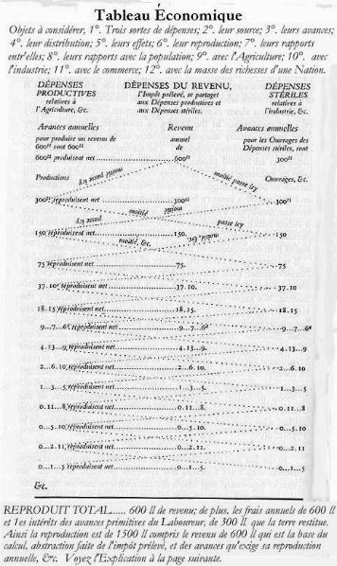
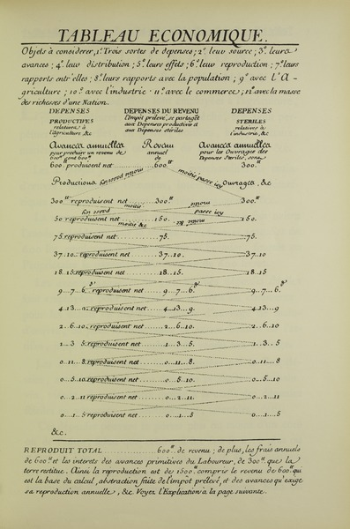
Figure 17: Tableau Économique

Source: Quesnay

The Physiocrats
However, the history of IO tables can be traced back to the Physiocrats, who were a group of French Enlightenment thinkers of the 1760s led by François Quesnay.
The origin of Physiocratic doctrine was the Tableau Économique (Quesnay, 1961). Quesnay diagrammed the relationship between the different economic classes and sectors of society and the flow of payments between them. Essentially the Tableau Économique was a descriptive device showing sales and purchase relationships among various producers and consumers in an economy. Through this, he developed the notion of economic equilibrium, a concept frequently used as a point of departure for subsequent economic analysis.

Wassily Leontief
Wassily Leontief developed the IO framework as both a theoretical and an applied economic tool. He constructed the first IO tables for the United States for the years 1919 and 1929. Leontief received the Nobel Prize for economic science in 1973. An economic model developed using IO analysis is generally referred to as a Leontief model. It is also called “interindustry analysis” because it analyses the independence of industries in an economy.

Richard Stone
Richard Stone, who received a Nobel Prize for economic science in 1984, integrated the IO framework into the SNA.
These early IOs had only a few sectors. Computing power was limited, and this made analysis and computation very difficult. However, as technology has improved the number of sectors (both industries and products) has increased. Modern IOs are limited by the raw data available. This is collected using surveys which are expensive.

The International Input-Output Association
Founded in 1988, the International Input-Output Association (IIOA) grew out of an informal worldwide network of economists and others with interests in IO analysis. It is a scientific non-profit membership organisation with the objective of advancing knowledge in the field of input-output analysis, including improvements in basic data, theoretical insights and modelling, and applications, both traditional and novel, of IO techniques.

Standard Industrial Classification of all Economic Activities (SIC) Seventh Edition

Section a: Agriculture, Forestry and Fishing
Division 01 Crop and animal production, hunting and related service activities
Division 02 Forestry and logging
Division 03 Fishing and aquaculture

Section B: Mining and Quarrying
Division 05 Mining of coal and lignite
Division 06 Extraction of crude petroleum and natural gas
Division 07 Mining of metal ores
Division 08 Other mining and quarrying
Division 09 Mining support service activities

Section C: Manufacturing
Division 10 Manufacture of food products
Division 11 Manufacture of beverages
Division 12 Manufacture of tobacco products
Division 13 Manufacture of textiles
Division 14 Manufacture of wearing apparel
Division 15 Manufacture of leather and related products
Division 16 Manufacture of wood and of products of wood and cork, except furniture; Manufacture of articles of straw and plaiting materials
Division 17 Manufacture of paper and paper products
Division 18 Printing and reproduction of recorded media
Division 19 Manufacture of coke and refined petroleum products
Division 20 Manufacture of chemicals and chemical products
Division 21 Manufacture of basic pharmaceutical products and pharmaceutical preparations
Division 22 Manufacture of rubber and plastics products
Division 23 Manufacture of other non-metallic mineral products
Division 24 Manufacture of basic metals
Division 25 Manufacture of fabricated metal products, except machinery and equipment
Division 26 Manufacture of computer, electronic and optical products
Division 27 Manufacture of electrical equipment
Division 28 Manufacture of machinery and equipment n.e.c.
Division 29 Manufacture of motor vehicles, trailers and semi-trailers
Division 30 Manufacture of other transport equipment
Division 31 Manufacture of furniture
Division 32 Other manufacturing
Division 33 Repair and installation of machinery and equipment

Section D: Electricity, Gas, Steam and Air Conditioning Supply
Division 35 Electricity, gas, steam and air conditioning supply

Section E: Water Supply; Sewerage, Waste Management and Remediation Activities
Division 36 Water collection, treatment and supply
Division 37 Sewerage
Division 38 Waste collection, treatment and disposal activities; materials recovery
Division 39 Remediation activities and other waste management services

Section F: Construction
Division 41 Construction of buildings
Division 42 Civil engineering
Division 43 Specialised construction activities

Section G: Wholesale and Retail Trade; Repair of Motor Vehicles and Motorcycles
Division 45 Wholesale and retail trade and repair of motor vehicles and motorcycles
Division 46 Wholesale trade, except of motor vehicles and motorcycles
Division 47 Retail trade, except for motor vehicles and motorcycles

Section H: Transportation and Storage
Division 49: Land transport and transport via pipelines
Division 50: Water transport
Division 51: Air transport
Division 52: Warehousing and support activities for transportation
Division 53: Postal and courier activities

Section I: Accommodation and Food Service Activities
Division 55: Accommodation
Division 56: Food and beverage service activities

Section J: Information and Communication
Division 58 Publishing activities
Division 59 Motion picture, video and television programme production, sound recording
and music publishing activities
Division 60 Programming and broadcasting activities
Division 61: Telecommunications
Division 62: Computer programming, consultancy and related activities
Division 63: Information service activities

Section K: Financial and Insurance Activities
Division 64 Financial service activities, except insurance and pension funding
Division 65 Insurance, reinsurance and pension funding, except compulsory social security
Division 66 Activities auxiliary to financial service and insurance activities

Section L: Real Estate Activities
Division 68 Real estate activities

Section M: Professional, Scientific and Technical Activities
Division 69 Legal and accounting activities
Division 70 Activities of head offices; management consultancy activities
Division 71 Architectural and engineering activities; technical testing and analysis
Division 72 Scientific research and development
Division 73 Advertising and market research
Division 74 Other professional, scientific and technical activities
Division 75 Veterinary activities

Section N: Administrative and Support Activities
Division 77 Rental and leasing activities
Division 78 Employment activities
Division 79: Travel agency, tour operator, reservation service and related activities
Division 80 Security and investigation activities
Division 81 Services to buildings and landscape activities
Division 82 Office administrative, office support and other business support activities

Section O: Public Administration and Defence; Compulsory Social Security
Division 84 Public administration and defence; compulsory social security

Section P: Education
Division 85 Education

Section Q: Human Health and Social Work Activities
Division 86 Human health activities
Division 87 Residential care activities
Division 88 Social work activities without accommodation

Section R: Arts, Entertainment and Recreation
Division 90 Creative, arts and entertainment activities
Division 91 Libraries, archives, museums and other cultural activities
Division 92 Gambling and betting activities
Division 93 Sports activities and amusement and recreation activities

Section S: Other Service Activities
Division 94 Activities of membership organisations
Division 95: Repair of computers and personal and household goods
Division 96 Other personal service activities

Section T: Activities of Households As Employers; Undifferentiated Goods and Services-producing Activities of Households for Own Use
Division 97 Activities of households as employers of domestic personnel
Division 98 Undifferentiated goods and services-producing activities of private households for own use.

Stats SA’s Annual Financial Statistics
The AFS provides supply data of cultural activities. The AFS is published by Stats SA on an annual basis in December each year, and is used in the annual calculation of the GDP. The 2014 AFS, for example, is based on a sample of 12 922 enterprises that was drawn from the total enterprise population (obtained in cooperation with the SA Revenue Services (SARS)). According to Stats SA, all enterprises are first stratified by the predominant type of activity (according to SIC codes) then by size, using turnover as a measure of size. All enterprises in the size group representing the largest enterprises according to turn over were selected: simply a census of large companies and not just a survey. These large enterprises account for approximately 41% of the total sample. For medium and small enterprises, samples are drawn by randomly selecting the allocated number of enterprises within these groups and each industry.
The AFS data excludes agricultural activities, selected financial activities, and the general government.
The AFS survey collects a range of financial statistics in respect of enterprises in the formal business sector of the South African economy. The purpose of the AFS is to derive a set of measures of industry performance based on information available from the financial accounts of enterprises. The AFS includes:
- income items;
- inventory;
- expenditure items;
- profit/loss;
- tax and dividends;
- current assets;
- equity;
- non-current liabilities; and
- current liabilities.
Importantly turnover for each sector is included in the income items, net profit and employment costs. It is therefore convenient to use the 2014 AFS so that the data are more aligned to the Stats SA 2014 South African IO (http://www.statssa.gov.za/?page_id=1854&PPN=P0021).
As discussed above, not all industry sectors have subcategories that include CCIs. In such cases, estimates have been based on the number of CCI employees as a percentage of total employees of the sector concerned. These data are based on the Quarterly Labour Force Survey (QLSF) 2014 (Quarter 3) provided by Stats SA.
The 2019 AFS consists for example of 299 industries (290 disaggregated and nine aggregated). The AFS provides financial data on income items, inventories, expenditure items, profit/loss, tax and dividends and assets and liabilities. Typical sectors (or part thereof) that can be considered are:
- Photographic activities (SIC 8894);
- Dramatic arts, music and other arts activities (SIC 9614);
- Library and archives activities (SIC 9631);
- Museum activities and preservation of historical sites and buildings (SIC 9632);
- Botanical and zoological gardens and nature reserve activities (SIC 9633);
- Motion picture and video production and distribution (SIC9611); and
- Sporting activities (SIC 9641).

List of Dimensions Included in the AFS

Income Items
- Turnover;
- Dividends;
- Government subsidies and incentives;
- Capital transfers received from government;
- Interest;
- Profit on financial and other assets: disposal of assets, realisation for cash and revaluation of assets;
- Profit on financial and other liabilities: redemption, liquidation and revaluation of liabilities;
- Profit on foreign transactions resulting from changes in foreign exchange rates;
- Provisions;
- Research and development;
- Royalties, franchise fees, copyright, trade names, trademarks and patent rights;
- Other;
- Total income.

Inventories
- Opening value of raw materials;
- Opening value of work in progress;
- Opening value of finished goods;
- Total opening value;
- Closing value of raw materials;
- Closing value of work in progress;
- Closing value of finished goods;
- Total closing value.

Expenditure Items
- Purchases;
- Advertising;
- Amortisation;
- Bank charges;
- Bursaries;
- Computer expenses;
- Containers and packaging materials;
- Depreciation;
- Employment cost.

Expenditure Items
- Excise and customs duty;
- IT security services;
- Insurance premiums;
- Interest;
- Losses on foreign transactions resulting from changes in foreign exchange rates;
- Losses on financial and other liabilities: redemption, liquidation and revaluation of liabilities;
- Losses on financial and other assets: disposal of assets, realisation for cash and revaluation of assets;
- Mineral rights leases;
- Motor vehicle running expenses;
- Operational leasing and hiring of plant, machinery, equipment and vehicles;
- Paper, printing and stationery;
- Postal and courier services;
- Property tax;
- Provisions;
- Railage and transport-out;
- Rental of land, buildings and other structures including water and electricity;
- Repair and maintenance;
- Research and development;
- Royalties, franchise fees, copyright, trade names, trademarks and patent rights;
- Security services;
- Staff training;
- Subcontractors;
- Telecommunication services;
- Travelling, accommodation and entertainment;
- Other.

Total Expenditure
- Profit/loss, tax and dividends;
- Net profit before providing for company tax and dividends;
- Company tax paid or provided for during the financial year;
- Dividends paid or provided for during the financial year;
- Net profit after providing for company tax and dividends.

Non-current Assets
- Property, plant and equipment and intangible assets;
- Long-term investments;
- Other non-current assets;
- Total non-current assets.

Current Assets
- Trade and other receivables;
- Cash and cash equivalents;
- Inventory;
- Other current assets;
- Total current assets;
- Total assets.

Equity
- Total equity

Non-current Liabilities
- Long-term loans
- Other non-current liabilities
- Total non-current liabilities.

Current Liabilities
- Trade and other payables
- Bank overdraft
- Other current liabilities
- Total current liabilities
- Total equity and liabilities.

PPE
- Carrying value of property, plant and equipment and intangible assets at the end of the financial year

ISIC Codes Description

ISIC Code 9000 – Creative, Arts and Entertainment Activities

Inclusions
This class includes the operation of facilities and provision of services to meet the cultural and entertainment interests of their customers. This includes the production and promotion of, and participation in, live performances, events or exhibits intended for public viewing; the provision of artistic, creative or technical skills for the production of artistic products and live performances.
This class includes:
- Production of live theatrical presentations, concerts and opera or dance productions and other stage productions
- Activities of groups, circuses or companies, orchestras or bands
- Activities of individual artists such as authors, actors, directors, musicians, lecturers or speakers, stage-set designers and builders etc.
- Operation of concert and theatre halls and other arts facilities
- Activities of sculptors, painters, cartoonists, engravers, etchers etc.
- Activities of individual writers, for all subjects including fictional writing, technical writing etc.
- Activities of independent journalists
- Restoration of works of art such as paintings etc.
- Activities of producers or entrepreneurs of arts live events, with or without facilities.

Exclusions
This class excludes:
- Restoring of stained glass windows, see ISIC Code - 2310
- Manufacture of statues, other than artistic originals, see ISIC Code - 2396
- Restoring of organs and other historical musical instruments, see ISIC Code - 3319
- Restoring of historical sites and buildings, see ISIC Code - 4100
- Motion picture and video production, see ISIC Code - 5911, ISIC Code - 5912
- Operation of cinemas, see ISIC Code - 5914
- Activities of personal theatrical or artistic agents or agencies, see ISIC Code - 7490
- Casting activities, see ISIC Code - 7810
- Activities of ticket agencies, see ISIC Code - 7990
- Operation of museums of all kinds, see ISIC Code - 9102
- Sports and amusement and recreation activities, see ISIC Code - 93
- Restoring of furniture (except museum type restoration), see ISIC Code - 9524

ISIC Code 9102 - Museums Activities and Operation of Historical Sites and Buildings

Inclusions
This class includes:
- Operation of museums of all kinds:
- Art museums, museums of jewellery, furniture, costumes, ceramics, silverware
- Natural history, science and technological museums, historical museums, including military museums
- Other specialised museums
- Open-air museums
- Operation of historical sites and buildings.

Exclusions
This class excludes:
- Restoration of works of art and museum collection objects, see ISIC Code - 9000
- Activities of libraries and archives, see ISIC Code – 9101.

ISIC Code 9103 - Botanical and Zoological Gardens and Nature Reserves Activities

Inclusions
This class includes:
- Operation of botanical and zoological gardens, including children's zoos
- Operation of nature reserves, including wildlife preservation, etc.

Exclusions
This class excludes:
- Landscape and gardening services, see ISIC Code - 8130
- Operation of sport fishing and hunting preserves, see ISIC Code – 9319.

ISIC Code 4764 - Retail Sale of Second-Hand Goods

Inclusions
This class includes:
- Retail sale of second-hand books
- Retail sale of other second-hand goods
- Retail sale of antiques
- Activities of auctioning houses (retail)
- Activities of trading stamps and coins.

Exclusions
This class excludes:
- Retail sale of second-hand motor vehicles, see ISIC Code - 4510
- Activities of Internet auctions and other non-store auctions (retail), see ISIC Code - 4791, ISIC Code - 4799
- Activities of pawn shops, see ISIC Code – 6492.

ISIC Code 3220 - Manufacture of Musical Instruments

Inclusions
This class includes:
- Manufacture of stringed instruments
- Manufacture of keyboard stringed instruments, including automatic pianos
- Manufacture of keyboard pipe organs, including harmoniums and similar keyboard instruments with free metal reeds
- Manufacture of accordions and similar instruments, including mouth organs
- Manufacture of wind instruments
- Manufacture of percussion musical instruments
- Manufacture of musical instruments, the sound of which is produced electronically
- Manufacture of musical boxes, fairground organs, calliopes etc.
- Manufacture of instrument parts and accessories
- Metronomes, tuning forks, pitch pipes, cards, discs and rolls for automatic mechanical instruments etc.
- Manufacture of whistles, call horns and other mouth-blown sound signalling instruments.

Exclusions
This class excludes:
- Reproduction of pre-recorded sound and video tapes and discs, see ISIC Code - 1820
- Manufacture of microphones, amplifiers, loudspeakers, headphones and similar components, see ISIC Code - 2640
- Manufacture of record players, tape recorders and the like, see ISIC Code - 2640
- Manufacture of toy musical instruments, see ISIC Code - 3240
- Restoring of organs and other historic musical instruments, see ISIC Code - 3319
- Publishing of pre-recorded sound and video tapes and discs, see ISIC Code - 5920
- Piano tuning, see ISIC Code - 9529

ISIC Code 5920 - Sound Recording and Music Publishing Activities

Inclusions
This class includes:
- Production of original (sound) master recordings, such as tapes, CDs
- Sound recording service activities in a studio or elsewhere, including the production of taped (i.e. non-live) radio programming, audio for film, television etc.
- Music publishing, i.e. activities of:
  - Acquiring and registering copyrights for musical compositions
  - Promoting, authorising and using these compositions in recordings, radio, television, motion pictures, live performances, print and other media
  - Distributing sound recordings to wholesalers, retailers or directly to the public.
Units engaged in these activities may own the copyright or act as administrator of the music copyrights on behalf of the copyright owners.
- Publishing of music and sheet books.

Exclusions
This class excludes:
- Reproduction from master copies of music or other sound recordings, see ISIC Code - 1820
- Wholesale of recorded audio tapes and disks, see ISIC Code - 4649

ISIC Code 4762 - Retail Sale of Music and Video Recordings in Specialised Stores

Inclusions
This class includes:
- Retail sale of musical records, audio tapes, compact discs and cassettes
- Retail sale of video tapes and DVDs
- Retail sale of blank tapes and discs

ISIC Code 7420 - Photographic Activities

Inclusions
This class includes:
- Commercial and consumer photograph production:
- Portrait photography for passports, schools, weddings etc.
- Photography for commercials, publishers, fashion, real estate or tourism purposes
- Aerial photography
- Videotaping of events: weddings, meetings etc.
- Film processing:
- Developing, printing and enlarging from client-taken negatives or cine-films
- Film developing and photo printing laboratories
- One hour photo shops (not part of camera stores)
- Mounting of slides
- Copying and restoring or transparency retouching in connection with photographs
- Activities of photojournalists
- Microfilming of documents

Exclusions
This class excludes:
- Processing motion picture film related to the motion picture and television industries, see ISIC Code - 5912
- Cartographic and spatial information activities, see ISIC Code - 7110

ISIC Code 5819 - Other Publishing Activities

Inclusions
This class includes:
- Publishing (including online) of:
- Catalogues
- Photos, engravings and postcards
- Greeting cards
- Forms
- Posters, reproduction of works of art
- Advertising material
- Other printed matter
- Online publishing of statistics or other information

Exclusions
This class excludes:
- Retail sale of software, see ISIC Code - 4741
- Publishing of advertising newspapers, see ISIC Code - 5813
- Online provision of software (application hosting and application service provisioning), see ISIC Code - 6311

ISIC Code 3211 - Manufacture of Jewellery and Related Articles

Inclusions
This class includes:
- Production of worked pearls
- Production of precious and semi-precious stones in the worked state, including the working of industrial quality stones and synthetic or reconstructed precious or semi-precious stones
- Working of diamonds
- Manufacture of jewellery of precious metal or of base metals clad with precious metals, or precious or semi-precious stones, or of combinations of precious metal and precious or semi-precious stones or of other materials
- Manufacture of goldsmiths' articles of precious metals or of base metals clad with precious metals:
- Dinnerware, flatware, hollowware, toilet articles, office or desk articles, articles for religious use etc.
- Manufacture of technical or laboratory articles of precious metal (except instruments and parts thereof): crucibles, spatulas, electroplating anodes etc.
- Manufacture of precious metal watch bands, wristbands, watch straps and cigarette cases
- Manufacture of coins, including coins for use as legal tender, whether or not of precious metal
- Engraving of personal precious and non-precious metal products

Exclusions
This class excludes:
- Manufacture of non-metal watch bands (fabric, leather, plastic etc.), see ISIC Code - 1512
- Manufacture of articles of base metal plated with precious metal (except imitation jewellery), see ISIC Code - 25
- Manufacture of watchcases, see ISIC Code - 2652
- Manufacture of (non-precious) metal watch bands, see ISIC Code - 3212

ISIC Code 7220 - Research and Experimental Development on Social Sciences and Humanities

Inclusions
This class includes:
- Research and development on social sciences
- Research and development on humanities
- Interdisciplinary research and development, predominantly on social sciences and humanities

Exclusions
This class excludes:
- Market research, see ISIC Code - 7320
- facture of imitation jewellery, see ISIC Code - 3212

ISIC Code 9101 - Library and Archives Activities

Inclusions
This class includes:
- Documentation and information activities of libraries of all kinds, reading, listening and viewing rooms, public archives providing service to the general public or to a special clientele, such as students, scientists, staff, members as well as operation of government archives:
- Organisation of a collection, whether specialised or not
- Cataloguing collections
- Lending and storage of books, maps, periodicals, films, records, tapes, works of art etc.
- Retrieval activities in order to comply with information requests etc.
- Stock photo libraries and services

ISIC Code 5811 - Book Publishing

Inclusions
This class includes the activities of publishing books in print, electronic (CD, electronic displays etc.) or audio form or on the Internet.
This class includes:
- Publishing of books, brochures, leaflets and similar publications, including publishing of dictionaries and encyclopaedias
- Publishing of atlases, maps and charts
- Publishing of audio books
- Publishing of encyclopaedias etc. on CD-ROM

Exclusions
This class excludes:
- Production of globes, see ISIC Code - 3290
- Publishing of advertising material, see ISIC Code - 5819
- Publishing of music and sheet books, see ISIC Code - 5920
- Activities of independent authors, see ISIC Code - 9000

ISIC Code 5813 - Publishing of Newspapers, Journals and Periodicals

Inclusions
This class includes:
- Publishing of newspapers, including advertising newspapers
- Publishing of periodicals and other journals, including publishing of radio and television schedules
Publishing can be done in print or electronic form, including on the Internet.

ISIC Code 5819 - Other Publishing Activities

Inclusions
This class includes:
- Publishing (including online) of:
- Catalogues
- Photos, engravings and postcards
- Greeting cards
- Forms
- Posters, reproduction of works of art
- Advertising material
- Other printed matter
- Online publishing of statistics or other information

Exclusions
This class excludes:
- Retail sale of software, see ISIC Code - 4741
- Publishing of advertising newspapers, see ISIC Code - 5813
- Online provision of software (application hosting and application service provisioning), see ISIC Code - 6311

ISIC Code 4751 - Retail Sale of Books, Newspapers and Stationery in Specialised Stores

Inclusions
This class includes:
- Retail sale of books of all kinds
- Retail sale of newspapers and stationery
- Retail sale of office supplies such as pens, pencils, paper etc.

Exclusions
This class excludes:
- Retail sale of second-hand or antique books, see ISIC Code - 4764

ISIC Code 6391 - News Agency Activities

Inclusions
This class includes:
- News syndicate and news agency activities furnishing news, pictures and features to the media

Exclusions
This class excludes:
- Activities of independent photojournalists, see ISIC Code - 7420
- Activities of independent journalists, see ISIC Code - 9000

ISIC Code 6399 - Other Information Service Activities Not Elsewhere Classified

Inclusions
This class includes other information service activities not elsewhere classified, such as:
- Telephone based information services
- Information search services on a contract or fee basis
- News clipping services, press clipping services, etc.

Exclusions
This class excludes:
- Activities of call centres, see ISIC Code - 8220

ISIC Code 4649 - Wholesale of Other Household Goods

Inclusions
This class includes:
- Wholesale of household furniture
- Wholesale of household appliances
- Wholesale of consumer electronics:
- Radio and TV equipment
- CD and DVD players and recorders
- Stereo equipment
- Video game consoles
- Wholesale of lighting equipment
- Wholesale of cutlery
- Wholesale of china and glassware
- Wholesale of woodenware, wickerwork and corkware etc.
- Wholesale of pharmaceutical and medical goods
- Wholesale of perfumeries, cosmetics and soaps
- Wholesale of bicycles and their parts and accessories
- Wholesale of stationery, books, magazines and newspapers
- Wholesale of photographic and optical goods (e.g. sunglasses, binoculars, magnifying glasses)
- Wholesale of recorded audio and video tapes, CDs, DVDs
- Wholesale of leather goods and travel accessories
- Wholesale of watches, clocks and jewellery
- Wholesale of musical instruments, games and toys, sports goods
- Wholesale of silverware and medals

Exclusions
This class excludes:
- Wholesale of blank audio and video tapes, CDs, DVDs, see ISIC Code - 4652
- Wholesale of radio and TV broadcasting equipment, see ISIC Code - 4652
- Wholesale of office furniture, see ISIC Code - 4659

ISIC Code 5911 - Motion Picture, Video and Television Programme Production Activities

Inclusions
This class includes:
- Production of motion pictures, videos, television programmes or television commercials

Exclusions
This class excludes:
- Film duplicating (except reproduction of motion picture film for theatrical distribution) as well as reproduction of audio and video tapes, CDs or DVDs from master copies, see ISIC Code - 1820
- Wholesale of recorded video tapes, CDs, DVDs, see ISIC Code - 4649
- Retail trade of video tapes, CDs, DVDs, see ISIC Code - 4762
- Post-production activities, see ISIC Code - 5912
- Reproduction of motion picture film for theatrical distribution, see ISIC Code - 5912
- Sound recording and recording of books on tape, see ISIC Code - 5920
- Creating a complete television channel programme, see ISIC Code - 6020
- Television broadcasting, see ISIC Code - 6020
- Film processing other than for the motion picture industry, see ISIC Code - 7420
- Activities of personal theatrical or artistic agents or agencies, see ISIC Code - 7490
- Renting of video tapes, DVDs to the general public, see ISIC Code - 7722
- Real-time (i.e. simultaneous) closed captioning of live television performances, meetings, conferences, etc., see ISIC Code - 8299
- Activities of own account actors, cartoonists, directors, stage designers and technical specialists, see ISIC Code - 9000

ISIC Code 5912 - Motion Picture, Video and Television Programme Post-Production Activities

Inclusions
This class includes:
- Post-production activities such as:
- Editing, titling, subtitling, credits
- Closed captioning
- Computer-produced graphics, animation and special effects
- Film/tape transfers
- Activities of motion picture film laboratories and activities of special laboratories for animated films:
- Developing and processing motion picture film
- Reproduction of motion picture film for theatrical distribution
- Activities of stock footage film libraries etc.

Exclusions
This class excludes:
- Film duplicating (except reproduction of motion picture film for theatrical distribution) as well as reproduction of audio and video tapes, CDs or DVDs from master copies, see ISIC Code - 1820
- Wholesale of recorded video tapes, CDs, DVDs, see ISIC Code - 4649
- Retail trade of video tapes, CDs, DVDs, see ISIC Code - 4762
- Film processing other than for the motion picture industry, see ISIC Code - 7420
- Renting of video tapes, DVDs to the general public, see ISIC Code - 7722
- Activities of own account actors, cartoonists, directors, stage designers and technical specialists, see ISIC Code - 9000

ISIC Code 5913 - Motion Picture, Video and Television Programme Distribution Activities

Inclusions
This class includes:
- Distributing film, video tapes, DVDs and similar productions to motion picture theatres, television networks and stations and exhibitors
- Acquiring film, video tape and DVD distribution rights

Exclusions
This class excludes:
- Film duplicating (except reproduction of motion picture film for theatrical distribution) as well as reproduction of audio and video tapes, CDs or DVDs from master copies, see ISIC Code - 1820
- Reproduction of motion picture film for theatrical distribution, see ISIC Code - 5912

ISIC Code 5920 - Sound Recording and Music Publishing Activities

Inclusions
This class includes:
- Production of original (sound) master recordings, such as tapes, CDs
- Sound recording service activities in a studio or elsewhere, including the production of taped (i.e. non-live) radio programming, audio for film, television etc.
- Music publishing, i.e. activities of:
- Acquiring and registering copyrights for musical compositions
- Promoting, authorising and using these compositions in recordings, radio, television, motion pictures, live performances, print and other media
- Distributing sound recordings to wholesalers, retailers or directly to the public
- Publishing of music and sheet books
Units engaged in these activities may own the copyright or act as administrator of the music copyrights on behalf of the copyright owners.

Exclusions
This class excludes:
- Reproduction from master copies of music or other sound recordings, see ISIC Code - 1820
- Wholesale of recorded audio tapes and disks, see ISIC Code – 4649

ISIC Code 5914 - Motion Picture Projection Activities

Inclusions
This class includes:
- Motion picture or videotape projection in cinemas, in the open air or in other projection facilities
- Activities of cine-clubs

ISIC Code 6010 - Radio Broadcasting

Inclusions
This class includes:
- Broadcasting audio signals through radio broadcasting studios and facilities for the transmission of aural programming to the public, to affiliates or to subscribers
- Activities of radio networks, i.e. assembling and transmitting aural programming to the affiliates or subscribers via over-the-air broadcasts, cable or satellite
- Radio broadcasting activities over the Internet (Internet radio stations)
- Data broadcasting integrated with radio broadcasting

Exclusions
This class excludes:
- Production of taped radio programming, see ISIC Code - 5920

ISIC Code 6020 - Television Programming and Broadcasting Activities

Inclusions
This class includes:
- Creation of a complete television channel programme, from purchased programme components (e.g. movies, documentaries etc.), self-produced programme components (e.g. local news, live reports) or a combination thereof
- Programming of video-on-demand channels
- Data broadcasting integrated with television broadcasting
This complete television programme can be either broadcast by the producing unit or produced for transmission by third party distributors, such as cable companies or satellite television providers.
The programming may be of a general or specialised nature (e.g. limited formats such as news, sports, education or youth oriented programming), may be made freely available to users or may be available only on a subscription basis.

Exclusions
This class excludes:
- Production of television programme elements (e.g. movies, documentaries, commercials), see ISIC Code - 5911
- Assembly of a package of channels and distribution of that package via cable or satellite to viewers, see ISIC Code - 61

ISIC Code 6312 - Web Portals

Inclusions
This class includes:
- Operation of websites that use a search engine to generate and maintain extensive databases of Internet addresses and content in an easily searchable format
- Operation of other websites that act as portals to the Internet, such as media sites providing periodically updated content

ISIC CODE 7722 - Renting of Video Tapes and Disks

Inclusions
This class includes:
- Renting of video tapes, records, CDs, DVDs etc.

ISIC Code 6391 - News Agency Activities

Inclusions
This class includes:
- News syndicate and news agency activities furnishing news, pictures and features to the media

Exclusions
This class excludes:
- Activities of independent photojournalists, see ISIC Code - 7420
- Activities of independent journalists, see ISIC Code - 9000

ISIC Code 4762 - Retail Sale of Music and Video Recordings in Specialised Stores

Inclusions
This class includes:
- Retail sale of musical records, audio tapes, compact discs and cassettes
- Retail sale of video tapes and DVDs
- Retail sale of blank tapes and discs

ISIC CODE 4781 - Retail Sale Via Mail Order Houses or Via Internet

Inclusions
This class includes retail sale activities via mail order houses or via Internet, i.e. retail sale activities where the buyer makes his choice on the basis of advertisements, catalogues, information provided on a website, models or any other means of advertising and places his order by mail, phone or over the Internet (usually through special means provided by a website). The products purchased can be either directly downloaded from the Internet or physically delivered to the customer.
This class includes:
- Retail sale of any kind of product by mail order
- Retail sale of any kind of product over the Internet
- Direct sale via television, radio and telephone
- Internet retail auctions

ISIC Code 7410 - Specialised Design Activities

Inclusions
This class includes:
- Fashion design related to textiles, wearing apparel, shoes, jewellery, furniture and other interior decoration and other fashion goods as well as other personal or household goods
- Industrial design, i.e. creating and developing designs and specifications that optimise the use, value and appearance of products, including the determination of the materials, construction, mechanism, shape, colour and surface finishes of the product, taking into consideration human characteristics and needs, safety, market appeal and efficiency in production, distribution, use and maintenance
- Activities of graphic designers
- Activities of interior decorators

Exclusions
This class excludes:
- Design and programming of web pages, see ISIC Code - 6201
- Architectural design, see ISIC Code - 7110
- Engineering design, i.e. applying physical laws and principles of engineering in the design of machines, materials, instruments, structures, processes and systems, see ISIC Code - 7110
- Theatrical stage-set design, see ISIC Code - 9000

ISIC Code 7110 - Architectural and Engineering Activities and Related Technical Consultancy

Inclusions
This class includes the provision of architectural services, engineering services, drafting services, building inspection services and surveying and mapping services and the like.
This class includes:
- Architectural consulting activities:
- Building design and drafting
- Town and city planning and landscape architecture
- Engineering design (i.e. applying physical laws and principles of engineering in the design of machines, materials, instruments, structures, processes and systems) and consulting activities for:
- Machinery, industrial processes and industrial plant
- Projects involving civil engineering, hydraulic engineering, traffic engineering
- Water management projects
- Projects elaboration and realisation relative to electrical and electronic engineering, mining engineering, chemical engineering, mechanical, industrial and systems engineering, safety engineering
- Project management activities related to construction
- Elaboration of projects using air conditioning, refrigeration, sanitary and pollution control engineering, acoustical engineering etc.
- Geophysical, geologic and seismic surveying
- Geodetic surveying activities:
- Land and boundary surveying activities
- Hydrologic surveying activities
- Subsurface surveying activities
- Cartographic and spatial information activities

Exclusions
This class excludes:
- Test drilling in connection with mining operations, see ISIC Code - 0910, ISIC Code - 0990
- Development or publishing of associated software, see ISIC Code - 5820, ISIC Code - 6201
- Activities of computer consultants, see ISIC Code - 6202, ISIC Code - 6209
- Technical testing, see ISIC Code - 7120
- Research and development activities related to engineering, see ISIC Code - 7210
- Industrial design, see ISIC Code - 7410
- Interior decorating, see ISIC Code - 7410
- Aerial photography, see ISIC Code - 7420

ISIC Code 7310 - Advertising

Inclusions
This class includes the provision of a full range of advertising services (i.e. through in-house capabilities or subcontracting), including advice, creative services, production of advertising material, media planning and buying.
This class includes:
- Creation and realisation of advertising campaigns:
- Creating and placing advertising in newspapers, periodicals, radio, television, the Internet and other media
- Creating and placing of outdoor advertising, e.g. billboards, panels, bulletins and frames, window dressing, showroom design, car and bus carding etc.
- Media representation, i.e. sale of time and space for various media soliciting advertising
- Aerial advertising
- Distribution or delivery of advertising material or samples
- Provision of advertising space on billboards etc.
- Creation of stands and other display structures and sites
- Conducting marketing campaigns and other advertising services aimed at attracting and retaining customers:
- Promotion of products
- Point-of-sale marketing
- Direct mail advertising
- Marketing consulting
- Merchandising activities

Exclusions
This class excludes:
- Publishing of advertising material, see ISIC Code - 5819
- Production of commercial messages for radio, television and film, see ISIC Code - 5911
- Public-relations activities, see ISIC Code - 7020
- Market research, see ISIC Code - 7320
- Graphic design activities, see ISIC Code - 7410
- Advertising photography, see ISIC Code - 7420
- Convention and trade show organisers, see ISIC Code - 8230
- Mailing activities, see ISIC Code - 8219

ISIC Code 8522 - Technical and Vocational Secondary Education

Inclusions
This class includes education typically emphasising subject-matter specialisation and instruction in both theoretical background and practical skills generally associated with present or prospective employment. The aim of a programme can vary from preparation for a general field of employment to a very specific job. Instruction may be provided in diverse settings, such as the unit's or client's training facilities, educational institutions, the workplace, or the home, and through correspondence, television, Internet, or other means.
This class includes:
- Technical and vocational education below the level of higher education as defined in ISIC Code - 853
- Instruction for tourist guides
- Instruction for chefs, hoteliers and restaurateurs
- Special education for handicapped students at this level
- Cosmetology and barber schools
- Computer repair training
- Driving schools for occupational drivers e.g. of trucks, buses, coaches

Exclusions
This class excludes: 75
- Technical and vocational education at post-secondary and university levels, see ISIC Code - 8530
- Adult education as defined in ISIC Code - 854
- Performing art instruction for recreation, hobby and self-development purposes, see ISIC Code - 8542
- Automobile driving schools not intended for occupational drivers, see ISIC Code - 8549
- Job training forming part of social work activities without accommodation, see ISIC Code - 8810, ISIC Code - 8890

ISIC Code 8530 - Higher Education

Inclusions
This class includes the provision of post-secondary non-tertiary and tertiary education, including granting of degrees at baccalaureate, graduate or postgraduate level. The requirement for admission is at least a high school diploma or equivalent general academic training. Education can be provided in classrooms or through radio, television broadcast, Internet or correspondence.
This class includes:
- Post-secondary non-tertiary education
- First stage of tertiary education (not leading to an advanced research qualification)
- Second stage of tertiary education (leading to an advanced research qualification)
- Performing arts schools providing higher education

Exclusions
This class excludes:
- Adult education as defined in ISIC Code - 854

ISIC CODE 8542 - Cultural education

Inclusions
This class includes provision of instruction in the arts, drama and music. Units giving this type of instructions might be named “schools”, “studios”, “classes” etc. They provide formally organised instruction, mainly for hobby, recreational or self-development purposes, but such instruction does not lead to a professional diploma, baccalaureate or graduate degree.
This class includes:
- Piano teachers and other music instruction
- Art instruction
- Dance instruction and dance studios
- Drama schools (except academic)
- Fine arts schools (except academic)
- Performing arts schools (except academic)
- Photography schools (except commercial)

Correspondence Tables or Concordances
Correspondence tables or Concordances are tools for the linking of classifications. It explains where, and to what extent, the categories in one classification may be found in other classifications, or in earlier versions of the same classification. Tables are important for the development and harmonisation of international classifications. There are many different circumstances under which one may want to establish relations between classifications, and many forms which these relations may take. Tables can be precise, depending on the convention to describe the type of link between tables (e.g. historical, hierarchical or whether they overlap). (Source: United Nations Statistics Division, Fourth Meeting of the Expert Group on International Economic and Social Classifications, New York, 2-4 November 1998: A Statement of Best Practices. http://unstats.un.org/unsd/class/family/glossary_short.asp)
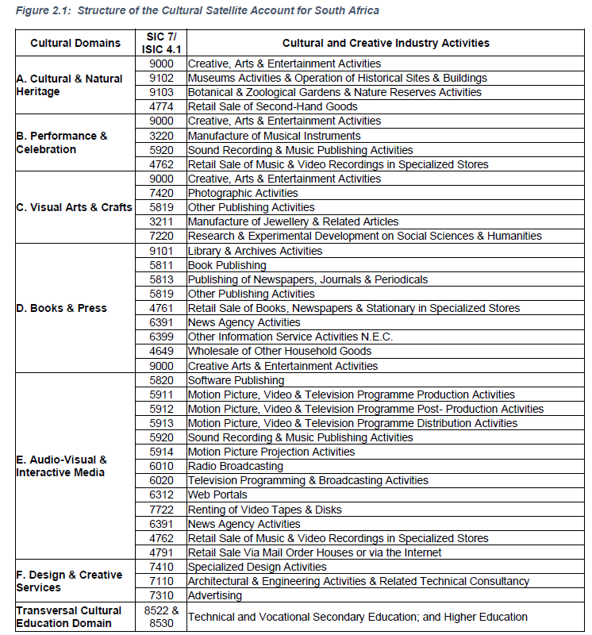
Figure 18: UNESCO mapping using ISIC

Appendix 2. A Simple Input-Output Framework
An IO table focuses on the interrelationship between industries in an economy with respect to the production and uses of their products and the products imported. Generally, the IO framework is represented in a table. In this form, the economy is viewed as each industry listed across the top is a consuming sector and down the side is a supplying sector.
Figure 19: Basic IO Transactions Table
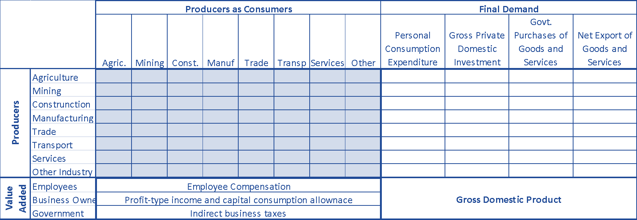
Source: Miller and Blair (2009, p. 3)
Although most industries will provide goods and services for final consumption, they will also provide inputs into the productive process of other industries. Besides buying inputs from other industries, producers need labour and capital to produce the goods and services. In addition, firms may receive subsidies or be required to pay taxes. In an open economy, companies would also import part of their input for production. The “recipe” for the manufacture of an industry’s products or services can be seen down each column.
Similarly, firms will produce products that will be used as inputs for production in other industries. They will supply goods and services (final demand) for consumers, investors and government. They will also provide goods and services to foreign markets.
The IO table, as discussed above, therefore shows how the GDP for a country is calculated using the production method, the expenditure method and the income method. The table shown above includes only a few industries. Many IO tables have considerably more industries listed. However, the greater number of industries the more complex and complicated it becomes to “balance” the table, bearing in mind that the three methods used to calculate the GDP must arrive at the same value.
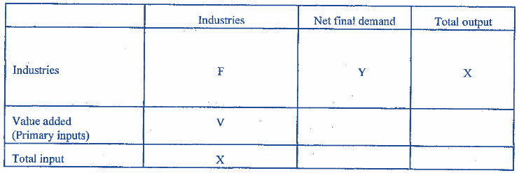
Figure 20: A highly simplified IO accounting framework
Source: United Nations (1999, p. 4)
Although the table makes it easier to grasp the economic concepts behind the analysis, an IO model primarily consists of a system of linear equations. Each equation describes the distribution of an industry’s product throughout the economy.
Leontief introduced the assumption of fixed-coefficient linear production functions relating to input used by an industry. These matrices, including the F-matrix, are shown above.
These relationships for a basic three sector model can be written as follows:
$$a_{11}X_{1}+a_{12}X_{2}+a_{13}X_{3}+Y_{1}=X_{1}$$
$$a_{21}X_{1}+a_{22}X_{2}+a_{23}X_{3}+Y_{2}=X_{2}$$
$a_{31}X_{1}+a_{32}X_{2}+a_{33}X_{3}+Y_{3}=X_{3}$ Equation 1
In matrix form these equations can be written as:
$\left[a_{11} a_{12} a_{13} a_{21} a_{22} a_{23} a_{31} a_{32} a_{33} \right]\left[X_{1} X_{2} X_{3} \right]+\left[Y_{1} Y_{2} Y_{3} \right]=\left[X_{1} X_{2} X_{3} \right]$ Equation 2
However, in any economy, there are considerably more than three industries and the more general way of denoting these is as follows:
$$a_{11}X_{1}+a_{12}X_{2}+{⋯a}_{1n}X_{3}+Y_{1}=X_{1}$$
$$a_{21}X_{1}+a_{22}X_{2}+⋯a_{2n}X_{3}+Y_{2}=X_{2}$$
$$∙ + ∙ +⋯ ∙ +∙ = ∙$$
$a_{n1}X_{1}+a_{n2}X_{2}+⋯a_{nn}X_{n}+Y_{n}=X_{n}$ Equation 3
In matrix form, this is denoted as:
$\left[a_{11} ⋯ a_{1n} ⋮ ⋱ ⋮ a_{n1} ⋯ a_{nn} \right]X_{1} ⋮ X_{n} +Y_{1} ⋮ Y_{n} =X_{1} ⋮ X_{n}$ Equation 4
Table 16: Technical coefficients of an IO table (Matrix A)
 |  | Buying sector
 |  | 1 | ⃛ | j | ⃛ | n
Selling sector | 1 | a₁₁ | ⃛ | a_{1j} | ⃛ | a₁₁
Selling sector |  | ⋮ |  | ⋮ |  | ⋮
Selling sector | i | a_{i1} | ⃛ | a_{ij} | ⃛ | a_{in}
Selling sector |  | ⋮ |  | ⋮ |  | ⋮
Selling sector | n | a_{n1} | ⃛ | a_{nj} | ⃛ | a_{nn}

Using matrix notation, it is usually written as:
$AX+Y=X$ Equation 5
This relationship is the basic IO system of equations, where:
- Matrix A is the IO coefficient matrix;
- Matrix X is the output vector; and
- Matrix Y is the net final demand vector.
The solution of an IO model is described below.
Final demand (Y) consists of the household, government and rest of the world sectors. Value added (V) to the producing sector consists of the returns to factors of production (capital and labour) that receive interest and wages.
IO tables and associated models are generally constructed from observed data for a particular area. Most often this area refers to a nation: it could however also refer to sub-national areas. The data are also collected for a given period of time, usually a year. Although theoretically, the IO table applies to units of production, this is impractical, and it is generally presented in monetary terms.
The discussion above referred to a closed economy and therefore did not include international trade (imports and exports). This is necessary because very few industries produce goods or services without using some imported components.

Splitting the Sectors
In this study, sectors and subsectors were assigned to domains using information from the guidelines provided by the UNESCO Framework for Cultural Statistics (2009), sector-specific research and information, and previous SACO mapping studies. Where specific sectors contained CCI components, but not entirely, use was made of other documents including Stats SA’s AFS, surveys and other research to determine ratios that were used to split these sectors into the specific CCI domains and non-CCI sectors. A conservative approach was used to ensure that the CCI were not overestimated. The original totals were compared to the new total to ensure that there was no double counting or inadvertent exclusions.
In principle, the F-matrix should be split according to the turnover of CCI sub-industries. The value-added matrix, or V-matrix, should be divided according to the returns of the factors of production (compensation or GVA). The Y-matrix, representing final demand, can be divided using either the total turnover or output or the proportion of CCI products and services purchased by households, government or exports.

Appendix 3. Available Data in South Africa

This section discusses available data sources that already exist that can be utilised to produce the South African CSAs. The table below provides an overview of the data followed by a brief description of the data source. Typical sectors are provided as an example for each source that can (depending on the definition of CSAs), be considered.
Table 17: Potential data sources that can be used in the CSA
Survey/administrative data | Coverage | Frequency | Demand or supply side data | Conducted by whom | Classification
Annual Financial Statistics | 12 922 (2014 AFS) | Annually | Supply side | Stats SA | SIC
Large sample surveys | - | Periodically | Supply side | Stats SA | SIC
Income and expenditure of households survey | 31 419 dwelling units (2010/11 IES) | Every 5 to 6 years | Demand side (expenditure data) | Stats SA | COICOP
Living conditions of households |  | Every 5 to 6 years | Demand side (expenditure data) | Stats SA | COICOP
Quarterly Labour Force Survey (QLFS) | Approximately 30 000 dwellings | Quarterly | Employment demand | Stats SA | -
TSA | - | Annually | Supply and demand | Stats SA | CPC
Non-profit Institutions Satellite Account | - | In progress | Supply and demand | Stats SA | -
SUT | 62 industries by 104 products  171 industries by 104 products | Annually  Periodically | Industry supply and demand | Stats SA | SIC (industries),  CPC (products)
Quarterly employment statistics | 20 000 formal non-agricultural business | Quarterly |  | Stats SA | SIC
Volunteer Activity Survey | Approximately 2 909 individuals | Periodically | Supply | Stats SA | -
Financial statistics of consolidated general government | - | Annually | Supply | Stats SA | -
National Treasury, Budget Vote data | Budgeted and actual expenditure data | Annually | Supply | National Treasury | -
Trade data | Approximately 5300 at six-digit level | Monthly | Import (demand)  Export (supply) | SARS | HS

Large Sample Surveys
The large sample surveys are periodic surveys done by Stats SA. The personal services industry survey covers Divisions 92 (Educational services) to Division 99 (Other service activities). Division 96 covers recreational, cultural and sporting activities. The sample for the surveys is drawn from Stats SA’s Business Register that is based on units registered for VAT and income tax (IT) at SARS. Results from these surveys are sued for compiling SA’s National Accounts including GDP and gross fixed capital formation. The 1993 edition of the Standard Industrial Classification of all Economic Activities (SIC), Fifth Edition, is used to classify the statistical units in these surveys. The SIC is based on the 1990 International Standard Industrial Classification of All Economic Activities (ISIC) with suitable adaptations for local conditions.
Income and Expenditure of Households Survey and Living Conditions Survey
The Income and Expenditure Survey and Living Conditions Survey provides household income information and household expenditure (demand). These survey data are collected by Stats SA using the Classification of Individual Consumption According to Purpose (COICOP). The 2010/11 IES has a sample size of 31 419 dwelling units. The 2005/06 IES has a sample size of 22 617 dwelling units that were covered during the 12 months of data collection. The COICOP for the 2010/11 IES covered 755 consumption categories, 36 in-kind consumption categories, and 15 non-CPI consumption categories. It also covers income, in-kind income, savings taxes, transfers, and debts. Typical items that can be considered include:
- Traditional herbs, medicine in private sector (06111210);
- Traditional herbs, medicine in public sector (06111211);
- Cinema, theatres, concerts, festivals (09421000);
- Museums and zoos etc (09422100);
- Film development and photo prints (09424300);
- Textbooks for public institutions (09511100);
- Textbooks for private institutions (09511101);
- Books (excluding those in 1614) (09511200);
- Newspapers - daily weekly (09521100);
- Magazines and periodicals (09521200); and
- Sorghum beer (traditional) from a food service place (11111333).
Living Conditions of Households
Stats SA conducts the Living Conditions of Households Survey that aims to provide data that will contribute to a better understanding of living conditions and poverty in South Africa. Data for the 2008/2009 survey (Stats SA, 2011) was collected from 25 075 households across the country over a period of 12 months using a combination of the diary and recall methods. Data is collected using the COICOP classification.
The General Household Survey (GHS)
The GHS presents the results of the survey conducted annually by Stats SA since 2002 of South African households. The survey collects information on a variety of subjects including education, health, the labour market, dwellings, access to services and facilities, transport, and quality of life. The survey replaced the October Household Survey which was introduced in 1993 and was terminated in 1999.
Quarterly Labour Force Survey (QLFS)
The QLFS is a household-based sample survey conducted by Stats SA. It collects data on the labour market activities of individuals aged 15 years and above who live in South Africa. The survey sample is of approximately 30 000 dwellings in which households reside. This data can provide insight into employment (Stats SA, 2016 a). Typical industries that can be considered include for example:
- Motion picture, radio, television and other entertainment activities
- Library, archives, museums and other cultural activities
- Sporting and other recreational activities
Tourism Satellite Account
The TSA (Stats SA, 2016b) quantify cultural services as one of its “characteristics products”. This is expressed in terms of domestic demand, international demand (exports), total domestic supply and tourism spending abroad (imports). The first five digits correspond to the CPC, Version 2.0 code, and the sixth digit is used exclusively for the TSA. Cultural services include:
- Performing arts
- Performing arts facility operation services (96230.0)
- Services of performing artists (96310.0)
- Museum and other cultural services
- Museum services except for historical sites and buildings (96411.0)
- Preservation services of historical sites and buildings (96412.0)
- Botanical and zoological garden services (96421.0)
- Nature reserve services including wildlife preservation services (96422.0)
Volunteer Activity Survey (VAS)
The VAS collects detailed information on volunteer activities. Stats SA conducted its second VAS in the second quarter of 2014, after the first one had been carried out in 2010. The survey was household-based and collected information on the volunteer activities (a maximum of three activities) of individuals aged 15 years and older in South Africa. The respondents were selected from the households enumerated during the QLFS. It covered unpaid non-compulsory work; that is, the time individuals give without pay to activities performed either through an organisation or directly for others outside their household in the four weeks preceding the survey interview. The survey covered three of the main volunteer activities in which respondents were involved. The volunteer activities could be conducted directly, through an organisation, or through both (direct and organisation-based volunteering). Approximately 2 909 individuals eligible for VAS were followed up to conduct detailed interviews about their volunteer activities during the reference period.
The 2014 survey included estimates on the number of hours, and value of volunteer work for different organisations including and culture and recreation (Stats SA, 2015).
Non-profit Institutions Satellite Account
Stats SA (2012) is in the process of developing a Non-Profit Institutions Satellite Account and published the first working paper in 2012. They started gradually, beginning with a consolidated account of the Non-profit Institution (NPI) sector, that is, the short form of NPISA, particularly excluding the details of volunteer labour with the non-market output of market NPIs. Stats SA concluded that it is not currently possible to compile the full elaboration of the NPISA tables to a required standard. As a result, the compilation of the full set of integrated economic accounts (IEA) per institutional sector and for the total economy is still in a development phase (the household sector and NPISH are combined, and the balance sheet section is not yet compiled). Unfortunately, there is insufficient data for the compilation of the full IEA. The proposed NPISA is proposed to consist of six tables, most with multiple parts including:
- Aggregated NPI sectors (transactions, flow and stock and other variables such as number of volunteers);
- Categories of expenses (operating expenses, intermediate consumption, compensation of employees), sources of revenue, transfer payments, paid and volunteer employment and compensation and asset accumulation and position;
- IEAs by sector and type of institution;
- Output, value added, employment and final consumption expenditure by sector and type of institution; and
- Non-profit entities, members, and membership.
The International Classification of Non-profit Organisations (ICNPO) includes 12 groups of which one is:
- Culture and recreation (Group 1) with subdivisions:
  - Culture and arts (1100)
  - Sport (1200)
  - Other recreation and social clubs (1300)
Table 18 below shows the differences in coding between SIC, ICNPO and ISIC for culture and arts.
Table 18: Differences in coding between SIC, ICNPO and ISIC
Major group | Sub-group | Theme | Description | SIC | ICNPO | ISIC
Culture and Recreation | Culture and Arts | Museums | General and specialised museums covering art, history, sciences, technology, culture. | 96320 | 1100 | 9102
Culture and Recreation | Culture and Arts | Services clubs | Membership organisations providing services to members and local communities, for e.g., Lions, Zonta International, Rotary clubs, Kiwanis. | 96200 | 1300 | 9199
Culture and Recreation | Culture and Arts | Media and communication | Production and dissemination of information and communication, includes radio and TV stations, publishing of books, journals, newspapers, and newsletters, film production, libraries. | 96200 | 1300 | 9199
Culture and Recreation | Culture and Arts | Performing arts | Performing arts centres, companies, and associations; includes theatres, dance, ballet, opera, orchestras, chorales and music ensembles. | 96121-30 | 1300 | 9210
Culture and Recreation | Culture and Arts | Historical, literacy and humanistic societies | Promotion and appreciation of the humanities, preservation of historical and cultural artefacts, commemoration of historical events; includes historical societies, poetry and literary societies, language associations, reading promotion, war memorials. | 96310 | 1100 | 9103
Culture and Recreation | Culture and Arts | Zoos and aquariums | Botanical and zoological gardens and nature reserve activities. | 96330 | 1100 | 9103
Source: Stats SA (2012)

Appendix 4. Household Income Deciles
Table 19: Household Income Deciles
Households: deciles | Cultural and natural heritage | Performance and celebration | Visual art and crafts | Books and press | Audio-visual and interactive media | Design and creative services
1 | 11 | 21 | 124 | 81 | 26 | 16
2 | 29 | 55 | 337 | 217 | 68 | 42
3 | 61 | 115 | 641 | 424 | 145 | 82
4 | 115 | 213 | 1 030 | 714 | 271 | 138
5 | 191 | 353 | 1 502 | 1 096 | 452 | 211
6 | 333 | 609 | 2 195 | 1 664 | 788 | 325
7 | 570 | 1 036 | 3 231 | 2 544 | 1 351 | 498
8 | 1 179 | 2 122 | 5 062 | 4 089 | 2 795 | 848
9 | 2 383 | 4 264 | 8 065 | 6 564 | 5 653 | 1 441
101 | 2 883 | 5 156 | 9 545 | 7 577 | 6 839 | 1 687
102 | 3 480 | 6 216 | 10 941 | 8 726 | 8 256 | 1 962
103 | 4 337 | 7 740 | 13 039 | 10 145 | 10 290 | 2 342
104 | 5 367 | 9 581 | 16 164 | 12 180 | 12 736 | 2 832
Gini | 0.6029 | 0.6355 | 0.6898 | 0.6095 | 0.5786 | 0.5843

The UNESCO mapping of SNA and StatsSA classifications and definitions to these domains is discussed in Appendix 1.
According to the National Small Business Amendment Act, 2004.
Stats SA generally rebases every five years. Rebasing was done in 1999, 2004, 2009, 2014 and 2021 (a bit longer for the latest one because of the pandemic.)
The figures presented, unless otherwise stated, are in constant 2015 prices and on a national accounts basis.
Although GDP is more commonly used and understood by the general public, the GVA is technically more correct. According to the SNA, the difference between the two concepts is marginal. GDP includes taxes and subsidies on products, whereas GVA excludes these two items. The CCI’s contribution to South Africa’s GDP is R119 billion. An example of GVA at Factor prices, GVA at Basic prices and GDP at Market Prices is shown in Table 2.
GVA at Basic Prices excludes taxes and subsidies on production.
Since the sector is dependent on weather, the size of the Agricultural sector varies from season to season and a direct comparison over time may be misleading.
The slowdown is less than the initial COVID-19 studies undertaken by SACO in 2020 and 2021. An important reason for the difference in estimates is that the original impact analysis was based on survey data, which found a far higher proportion of informal CCI activity than is captured in the national accounts data used for the mapping study. The results presented here may thus be an under-estimate of the impact of COVID-19 on the CCIs. The original studies were also done before the GDP rebasing discussed earlier, which may also account for some of the differences.
The change in inventories is the difference of the sectors’ stock at the beginning of the year and the stock at the end of the year. Investment in new stock increases inventories, while sales and depreciation reduces inventories.
https://www.had2know.com/academics/gini-coefficient-calculator.html
There is also deflation where the prices generally drop. For the purpose of this section price changes will simply be referred to as inflation.
Quantec maintains and distributes a comprehensive set of data collections covering macro and regional economic, industry and international trade data.
http://www.econlib.org/library/Enc/ bios/Quesnay.html
http://www.statssa.gov.za/classifications/codelists/Web_SIC7a/SIC_7_Final_Manual_Errata.pdf
StatsSA, 2009. Personal services industry, 2008. Statistical release P9001. http://www.statssa.gov.za/publications/P9001/P90012008.pdf
StatsSA, 2012. Income and expenditure of households, 2010/11. Statistical release P0100. http://www.statssa.gov.za/?page_id=1854&PPN=P0100
Cultural services according to the ISIC, Rev. 3 includes 9232, 9233 (9232-1, 9232-2, 9233-1, 9233-2
The tenth decile is further divided into four categories

