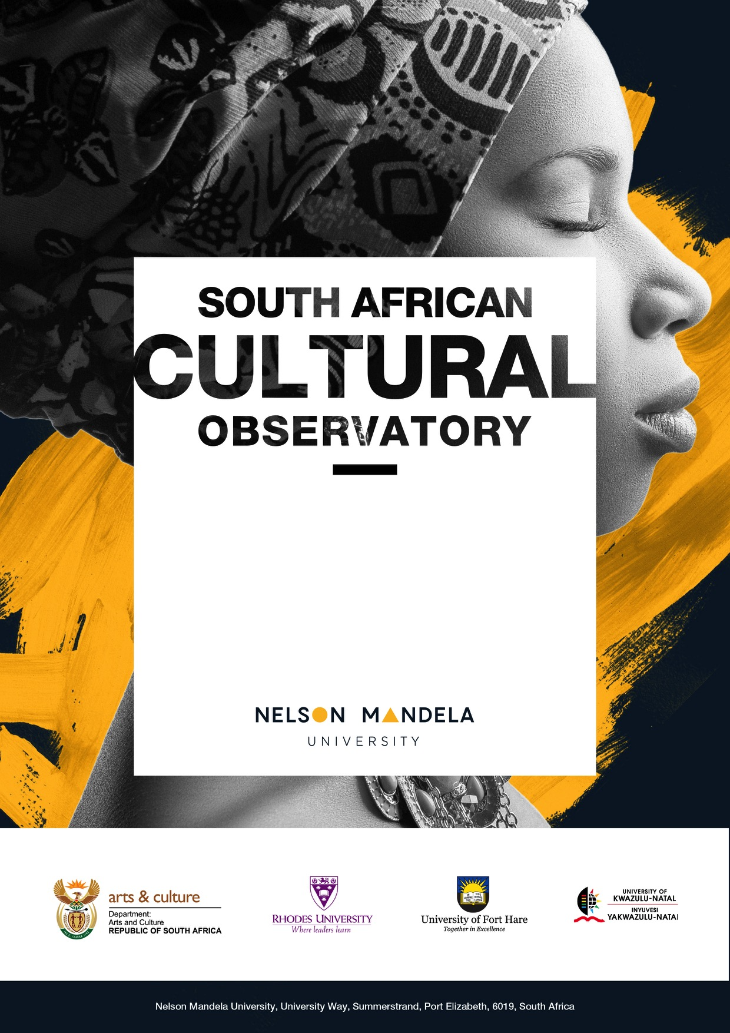

Provincial Profiles: Cultural and Creative Industries in South Africa
2022

Provincial Profiles: Cultural and Creative Industries in South Africa
2022

  - Summary
  - Key Findings
- Using the UNESCO framework, the CCI Gross Value Added, employment and exports are estimated for South Africa’s nine provinces.
- Three provinces (Gauteng, the Western Cape and KwaZulu-Natal) emerge as the prime contributors to South Africa’s CCIs.
- Gauteng contributes 36.3% to South Africa’s CCI Gross Value Added while the Western Cape (17.4%) and KwaZulu-Natal (15.6%) are the leading provincial contributors.
- The provinces with the largest CCI employment shares are Gauteng (29.4%), Western Cape (18%) and KwaZulu-Natal (17%).
- The Western Cape is responsible for approximately 53% of South Africa’s CCI exports, followed by Gauteng (32.4%) and KwaZulu-Natal (10.9%).
- The three leading provinces in terms of production of CCIs are also the three provinces that export most.
- Provinces each bring their own richness to the sector and regional differences need to be explored to determine where additional CCI production can be encouraged, especially where it leads to employment and exports.

The size and composition of the creative economy at a provincial level is an important aim of the mapping study since much cultural policy is applied sub-nationally. This chapter augments Chapters 1 (The macroeconomic impact of the Cultural and Creative Industries (CCIs) in South Africa), 2 (Cultural Employment and Transformation) and 3 (International Trade in Cultural Goods and Services).
Information about the creative economy at sub-national level could form an important part of both regional and provincial growth and development and local economic development (LED) strategies. This report highlights the size and composition (according to the domains set out in the UNESCO Framework) of the CCI contribution to the gross domestic product (GDP), its labour force as well as CCI exports.
As can be expected, the trends observed when analysing economic growth, employment or trade tend to follow each other.
As found in previous mapping studies, the largest domains in terms of contribution to GDP are Design and Creative Services, and Audio-visual and Interactive Media. The dominance of these domains is expected, since they create more commercial cultural and creative content which is used in film and television, video games, fashion design, architecture and advertising.
Gauteng contributes 36.3% to South Africa’s CCI Gross Value Added (GVA) which is the highest contribution from any province. The other two provinces that are substantial contributors are the Western Cape (17.4%) and KwaZulu-Natal (15.6%). All provinces, including these three, have the potential to increase the production of the CCIs and their contribution to the provincial economy.
The UNESCO (2009) Framework points out that cultural workers may be found in cultural industries, but also in other industries doing cultural work. A useful model for demonstrating this effect is the “Cultural Trident” (Higgs and Cunningham, 2008). CCI employment was analysed per province using this approach with data collected by Statistics South Africa’s (Stats SA) Quarterly Labour Force Survey 2019 (the most recent annual data at the time of writing). The creative economy employment still makes up a relatively small percentage of the South African workforce (6% in 2019). The provinces with the largest CCI employment shares are Gauteng (29.4%), Western Cape (18%), and KwaZulu-Natal (17%).
The three leading provinces in terms of production of CCIs are also the three provinces that export most. The Western Cape is responsible for approximately 53% of South Africa’s CCI exports, followed by Gauteng (32.4%) and KwaZulu-Natal (10.9%). Again, there is potential for the provinces, especially those that border on other African countries, to increase cultural goods. The Northern Cape’s largest market for CCI exports, for example, is Namibia.
South Africa’s culture and creativity have important intrinsic and social values, as well as the economic ones discussed here. Provinces each bring their own richness to the sector and regional differences need to be explored to determine where additional CCI production can be encouraged, especially where it leads to employment and exports.

Table of Contents

Table of Contents ii
Research Team iii
List of Tables iv
List of Figures vi
Abbreviations viii
1 Introduction and Purpose 1
2 The CCIs and Regional Development 2
3 Data and Research Methods 4
3.1 GVA Contribution by Province 4
3.2 Cultural Occupations and Location Quotients 6
3.3 International Cultural Trade by Province 7
4 Provincial Profiles 8
4.1 Eastern Cape 8
4.1.1 Contribution to GVA and Domain Analysis 8
4.1.2 Cultural Employment 10
4.1.3 International Trade in Cultural Goods 13
4.2 Free State 16
4.2.1 Contribution to GVA and Domain Analysis 16
4.2.2 Cultural Employment 18
4.2.3 International Trade in Cultural Goods 22
4.3 Gauteng 25
4.3.1 Contribution to GVA and Domain Analysis 25
4.3.2 Cultural Employment 27
4.3.3 International Trade in Cultural Goods 31
4.4 KwaZulu-Natal 33
4.4.1 Contribution to GVA and Domain Analysis 33
4.4.2 Cultural Employment 35
4.4.3 International Trade in Cultural Goods 39
4.5 Limpopo 41
4.5.1 Contribution to GVA and Domain Analysis 42
4.5.2 Cultural Employment 44
4.5.3 International Trade in Cultural Goods 47
4.6 Mpumalanga 49
4.6.1 Contribution to GVA and Domain Analysis 49
4.6.2 Cultural Employment 51
4.6.3 International Trade in Cultural Goods 55
4.7 North West 57
4.7.1 Contribution to GVA and Domain Analysis 58
4.7.2 Cultural Employment 59
4.7.3 International Trade in Cultural Goods 63
4.8 Northern Cape 65
4.8.1 Contribution to GVA and Domain Analysis 65
4.8.2 Cultural Employment 67
4.8.3 International Trade in Cultural Goods 71
4.9 Western Cape 73
4.9.1 Contribution to GVA and Domain Analysis 74
4.9.2 Cultural Employment 76
4.9.3 International Trade in Cultural Goods 79
5 Comparative Summary and Implications 82
References 85
Appendix 1. GVA Statistics by Province 86
Appendix 2. The Tress Index of Economic Diversification 88
Appendix 3. Population Statistics by Province 89
Appendix 4. Gross Value Added per Province by Domain 90
Appendix 5. Exports per Province by Domain 91

Research Team
Dr Andre Gouws, Independent Economic Consultant; Researcher, South African Cultural Observatory.
Prof. Mike Burton, Professor of Mathematics, Department of Economics and Economic History, Rhodes University.
Prof. Jen Snowball, Chief Research Strategist, South African Cultural Observatory and Professor of Economics, Department of Economics and Economic History, Rhodes University
Ms. Niki Cattaneo, Senior Lecturer, Department of Economics and Economic History, Rhodes University
Mr. Serge Hadisi, Independent Economist Consultant, and Research Associate at Political Economy Southern Africa (PESA).
Prof. Mike Rogan, Associate Professor of Economics, Department of Economics and Economic History, Rhodes University.

List of Tables
Table 1: GVA at basic prices for the Eastern Cape by CCI domain (R millions constant 2015 prices) 9
Table 2: Percentage contribution by CCIs in the Eastern Cape to the South African creative economy by
domain 9
Table 3: Percentage change of CCI GVA per domain in the Eastern Cape 10
Table 4: Occupation type and income category for cultural workers in the Eastern Cape and South Africa 13
Table 5: Eastern Cape’s international trade in cultural goods (R millions current prices) 14
Table 6: Eastern Cape’s top export markets for CCI goods in 2019 (nominal rand) 15
Table 7: GVA at basic prices for the Free State by CCI domain (R millions constant 2015 prices) 17
Table 8: Percentage contribution by CCIs in the Free State to the South African creative economy by domain 17
Table 9: Percentage change of CCI GVA in the Free State 18
Table 10: Occupation type and income category for cultural workers in the Free State and South Africa 21
Table 11: The Free State’s international trade in cultural goods (R millions current prices) 22
Table 12: The Free State’s top export markets for CCIs (Rand millions) 24
Table 13: GVA at basic prices for Gauteng by CCI domain (R millions constant 2015 prices) 26
Table 14: Percentage contribution by CCIs in Gauteng to the South African creative economy by domain 27
Table 15: Percentage change of CCI GVA in Gauteng 27
Table 16: Occupation type and income category for cultural workers in Gauteng and South Africa 30
Table 17: Gauteng’s international trade in cultural goods (R millions in current prices) 31
Table 18: Gauteng’s top export markets for CCIs 32
Table 19: GVA at basic prices for KwaZulu-Natal by CCI domain (R millions constant 2015 prices) 34
Table 20: Percentage contribution by CCIs in KwaZulu-Natal to the South African creative economy by
domain 34
Table 21: Percentage change of CCI GVA in KwaZulu-Natal 35
Table 22: Occupation type and income category for cultural workers in KwaZulu-Natal and South Africa 38
Table 23: KwaZulu-Natal’s international trade in cultural goods (R millions in current prices) 39
Table 24: KwaZulu-Natal’s top export markets for CCIs 41
Table 25: GVA at basic prices for Limpopo by CCI domain (R millions constant 2015 prices) 42
Table 26: Percentage contribution by CCIs in Limpopo to the South African creative economy by domain 43
Table 27: Percentage change of CCI GVA in Limpopo 43
Table 28: Occupation type and income category for cultural workers in Limpopo and South Africa 46
Table 29: Limpopo’s international trade in cultural goods (R millions in current prices) 47
Table 30: Limpopo’s top export markets for CCIs 48
Table 31: GVA at basic prices for Mpumalanga by CCI domain (R millions constant 2015 prices) 50
Table 32: Percentage contribution by CCIs in Mpumalanga to the South African creative economy by domain 51
Table 33: Percentage change of CCI GVA in Mpumalanga 51
Table 34: Occupation type and income category for cultural workers in Mpumalanga and South Africa 54
Table 35: Mpumalanga’s international trade in cultural goods (R millions in current prices) 55
Table 36: Mpumalanga’s top export markets for CCIs 57
Table 37: GVA at basic prices for the North West by CCI domain (R millions constant 2015 prices) 58
Table 38: Percentage contribution by CCIs in the North West to the South African creative economy by
domain 59
Table 39: Percentage change of CCI GVA in the North West 59
Table 40: Occupation type and income category for cultural workers in the North West and South Africa 62
Table 41: The North West province’s international trade in cultural goods (R millions in current prices) 64
Table 42: The North West province’s top export markets for CCIs in 2020 64
Table 43: GVA at basic prices for the Northern Cape by CCI domain (R millions constant 2015 prices) 66
Table 44: Percentage contribution by CCIs in the Northern Cape to the South African creative economy by
domain 67
Table 45: Percentage change of CCI GVA in the Northern Cape 67
Table 46: Occupation type and income category for cultural workers in the Northern Cape and South Africa 70
Table 47: Northern Cape’s international trade in cultural goods (R millions in current prices) 71
Table 48: Northern Cape’s top export markets for CCIs 73
Table 49: GVA at basic prices for the Western Cape by CCI domain (R millions constant 2015 prices) 74
Table 50: Percentage contribution by CCIs in the Western Cape to the South African creative economy by
domain 74
Table 51: Percentage change of CCI GVA in the Western Cape 75
Table 52: Occupation type and income category for cultural workers in the Western Cape and South Africa 78
Table 53: Western Cape’s international trade in cultural goods (R millions in current prices) 79
Table 54: Western Cape’s top export markets for CCIs 81
Table 55: Comparison of provincial contributions to South Africa’s creative economy 83
Table 56: Provincial economic growth rates 86
Table 57: South Africa’s population growth rates per province 89

List of Figures
Figure 1: UNESCO’s cultural domains 5
Figure 2: The contribution of each domain to the Eastern Cape’s GVA 9
Figure 3: The Cultural Trident for employment in the Eastern Cape (2019) 10
Figure 4: Percentage of cultural occupations by province 2017 and 2019 11
Figure 5: Percentage of cultural occupations by domain for the Eastern Cape province and South Africa 11
Figure 6: Sociodemographic profile of Cultural Occupation workers in the Eastern Cape and South Africa 12
Figure 7: Eastern Cape’s exports by domain in 2019 15
Figure 8: Destination of the Eastern Cape’s CCI exports 15
Figure 9: The contribution of each domain to the Free State’s GVA 17
Figure 10: The Cultural Trident for employment in the Free State (2019) 19
Figure 11: Percentage of cultural occupations by province 2017 and 2019 19
Figure 12: Percentage of cultural occupations in the top 4 domains for the Free State province and South
Africa 20
Figure 13: Sociodemographic profile of Cultural Occupation workers in the Free State and South Africa 21
Figure 14: Free State’s exports by domain in 2019 23
Figure 15: Destination of the Free State’s CCI exports 24
Figure 16: The contribution of each domain to Gauteng’s GVA 26
Figure 17: The Cultural Trident for employment in Gauteng (2019) 28
Figure 18: Percentage of cultural occupations by province 2017 and 2019 28
Figure 19: Percentage of cultural occupations by largest domains for Gauteng and South Africa 29
Figure 20: Sociodemographic profile of Cultural Occupation workers in Gauteng and South Africa 29
Figure 21: Gauteng’s exports by domain in 2019 23
Figure 22: Destination of Gauteng’s CCI exports 24
Figure 23: The contribution of each domain to KwaZulu-Natal’s GVA 34
Figure 24: The Cultural Trident for employment in KwaZulu-Natal (2019) 36
Figure 25: Percentage of cultural occupations by province 2017 and 2019 36
Figure 26: Percentage of cultural occupations in the top 4 domains for KwaZulu-Natal and South Africa 37
Figure 27: Sociodemographic profile of Cultural Occupation workers in KwaZulu-Natal and South Africa 38
Figure 28: KwaZulu-Natal’s exports by domain in 2019 40
Figure 29: Destination of KwaZulu-Natal’s CCI exports 40
Figure 30: The contribution of each domain to Limpopo’s GVA 42
Figure 31: The Cultural Trident for employment in Limpopo (2019) 44
Figure 32: Percentage of cultural occupations by province 2017 and 2019 45
Figure 33: Percentage of cultural occupations in the top 4 domains for Limpopo and South Africa 45
Figure 34: Sociodemographic profile of Cultural Occupation workers in Limpopo and South Africa 46
Figure 35: Limpopo’s exports by domain in 2019 40
Figure 36: Destination of Limpopo’s CCI exports 48
Figure 37: The contribution of each domain to Mpumalanga’s GVA 50
Figure 38: The Cultural Trident for employment in Mpumalanga (2019) 52
Figure 39: Percentage of cultural occupations by province 2017 and 2019 53
Figure 40: Percentage of cultural occupations in the top 4 domains for Mpumalanga and South Africa 53
Figure 41: Sociodemographic profile of Cultural Occupation workers in Mpumalanga and South Africa 54
Figure 42: Mpumalanga’s cultural goods exports by domain in 2019 56
Figure 43: Destination of Mpumalanga’s CCI exports 56
Figure 44: The contribution of each domain to the North West province’s GVA 58
Figure 45: The Cultural Trident for employment in the North West (2019) 60
Figure 46: Percentage of cultural occupations by province 2017 and 2019 60
Figure 47: Percentage of cultural occupations in the top 4 domains for the North West province and South
Africa 61
Figure 48: Sociodemographic profile of Cultural Occupation workers in the North West and South Africa 61
Figure 49: North West’s exports by domain in 2019 64
Figure 50: Destination of the North West province’s CCI exports 64
Figure 51: The contribution of each domain to the Northern Cape’s GVA 66
Figure 52: The Cultural Trident for employment in the Northern Cape (2019) 68
Figure 53: Percentage of cultural occupations by province 2017 and 2019 69
Figure 54: Percentage of cultural occupations in the top 4 domains for the Northern Cape Province and South Africa 69
Figure 55: Sociodemographic profile of Cultural Occupation workers in the Northern Cape and South Africa 70
Figure 56: Northern Cape’s exports by domain in 2019 72
Figure 57: Destination of the Northern Cape’s CCI exports 72
Figure 58: The contribution of each domain to the Western Cape’s GVA 74
Figure 59: The Cultural Trident for employment in the Western Cape (2019) 76
Figure 60: Percentage of cultural occupations by province 2017 and 2019 76
Figure 61: Percentage of cultural occupations by domain for the Western Cape and South Africa 77
Figure 62: Sociodemographic profile of Cultural Occupation workers in the Western Cape and South Africa 77
Figure 63: The Western Cape’s exports by domain in 2019 80
Figure 64: Destination of the Western Cape’s CCI exports 81
Figure 65: Graphical comparison of provincial contributions to South Africa’s creative economy 83
Figure 66: Percentage contribution to GVA per province in 2020 86
Figure 67: GVA at basic prices per sector per province 87
Figure 68: Provincial Tress Indices 88
Figure 69: Distribution of South Africa’s population per province 89
Figure 70: Cultural and Natural Heritage GVA per province 90
Figure 71: Performance and Celebration GVA per province 90
Figure 72: Visual Arts and Crafts GVA per province 90
Figure 73: Books and Press GVA per province 90
Figure 74: Audio-visual and Interactive Media GVA per province 90
Figure 75: Design and Creative Services GVA per province 90
Figure 76: Cultural and Natural Heritage exports per province 91
Figure 77: Performance and Celebration exports per province 91
Figure 78: Visual Arts and Crafts exports per province 91
Figure 79: Books and Press exports per province 91
Figure 80: Design and Creative Services exports per province 91

Abbreviations
AU African Union
CAGR compound annual growth rate
CCI Cultural and Creative Industries
FCS Framework for Cultural Statistics
GDP Gross Domestic Product
GIS Geographic Information Systems
GVA Gross Value Added
HS Harmonised System
IO Input-Output
LED Local Economic Development
LMDS Labour Market Dynamics Survey
LQ Location Quotient
PESA Political Economy Southern Africa
QLFS Quarterly Labour Force Survey
SACO South African Cultural Observatory
SAM Social Accounting Matrices
SARB South African Reserve Bank
SARS South Africa Revenue Service
SIC Standard Industrial Classification
SNA System of National Accounts
Stats SA Statistics South Africa

Introduction and Purpose
While understanding the size and composition of the creative economy at a national level is an important objective of the mapping study, the report also aims to be useful at a provincial level, where much cultural policy is applied, and could form an important part of regional LED strategies.
The creative industries have been recognised as a strategically important sector in the Re-imagined Industrial Strategy for South Africa (2019) and is one of the sectors for which a Masterplan is being developed. All provinces have departments of Sports, Recreation, Arts and Culture, as well as municipal-level representatives. One of the resolutions of the 52nd ANC Conference in Polokwane in 2007 was that “local government must provide funding for arts and culture”. However, Nawa (2012) found that cultural activities at the regional level tend to be allocated a small budget, and that the focus of municipal spending is on addressing backlogs in basic infrastructure investment for service delivery. Nevertheless, Nawa (2012: 172) concludes that “cultural policy is a bed-rock of development with socioeconomic expressions” and that regional cultural development is worth incorporating into regional development strategies.
However, to be sustainable, regional cultural clusters need to be based on existing areas of specialisation, and to consider the characteristics of the region. Understanding provincial cultural economies is thus an important first step to developing successful and sustainable regional cultural policy.
This report forms one part (Chapter 4) of the Cultural and Creative Industries Mapping Study (SACO, 2022). Other chapters, which give more detail on the methods and data used, and a national picture of the creative economy in South Africa, are:
Chapter 1: The macroeconomic impact of the CCIs in South Africa
Chapter 2: Cultural Employment and Transformation
Chapter 3: International Trade in Cultural Goods and Services
Chapter 4: Provincial Profiles (this report)
Chapter 5: The South African Creative Economy in Historical Context
The aims of this chapter are to provide:
- Information on the provincial distribution of the Gross Value Added (GVA) contribution of the CCIs to the economies of each province.
- An analysis of the GVA contribution of specific domains (using the UNESCO FCS, 2009 definitions) for each province.
- An analysis of the provincial distribution of the employment contribution of the CCIs
- The identification of comparative employment advantage by province (using location quotients)
- A profile of international cultural goods trade by province
The chapter starts by giving a brief literature review of South African and international studies on the regional distribution of the CCIs, and their potential role in development. Section 3 provides an overview of the methods and data used, followed by a separate section for each of South Africa’s nine provinces, arranged in alphabetical order. For each province, information on the cultural economy’s contribution to provincial GVA, international trade in cultural goods, and employment is provided. The report concludes with a comparative summary of the main findings, and the implications of the analysis.

The CCIs and Regional Development
Since the publication of Richard Florida’s (2002) book, The Rise of the Creative Class, there has been much interest in the CCIs as drivers of regional economic development. Florida’s (2002) theory was that cities with faster growth rates also tended to have higher proportions of cultural and creative professionals and firms. The argument was that those regions that were growing fastest and offered a rich diversity of cultural activities would attract the “creative class” – highly skilled and innovative professionals who could drive productivity increases in the knowledge economy.
Florida’s work was criticised on the grounds that deliberate regional policies to attract the creative class could be exclusionary, would worsen inequality, and lead to the “gentrification” of cultural districts, often making them too expensive for artists and other creatives to afford. His work also did not prove causality: were the creative class attracted to a particular city because of the presence of the cultural sector, or did the cultural sector develop because of the presence of the creative class? (Flew, 2010; Sacco et al., 2014). Nevertheless, Florida’s work revitalised the discussion about the role of the CCIs in regional development, and the role that regional cultural policy could play.
Porter’s (2003) theory of comparative advantage suggested that encouraging firms and workers from specific industries to group or cluster together could help regions to develop important competitive advantages. Porter (2000) defines a cluster as “a geographic concentration of interconnected companies…and institutions in a particular field that compete, but also cooperate”. For example, it has been found that cultural clusters are associated with cost advantages for the firms that result from things such as making inter-firm trade easier, using group marketing strategies, and the development of specialist skills. In addition, they have been linked to faster innovation because of “spill-over” effects – both between cultural firms, and between cultural and non-cultural firms (Flew, 2010; Sacco et al., 2014; CCI Spill-overs Report, 2015).
Cluster development might be particularly important given the short-term contract nature of much of the work in the cultural and creative industries (Flew, 2014; Eikhof and Warhurst, 2013), which make networks and geographical proximity important for the quick production of specific cultural goods or services. As outlined in Chapter 2 of this mapping study, people in cultural occupations in South Africa are more likely to be working as freelancers (“own account workers with no employees”) than people in other kinds of jobs. The short-term contact mode of operation in many parts of the creative economy make industry networks particularly important in regional cluster development. These networks are what Flew (2010) refers to as the “soft infrastructure” of the cultural sector, which is often neglected in favour of investment in “hard infrastructure” (such as galleries, museum, libraries, universities, theatres etc.):
“Soft infrastructure [can be defined as] the relational assets associated with economically successful networks, such as trust, reciprocity, exchange of tacit knowledge, and propensity to share and pool economic risk”.
A recent SACO report on the Cape Town creative industries cluster (Snowball et al., 2019) investigated ways in which firms combine digital technology and creative design to innovate. Such “Fused” firms were found to have higher levels of innovation in business processes, goods, and services. They were also more likely to employ demographically diverse people. Cities provide important markets: 79% of firms identified Cape Town as a “very important” source of clients, as well as being an important base from which to reach the rest of South Africa and international markets.
A challenge for some regions is that that the CCIs tend to cluster around cities (Lazzeretti et al., 2010; Flew, 2010), although patterns can differ between countries. For example, Kemeny et al. (2019) use the creative trident method of measuring cultural employment to explore regional creative economy job creation in the UK and the US. Their findings support the view that regions with large metropolitan areas tend to have a higher proportion of creative economy employment than areas with smaller towns. However, the UK is described as a “unipolar” system, with London being by far the most the important city for cultural employment, while the US has a “polycentric” system, with multiple creative employment hubs. They also find that larger cities tend to have more specialised (less diversified) concentrations of cultural and creative industry types than smaller, “second-tier” cities. Bakhshi et al. (2015) used GIS to identify clusters of creative and high-tech companies in regions in the UK, with a special focus on the sub-regional distribution of employment in these sectors. Their findings show that creative and high-tech companies tend to “co-locate” (cluster), especially around London. They conclude that this kind of analysis can be used to design policies that investigate (and encourage) knowledge spillovers between related sectors (such as the creative and high-tech industries).
There are several reasons why the CCIs tend to cluster in cities, and why such locations can be important, especially for small and medium sized CCI start-ups. As listed by Gong and Hassink (2017: 588):
- Cities provide amenities (hard and soft infrastructure) – “quality of place” rather than “access to place” has become most important in developing and maintaining a competitive advantage;
- Face-to-face interactions between a “critical mass” of entrepreneurs, intellectuals, artists, managers, students etc. found in cities facilitates the flow of ideas and innovations;
- Cities provide “a nexus of buildings and institutions”, including Information and Communication Technology (ICT), and housing and recreational amenities that are attractive to the “creative class”; and
- Cities offer larger local markets and opportunities for firms to interact with their customers and users.
However, some research in the Sarah Baartman District Municipality – a largely rural area in the Eastern Cape province, without large cities – has shown that it is possible for cultural clusters to develop in more rural areas (Drummond and Snowball, 2018). Using GIS mapping techniques, the study showed that, in areas where a threshold level of economic development had been reached, it was possible for creative industries from some domains to cluster. The results suggest that, if existing regional creative economy patterns are understood, they could be built-on as part of an effective LED strategy, even in rural provinces.
Other research on the distribution of Mzanzi’s Golden Economy funding in South Africa by province (Van der Linde et al., 2020) showed that public funding can be an important way to stimulate cultural activity in more rural areas. While more public funding was allocated to the creative industries clusters in cities, some funding categories were more geographically dispersed, sometimes occurring in provinces where there was little other cultural activity, and thus contributing to more equitable cultural access in South Africa.
While a focus on regional cultural policy has undoubted benefits, a danger is that cultural and creative activities will become “instrumentalised” and valued only for their economic contributions to production, international trade, and job creation, neglecting their other important social and intrinsic cultural roles (Sacco et al., 2014). Top-down regional cultural policies that do not consider the existing context, that is, do not connect to the cultural “roots” of the region, are unlikely to be successful or sustainable. Lee et al. (2014: 220) argue that regional cultural policies are most likely to be successful when regions are “able to take different approaches, best suited to their region’s own creative economy”, and when the whole value chain (consumption and production) is considered.
To conclude, growing regional cultural and creative economies can have direct benefits in terms of economic activity and job creation, but also have the potential to drive growth and innovation through knowledge, industry, and network spill-over effects that can increase the productivity of other industries, and societal well-being. However, to be sustainable, regional policy needs to be based on existing areas of specialisation and to take into account the characteristics of the province. Understanding provincial cultural economies is thus an important first step to developing successful and sustainable regional cultural policy.

Data and Research Methods
The UNESCO (2009) Framework for Cultural Statistics is the definition used by the South African Cultural Observatory, and the basis for the CCI Mapping Study of which this chapter is a part. The Framework defines six main domains: Cultural and Natural Heritage, Performance and Celebration, Visual Arts and Crafts, Books and Press, Audio-visual and Interactive Media and lastly, Design and Creative Services. Each cultural sector is placed within one specific domain. The Framework also includes Transversal domains that run across all the six main domains, such as Education and Training, Archiving and Preserving, and Equipment and Supporting Materials. As far as possible, the guidelines and data sources recommended by the Framework have been adhered to in this report.

GVA Contribution by Province
Using the same methodology that was used in Chapter 1, individual provincial Input-Output tables were constructed using data from Quantec and Statistics South Africa (Stats SA). The more disaggregated the data are, the more difficult it is to get. When official census bureaux, such as Stats SA, collect the data either by survey techniques or a census of businesses, they aggregate the data to ensure that businesses and other respondents’ anonymity is protected. To overcome this problem several techniques have been proposed to develop sub-national Input-Output tables. Input-output models are overall one of the best and most effective quantitative methods for estimating the size of the various components of a sub-national economy, and for planning purposes.
The System of National accounts (SNA) (United Nations et al., 2009) defines two methodologies to develop satellite accounts. The first group involves a rearrangement of the central classifications with the possible introduction of additional elements. Although there are differences, they do not modify the SNA concepts significantly. The main reason for developing this type of account is to shed light on important social or economic areas of concern without overloading or unbalancing the standard system. Many components contained in these satellite accounts would be invisible in the central accounts and aggregates appearing in global variables. This type of account is used in areas of tourism, environmental protection expenditures, and culture, for example. The second type of satellite analysis is mainly based on alternative concepts to those used in the SNA. Therefore, alternative definitions of production, consumption and capital formation can be employed. Since it is not necessary to redefine the SNAs definitions, and indeed will make the study more difficult and not comparable to the national accounts, the first method is used, especially regarding the classifications of products and services. Satellite accounts generally use Input-Output (IO) models. An IO model is essentially a matrix that represents the national (or regional) economic accounting in a way that shows how industries trade with one another and their production (in other words, the flow of goods and services). A sectoral IO is developed by disaggregating the economy-wide table to identify components the sector (in this case, the cultural and creative industries) and then re-aggregated.
Therefore, before a mapping study can be undertaken or an IO for the CCIs can be developed, it is necessary that cultural products and services be defined. Cultural goods and services are derived from the society’s culture. In many cases, these goods and services have little or no commercial value, although they may have important social and cultural value. However, many cultural goods and services do have an economic value. There are several approaches that can be used to measure the contribution of CCIs to the South African economy and its provinces. One is to use the country’s national accounts. Unfortunately, components that make-up CCIs are not included in the South African SNA.
Figure 1: UNESCO’s cultural domains
Source: The UNESCO Framework for Cultural Statistics (2009: 24)
Because it is difficult to define the CCIs there have been numerous disagreements on what should be included or excluded. Galloway and Dunlop (2007) summarise the debate crisply, stating that the “terminology currently used in creative industries policy lacks rigour and is frequently inconsistent and confusing.” There are many different definitions that are described in Chapter 1. However, the UNESCO Framework for Cultural Statistics, 2009 (Figure 1) is increasingly used in South African policy and research and was used for the development of the macroeconomic model of the economy in this mapping study.
In compiling the CCI IO, a bottom-up approach was used. The first step involves deriving the CCI activities out of the various Secondary Industrial Classification (SIC) sectors where they have previously been accounted for, using both direct and indirect extraction methods.
The process of deriving the CCIs has two areas of focus:
- Firstly, establishing the Rand-value magnitudes of the CCIs in terms of variables such as production, capital and labour usage, etc.; and
- Secondly, deriving the structures of the CCIs in terms of how they link backward and forward to other sectors.
Although sub-national IO tables can be generated using surveys, these are costly and have limitations. It is therefore common practice to compile regional IO tables through estimation (non-survey) techniques using national IO tables. A combination of both survey and non-survey methods is ideal for developing sector specific or regional IOs. Most of the non-survey techniques use a location quotient that is either based on regional output or on employment per sector. This report uses the Quantec’s provincial Social Accounting Matrices (SAM) which were then used to derive provincial IO tables. In turn, these were used to estimate provincial CCI IOs.

Cultural Occupations and Location Quotients
As explained in more detail in Chapter 2, the data used to determine employment in the creative economy is from official national data collected by Statistics South Africa. The Quarterly Labour Force Survey (QLFS) is a household survey undertaken every three months, which is then pooled into an annual dataset called the Labour Market Dynamics Survey (LMDS). The LMDS data are currently available from 2008 to 2019.
Although the LMDS is a large sample survey, creative economy employment still makes up a relatively small percentage of the overall workforce (6% in 2019, as reported in Chapter 2). This means that, for provinces with smaller shares of the creative economy employment, sample size limits the reliability of the regional findings.
The UNESCO (2009) Framework points out that cultural workers may be found in cultural industries, but also in other industries doing cultural work. A useful model for demonstrating this effect is the “Cultural Trident” (Higgs and Cunningham, 2008) which distinguishes between:
  - Cultural occupations in the cultural industries (such as a director in a film company);
  - Cultural occupations in non-cultural industries (such as a designer in a motorcar manufacturing firm); and
  - Non-cultural occupations in cultural industries, also called support occupations (such as an accountant in a theatre company).
This definition gives rise to three different ways of expressing employment in the cultural sector:
- The Creative Economy, which includes those employed in creative occupations inside and outside the creative sector, as well as those in non-cultural jobs in creative sector firms (A + B + C);
- The Creative Industries, which is a sub-set of the creative economy, focusing on cultural and non-cultural workers, but only those employed in CCIs (A + C); and
- Creative Occupations, which is a sub-set of the creative economy that focuses on cultural work both in, and outside of, cultural firms (A + B).
The Cultural Trident method is used to describe both cultural occupations and creative economy employment for each province. However, because of the difficulty of identifying support (non-cultural) occupations in creative industries, the focus in this chapter is on cultural occupations.
Location Quotients (LQs) can be used to identify locational concentrations or clusters within a region. If X’ and Y’ are similar data points for some larger reference region (like a province), then the LQ or relative concentration of that sector in the province compared to the nation is given by the equation:
$$LQ=\left(\frac{X}{Y}\right)/(\frac{X^{'}}{Y^{'}})$$
Where X = cultural jobs in the province; Y = cultural jobs in the country; X’ = all jobs in the province; and Y’ = all jobs in the country.
An LQ of more than one would indicate that the province has a relative concentration of cultural jobs compared to other provinces and show what makes a regional economy unique. Combined with job information on the size of the sector, LQs can identify potential industry development nodes. LQs are calculated for cultural occupations for each province for 2017 and 2019.

International Cultural Trade by Province
Chapter 3 (International Trade in Cultural Goods and Services) provides all the necessary background on international cultural trade at a national level. Trade has been recognised as both an important component of GDP and a driver of economic growth. Improved trade performance leads to more and better jobs, as well as contributing to higher income and wealth generation. This is also true at sub-national level.
Trade data are collected by SARS for both imports and exports of all goods (physical products) but not for services. The data are collected, inter alia, according to the country of origin or destination, port of entry, the Harmonised System (HS) classification number, and the importer’s or exporter’s postal code. The UNESCO FCS has included an allocation of the relevant HS codes according to the corresponding domain. All these data are in nominal South African Rand as reported to SARS.
There is limited, and rather aggregated data available on services at national level that does not make it possible to disaggregate according to the CCI domains and no data are available at sub-national level. The analysis of cultural goods trade is thus presented for each province, based on the postal code data for importers and exporters. The data must be used with caution, especially for imports, which may be brought into a particular province by an importer but may be sold and consumed in other provinces.

Provincial Profiles

Eastern Cape
The Eastern Cape province has 11% of the population of South Africa and had an annual population growth rate of 0.2% per year between 2017 and 2019 (compared to a 1.5% year-on-year growth rate for South Africa as a whole). In 2019, the Eastern Cape produced 7.7% of South Africa’s GVA but has generally had a slower GVA year-on-year growth rate than South Africa as a whole (Appendix 1). The Tress Index of Economic Diversification shows that the Eastern Cape has one of the more concentrated (less diversified) economies in South Africa, which makes it potentially more vulnerable to shocks or slowdowns in specific sectors (Appendix 2).

Contribution to GVA and Domain Analysis
In 2020 the Eastern Cape’s GVA was R299.2 billion (constant 2015 prices) and contributed approximately 7.4% to South Africa’s GVA.
The CCIs’ contribution to the province’s GVA was just under R10 billion (constant 2015 prices) and this represents 3.3% of the province’s total GVA.
The Eastern Cape contributes 7.5% to South Africa’s CCI GVA, ranking the province fourth in terms of its contribution to South Africa’s CCIs.
Figure 2 shows the relative size of each domain in 2019.

Figure 2: The contribution of each domain to the Eastern Cape’s GVA
The largest domains are Design and Creative Services (25.5%) and Audio-visual and Interactive Media (24.5%).
Further information on the size of the CCI domains from 2015 to 2020 is provided in Table 1 below.
Table 1: GVA at basic prices for the Eastern Cape by CCI domain (R millions constant 2015 prices)
 | 2015 | 2016 | 2017 | 2018 | 2019 | 2020
Cultural and Natural Heritage | R 387 | R 397 | R 401 | R 405 | R 406 | R 394
Performance and Celebration | R 457 | R 475 | R 487 | R 489 | R 495 | R 484
Visual Arts and Crafts | R 1 320 | R 1 325 | R 1 351 | R 1 374 | R 1 342 | R 1 232
Books and Press | R 864 | R 868 | R 884 | R 872 | R 860 | R 788
Audio-visual and Interactive Media | R 2 290 | R 2 386 | R 2 447 | R 2 453 | R 2 487 | R 2 438
Design and Creative Services | R 2 395 | R 2 473 | R 2 530 | R 2 543 | R 2 584 | R 2 532
Transversal: Education and Training | R 1 981 | R 2 014 | R 2 048 | R 2 072 | R 2 109 | R 2 069
Total | R 9 694 | R 9 939 | R 10 148 | R 10 207 | R 10 285 | R 9 938
Audio-visual and Interactive Media has been the fastest growing domain with a compound annual growth rate (CAGR) of 1.7% over the 2015–2019 period and drop -2% in 2020. Books and Press has had a -0.1% CAGR over the same period and dropped a further 8.4% in 2020.
Table 2 below shows the Eastern Cape’s contribution, in percentage terms, by each domain to each of the corresponding CCI domains in South Africa.
Table 2: Percentage contribution by CCIs in the Eastern Cape to the South African creative economy by domain
 | 2015 | 2016 | 2017 | 2018 | 2019 | 2020
Cultural and Natural Heritage | 7.98% | 7.97% | 7.95% | 7.96% | 7.93% | 8.01%
Performance and Celebration | 6.90% | 6.96% | 6.97% | 6.98% | 6.97% | 6.96%
Visual Arts and Crafts | 6.97% | 6.98% | 7.01% | 6.97% | 6.94% | 7.02%
Books and Press | 4.96% | 5.02% | 5.07% | 5.07% | 5.10% | 5.25%
Audio-visual and Interactive Media | 6.95% | 7.01% | 7.01% | 7.02% | 7.02% | 7.00%
Design and Creative Services | 6.70% | 6.75% | 6.74% | 6.73% | 6.72% | 6.76%
Transversal: Education and Training | 12.53% | 12.61% | 12.61% | 12.57% | 12.54% | 12.54%
Total CCI | 7.33% | 7.38% | 7.38% | 7.39% | 7.39% | 7.46%
All domains show some decline in 2020 due to the impact of the COVID-19 pandemic-induced recession.
The Books and Press domain, the fifth largest domain in 2020 in the Eastern Cape, has been growing very slowly and steadily shrinking since 2018. The Visual Arts and Crafts domain had a 0.3% annual average growth from 2015 to 2019 and drop of -8.2% in 2020.
Table 3 shows the annual GVA growth rate of each domain in the Eastern Cape. The impact of COVID-19 can be seen in 2020.
Table 3: Percentage change of CCI GVA per domain in the Eastern Cape
 | 2016 | 2017 | 2018 | 2019 | 2020
Cultural and Natural Heritage | 2.7% | 0.9% | 0.9% | 0.4% | -3.0%
Performance and Celebration | 4.0% | 2.6% | 0.3% | 1.3% | -2.2%
Visual Arts and Crafts | 0.4% | 1.9% | 1.7% | -2.3% | -8.2%
Books and Press | 0.4% | 1.9% | -1.4% | -1.4% | -8.4%
Audio-visual and Interactive Media | 4.2% | 2.6% | 0.2% | 1.4% | -2.0%
Design and Creative Services | 3.3% | 2.3% | 0.5% | 1.6% | -2.0%
Transversal: Education and Training | 1.7% | 1.7% | 1.2% | 1.8% | -1.9%
Total | 2.5% | 2.1% | 0.6% | 0.8% | -3.4%

Cultural Employment
Overall, the creative economy accounted for 6% of all jobs in South Africa in 2019, which translates into just over 1 million jobs. This is a slight increase from 2017, when the creative economy made up 5.9% of all jobs (approximately 965 000 jobs).
Figure 3: The Cultural Trident for employment in the Eastern Cape (2019)
In 2017, the Eastern Cape accounted for 8% of all South African cultural occupations (30 500 jobs), the fourth largest after provinces with large metropolitan areas (Gauteng, 29.4%; W. Cape, 18%; KwaZulu-Natal, 17%). When non-cultural support occupations in the CCIs are included, the Eastern Cape accounted for 7.7% of all creative economy occupations in 2017.
In 2019, despite a stagnant growth rate, the Eastern Cape creative economy employment increased: people in cultural occupations increased to 33 700 which made up 8.7% of all South African cultural occupations. Including cultural occupations and support occupations in the creative industries, total creative economy employment in the Eastern Cape in 2019 accounted for 70 400 jobs (7% of all creative economy jobs in South Africa).

Figure 4: Percentage of cultural occupations by province 2017 and 2019
LQs are a method of identifying potential comparative advantage in a particular sector, with a score of one or more indicating that the region has a higher concentration of cultural employment than other occupations. In 2017, the cultural occupations LQ for the Eastern Cape was 0.92. However, by 2019, the LQ had increased to 1.04, suggesting a developing area of comparative advantage in cultural occupations for the province.

Figure 5: Percentage of cultural occupations by domain for the Eastern Cape province and South Africa
Using the UNESCO Framework for Cultural Statistics format of grouping the CCIs into domains, the largest cultural occupation employment domain in the Eastern Cape (and in South Africa as a whole) is Visual Arts and Crafts, which accounted for 57.6% of cultural occupations in the Eastern Cape in 2019. The second largest employment domain in the Eastern Cape is Intangible Cultural Heritage (27.4%) which includes categories such as “Traditional chiefs and heads of villages”, and “Religious and associated professionals”. These two domains dominate cultural occupations in the province, accounting for 85% of people in cultural occupations. Other important employment domains for the province are Books, Information and Press (6.8%) and Performance and Celebration (3.5%).

Figure 6: Sociodemographic profile of Cultural Occupation workers in the Eastern Cape and South Africa
In terms of the sociodemographic characteristics of people working in cultural occupations in the Eastern Cape, the largest population group is Black African people (81.3%) which is higher than in cultural occupations in South Africa overall (75.5% Black African). The next largest group of people in cultural occupations in the Eastern Cape is Coloured people (12.2) followed by white people (4.6%).
The distribution of age groups in cultural occupations in the Eastern Cape is fairly similar both to national cultural occupations and to non-cultural occupations in the province. There is a lower percentage of youth in cultural occupations (29%) compared to cultural occupations nationally (32.9%). As in national cultural occupations, the proportion of men in cultural occupations in the Eastern Cape is greater than women (58.8% men). However, in non-cultural occupations in the Eastern Cape the gender balance is better (51% men).
A significantly lower percentage of people in cultural occupations in the Eastern Cape have tertiary education (9%) compared to the national average for cultural occupations (25.5%), with larger proportions falling into the lower education levels (primary school, and secondary school not completed). While this means that cultural occupations provide a valuable labour market entry point for those with lower levels of education, it may constrain future growth in the sector.
In terms of employment type, it is notable that a lower percentage of cultural workers in Eastern Cape are employees (53.4% working for someone else for pay) than in cultural occupations nationally (60%). Correspondingly, there is a greater percentage of Eastern Cape cultural workers in the freelance category (39.8% own account workers with no employees) than the national cultural occupation average (34.5%).
In line with this, cultural workers in the Eastern Cape are less likely to be permanently employed (48.8%) than both non-cultural workers in the province (50.4% permanent) and cultural workers nationally (66.9%). This is also associated with a higher proportion of informal sector work for cultural occupations in the Eastern Cape (64.8%) than cultural workers in South Africa as a whole (46.3%).
Table 4: Occupation type and income category for cultural workers in the Eastern Cape and South Africa
 |  | Eastern Cape |  | South Africa
Data | Categories | Cultural Occupations | Non-Cultural Occupations | Cultural Occupations
Employment Type | Working for someone else for pay | 53.40% | 84.67% | 60.01%
Employment Type | An employer | 6.82% | 4.69% | 5.27%
Employment Type | Own account worker (no employees) | 39.78% | 9.90% | 34.46%
Employment Type | Helping without pay | 0.00% | 0.75% | 0.25%
Work Status | Limited duration | 21.64% | 23.51% | 11.41%
Work Status | Permanent | 48.77% | 50.35% | 66.90%
Work Status | Unspecified | 29.59% | 26.14% | 21.69%
Formal or Informal | Formal | 33.63% | 59.60% | 48.64%
Formal or Informal | Informal | 64.81% | 36.78% | 46.34%
Formal or Informal | Other | 1.56% | 3.62% | 5.02%
Earnings | R2 500 or less | 35.61% | 40.19% | 28.01%
Earnings | R2 501–R6 000 | 32.40% | 27.67% | 27.30%
Earnings | R6 001–R16 000 | 17.50% | 13.53% | 16.25%
Earnings | R16 001–R37 500 | 4.53% | 6.79% | 9.09%
Earnings | R37 501or more | 4.69% | 2.38% | 3.75%
Earnings | Refused to Answer | 5.27% | 9.44% | 15.60%
With higher levels of informal sector and permanent employment and lower education levels, it is not surprising that a higher percentage of people in cultural occupations in the province fall into the lower income categories: 68% of people in cultural occupations in the province earn less than R6 000 per month, compared to 55% of people in cultural occupations in South Africa as a whole.
In summary, the Eastern Cape has the fourth highest percentage of cultural occupations in South Africa, and the number of cultural occupations grew between 2017 and 2019 despite a decline in provincial growth rate. Visual Arts and Crafts and Intangible Cultural Heritage domains account for 85% of people in cultural occupations in the Eastern Cape. People in cultural occupations in the province have lower levels of education than the average for cultural occupations in South Africa overall. They are also more likely to be working as freelancers and in the informal sector than people in cultural occupations in South Africa overall.

International Trade in Cultural Goods
Of South Africa’s nine provinces, in 2019 the Eastern Cape had the fourth highest cultural goods exports of R129.9 million which represented 1.4% of South Africa’s total cultural goods exports. In 2020 cultural goods exports for the province dropped to R118.2 million (1.2% of South Africa’s total cultural goods exports).
Table 5: Eastern Cape’s international trade in cultural goods (R millions current prices) per domain. The data are from Quantec, based on South Africa Revenue Service (SARS) data (Customs and Excise). The data for the province is estimated from the postal codes used by the CCI exporters and importers. The data must be used with caution, especially the import data, because cultural goods may be brought into the Eastern Cape but sold in other provinces.
Table 5: Eastern Cape’s international trade in cultural goods (R millions current prices)
Domain | 2018 import | 2018 export | 2019 import | 2019 export | 2020 import | 2020 export
Cultural and Natural Heritage | R 19.9 | R 89.8 | R 17.3 | R 108.6 | R 11.8 | R 89.7
Performance and Celebration | R 3.3 | R 1.8 | R 2.3 | R 2.5 | R 4.4 | R 1.9
Visual Arts and Crafts | R 39.6 | R 10.0 | R 38.3 | R 14.7 | R 23.4 | R 23.8
Books and Press | R 17.7 | R 3.5 | R 20.6 | R 4.0 | R 14.1 | R 2.8
Design and Creative Services | R 0.0 | R 0.0 | R 0.0 | R 0.0 | R 0.1 | R0.0
Total | R 80.5 | R 105.1 | R 78.5 | R 129.9 | R 53.9 | R 118.2
Source: SARS (Customs and Excise)
Figure 7 shows the relative value of the Eastern Cape’s CCI exports. The Eastern Cape’s largest export domain by far is Cultural and Natural Heritage.

Figure 7: Eastern Cape’s exports by domain in 2019
There is no information on Audio-visual and Interactive Media domain exported from the province. The sector has “dematerialised” and services are sold virtually. The data are therefore not covered by SARS, and the SARB does not have disaggregated information.
The map below (Figure 8) gives a graphic presentation of the markets to which the Eastern Cape sold in 2019. North America and particularly the USA dominate the province’s export markets with R65 million.
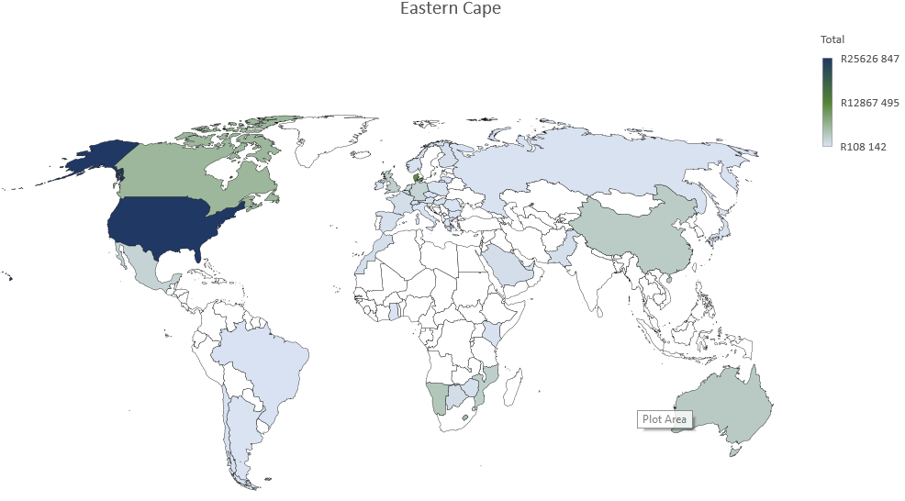
Figure 8: Destination of the Eastern Cape’s CCI exports
Table 6 below gives more detail of each market and the value of cultural goods exports from each of the CCI domains and their most important destinations.
Table 6: Eastern Cape’s top export markets for CCI goods in in 2020 (current rand)
 | Cultural and Natural Heritage | Performance and celebration | Visual art and crafts | Books and Press | Audio-visual and Interactive Media | Design and creative services | Total
USA | R 62 345 046 | R 790 175 | R 2 354 042 | R 137 584 | R .0.0 | R .0.0 | R 65 626 847
Denmark | R 11 529 053 | R .0.0 | R 126 966 | R .0.0 | R .0.0 | R .0.0 | R 11 656 019
Canada | R 5 489 118 | R 39 592 | R 414 464 | R .0.0 | R .0.0 | R .0.0 | R 5 943 174
Lesotho | R .0.0 | R 2 321 | R 5 070 024 | R 9 382 | R .0.0 | R .0.0 | R 5 081 727
Namibia | R 1 027 306 | R 4 415 | R 450 705 | R 2 467 792 | R .0.0 | R .0.0 | R 3 950 218
Australia | R 2 027 106 | R .0.0 | R 1 335 571 | R 15 | R .0.0 | R .0.0 | R 3 362 692
China | R 2 705 461 | R .0.0 | R 468 896 | R .0.0 | R .0.0 | R .0.0 | R 3 174 357
Mozambique | R 2 648 934 | R 2 000 | R 111 085 | R 13 919 | R .0.0 | R .0.0 | R 2 775 938
UK | R 2 117 212 | R 1 | R 299 463 | R 276 942 | R .0.0 | R .0.0 | R 2 693 618
Germany | R 1 498 020 | R 330 939 | R 256 836 | R 138 807 | R .0.0 | R .0.0 | R 2 224 602
Mexico | R 2 153 203 | R .0.0 | R 1 349 | R .0.0 | R .0.0 | R .0.0 | R 2 154 552
Belgium | R 1 329 429 | R 950 | R 641 339 | R 4 320 | R .0.0 | R .0.0 | R 1 976 038
Netherlands | R 915 163 | R .0.0 | R 418 100 | R 555 | R .0.0 | R .0.0 | R 1 333 818
Botswana | R 125 680 | R 134 150 | R 606 262 | R 39 145 | R .0.0 | R .0.0 | R 905 237
France | R 176 328 | R 582 669 | R .0.0 | R .0.0 | R .0.0 | R 7 706 | R 766 703
Saudi Arabia | R 617 769 | R .0.0 | R 109 338 | R .0.0 | R .0.0 | R .0.0 | R 727 107
Morocco | R 665 094 | R .0.0 | R 1 242 | R .0.0 | R .0.0 | R .0.0 | R 666 336
Pakistan | R 530 033 | R .0.0 | R 116 385 | R .0.0 | R .0.0 | R .0.0 | R 646 418
Finland | R 621 323 | R .0.0 | R .0.0 | R .0.0 | R .0.0 | R .0.0 | R 621 323

Free State
The Free State province has 4.9% of the population of South Africa and had an annual population growth rate of 0.55% per year between 2017 and 2020 (compared to a 1.5% year-on-year growth rate for South Africa as a whole). In 2019, the Free State produced 5.1% of South Africa’s GVA and is one of a few provinces which generally had a slower GVA year-on-year growth rate than South Africa as a whole, with a negative year-on-year growth rate of -0.4% in 2019 (Appendix 1). However, the Tress Index of Economic Diversification shows that the Free State is the least concentrated (most diversified) provincial economy in South Africa, which makes it potentially less vulnerable to shocks or slowdowns in specific sectors (Appendix 2).

Contribution to GVA and Domain Analysis
In 2020 the Free State’s GVA was R195.4 billion (constant 2015 prices) and contributed approximately 5% to South Africa’s GVA. The CCIs’ contribution to the province’s GVA was R5,6 billion (constant 2015 prices) and this represents 2.8% of the province’s total GVA. The Free State contributes 4% to South Africa’s CCI GVA, ranking the province seventh in terms of its contribution to South Africa’s CCIs.
Figure 9 shows the relative size of each domain in 2020.

Figure 9: The contribution of each domain to the Free State’s GVA
The largest domain is the Audio-visual and Interactive Media domain, making up 29% of the contribution of the CCIs to the provincial GVA. This is followed by Design and Creative Services (27%).
Further information on the size of the CCI domains from 2015 to 2020 is provided in Table 7 below.
Table 7: GVA at basic prices for the Free State by CCI domain (R millions constant 2015 prices)
 | 2015 | 2016 | 2017 | 2018 | 2019 | 2020
Cultural and Natural Heritage | R249 | R254 | R258 | R261 | R263 | R254
Performance and Celebration | R296 | R306 | R315 | R317 | R321 | R314
Visual Arts and Crafts | R751 | R747 | R760 | R763 | R747 | R673
Books and Press | R411 | R413 | R420 | R414 | R411 | R379
Audio-visual and Interactive Media | R1 494 | R1 547 | R1 590 | R1 605 | R1 626 | R1 592
Design and Creative Services | R1 383 | R1 426 | R1 461 | R1 479 | R1 509 | R1 479
Transversal: Education and Training | R836 | R843 | R856 | R869 | R881 | R860
Total CCI | R5 420 | R5 536 | R5 659 | R5 708 | R5 757 | R5 551
Design and Creative Services has been the fastest growing domain with a compound annual growth rate a compound annual growth rate (CAGR) of 1.8% over the 2015–2019 period. Visual Arts and Crafts has had a -0.1% CAGR over the same period and dropped a further 10% in 2020.
Table 8 below shows the Free State’s contribution to each of South Africa’s CCI domains in percentage terms.
Table 8: Percentage contribution by CCIs in the Free State to the South African creative economy by domain
 | 2015 | 2016 | 2017 | 2018 | 2019 | 2020
Cultural and Natural Heritage | 5.13% | 5.10% | 5.11% | 5.14% | 5.12% | 5.16%
Performance and Celebration | 4.47% | 4.48% | 4.50% | 4.53% | 4.53% | 4.51%
Visual Arts and Crafts | 3.96% | 3.94% | 3.94% | 3.87% | 3.86% | 3.83%
Books and Press | 2.36% | 2.39% | 2.40% | 2.41% | 2.43% | 2.52%
Audio-visual and Interactive Media | 4.54% | 4.54% | 4.56% | 4.60% | 4.59% | 4.57%
Design and Creative Services | 3.87% | 3.89% | 3.89% | 3.91% | 3.93% | 3.95%
Transversal: Education and Training | 5.29% | 5.28% | 5.27% | 5.27% | 5.24% | 5.21%
Total CCI | 4.10% | 4.11% | 4.12% | 4.13% | 4.14% | 4.17%
Table 9 shows the annual GVA growth rate of each domain in the Free State. The impact of COVID-19 can be seen in 2020.
Table 9: Percentage change of CCI GVA in the Free State
 | 2016 | 2017 | 2018 | 2019 | 2020
Cultural and Natural Heritage | 2.3% | 1.3% | 1.4% | 0.4% | -3.2%
Performance and Celebration | 3.4% | 2.8% | 0.9% | 1.2% | -2.3%
Visual Arts and Crafts | -0.5% | 1.7% | 0.5% | -2.1% | -10.0%
Books and Press | 0.4% | 1.7% | -1.4% | -0.8% | -7.7%
Audio-visual and Interactive Media | 3.5% | 2.8% | 0.9% | 1.3% | -2.1%
Design and Creative Services | 3.1% | 2.4% | 1.3% | 2.0% | -2.0%
Transversal: Education and Training | 0.8% | 1.6% | 1.5% | 1.4% | -2.4%
Total CCI | 2.1% | 2.2% | 0.9% | 0.9% | -3.6%

Cultural Employment
Overall, the creative economy accounted for 6% of all jobs in South Africa in 2019, which translates into just over 1 million jobs. This is a slight increase from 2017, when the creative economy made up 5.9% of all jobs (approximately 965 000 jobs).
Figure 10: The Cultural Trident for employment in the Free State (2019)
In 2017, the Free State accounted for 3.6% of all South African cultural occupations (13 600 jobs). When non-cultural support occupations in the CCIs are included, the Free State accounted for 3.4% of all creative economy occupations in 2017.
In 2019, the Free State creative economy employment increased, despite the negative economic growth rate in the province: people in cultural occupations increased to 16 500 which made up 4.3% of all South African cultural occupations. Including cultural occupations and support occupations in the creative industries, total creative economy employment in the Free State in 2019 accounted for 38 700 jobs (3.9% of all creative economy jobs in South Africa).

Figure 11: Percentage of cultural occupations by province 2017 and 2019
LQs are a method of identifying potential comparative advantage in a particular sector, with a score of one or more indicating that the region has a higher concentration of cultural employment than other occupations. In 2017, the cultural occupations LQ for the Free State was 0.73, which increased to 0.87 by 2019. Thus, although the Free State has one of the smallest shares of cultural occupations in South Africa, there is some indication that the sector is growing.

Figure 12: Percentage of cultural occupations in the top 4 domains for the Free State province and South Africa
Using the UNESCO Framework for Cultural Statistics format of grouping the CCIs into domains, the largest cultural occupation employment domain in the Free State (and in South Africa as a whole) is Visual Arts and Crafts, which accounted for 54.5% of cultural occupations in the Free State in 2019. The second largest employment domain in the Free State is Intangible Cultural Heritage (19%) which includes categories such as “Traditional chiefs and heads of villages”, and “Religious and associated professionals”. Smaller, but still important, domains in the province are Books, Information and Press (13.8%) and Design and Creative Services (10.8%).

Figure 13: Sociodemographic profile of Cultural Occupation workers in the Free State and South Africa
In terms of the sociodemographic characteristics of people working in cultural occupations in the Free State, the largest population group is Black Africans (90.3%) followed by white people (8.9%). This is a fairly similar pattern to what is found in non-cultural occupations in the Free State, but somewhat different from cultural occupations in South Africa as a whole where there is a greater percentage of Coloured people (7.4% at national level) and white people (13.3% at national level). This can partly be explained by the different demographic make-up of the provinces.
The distribution of age groups in cultural occupations in the Free State is somewhat different to both the national picture of cultural occupations and workers in non-cultural occupations in the province. In particular, only 20.1% of cultural workers in the Free State are youth (up to 34 years old), which is lower than cultural occupations in SA overall (33%) and non-cultural workers in the Free State province (37%). Although there is some missing data, the gender balance in cultural occupations in the province appears to be fairly even, with 51.8% of people in cultural occupations being men (compared to 57% nationally, and 56% in non-cultural jobs in the province).
A lower percentage of people in cultural occupations in the Free State have tertiary education (15.7%) compared to the national average for cultural occupations (25.5%), and to non-cultural workers in the province (18.7%). A larger percentage of people in cultural occupations are in the “primary school or less” education category (25.2%) than the national average for cultural occupations (13.6%) or non-cultural workers in the Free State (13.2%). While this means that cultural occupations provide a valuable labour market entry point for those with lower levels of education, it may constrain future growth in the sector.
In terms of employment type, a higher percentage of cultural workers in the Free State are freelance workers (own account workers with no employees, 40.4%) than cultural occupation workers in South Africa (34.5%) or non-cultural workers in the Free State (8.6%). Lower proportions of cultural workers in the Free State are employees (working for someone else for pay, 48.4%), and a higher percentage are employers (11.2% in the province, compared to 5% nationally).
Table 10: Occupation type and income category for cultural workers in the Free State and South Africa
 |  | Free State |  | South Africa
Data | Category | Cultural Occupations | Non-Cultural Occupations | Cultural Occupations
Job Type | Working for someone else for pay | 48.4% | 85.7% | 60.0%
Job Type | An employer | 11.2% | 5.1% | 5.3%
Job Type | Own account worker (no employees) | 40.4% | 8.6% | 34.5%
Job Type | Helping without pay | 0.0% | 0.6% | 0.3%
Work Status | Limited duration | 8.7% | 12.8% | 11.4%
Work Status | Permanent | 76.6% | 62.9% | 66.9%
Work Status | Unspecified | 14.7% | 24.4% | 21.7%
Formal or Informal | Formal | 41.6% | 63.1% | 48.6%
Formal or Informal | Informal | 51.4% | 33.1% | 46.3%
Formal or Informal | Other | 7.0% | 3.8% | 5.0%
Earnings | R2 500 or less | 45.9% | 40.8% | 28.0%
Earnings | R2 501–R6 000 | 30.5% | 30.1% | 27.3%
Earnings | R6 001–R16 000 | 10.8% | 16.3% | 16.3%
Earnings | R16 001–R37 500 | 10.2% | 7.6% | 9.1%
Earnings | R37 501 or more | 1.2% | 2.4% | 3.8%
Earnings | Refused to answer | 1.4% | 2.9% | 15.6%
In line with national trends, most cultural workers in the Free State are permanently employed (76.6%), but there are higher levels of informal cultural work in the province (51.4%) than in cultural occupations nationally (46.3%). The lower levels of education and greater percentage of informal work are linked to lower average earnings: 76.5% of cultural workers in the Free State earn R6 000 per month or less, compared to 55.3% of cultural workers nationally.
In summary, the Free State has one of the lowest proportions of cultural occupations in the country, but the sector did show job creation between 2017 and 2019. The largest cultural employment domains are Visual Arts and Crafts and Intangible Cultural Heritage. However, cultural workers have lower levels of education than people in cultural occupations generally in South Africa, and more precarious employment (higher percentages of cultural occupations are freelance and in the informal sector). This constrains earnings, which are lower than for cultural occupations nationally.

International Trade in Cultural Goods
Of South Africa’s nine provinces, in 2019 the Free State had the eighth highest cultural goods exports of R40.5 million which represented 0.4% of South Africa’s total cultural goods exports. In 2020 cultural goods exports for the province dropped to R38.6 million, that stood for a share of 0.4% of South Africa’s total cultural goods exports.
Table 11 below shows value of imports and exports for the Free State by domain.
Table 11: The Free State’s international trade in cultural goods (current rand)
Domain | 2018 import | 2018 export | 2019 import | 2019 export | 2020 import | 2020 export
Cultural and Natural Heritage | R 0.63 | R 21.19 | R 1.29 | R 17.50 | R 1.19 | R 19.57
Performance and Celebration | R 0.62 | R 1.75 | R 0.79 | R 1.11 | R 0.26 | R 0.69
Visual Arts and Crafts | R 2.00 | R 18.25 | R 3.76 | R 11.76 | R 3.57 | R 10.16
Books and Press | R 7.73 | R 14.92 | R 6.11 | R 10.08 | R 1.65 | R 8.17
Audio-visual and Interactive Media | R .0.0 | R .0.0 | R .0.0 | R .0.0 | R .0.0 | R .0.0
Design and Creative Services | R .0.0 | R 0.03 | R 0.01 | R 0.02 | R 0.00 | R .0.0
Total | R 10.98 | R 56.13 | R 11.95 | R 40.46 | R 6.67 | R 38.58
Source: SARS (Customs and Excise)
The data are from Quantec and are based on SARS (Customs and Excise) data. The data for the Free State is identified from the postal codes used by CCI exporters and importers. The data must be used with caution, especially the import data, because cultural goods may be brought into the Free State but may be sold in other provinces. Overall, the Free State had a trade surplus (the value of cultural goods exports is more than the value of cultural goods imports) for 2020.
The Free State’s largest export domain is Cultural and Natural Heritage.

Figure 14: Free State’s exports by domain in 2019
The map below (Figure 15) gives a graphic presentation of the markets to which the Free State sold cultural goods in 2019. Lesotho, Namibia and the USA are the province’s largest markets.
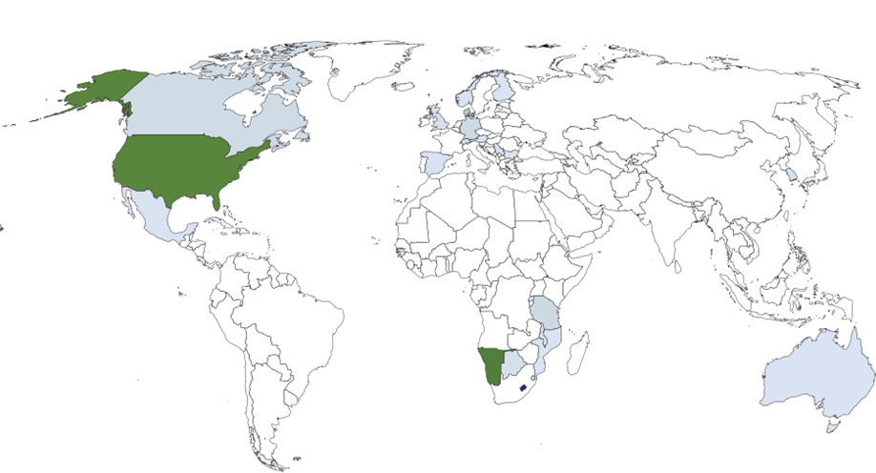
Figure 15: Destination of the Free State’s CCI exports
Table 12 below gives more detail of each market and the value of exports from each of the CCI domains for the Free State. It is interesting to note that the Free State’s top export destination for cultural goods is Lesotho, which it borders on.
Table 12: The Free State’s top export markets for CCIs in 2020 (current rand)
 | Cultural and Natural Heritage | Performance and celebration | Visual art and crafts | Books and Press | Audio-visual and Interactive Media | Design and creative services | Total
Lesotho | R932 532 | R784 711 | R4 188 175 | R8 378 807 | R 0 | R15 600 | R14 299 825
Namibia | R156 299 | R19 477 | R7 036 557 | R399 103 | R 0 | R 0 | R7 611 436
USA | R6 902 890 | R 0 | R21 310 | R10 | R 0 | R 0 | R6 924 210
Denmark | R2 111 940 | R 0 | R4 906 | R 0 | R 0 | R 0 | R2 116 846
Tanzania | R 0 | R 0 | R 0 | R825 305 | R 0 | R 0 | R825 305
Germany | R770 562 | R 0 | R5 610 | R146 | R 0 | R 0 | R776 318
Canada | R638 765 | R 0 | R4 000 | R 0 | R 0 | R 0 | R642 765
Swaziland | R 0 | R119 849 | R97 092 | R145 871 | R 0 | R 0 | R362 812
Botswana | R26 839 | R111 868 | R187 132 | R27 460 | R 0 | R 0 | R353 299
UK | R346 294 | R 0 | R100 | R 0 | R 0 | R 0 | R346 394
Korea | R308 647 | R 0 | R 0 | R 0 | R 0 | R 0 | R308 647
Austria | R293 374 | R 0 | R 0 | R 0 | R 0 | R 0 | R293 374
Lebanon | R256 695 | R 0 | R 0 | R 0 | R 0 | R 0 | R256 695
Switzerland | R230 542 | R 0 | R 0 | R 0 | R 0 | R 0 | R230 542
Norway | R216 199 | R 0 | R 0 | R 0 | R 0 | R 0 | R216 199
Mexico | R192 200 | R 0 | R 0 | R 0 | R 0 | R 0 | R192 200
Luxembourg | R169 775 | R 0 | R17 590 | R 0 | R 0 | R 0 | R187 365
Bulgaria | R178 312 | R 0 | R 0 | R 0 | R 0 | R 0 | R178 312
Singapore | R 0 | R 0 | R173 637 | R 0 | R 0 | R 0 | R173 637
Spain | R163 910 | R 0 | R 0 | R 0 | R 0 | R 0 | R163 910

Gauteng
Gauteng Province has 26% of the population of South Africa and had an annual population growth rate of 2.5% per year between 2017 and 2020 (compared to a 1.5% year-on-year growth rate for South Africa as a whole). Gauteng produced 35.7% of South Africa’s GVA in 2019, and is one of a few provinces that generally has a faster GVA year-on-year growth rate than South Africa as a whole (Appendix 1). However, the Tress Index of Economic Diversification shows that Gauteng has one of the more concentrated (less diversified) economies in South Africa, which makes it potentially more vulnerable to shocks or slowdowns in specific sectors (Appendix 2).

Contribution to GVA and Domain Analysis
In 2020 Gauteng’s GVA was R1 377.4 billion (constant 2015 prices) and contributed approximately 34.8% to South Africa’s GVA.
The CCIs’ contribution to the province’s GVA was R60 billion (constant 2015 prices) and this represents 4.5% of the province’s total GVA.
Gauteng contributes 47% to South Africa’s CCI GVA, ranking the province first in terms of the size of its contribution to South Africa’s CCI production.
Figure 16 shows the relative size of each domain in 2019.

Figure 16: The contribution of each domain to Gauteng’s GVA
The largest domains are Audio-visual and Interactive Media and Design and Creative Services, each contributing 29% to the CCIs GVA of the province.
Further information on the size of the CCI domains from 2015 to 2020 is provided in Table 13.
Table 13: GVA at basic prices for Gauteng by CCI domain (R millions constant 2015 prices)
 | 2015 | 2016 | 2017 | 2018 | 2019 | 2020
Cultural and Natural Heritage | R2 122 | R2 185 | R2 221 | R2 238 | R2 263 | R2 190
Performance and Celebration | R3 329 | R3 433 | R3 519 | R3 530 | R3 583 | R3 539
Visual Arts and Crafts | R8 622 | R8 655 | R8 791 | R9 024 | R8 896 | R8 149
Books and Press | R8 077 | R8 006 | R8 074 | R7 984 | R7 854 | R7 041
Audio-visual and Interactive Media | R16 596 | R17 136 | R17 575 | R17 616 | R17 901 | R17 731
Design and Creative Services | R16 740 | R17 171 | R17 614 | R17 763 | R18 093 | R17 710
Transversal: Education and Training | R5 290 | R5 334 | R5 442 | R5 551 | R5 682 | R5 626
Total CCI | R60 776 | R61 920 | R63 237 | R63 705 | R64 271 | R61 987
Design and Creative Services for Gauteng has been the province’s fastest growing domain with a compound annual growth rate (CAGR) of 1.6% over the 2015–2019 period. Books and Press has had a -0.6% CAGR over the same period and dropped a further 10.3% in 2020.
Table 14 below shows Gauteng’s contribution to each domain of South Africa’s CCI domains in percentage terms. Gauteng is dominant in all domains. Both the Performance and Celebration as well as the Performance and Celebration domains contribute more than 50 per cent respectively to each of South Africa’s domains.
Table 14: Percentage contribution by CCIs in Gauteng to the South African creative economy by domain
 | 2015 | 2016 | 2017 | 2018 | 2019 | 2020
Cultural and Natural Heritage | 43.8% | 43.9% | 44.0% | 44.0% | 44.2% | 44.5%
Performance and Celebration | 50.3% | 50.3% | 50.3% | 50.4% | 50.5% | 50.9%
Visual Arts and Crafts | 45.5% | 45.6% | 45.6% | 45.8% | 46.0% | 46.4%
Books and Press | 46.3% | 46.3% | 46.2% | 46.4% | 46.5% | 46.9%
Audio-visual and Interactive Media | 50.4% | 50.3% | 50.4% | 50.4% | 50.5% | 50.9%
Design and Creative Services | 46.9% | 46.9% | 47.0% | 47.0% | 47.1% | 47.3%
Transversal: Education and Training | 33.5% | 33.4% | 33.5% | 33.7% | 33.8% | 34.1%
Total CCI | 45.9% | 46.0% | 46.0% | 46.1% | 46.2% | 46.5%
Gauteng contributes the most to South Africa’s CCI GVA. The Performance and Celebration and Audio-visual and Interactive Media domains contribute than half to the respective domains in South Africa. Transversal: Education and Training only provides just over a third to South Africa’s Transversal: Education and Training.
Table 15 shows the annual GVA growth rate of each domain in Gauteng. The impact of COVID-19 can be seen in 2020.
Table 15: Percentage change of CCI GVA in Gauteng
 | 2016 | 2017 | 2018 | 2019 | 2020
Cultural and Natural Heritage | 3.0% | 1.6% | 0.7% | 1.1% | -3.2%
Performance and Celebration | 3.1% | 2.5% | 0.3% | 1.5% | -1.2%
Visual Arts and Crafts | 0.4% | 1.6% | 2.6% | -1.4% | -8.4%
Books and Press | -0.9% | 0.8% | -1.1% | -1.6% | -10.3%
Audio-visual and Interactive Media | 3.3% | 2.6% | 0.2% | 1.6% | -0.9%
Design and Creative Services | 2.6% | 2.6% | 0.8% | 1.9% | -2.1%
Transversal: Education and Training | 0.8% | 2.0% | 2.0% | 2.4% | -1.0%
Total CCI | 1.9% | 2.1% | 0.7% | 0.9% | -3.6%

Cultural Employment
Overall, the creative economy accounted for 6% of all jobs in South Africa in 2019, which translates into just over 1 million jobs. This is a slight increase from 2017, when the creative economy made up 5.9% of all jobs (approximately 965 000 jobs).
Figure 17: The Cultural Trident for employment in Gauteng (2019)
In 2017, Gauteng accounted for 29.4% of all South African cultural occupations (111 900 jobs), by far the largest provincial share of cultural occupations, followed by the Western Cape at 18%. When non-cultural support occupations in the CCIs are included, Gauteng accounted for 33.3% of all creative economy occupations in 2017.
In 2019, Gauteng creative economy employment increased: people in cultural occupations rose to 123 400 which made up 32% of all South African cultural occupations. Including cultural occupations and support occupations in the creative industries, total creative economy employment in Gauteng in 2019 accounted for 356 600 jobs (37.7% of all creative economy jobs in South Africa).

Figure 18: Percentage of cultural occupations by province 2017 and 2019
LQs are a method of identifying potential comparative advantage in a particular sector, with a score of one or more indicating that the region has a higher concentration of cultural employment than other occupations. In 2017, the cultural occupations LQ for Gauteng was 0.94, but by 2019, the LQ had increased to 1.03, indicating an emerging comparative advantage in the sector.

Figure 19: Percentage of cultural occupations by largest domains for Gauteng and South Africa
Using the UNESCO Framework for Cultural Statistics format of grouping the CCIs into domains, the largest cultural occupation employment domain in Gauteng (and in South Africa as a whole) is Visual Arts and Crafts, which accounted for 39.3% of cultural occupations in Gauteng in 2019 – lower than the national average of 44.5%. The second largest employment domain in Gauteng is Intangible Cultural Heritage (19.4%), but again less prevalent than in South Africa as a whole. Gauteng leads in Design and Creative Services (18.8%) and Books, Information and Press (14.1%), which account for a larger percentage of cultural occupations in Gauteng than they do nationally.

Figure 20: Sociodemographic profile of Cultural Occupation workers in Gauteng and South Africa
In terms of the sociodemographic characteristics of people working in cultural occupations in Gauteng, the largest population groups are Black Africans (77.1%) followed by white people (17.6%), which is very similar to the profile of people employed in non-cultural jobs in the province. Age distribution is again very similar to that found in other jobs in the province and cultural occupations nationally, with 34.1% of cultural workers in the province being in the youth (18–34) category. Gauteng cultural workers are considerably more highly educated than cultural workers nationally: only 35% of cultural workers in Gauteng have not completed secondary school compared to 45% of cultural workers nationally. A greater percentage of Gauteng cultural workers (30.6%) have tertiary education, compared to cultural workers nationally (25.5%).
Like all cultural workers in South Africa, those in cultural occupations in Gauteng are more likely to be freelancers (31.5% own account workers with no employees) than non-cultural workers in the province (9.6%). However, a greater proportion of Gauteng cultural workers are permanently employed (72.1%) than the national average (66.9%). Although higher than for non-cultural workers in the province, levels of informal work for Gauteng cultural workers (36.8%) are lower than for cultural workers nationally (46.3%). In line with higher levels of education, cultural workers in Gauteng are also more likely to be in the higher earnings categories: 38% of Gauteng cultural workers earn R6 000 per month or more, compared to 29% of cultural workers nationally
Table 16: Occupation type and income category for cultural workers in Gauteng and South Africa
 |  | Gauteng |  |  | South Africa
Data | Categories | Cultural Occupations | Non-Cultural Occupations | Cultural Occupations
Employment Type | Working for someone else for pay | 61.0% | 82.8% | 60.0%
Employment Type | An employer | 7.3% | 7.1% | 5.3%
Employment Type | Own account worker (no employees) | 31.5% | 9.6% | 34.5%
Employment Type | Helping without pay | 0.3% | 0.6% | 0.3%
Work Status | Limited duration | 9.4% | 7.8% | 11.4%
Work Status | Permanent | 72.1% | 69.3% | 66.9%
Work Status | Unspecified | 18.5% | 23.0% | 21.7%
Formal or Informal | Formal | 55.1% | 68.4% | 48.6%
Formal or Informal | Informal | 36.8% | 24.9% | 46.3%
Formal or Informal | Other | 8.2% | 6.8% | 5.0%
Earnings | R2 500 or less | 22.5% | 22.9% | 28.0%
Earnings | R2 501–R6 000 | 27.6% | 26.7% | 27.3%
Earnings | R6 001–R16 000 | 16.1% | 21.0% | 16.3%
Earnings | R16 001–R37 500 | 15.2% | 12.7% | 9.1%
Earnings | R37 501 or more | 6.6% | 6.3% | 3.8%
Earnings | Refused to answer | 11.9% | 10.4% | 15.6%
In summary, Gauteng has the highest percentage of cultural occupations in South Africa, which increased between 2017 and 2019. While the Visual Arts and Crafts and Intangible Cultural Heritage domains employ the largest percentage of cultural workers in the province, there is also evidence of clusters in Design and Creative Services and Books, Information and Press. People in cultural occupations in the province are considerably more highly educated than the average for cultural occupations in South Africa overall. While they are more likely than non-cultural workers to be working as freelancers, there are lower levels of informality than for cultural occupations nationally, making cultural occupations in Gauteng relatively stable. A greater percentage of Gauteng cultural workers also fall into the higher income categories than the national average.

International Trade in Cultural Goods
Of South Africa’s nine provinces, in 2019 Gauteng had the second highest cultural goods exports of R3.8 billion which represented 40.9% of South Africa’s total cultural goods exports. In 2020 cultural goods exports for the province dropped to R3.1 billion, making up 32.2% of South Africa’s total cultural goods exports.
Table 17: Gauteng’s international trade in cultural goods (R millions current prices)
Domain | 2018 import | 2018 export | 2019 import | 2019 export | 2020 import | 2020 export
Cultural and Natural Heritage | R 897 | R 2 649 | R 870 | R 1 684 | R 1 178 | R 1 281
Performance and Celebration | R 1 255 | R 230 | R 912 | R 319 | R 743 | R 215
Visual Arts and Crafts | R 1 506 | R 2 112 | R 1 265 | R 1 282 | R 745 | R 755
Books and Press | R 1 076 | R 530 | R 957 | R 468 | R 669 | R 842
Audio-visual and Interactive Media | R 0 | R 0 | R 0 | R 0 | R .0.0 | R 0
Design and Creative Services | R 2 | R 4 | R 1 | R 0 | R 11 | R 0
Total | R .0.0 | R .0.0 | R .0.0 | R .0.0 | R .0.0 | R .0.0
Source: SARS (Customs and Excise)
North America and particularly the USA dominate the province’s export markets with R454m. China and the UK were the second and third largest markets respectively for Gauteng’s CCI exports. SADC is also an important market for the provinces CCI exports.
Gauteng’s largest export domain is the Cultural and Natural Heritage domain. The Books and Press as well as the Visual Arts and Crafts domain follow with 27% and 24% respectively.

Figure 21: Gauteng’s exports by domain in 2019
The map below (Figure 22) gives a graphic presentation of the markets to which Gauteng sold in 2019.

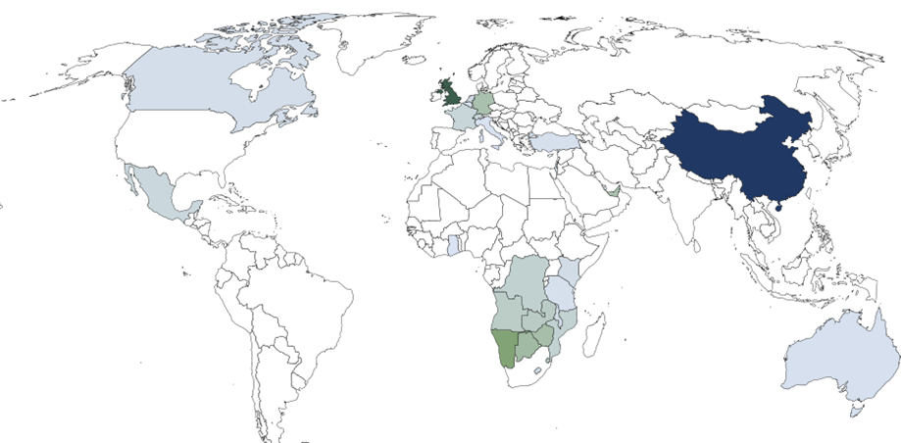
Figure 22: Destination of Gauteng’s CCI exports
Table 18 below shows the top markets for the province’s cultural and creative goods exports. As found in Chapter 2 of the mapping study, the US is one of the most important destinations for South African cultural goods exports. For Gauteng, it is the largest market with Visual Art and Crafts and Cultural and Natural Heritage domains contributing the most.
Table 18: Gauteng’s top export markets for CCIs in 2020 (current rand)
 | Cultural and Natural Heritage | Performance and Celebration | Visual Art and Crafts | Books and Press | Design and Creative Services | Total
United States | R96 554 303 | R4 162 495 | R349 643 324 | R4 562 945 | R50 | R454 923 117
China | R10 341 435 | R6 657 960 | R403 938 487 | R308 036 | R- | R421 245 918
UK | R70 165 263 | R4 470 558 | R231 303 627 | R10 544 039 | R381 | R316 483 868
Namibia | R62 508 492 | R22 334 630 | R20 851 103 | R39 897 314 | R- | R145 592 534
Botswana | R8 635 177 | R19 808 469 | R22 645 894 | R45 605 011 | R633 | R96 695 579
Zimbabwe | R549 438 | R8 428 565 | R6 774 925 | R73 281 686 | R- | R89 034 614
UEA | R52 931 689 | R21 781 654 | R8 419 386 | R1 811 639 | R- | R84 944 368
Germany | R19 336 967 | R38 457 815 | R24 601 360 | R1 280 497 | R- | R83 676 639
Swaziland | R1 558 705 | R7 023 658 | R6 521 721 | R53 206 230 | R1 064 | R68 311 378
Zambia | R658 311 | R22 256 884 | R4 634 857 | R33 708 219 | R- | R61 258 271
Angola | R6 619 854 | R10 480 878 | R2 028 577 | R36 962 699 | R6 592 | R56 098 600
DRC | R44 625 | R5 139 535 | R2 323 542 | R41 596 155 | R583 | R49 104 440
Mozambique | R786 452 | R10 855 556 | R4 479 638 | R29 871 726 | R61 423 | R46 054 795
France | R18 547 233 | R18 995 | R19 074 630 | R393 932 | R500 | R38 035 290
Switzerland | R2 399 101 | R30 996 | R35 191 601 | R71 414 | R- | R37 693 112
Mexico | R435 677 | R34 056 529 | R487 921 | R8 248 | R- | R34 988 375
Hong Kong China | R20 448 418 | R120 309 | R11 176 272 | R35 614 | R- | R31 780 613
Seychelles | R19 375 231 | R452 860 | R8 797 784 | R425 035 | R- | R29 050 910
Netherlands | R10 250 363 | R10 832 432 | R5 942 254 | R502 743 | R- | R27 527 792
Lesotho | R1 023 958 | R3 386 317 | R9 411 182 | R11 316 592 | R- | R25 138 049
Kenya | R5 631 707 | R6 094 855 | R861 106 | R11 712 914 | R- | R24 300 582

KwaZulu-Natal
KwaZulu-Natal Province has 19.3% of the population of South Africa and had an annual population growth rate of 1.3% per year between 2017 and 2020 (compared to a 1.5% year-on-year growth rate for South Africa as a whole). In 2019, KwaZulu-Natal produced 16.3% of South Africa’s GVA and generally has a similar GVA year-on-year growth rate to South Africa as a whole (Appendix 1). The Tress Index of Economic Diversification shows that KwaZulu-Natal has one of the less concentrated (more diversified) regional economies in South Africa, which makes it potentially less vulnerable to shocks or slowdowns in specific sectors (Appendix 2).

Contribution to GVA and Domain Analysis
In 2020 KwaZulu-Natal’s GVA was R633.9 billion (constant 2015 prices) and contributed approximately 17.1% to South Africa’s GVA.
The CCIs’ contribution to the province’s GVA was R18.9 billion (constant 2015 prices) and this represents 3% of the province’s total GVA.
KwaZulu-Natal contributes 14% to South Africa’s CCI GVA and this ranks the province second in terms of its contribution to South Africa’s CCIs.
Figure 23 shows the relative size of each domain in 2020.

Figure 23: The contribution of each domain to KwaZulu-Natal’s GVA
The largest domains are Audio-visual and Interactive Media (23%) and Design and Creative Services (27%).
Further information on the size of the CCI domains from 2015 to 2020 is provided in Table 19 below.
Table 19: GVA at basic prices for KwaZulu-Natal by CCI domain (R millions constant 2015 prices)
 | 2015 | 2016 | 2017 | 2018 | 2019 | 2020
Cultural and Natural Heritage | R682 | R702 | R706 | R710 | R715 | R674
Performance and Celebration | R846 | R873 | R891 | R887 | R898 | R869
Visual Arts and Crafts | R3 087 | R3 070 | R3 104 | R3 165 | R3 067 | R2 721
Books and Press | R3 099 | R3 063 | R3 098 | R3 038 | R2 957 | R2 568
Audio-visual and Interactive Media | R4 161 | R4 306 | R4 393 | R4 371 | R4 436 | R4 312
Design and Creative Services | R4 980 | R5 090 | R5 195 | R5 207 | R5 285 | R5 086
Transversal: Education and Training | R2 508 | R2 550 | R2 599 | R2 638 | R2 705 | R2 646
Total CCI | R19 364 | R19 655 | R19 986 | R20 015 | R20 063 | R18 874
Audio-visual and Interactive Media has been the fastest growing domain with a compound annual growth rate (CAGR) of 1.3% over the 2015–2019 period. Books and Press had a -0.9% CAGR over the same period and dropped a further 13.3% in 2020.
Table 20 below shows KwaZulu-Natal’s contribution to each of South Africa’s CCI domains in percentage terms.
Table 20: Percentage contribution by CCIs in KwaZulu-Natal to the South African creative economy by domain
 | 2015 | 2016 | 2017 | 2018 | 2019 | 2020
Cultural and Natural Heritage | 14.07% | 14.08% | 13.99% | 13.96% | 13.95% | 13.69%
Performance and Celebration | 12.79% | 12.79% | 12.73% | 12.66% | 12.65% | 12.49%
Visual Arts and Crafts | 16.31% | 16.17% | 16.10% | 16.06% | 15.85% | 15.50%
Books and Press | 17.77% | 17.72% | 17.74% | 17.66% | 17.52% | 17.09%
Audio-visual and Interactive Media | 12.63% | 12.64% | 12.59% | 12.52% | 12.51% | 12.37%
Design and Creative Services | 13.94% | 13.89% | 13.85% | 13.78% | 13.75% | 13.57%
Transversal: Education and Training | 15.87% | 15.97% | 16.00% | 16.00% | 16.09% | 16.03%
Total CCI | 14.63% | 14.59% | 14.54% | 14.48% | 14.42% | 14.16%
KwaZulu-Natal contributes 17% to South Africa’s Books and Press GVA but is also showing negative growth.
Table 21 shows the annual GVA growth rate of each domain in KwaZulu-Natal. The impact of COVID-19 can be seen in 2020.
Table 21: Percentage change of CCI GVA in KwaZulu-Natal
 | 2016 | 2017 | 2018 | 2019 | 2020
Cultural and Natural Heritage | 2.8% | 0.6% | 0.5% | 0.8% | -5.8%
Performance and Celebration | 3.2% | 2.0% | -0.4% | 1.2% | -3.2%
Visual Arts and Crafts | -0.6% | 1.1% | 2.0% | -3.1% | -11.3%
Books and Press | -1.2% | 1.1% | -1.9% | -2.6% | -13.2%
Audio-visual and Interactive Media | 3.5% | 2.0% | -0.5% | 1.5% | -2.8%
Design and Creative Services | 2.2% | 2.1% | 0.2% | 1.5% | -3.8%
Transversal: Education and Training | 1.7% | 1.9% | 1.5% | 2.6% | -2.2%
Total CCI | 1.5% | 1.7% | 0.1% | 0.2% | -5.9%
All domains show some decline in 2020 due to the impact of the COVID-19 pandemic-induced recession.

Cultural Employment
Overall, the creative economy accounted for 6% of all jobs in South Africa in 2019, which translates into just over 1 million jobs. This is a slight increase from 2017, when the creative economy made up 5.9% of all jobs (approximately 965 000 jobs).
Figure 24: The Cultural Trident for employment in KwaZulu-Natal (2019)
In 2017, KwaZulu-Natal accounted for 17% of all South African cultural occupations (64 600 jobs) and had the third largest percentage of cultural occupations after Gauteng, which accounted for 29.4% of 2017 cultural occupations, and the Western Cape (18%). When non-cultural support occupations in the CCIs are included, KwaZulu-Natal accounted for 16% of all creative economy occupations in 2017.
In 2019, KwaZulu-Natal’s creative economy employment increased: people in cultural occupations increased to 70 400 which made up 18.2% of all South African cultural occupations, now moving into second largest behind Gauteng (32%). Including cultural occupations and support occupations in the creative industries, total creative economy employment in KwaZulu-Natal in 2019 accounted for 162 400 jobs (16.2% of all creative economy jobs in South Africa).

Figure 25: Percentage of cultural occupations by province 2017 and 2019
LQs are a method of identifying potential comparative advantage in a particular sector, with a score of one or more indicating that the region has a higher concentration of cultural employment than other occupations. In 2017, the cultural occupations LQ for KwaZulu-Natal was 1.08, indicating a creative economy employment cluster. By 2019, the LQ had increased to 1.13, indicating a further strengthening of creative economy occupations in the province.

Figure 26: Percentage of cultural occupations in the top 4 domains for KwaZulu-Natal and South Africa
Using the UNESCO Framework for Cultural Statistics format of grouping the CCIs into domains, the largest cultural occupation employment domain in KwaZulu-Natal (and in South Africa as a whole) is Visual Arts and Crafts, which accounted for 44.5% of cultural occupations in KwaZulu-Natal in 2019. The second largest employment domain in KwaZulu-Natal is Intangible Cultural Heritage (30.5%) which includes “Traditional chiefs and heads of villages”, and “Religious and associated professionals”. These domains tend to be more important for cultural occupations in provinces with larger rural areas (such as the Eastern Cape and Limpopo). Next most important in the province is Books, Information and Press (13.6%), and Design and Creative Services (11.4%) with other domains contributing smaller amounts to job creation in the province.

Figure 27: Sociodemographic profile of Cultural Occupation workers in KwaZulu-Natal and South Africa
In terms of the sociodemographic characteristics of people working in cultural occupations in KwaZulu-Natal, the largest population groups are Black African people (78.7%), followed by people of Indian/Asian origin (12%) and white people (8%). Compared to people in cultural occupations in South Africa as a whole, there is a greater proportion of Indian/Asian people working in the sector (12% compared to 3.8% in South Africa), which can partly be explained by the different demographic make-up of the provinces.
The distribution of age groups in cultural occupations in KwaZulu-Natal is very similar both to national cultural occupations and to non-cultural occupations in the province. There is a slightly higher percentage of youth in cultural occupations (35.1%) compared to cultural occupations nationally (32.9%). The proportion of men and women in cultural occupations in the province is almost even (50.9% women), which is more balanced than in cultural occupations at a national level (42.7% women).
Compared to people in non-cultural occupations in the province, a higher percentage of cultural workers have tertiary education (21.4% compared to 17.8%), but this is still somewhat below the national average for cultural occupations (25.5%). However, a higher percentage of KwaZulu-Natal cultural workers have completed secondary school (33.4%) than the national average for cultural workers (28.7%).
In terms of employment type, the profile of cultural workers in KwaZulu-Natal is very similar to national averages for cultural occupations. Compared to non-cultural workers in the province, cultural workers are less likely to be employees (60.8% working for someone else for pay) and more likely to be in the freelance category (35.7% own account workers with no employees).
Cultural workers in KwaZulu-Natal are more likely to be permanently employed (60.3%) than non-cultural workers in the province (50.4% permanent). However, a greater percentage of cultural workers are in the informal sector (47.9%) than workers in other sectors in the province (34.3%), which is very much in line with national patterns of cultural occupation informality.
Table 22: Occupation type and income category for cultural workers in KwaZulu-Natal and South Africa
 |  | KwaZulu-Natal |  | South Africa
Data | Categories | Cultural Occupations | Non-Cultural Occupations | Cultural Occupations
Employment Type | Working for someone else for pay | 60.8% | 84.9% | 60.0%
Employment Type | An employer | 3.5% | 5.4% | 5.3%
Employment Type | Own account worker (no employees) | 35.7% | 9.2% | 34.5%
Employment Type | Helping without pay | 0.0% | 0.5% | 0.3%
Work Status | Limited duration | 13.9% | 17.2% | 11.4%
Work Status | Permanent | 63.2% | 50.4% | 66.9%
Work Status | Unspecified | 23.0% | 32.4% | 21.7%
Formal or Informal | Formal | 49.2% | 62.1% | 48.6%
Formal or Informal | Informal | 47.9% | 34.3% | 46.3%
Formal or Informal | Other | 2.9% | 3.6% | 5.0%
Earnings | R2 500 or less | 36.2% | 33.9% | 28.0%
Earnings | R2 501–R6 000 | 23.1% | 27.7% | 27.3%
Earnings | R6 001–R16 000 | 18.0% | 13.0% | 16.3%
Earnings | R16 001–R37 500 | 6.6% | 6.7% | 9.1%
Earnings | R37 501 or more | 4.2% | 2.2% | 3.8%
Earnings | Refused to answer | 11.9% | 16.5% | 15.6%
In terms of earnings, a slightly higher percentage of cultural workers in the province fall into the lower two income categories (up to R6 000 per month) than cultural workers nationally. However, compared to other workers in the province, a great proportion of cultural workers are in the top 3 income categories.
In summary, KwaZulu-Natal has one of the highest percentages of cultural occupations in South Africa, and there is evidence of job creation in the sector between 2017 and 2019. As in other provinces with larger rural areas, the most important employment domains are Visual Arts and Crafts and Intangible Cultural Heritage. While there is a higher than average proportion of cultural workers in the province who earn in the lower income category, there is also evidence of some highly paid jobs.

International Trade in Cultural Goods
Of South Africa’s nine provinces, in 2019 KwaZulu-Natal had the third highest cultural goods exports of R931.1 million which represented 10.2% of South Africa’s total cultural goods exports. In 2020 cultural goods exports for the province actually rose to R1.1 billion, making up 11.6% of South Africa’s total cultural goods exports.
Table 23 below shows the trade per domain for the province. The data are from Quantec and are based on SARS (Customs and Excise) information. The data for KwaZulu-Natal is identified from the postal codes used by CCI exporters and importers. The data must be used with caution, especially the import data, because cultural goods brought into KwaZulu-Natal may be sold in other provinces.
Table 23: KwaZulu-Natal’s international trade in cultural goods (R millions in current prices)
Domain | 2018 import | 2018 export | 2019 import | 2019 export | 2020 import | 2020 export
Cultural and Natural Heritage | R 118.8 | R 720.1 | R 77.2 | R 6 94.5 | R 52.0 | R 824.9
Performance and Celebration | R 65.7 | R 21.0 | R 72.0 | R 8.6 | R 51.0 | R 7.3
Visual Arts and Crafts | R 7 08.2 | R 152.9 | R 720.7 | R 145.9 | R 677.8 | R 178.4
Books and Press | R 70.1 | R 89.3 | R 143.8 | R 82.1 | R 50.2 | R 99.5
Audio-visual and Interactive Media | R .0.0 | R .0.0 | R .0.0 | R 0.0 | R .0.0 | R .0.0
Design and Creative Services | R 0.1 | R 0.0 | R 0.0 | R 0.1 | R 0.2 | R 0.0
Total | R 962.8 | R 983.3 | R 1 013.7 | R 9 31.2 | R 831.2 | R 1 110.0
Source: SARS (Customs and Excise)
KwaZulu-Natal’s largest export domain is the Cultural and Natural Heritage domain.

Figure 28: KwaZulu-Natal’s exports by domain in 2019
North America and particularly the USA dominate the province’s export markets with R38 million.
The map below (Figure 29) gives a graphic presentation of the markets to which KwaZulu-Natal sold in 2019.
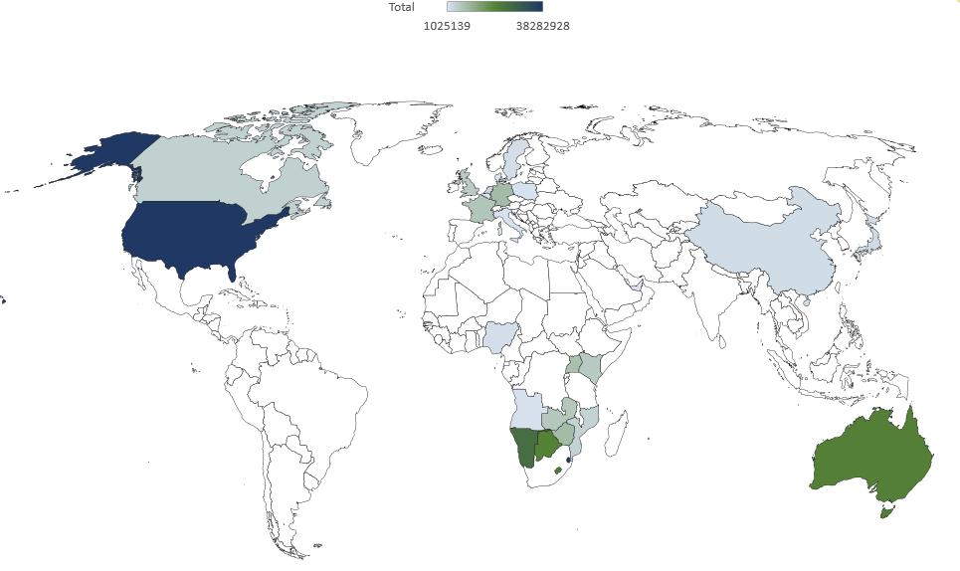
Figure 29: Destination of KwaZulu-Natal’s CCI exports
Table 24 below gives more detail of each market and the exports from each of the CCI domains.
Table 24: KwaZulu-Natal’s top export markets for CCIs in 2020 (current rand)
 | Cultural and Natural Heritage | Performance and Celebration | Visual Art and Crafts | Books and Press | Total
USA | R5 090 095 | R17 559 | R32 758 723 | R416 551 | R38 282 928
Swaziland | R1 934 965 | R1 316 254 | R13 583 355 | R20 221 169 | R37 055 743
Namibia | R2 338 501 | R1 408 413 | R11 754 119 | R9 252 818 | R24 754 543
Lesotho | R189 451 | R361 115 | R10 991 709 | R8 940 705 | R20 482 980
Australia | R859 214 | R2 100 | R19 100 789 | R137 335 | R20 099 438
Botswana | R3 347 | R1 560 710 | R13 783 530 | R4 676 054 | R20 025 750
Zimbabwe | R 0 | R182 203 | R1 499 200 | R7 096 477 | R8 777 880
Germany | R1 407 622 | R981 485 | R6 027 332 | R84 340 | R8 500 779
Uganda | R 0 | R176 624 | R232 548 | R7 303 774 | R7 712 946
France | R145 248 | R 0 | R6 235 763 | R355 746 | R6 736 757
Zambia | R3 904 | R471 737 | R3 146 180 | R2 675 520 | R6 297 341
Kenya | R418 | R1 619 | R3 260 850 | R2 522 827 | R5 785 714
UK | R1 662 874 | R738 945 | R2 480 388 | R756 010 | R5 638 217
Canada | R535 588 | R 0 | R3 843 390 | R87 868 | R4 466 846
Mozambique | R3 085 | R66 552 | R1 137 273 | R2 956 559 | R4 163 469
Mauritius | R150 302 | R185 583 | R1 640 032 | R1 423 103 | R3 399 020
Netherlands | R282 627 | R141 007 | R1 933 027 | R329 536 | R2 686 197
Japan | R 0 | R58 859 | R2 393 920 | R80 | R2 452 859
China | R645 938 | R2 827 | R1 061 232 | R540 930 | R2 250 927
Sweden | R66 097 | R 0 | R1 924 605 | R11 229 | R2 001 931
Nigeria | R47 957 | R28 503 | R28 574 | R1 814 941 | R1 919 975
Angola | R 0 | R 0 | R209 761 | R1 256 966 | R1 466 727
Poland | R 0 | R 0 | R1 376 265 | R872 | R1 377 137

Limpopo
Limpopo Province has 9.8% of the population of South Africa and had an annual population growth rate of 0.7% per year between 2017 and 2019 (compared to a 1.5% year-on-year growth rate for South Africa as a whole). In 2019, Limpopo produced 6.7% of South Africa’s GVA but has generally had a slower GVA year-on-year growth rate than South Africa as a whole (Appendix 1). The Tress Index of Economic Diversification shows that Limpopo has a more concentrated (less diversified) regional economy, which makes it potentially more vulnerable to shocks or slowdowns in specific sectors (Appendix 2).

Contribution to GVA and Domain Analysis
In 2020 Limpopo’s GVA was R258.4 billion (constant 2015 prices) and contributed approximately 6.4% to South Africa’s GVA.
The CCIs’ contribution to the province’s GVA was R6.9 (constant 2015 prices) and this represents 2.7% of the province’s total GVA.
Limpopo contributes 5% of South Africa’s CCI GVA, ranking the province fifth in terms of its contribution to South Africa’s CCIs.
Figure 30 shows the relative size of each domain in 2020.

Figure 30: The contribution of each domain to Limpopo’s GVA
Transversal: Education and Training is the largest contributor to Limpopo’s CCI GVA while the largest domains are Audio-visual and Interactive Media (26%) and Design and Creative Services (25%).
Further information on the size of the CCI domains from 2015 to 2020 is provided in Table 25.
Table 25: CCI GVA at basic prices for Limpopo by CCI domain (R millions constant 2015 prices)
 | 2015 | 2016 | 2017 | 2018 | 2019 | 2020
Cultural and Natural Heritage | R287 | R295 | R299 | R302 | R302 | R289
Performance and Celebration | R331 | R346 | R355 | R356 | R360 | R351
Visual Arts and Crafts | R581 | R598 | R612 | R620 | R619 | R583
Books and Press | R360 | R372 | R380 | R379 | R380 | R363
Audio-visual and Interactive Media | R1 697 | R1 771 | R1 819 | R1 820 | R1 841 | R1 794
Design and Creative Services | R1 617 | R1 680 | R1 721 | R1 734 | R1 770 | R1 742
Transversal: Education and Training | R1 762 | R1 782 | R1 803 | R1 813 | R1 835 | R1 785
Total CCI | R6 635 | R6 843 | R6 990 | R7 025 | R7 107 | R6 908
Table 26 below shows Limpopo’s contribution to each of South Africa’s CCI domains in percentage terms.
Table 26: Percentage contribution by CCIs in Limpopo to the South African creative economy by domain
 | 2015 | 2016 | 2017 | 2018 | 2019 | 2020
Cultural and Natural Heritage | 5.91% | 5.92% | 5.92% | 5.93% | 5.90% | 5.87%
Performance and Celebration | 5.01% | 5.07% | 5.08% | 5.08% | 5.07% | 5.04%
Visual Arts and Crafts | 3.07% | 3.15% | 3.18% | 3.15% | 3.20% | 3.32%
Books and Press | 2.07% | 2.15% | 2.18% | 2.20% | 2.25% | 2.41%
Audio-visual and Interactive Media | 5.15% | 5.20% | 5.21% | 5.21% | 5.19% | 5.15%
Design and Creative Services | 4.53% | 4.58% | 4.59% | 4.59% | 4.60% | 4.65%
Transversal: Education and Training | 11.14% | 11.16% | 11.09% | 11.00% | 10.91% | 10.82%
Total CCI | 5.01% | 5.08% | 5.09% | 5.08% | 5.11% | 5.18%
Table 27 shows the annual GVA growth rate of each domain in Limpopo. The impact of COVID-19 can be seen in 2020.
Table 27: Percentage change of CCI GVA in Limpopo
 | 2016 | 2017 | 2018 | 2019 | 2020
Cultural and Natural Heritage | 2.8% | 1.3% | 0.9% | 0.3% | -4.4%
Performance and Celebration | 4.4% | 2.8% | 0.1% | 1.1% | -2.5%
Visual Arts and Crafts | 2.9% | 2.4% | 1.3% | -0.2% | -5.8%
Books and Press | 3.3% | 2.2% | -0.3% | 0.3% | -4.6%
Audio-visual and Interactive Media | 4.4% | 2.7% | 0.1% | 1.1% | -2.5%
Design and Creative Services | 3.9% | 2.5% | 0.8% | 2.1% | -1.6%
Transversal: Education and Training | 1.1% | 1.2% | 0.6% | 1.2% | -2.7%
Total CCI | 3.1% | 2.1% | 0.5% | 1.2% | -2.8%
All domains show some decline in 2020 due to the impact of the COVID-19 pandemic-induced recession.

Cultural Employment
Overall, the creative economy accounted for 6% of all jobs in South Africa in 2019, which translates into just over 1 million jobs. This is a slight increase from 2017, when the creative economy made up 5.9% of all jobs (approximately 965 000 jobs).
Figure 31: The Cultural Trident for employment in Limpopo (2019)
In 2017, Limpopo accounted for 9.4% of all South African cultural occupations (35 700 jobs), the fourth largest after provinces with big metropolitan areas (Gauteng, 29.4%; Western Cape, 18%; KwaZulu-Natal, 17%). When non-cultural support occupations in the CCIs are included, Limpopo accounted for 7.5% of all creative economy occupations in South Africa in 2017.
In 2019, Limpopo creative economy employment increased: people in cultural occupations increased to 38 600 which made up 10% of all South African cultural occupations. Including cultural occupations and support occupations in the creative industries, total creative economy employment in Limpopo in 2019 accounted for 81 100 jobs (8.1% of all creative economy jobs in South Africa).

Figure 32: Percentage of cultural occupations by province 2017 and 2019
LQs are a method of identifying potential comparative advantage in a particular sector, with a score of one or more indicating that the region has a higher concentration of cultural employment than other occupations. In 2017, the cultural occupations LQ for Limpopo was 1.08, which had increased to 1.15 by 2019, suggesting a strengthening area of comparative advantage in cultural occupations for the province.

Figure 33: Percentage of cultural occupations in the top 4 domains for Limpopo and South Africa
Using the UNESCO Framework for Cultural Statistics format of grouping the CCIs into domains, the largest cultural occupation employment domain in Limpopo (and in South Africa as a whole) is Visual Arts and Crafts, which accounted for 58.5% of cultural occupations in Limpopo in 2019. The second largest employment domain in Limpopo is Intangible Cultural Heritage (24.2%) which includes categories such as “Traditional chiefs and heads of villages”, and “Religious and associated professionals”. These two domains dominate cultural occupations in the province, accounting for 83% of cultural jobs. Although small, Limpopo is one of the few provinces where cultural occupations in Cultural and Natural Heritage domain (2.5%) are larger than the national average.

Figure 34: Sociodemographic profile of Cultural Occupation workers in Limpopo and South Africa
In terms of the sociodemographic characteristics of people working in cultural occupations in Limpopo, the largest population group is Black Africans (99.2%), with other groups representing only a tiny proportion. This is a similar pattern to that found in non-cultural occupations in the province (95.9% Black African) and can be explained by the different demographic make-up of the provinces.
The distribution of age groups in cultural occupations in Limpopo shows a slightly higher proportion of youth (18 to 34) in cultural occupations (35.3%) than is found in cultural occupations nationally (32.9%). However, compared to non-cultural occupations in the province, a significantly higher proportion of cultural workers are in the 50+ age group (31.9% of cultural workers, compared to 19.6% of non-cultural workers). However, the gender imbalance in cultural occupations in the province is worse (64.5% men) than for cultural workers at a national level (57.3% men). As in national cultural occupations, the proportion of men in cultural occupations in Limpopo is greater than women (64.5% men).
A significantly lower percentage of people in cultural occupations in Limpopo have completed secondary school or have tertiary education (35%) compared to the national average for cultural occupations (54.2%), with larger proportions falling into the lower education levels (primary school, and secondary school not completed). While this means that cultural occupations provide a valuable labour market entry point for those with lower levels of education, it may constrain future growth in the sector.
In terms of employment type, it is notable that a greater percentage of Limpopo cultural workers in the freelance category (48.2% own account workers with no employees) than the national cultural occupation average (34.5%). In line with this, cultural workers in Limpopo are less likely to be permanently employed (42.7%) than both non-cultural workers in the province (53.1% permanent) and cultural workers nationally (66.9%). This is also associated with a higher proportion of informal sector work for cultural occupations in Limpopo (77.9%) than cultural workers in South Africa as a whole (46.3%).
Table 28: Occupation type and income category for cultural workers in Limpopo and South Africa
 |  | Limpopo |  | South Africa
Data | Categories | Cultural Occupations | Non-Cultural Occupations | Cultural Occupations
Employment Type | Working for someone else for pay | 44.6% | 78.7% | 60.0%
Employment Type | An employer | 5.7% | 5.8% | 5.3%
Employment Type | Own account worker (no employees) | 48.2% | 14.5% | 34.5%
Employment Type | Helping without pay | 1.6% | 1.0% | 0.3%
Work Status | Limited duration | 17.4% | 15.0% | 11.4%
Work Status | Permanent | 42.7% | 53.1% | 66.9%
Work Status | Unspecified | 39.9% | 31.9% | 21.7%
Formal or Informal | Formal | 22.1% | 56.3% | 48.6%
Formal or Informal | Informal | 77.9% | 41.5% | 46.3%
Formal or Informal | Other | 0.0% | 2.2% | 5.0%
Earnings | R2 500 or less | 38.1% | 30.6% | 28.0%
Earnings | R2 501 – R6 000 | 31.3% | 26.6% | 27.3%
Earnings | R6 001 – R16 000 | 10.3% | 14.5% | 16.3%
Earnings | R16 001 – R37 500 | 3.9% | 7.0% | 9.1%
Earnings | R37 501 or more | 1.8% | 1.9% | 3.8%
Earnings | Refused to answer | 14.6% | 19.4% | 15.6%
With higher levels of informal sector and permanent employment and lower education levels, it is not surprising that a higher percentage of people in cultural occupations in the province fall into the lower income categories: 69% of people in cultural occupations in the province earn less than R6 000 per month, compared to 55% of people in cultural occupations in South Africa as a whole.
In summary, Limpopo has the fourth highest percentage of cultural occupations in South Africa, and the number of cultural occupations grew between 2017 and 2019. However, cultural occupations in the province are dominated by Visual Arts and Crafts and Intangible Cultural Heritage domains, and employment is quite precarious with higher levels of freelance and informal work than cultural workers at a national level.

International Trade in Cultural Goods
Of South Africa’s nine provinces, in 2019 Limpopo had the fifth highest cultural goods exports of R65.2 million which represented 0.7% of South Africa’s total cultural goods exports. In 2020 cultural goods exports for the province dropped to R62 million (and dropped to sixth position), making up 0.6% of South Africa’s total cultural goods exports.
Table 29 shows Limpopo’s trade per domain. The data are from Quantec and are based on SARS (Customs and Excise) information. The data for Limpopo is identified from the postal codes used by the CCI exporters and importers. The data must be used with caution, especially the import data, because cultural goods brought into Limpopo may be sold in other provinces.
Table 29: Limpopo’s international trade in cultural goods (R millions in current prices)
Domain | 2018 import | 2018 export | 2019 import | 2019 export | 2020 import | 2020 export
Cultural and Natural Heritage | R 2.0 | R 51.5 | R 1.9 | R 58.2 | R 3.3 | R 59.5
Performance and Celebration | R 0.0 | R 2.1 | R 0.2 | R 2.4 | R 3.4 | R 0.3
Visual Arts and Crafts | R 1.1 | R 2.8 | R 2.2 | R 2.3 | R 0.6 | R 0.8
Books and Press | R 0.9 | R 1.7 | R 0.8 | R 2.2 | R 1.7 | R 1.4
Audio-visual and Interactive Media | R .0.0 | R .0.0 | R .0.0 | R .0.0 | R .0.0 | R .0.0
Design and Creative Services | R .0.0 | R .0.0 | R .0.0 | R .0.0 | R .0.0 | R .0.0
Total | R 4.1 | R 58.1 | R 5.2 | R 65.2 | R 9.0 | R 62.0
Source: SARS (Customs and Excise)
Limpopo’s largest export domain is the Cultural and Natural Heritage domain.

Figure 35: Limpopo’s exports by domain in 2019
The map below (Figure 36) gives a graphic presentation of the markets to which Limpopo sold cultural goods exports in 2019. North America and particularly the USA dominate the province’s export markets with earnings of R39 million.

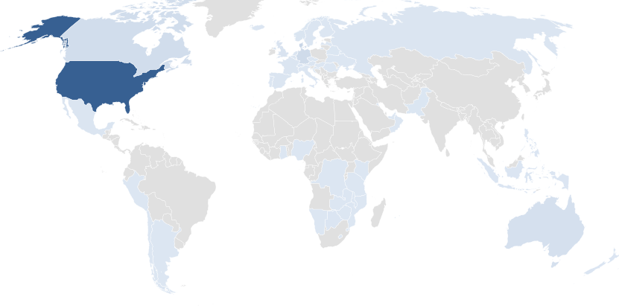
Figure 36: Destination of Limpopo’s CCI exports
Table 30 below gives more detail of each market and the value of exports from each of the CCI domains.
Table 30: Limpopo’s top export markets for CCIs in 2020 (current rand)
 | Cultural and Natural Heritage | Performance and Celebration | Visual Art and Crafts | Books and Press | Total
United States | R39 241 421 | R20 895 | R692 188 | R5 125 | R39 959 629
Denmark | R4 865 233 | R 0 | R3 458 | R 0 | R4 868 691
Germany | R3 207 866 | R 0 | R31 899 | R 0 | R3 239 765
Canada | R2 643 343 | R231 | R1 059 | R 0 | R2 644 633
DRC | R 0 | R924 620 | R1 209 665 | R 0 | R2 134 285
Australia | R1 683 154 | R 0 | R13 312 | R4 925 | R1 701 391
Zambia | R 0 | R256 652 | R66 378 | R712 867 | R1 035 897
Botswana | R177 277 | R834 118 | R14 310 | R10 181 | R1 035 886
UK | R781 800 | R 0 | R 0 | R50 | R781 850
Zimbabwe | R 0 | R101 404 | R4 507 | R533 786 | R639 697
Swaziland | R 0 | R28 613 | R54 103 | R461 890 | R544 606
Tanzania | R 0 | R 0 | R 0 | R392 818 | R392 818
Norway | R389 112 | R 0 | R 0 | R 0 | R389 112
Austria | R348 194 | R 0 | R 0 | R 0 | R348 194
Russian Federation | R341 004 | R 0 | R 0 | R 0 | R341 004
France | R323 718 | R 0 | R6 463 | R100 | R330 281
Netherlands | R318 203 | R 0 | R 0 | R 0 | R318 203
Sweden | R310 570 | R 0 | R 0 | R 0 | R310 570
Spain | R301 172 | R 0 | R 0 | R 0 | R301 172
Belgium | R276 160 | R 0 | R15 097 | R 0 | R291 257
Kuwait | R228 000 | R 0 | R 0 | R 0 | R228 000

Mpumalanga
Mpumalanga province has 7.9% of the population of South Africa and had an annual population growth rate of 1.55% per year between 2017 and 2019 (compared to a 1.5% year-on-year growth rate for South Africa as a whole). In 2019, Mpumalanga produced 6.8% of South Africa’s GVA but has generally had a slower GVA year-on-year growth rate than South Africa as a whole (Appendix 1). The Tress Index of Economic Diversification shows that Mpumalanga has one of the more diversified regional economies in South Africa, which makes it potentially less vulnerable to shocks or slowdowns in specific sectors (Appendix 2).

Contribution to GVA and Domain Analysis
In 2020 Mpumalanga’s GVA was R260.9 billion (constant 2015 prices) and contributed approximately 7.4% to South Africa’s GVA.
The CCIs’ contribution to the province’s GVA as R6.2 billion (constant 2015 prices) and this represents 2.4% of the province’s total GVA.
The province contributes 5% to South Africa’s CCI GVA, ranking the province sixth in terms of its contribution to South Africa’s CCIs.
Figure 37 shows the relative size of each domain in 2020.

Figure 37: The contribution of each domain to Mpumalanga’s GVA
The largest domains are Audio-visual and Interactive Media (28%) and Design and Creative Services (27%).
Further information on the size of the CCI domains from 2015 to 2020 is provided in Table 31 below.
Table 31: GVA at basic prices for Mpumalanga by CCI domain (R millions constant 2015 prices)
 | 2015 | 2016 | 2017 | 2018 | 2019 | 2020
Cultural and Natural Heritage | R275 | R282 | R286 | R289 | R290 | R278
Performance and Celebration | R321 | R332 | R342 | R343 | R347 | R338
Visual Arts and Crafts | R885 | R891 | R910 | R919 | R909 | R799
Books and Press | R457 | R461 | R468 | R460 | R459 | R417
Audio-visual and Interactive Media | R1 617 | R1 675 | R1 722 | R1 727 | R1 750 | R1 710
Design and Creative Services | R1 546 | R1 596 | R1 636 | R1 647 | R1 679 | R1 645
Transversal: Education and Training | R982 | R989 | R1 003 | R1 012 | R1 027 | R1 002
Total CCI | R6 084 | R6 225 | R6 367 | R6 397 | R6 460 | R6 189
Table 32 below shows Mpumalanga’s contribution to each of South Africa’s CCI domains in percentage terms.
Table 32: Percentage contribution by CCIs in Mpumalanga to the South African creative economy by domain
 | 2015 | 2016 | 2017 | 2018 | 2019 | 2020
Cultural and Natural Heritage | 5.68% | 5.66% | 5.67% | 5.68% | 5.65% | 5.65%
Performance and Celebration | 4.85% | 4.87% | 4.88% | 4.89% | 4.89% | 4.86%
Visual Arts and Crafts | 4.67% | 4.69% | 4.72% | 4.66% | 4.70% | 4.55%
Books and Press | 2.62% | 2.66% | 2.68% | 2.68% | 2.72% | 2.78%
Audio-visual and Interactive Media | 4.91% | 4.92% | 4.93% | 4.95% | 4.94% | 4.91%
Design and Creative Services | 4.33% | 4.36% | 4.36% | 4.36% | 4.37% | 4.39%
Transversal: Education and Training | 6.21% | 6.19% | 6.17% | 6.14% | 6.11% | 6.07%
Total CCI | 4.60% | 4.62% | 4.63% | 4.63% | 4.64% | 4.64%
Table 33 shows the annual GVA growth rate of each domain in Mpumalanga. The impact of COVID-19 can be seen in 2020.
Table 33: Percentage change of CCI GVA in Mpumalanga
 | 2016 | 2017 | 2018 | 2019 | 2020
Cultural and Natural Heritage | 2.5% | 1.3% | 1.0% | 0.3% | -4.0%
Performance and Celebration | 3.5% | 2.8% | 0.3% | 1.2% | -2.6%
Visual Arts and Crafts | 0.7% | 2.2% | 0.9% | -1.0% | -12.1%
Books and Press | 0.7% | 1.7% | -1.7% | -0.3% | -9.1%
Audio-visual and Interactive Media | 3.6% | 2.8% | 0.3% | 1.3% | -2.3%
Design and Creative Services | 3.2% | 2.6% | 0.7% | 1.9% | -2.0%
Transversal: Education and Training | 0.7% | 1.4% | 0.9% | 1.5% | -2.5%
Total | 2.3% | 2.3% | 0.5% | 1.0% | -4.2%

Cultural Employment
Overall, the creative economy accounted for 6% of all jobs in South Africa in 2019, which translates into just over 1 million jobs. This is a slight increase from 2017, when the creative economy made up 5.9% of all jobs (approximately 965 000 jobs).
Figure 38: The Cultural Trident for employment in Mpumalanga (2019)
In 2017, Mpumalanga accounted for 7.7% of all South African cultural occupations (29 300 jobs), the fifth largest after provinces with large metropolitan areas (Gauteng, 29.4%; Western Cape, 18%; KwaZulu-Natal, 17% and the Eastern Cape, 8%). When non-cultural support occupations in the CCIs are included, Mpumalanga accounted for 8.2% of all creative economy occupations in 2017.
In 2019, Mpumalanga creative economy employment had decreased somewhat: people in cultural occupations fell to 25 600 which made up 6.6% of all South African cultural occupations. Including cultural occupations and support occupations in the creative industries, total creative economy employment in Mpumalanga in 2019 accounted for 75 300 jobs (7.5% of all creative economy jobs in South Africa).

Figure 39: Percentage of cultural occupations by province 2017 and 2019
LQs are a method of identifying potential comparative advantage in a particular sector, with a score of one or more indicating that the region has a higher concentration of cultural employment than other occupations. In 2017, the cultural occupations LQ for Mpumalanga was 1.02, indicating an area of potential comparative advantage. However, by 2019, the LQ had fallen to 0.88.

Figure 40: Percentage of cultural occupations in the top 4 domains for Mpumalanga and South Africa
Using the UNESCO Framework for Cultural Statistics format of grouping the CCIs into domains, the largest cultural occupation employment domain in Mpumalanga (and in South Africa as a whole) is Visual Arts and Crafts, which accounted for 48.1% of cultural occupations in Mpumalanga in 2019. The second largest employment domain in Mpumalanga is Intangible Cultural Heritage (37.4%) which includes categories such as “Traditional chiefs and heads of villages”, and “Religious and associated professionals”. These two domains dominate cultural occupations in the province, accounting for 85.5% of people in cultural occupations. The third and fourth most important domains for cultural occupations in the province are Design and Creative Services (8.2%) and Books, Information and Press (5.6%).

Figure 41: Sociodemographic profile of Cultural Occupation workers in Mpumalanga and South Africa
In terms of the sociodemographic characteristics of people working in cultural occupations in Mpumalanga, the largest population groups are Black African people (95.1%). Fewer people in cultural occupations in Mpumalanga are in the youth (18–34) age group (15.7%, compared to 32.9% for cultural occupations nationally). Gender distribution is very similar to national cultural occupations, with 57.9% of people in cultural occupations in the province being men. In terms of education level, cultural workers in Mpumalanga are more likely to fall into the “Primary school or less” category (32.7%) than both cultural workers nationally (13.6%) or non-cultural workers in the province (11.5%). A lower percentage of cultural workers in Mpumalanga have tertiary education (19.6%) than nationally (25.5%). While this means that cultural occupations provide a valuable labour market entry point for those with lower levels of education, it may constrain future growth in the sector.
In terms of employment type, it is notable that a lower percentage of cultural workers in Mpumalanga are employees (53.4% working for someone else for pay) than in cultural occupations nationally (60%). Correspondingly, there is a greater percentage of Mpumalanga cultural workers in the freelance category (39.8% own account workers with no employees) than the national cultural occupation average (34.5%).
In line with this, cultural workers in Mpumalanga are much more likely than other workers in the province to be freelancers (52.6% own account workers with no employees), and less likely than cultural workers nationally to be permanently employed (57.3% of Mpumalanga cultural workers are permanently employed compared to 66.9% of cultural workers nationally). Cultural occupations are also more likely to be in the informal sector (69.4%) than cultural workers nationally (46.3%) and non-cultural workers in Mpumalanga (36.6%). Although the distribution of earnings categories of cultural workers is fairly close to other workers in the province, a greater percentage of people in cultural occupations in Mpumalanga earn less than R6 000 per month (66%) than cultural workers nationally (55.3%).
Table 34: Occupation type and income category for cultural workers in Mpumalanga and South Africa
 |  | Mpumalanga |  | South Africa
Data | Categories | Cultural Occupations | Non-Cultural Occupations | Cultural Occupations
Employment Type | Working for someone else for pay | 44.7% | 82.1% | 60.0%
Employment Type | An employer | 2.7% | 5.2% | 5.3%
Employment Type | Own account worker (no employees) | 52.6% | 12.2% | 34.5%
Employment Type | Helping without pay | 0.0% | 0.5% | 0.3%
Work Status | Limited duration | 3.4% | 11.0% | 11.4%
Work Status | Permanent | 57.3% | 57.1% | 66.9%
Work Status | Unspecified | 39.3% | 31.9% | 21.7%
Formal or Informal | Formal | 30.6% | 60.0% | 48.6%
Formal or Informal | Informal | 69.4% | 36.6% | 46.3%
Formal or Informal | Other | 0.0% | 3.4% | 5.0%
Earnings | R2 500 or less | 33.0% | 33.4% | 28.0%
Earnings | R2 501–R6 000 | 33.2% | 32.3% | 27.3%
Earnings | R6 001–R16 000 | 23.7% | 17.2% | 16.3%
Earnings | R16 001–R37 500 | 9.3% | 10.3% | 9.1%
Earnings | R37 501 or more | 0.0% | 2.3% | 3.8%
Earnings | Refused to answer | 0.7% | 4.6% | 15.6%
In summary, the Mpumalanga province accounts for one of the lower proportions of cultural occupations in the country, and the number of cultural occupations fell between 2017 and 2019. Visual Arts and Crafts and Intangible Cultural Heritage domains account for 85.5% of people in cultural occupations in Mpumalanga. People in cultural occupations in the province have lower levels of education that the average for cultural occupations in South Africa overall, and are more likely than cultural workers nationally to fall into the older (50+) age group. They are also more likely to be working as freelancers and in the informal sector than people in cultural occupations in South Africa overall, attributes that make cultural occupations more precarious than non-cultural jobs.

International Trade in Cultural Goods
Of South Africa’s nine provinces, in 2019 Mpumalanga had the sixth highest cultural goods exports of R63.6 million which represented 0.7% of South Africa’s total cultural goods exports. In 2020 cultural goods exports for the province actually rose to R68.3 million (and rose to fifth position), making up 0.7% of South Africa’s total cultural goods exports.
Table 35 below shows the trade per domain. The data are from Quantec and are based on SARS (Customs and Excise). The data for geographical areas is identified from the postal codes used by the CCI exporters and importers. The data must be used with caution, especially the import data, because cultural goods may be brought into the province but may be sold in other provinces.
Table 35: Mpumalanga’s international trade in cultural goods (R millions in current prices)
Domain | 2018 import | 2018 export | 2019 import | 2019 export | 2020 import | 2020 export
Cultural and Natural Heritage | R 4 | R 26 | R 4 | R 37 | R 4 | R 28
Performance and Celebration | R 1 | R 3 | R 0 | R 2 | R 0 | R 3
Visual Arts and Crafts | R 8 | R 17 | R 6 | R 18 | R 13 | R 23
Books and Press | R 1 | R 4 | R 1 | R 6 | R 0 | R 15
Audio-visual and Interactive Media | R .0.0 | R .0.0 | R .0.0 | R .0.0 | R .0.0 | R .0.0
Design and Creative Services | R 0 | R .0.0 | R .0.0 | R .0.0 | R 0 | R 0
Total | R 14 | R 49 | R 11 | R 64 | R 18 | R 68
Source: SARS (Customs and Excise)
Mpumalanga’s largest CCI good exports domain is Cultural and Natural Heritage, which accounted for more than half of the province’s cultural goods exports (58%). Next most important is Visual Arts and Crafts.

Figure 42: Mpumalanga’s cultural goods exports by domain in 2019
North America is the province’s largest export market for cultural goods: this amounted to nearly R16 million to the US and R760 000 to Canada in 2019. This is followed by Swaziland, China and Russia, and a few SADC countries.
The map below (Figure 43) gives a graphic presentation of the markets to which Mpumalanga exported cultural goods in 2019.
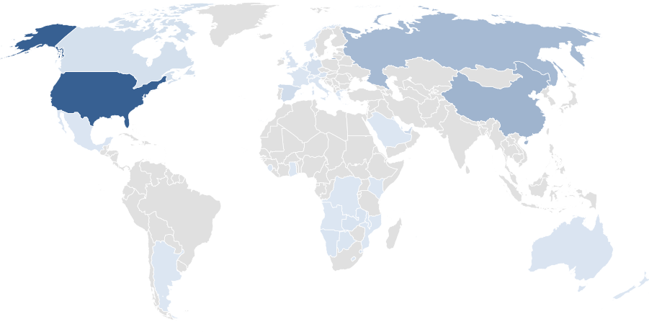
Figure 43: Destination of Mpumalanga’s CCI exports
Table 36 below gives more detail of each market and the value of exports from each of the CCI domains.
Table 36: Mpumalanga’s top export markets for CCIs in 2020 (current rand)
 | Cultural and Natural Heritage | Performance and Celebration | Visual Art and Crafts | Books and Press | Total
United States | R15 903 990 | R- | R444 612 | R17 859 | R16 366 461
Swaziland | R785 545 | R965 162 | R5 878 724 | R4 407 069 | R12 036 500
China | R5 925 918 | R- | R- | R- | R5 925 918
Russia | R5 179 645 | R- | R14 919 | R2 016 | R5 196 580
Mozambique | R3 696 | R854 343 | R2 028 086 | R1 517 850 | R4 403 975
Namibia | R242 762 | R2 200 | R2 947 043 | R20 831 | R3 212 836
Lesotho | R 0 | R- | R2 597 496 | R389 | R2 597 885
UAE | R1 381 753 | R- | R1 004 092 | R286 | R2 386 131
Spain | R1 148 764 | R- | R81 230 | R- | R1 229 994
Germany | R794 725 | R- | R22 284 | R- | R817 009
Canada | R758 716 | R- | R- | R- | R758 716
United Kingdom | R304 775 | R- | R401 032 | R1 720 | R707 527
Denmark | R575 367 | R- | R- | R- | R575 367
Botswana | R157 158 | R6 157 | R176 427 | R126 710 | R466 452
Zambia | R341 184 | R1 763 | R- | R5 830 | R348 777
Austria | R339 944 | R- | R888 | R1 480 | R342 312
Saudi Arabia | R 0 | R290 871 | R- | R- | R290 871
Angola | R 0 | R1 510 | R230 100 | R- | R231 610
Seychelles | R 0 | R- | R225 150 | R- | R225 150
Belgium | R177 749 | R- | R24 500 | R- | R202 249
Australia | R185 404 | R- | R- | R- | R185 404

North West
The North West province has 6.9% of the population of South Africa and had an annual population growth rate of 1.7% per year between 2017 and 2020 (compared to a 1.5% year-on-year growth rate for South Africa as a whole). In 2019, the North West produced 5.5% of South Africa’s GVA, but has generally has a slower GVA year-on-year growth rate than South Africa as a whole, with a negative year-on-year growth rate of -0.3% in 2019 (Appendix 1). However, the Tress Index of Economic Diversification shows that the North West has a fairly diversified provincial economy, which makes it potentially less vulnerable to shocks or slowdowns in specific sectors (Appendix 2).

Contribution to GVA and Domain Analysis
In 2020 the North West’s GVA was R210.8 billion (constant 2015 prices) and contributed approximately 5.4% to South Africa’s GVA.
The CCIs’ contribution to the province’s GVA was R5.3 billion (constant 2015 prices) and this represents 2.5% of the province’s total GVA.
The North West contributes 4% to South Africa’s CCI GVA, ranking the province eighth in terms of its contribution to South Africa’s CCIs.
Figure 44 shows the relative size of each domain in 2020.

Figure 44: The contribution of each domain to the North West province’s GVA
The largest domains are Audio-visual and Interactive Media (29%) and Design and Creative Services (27%).
Further information on the size of the CCI domains from 2015 to 2020 is provided in Table 37 below.
Table 37: GVA at basic prices for the North West by CCI domain (R millions constant 2015 prices)
 | 2015 | 2016 | 2017 | 2018 | 2019 | 2020
Cultural and Natural Heritage | R221 | R225 | R229 | R231 | R232 | R226
Performance and Celebration | R287 | R295 | R303 | R305 | R309 | R301
Visual Arts and Crafts | R626 | R638 | R655 | R668 | R663 | R609
Books and Press | R364 | R368 | R375 | R372 | R372 | R347
Audio-visual and Interactive Media | R1 456 | R1 495 | R1 536 | R1 542 | R1 564 | R1 528
Design and Creative Services | R1 367 | R1 404 | R1 440 | R1 452 | R1 481 | R1 453
Transversal: Education and Training | R870 | R870 | R882 | R890 | R904 | R882
Total CCI | R5 190 | R5 296 | R5 420 | R5 459 | R5 523 | R5 347
Table 38 below shows the North West’s contribution to each of South Africa’s CCI domains in percentage terms.
Table 38: Percentage contribution by CCIs in the North West to the South African creative economy by domain
 | 2015 | 2016 | 2017 | 2018 | 2019 | 2020
Cultural and Natural Heritage | 4.56% | 4.52% | 4.54% | 4.54% | 4.52% | 4.58%
Performance and Celebration | 4.35% | 4.32% | 4.34% | 4.35% | 4.35% | 4.33%
Visual Arts and Crafts | 3.31% | 3.36% | 3.40% | 3.39% | 3.42% | 3.47%
Books and Press | 2.09% | 2.13% | 2.15% | 2.16% | 2.20% | 2.31%
Audio-visual and Interactive Media | 4.42% | 4.39% | 4.40% | 4.42% | 4.41% | 4.39%
Design and Creative Services | 3.83% | 3.83% | 3.84% | 3.84% | 3.85% | 3.88%
Transversal: Education and Training | 5.50% | 5.45% | 5.43% | 5.40% | 5.37% | 5.34%
Total CCI | 3.92% | 3.93% | 3.94% | 3.95% | 3.97% | 4.01%
Table 39 shows the annual GVA growth rate of each domain in the North West. The impact of COVID-19 can be seen in 2020.
Table 39: Percentage change of CCI GVA in the North West
 | 2016 | 2017 | 2018 | 2019 | 2020
Cultural and Natural Heritage | 2.0% | 1.5% | 0.9% | 0.3% | -2.6%
Performance and Celebration | 2.7% | 2.7% | 0.4% | 1.4% | -2.5%
Visual Arts and Crafts | 1.9% | 2.7% | 1.9% | -0.8% | -8.0%
Books and Press | 1.2% | 2.0% | -0.8% | -0.1% | -6.5%
Audio-visual and Interactive Media | 2.7% | 2.7% | 0.4% | 1.4% | -2.3%
Design and Creative Services | 2.7% | 2.5% | 0.8% | 2.0% | -1.8%
Transversal: Education and Training | 0.0% | 1.4% | 0.9% | 1.6% | -2.4%
Total CCI | 2.0% | 2.4% | 0.7% | 1.2% | -3.2%
All domains show some decline in 2020 due to the impact of the COVID-19 pandemic-induced recession.

Cultural Employment
Overall, the creative economy accounted for 6% of all jobs in South Africa in 2019, which translates into just over 1 million jobs. This is a slight increase from 2017, when the creative economy made up 5.9% of all jobs (approximately 965 000 jobs).
Figure 45: The Cultural Trident for employment in the North West (2019)
In 2017, the North West accounted for 5.7% of all South African cultural occupations (21 700 jobs). When non-cultural support occupations in the CCIs are included, the North West accounted for 5.3% of all creative economy occupations in 2017.
By 2019, the North West creative economy employment had decreased quite significantly: the number of people in cultural occupations fell to 16 100 which made up 4.2% of all South African cultural occupations. Including cultural occupations and support occupations in the creative industries, total creative economy employment in the North West in 2019 accounted for 33 800 jobs (3.4% of all creative economy jobs in South Africa).

Figure 46: Percentage of cultural occupations by province 2017 and 2019
LQs are a method of identifying potential comparative advantage in a particular sector, with a score of one or more indicating that the region has a higher concentration of cultural employment than other occupations. In 2017, the cultural occupations LQ for the North West was 0.94, which decreased to 0.71 by 2019.

Figure 47: Percentage of cultural occupations in the top 4 domains for the North West province and South Africa
Using the UNESCO Framework for Cultural Statistics format of grouping the CCIs into domains, the largest cultural occupation employment domain in the North West (and in South Africa as a whole) is Visual Arts and Crafts, which accounted for 43.2% of cultural occupations in the North West in 2019. The second largest employment domain in the North West is Design and Creative Services (24.9%), which is higher than the proportion of employment in this domain nationally. Intangible Cultural Heritage, which includes categories such as “Traditional chiefs and heads of villages” and “Religious and associated professionals”, makes up 12.9% of cultural occupations in the province, somewhat lower than the national average. A smaller, but still important, domain in the province is Books, Information and Press (11.6%).

Figure 48: Sociodemographic profile of Cultural Occupation workers in the North West and South Africa
The majority of people working in cultural occupations in the North West province are Black Africans (89.1%), followed by white people (10.9%). Cultural workers in the province are also younger than cultural workers nationally: 49.4% are in the youth (18–34) age group, compared to only 32.9% of cultural workers in South Africa overall. The gender imbalance amongst those in cultural occupations in the North West (59% men) is very similar to the national pattern. Cultural workers in the North West are slightly less well educated that cultural workers at a national level, with a larger percentage (19.9%) in the “primary school or less” category, and a smaller proportion with tertiary education (14.4% in the province, compared to 25.5% nationally). While this means that cultural occupations provide a valuable labour market entry point for those with lower levels of education, it may constrain future growth in the sector.
As generally found in cultural occupations, a higher percentage of cultural workers in the North West operate as freelancers (own account workers with no employees, 29.3%) than non-cultural workers in the province (7.3%). A greater percentage of cultural workers are working on limited duration contracts (49%, compared to only 14% of non-cultural workers in the province) and cultural workers are more likely to be employed in the informal sector (39.2%, compared to 30.3% of non-cultural workers in the province). All these attributes contribute to the precarious nature of cultural work, which makes the sector vulnerable to shocks, such as the COVID-19 crisis. Earnings categories are nevertheless very similar to national patterns, although there is a slightly lower percentage of people in the higher earnings categories.
Table 40: Occupation type and income category for cultural workers in the North West and South Africa
 |  | North West |  | South Africa
Data | Categories | Cultural Occupations | Non-Cultural Occupations | Cultural Occupations
Employment Type | Working for someone else for pay | 69.2% | 88.4% | 60.0%
Employment Type | An employer | 1.5% | 3.8% | 5.3%
Employment Type | Own account worker (no employees) | 29.3% | 7.3% | 34.5%
Employment Type | Helping without pay | 0.0% | 0.5% | 0.3%
Work Status | Limited duration | 23.4% | 14.1% | 11.4%
Work Status | Permanent | 49.2% | 57.7% | 66.9%
Work Status | Unspecified | 27.5% | 28.3% | 21.7%
Formal or Informal | Formal | 56.2% | 66.5% | 48.6%
Formal or Informal | Informal | 39.2% | 30.3% | 46.3%
Formal or Informal | Other | 4.6% | 3.2% | 5.0%
Earnings | R2 500 or less | 23.3% | 27.6% | 28.0%
Earnings | R2 501–R6 000 | 29.8% | 28.4% | 27.3%
Earnings | R6 001–R16 000 | 28.9% | 20.6% | 16.3%
Earnings | R16 001–R37 500 | 3.8% | 9.2% | 9.1%
Earnings | R37 501 or more | 0.0% | 2.1% | 3.8%
Earnings | Refuse | 14.2% | 12.2% | 15.6%
In summary, the North West has one of the smaller proportions of cultural occupations in the country, and the number of jobs fell between 2017 and 2019. The largest cultural employment domains are Visual Arts and Crafts and (unusually) Design and Creative Services. Nearly half of those working in cultural occupations in the province are youth, and a lower percentage than average have tertiary education. Nearly a third work as freelancers, and only half have permanent jobs. Coupled with higher than average levels of informality, this makes cultural occupations in the province especially risky and precarious.

International Trade in Cultural Goods
Of South Africa’s nine provinces, in 2019 the North West had the seventh highest cultural goods exports of R57.2 million which represented 0.6% of South Africa’s total cultural goods exports. In 2020 cultural goods exports for the province dropped to R55.6 million, making up 0.6% of South Africa’s total cultural goods exports.
The data are from Quantec and are based on SARS (Customs and Excise) information. The data for the North West province is identified from the postal codes used by the CCI exporters and importers. The data must be used with caution, especially the import data, because cultural goods that are brought into the North West province may be sold in other provinces.
Table 41: The North West province’s international trade in cultural goods (R millions in current prices)
Domain | 2018 import | 2018 export | 2019 import | 2019 export | 2020 import | 2020 export
Cultural and Natural Heritage | R 10.7 | R 41.1 | R 9.3 | R 46.7 | R 15.3 | R 42.4
Performance and Celebration | R 1.0 | R 1.2 | R 4.8 | R 0.9 | R 2.2 | R 1.8
Visual Arts and Crafts | R 3.7 | R 3.6 | R 2.5 | R 4.6 | R 1.9 | R 7.6
Books and Press | R 3.6 | R 1.4 | R 5.3 | R 5.0 | R 2.2 | R 3.8
Audio-visual and Interactive Media | R .0.0 | R .0.0 | R 0.0 | R 0.0 | R .0.0 | R .0.0
Design and Creative Services | R .0.0 | R 0.0 | R .0.0 | R 0.0 | R .0.0 | R .0.0
Total | R 18.9 | R 47.4 | R 21.9 | R 57.2 | R 21.6 | R 55.6
Source: SARS (Customs and Excise)
The North West province’s largest CCI export is the Cultural and Natural Heritage domain, making up more than 80% of cultural goods export earnings.

Figure 49: North West’s exports by domain in 2019
The map below (Figure 50) gives a graphic presentation of the markets to which the North West province sold in 2019. By far the most important export market for cultural goods from the province is Botswana, followed by the US and Russia.
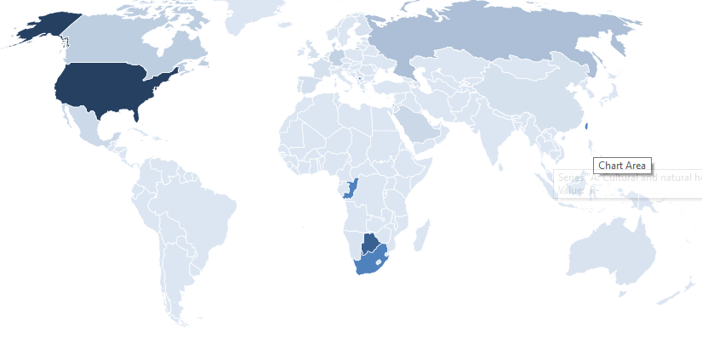
Figure 50: Destination of the North West province’s CCI exports
Table 42 below gives more detail of each market and the exports from each of the CCI domains.
Table 42: The North West province’s top export markets for CCIs in 2020 (current rand)
 | Cultural and Natural Heritage | Performance and Celebration | Visual Art and Crafts | Books and Press | Total
Botswana | R5 161 556 | R619 140 | R2 544 898 | R4 406 689 | R12 732 772
United States | R10 373 473 | R 0 | R231 176 | R 0 | R10 604 649
Russian Federation | R1 504 258 | R 0 | R724 | R 0 | R1 504 982
Namibia | R66 580 | R9 243 | R671 587 | R234 291 | R981 701
Australia | R105 951 | R 0 | R860 142 | R 0 | R966 093
Canada | R943 199 | R 0 | R 0 | R 0 | R943 199
Germany | R783 547 | R77 514 | R34 510 | R 0 | R895 571
Saudi Arabia | R538 212 | R 0 | R 0 | R 0 | R538 212
Denmark | R513 188 | R 0 | R 0 | R 0 | R513 188
Mexico | R495 045 | R 0 | R 0 | R 0 | R495 045
United Kingdom | R208 067 | R 0 | R180 478 | R390 | R388 935
Mozambique | R 0 | R1 686 | R 0 | R315 198 | R316 884
Belgium | R276 890 | R 0 | R 0 | R 0 | R276 890
Spain | R215 193 | R 0 | R 0 | R 0 | R215 193
France | R197 116 | R 0 | R 0 | R5 158 | R202 274
China | R193 130 | R 0 | R 0 | R 0 | R193 130
Luxembourg | R170 829 | R 0 | R 0 | R 0 | R170 829
Austria | R169 390 | R 0 | R 0 | R 0 | R169 390
Qatar | R141 263 | R 0 | R 0 | R 0 | R141 263
Finland | R138 117 | R 0 | R 0 | R 0 | R138 117
Ghana | R 0 | R106 100 | R 0 | R 0 | R106 100

Northern Cape
The Northern Cape Province has 2.2% of the population of South Africa and had an annual population growth rate of 1.25% per year between 2017 and 2019 (compared to a 1.5% year-on-year growth rate for South Africa as a whole). In 2019, the Northern Cape produced 2% of South Africa’s GVA but has generally had a slower GVA year-on-year growth rate than South Africa as a whole (Appendix 1), with the province’s GVA declining by -0.5% between 2018 and 2019. The Tress Index of Economic Diversification shows that the Northern Cape has a reasonably diversified economy, which may make it potentially less vulnerable to shocks or slowdowns in specific sectors (Appendix 2).

Contribution to GVA and Domain Analysis
In 2020 the Northern Cape’s GVA was R80.1 billion (constant 2015 prices) and contributed approximately 2.1% to South Africa’s GVA.
The CCIs’ contribution to the province’s GVA was R1.9 billion (constant 2015 prices) and this represents 2.4% of the province’s total GVA.
The Northern Cape contributes 1.5% to South Africa’s CCI GVA, ranking the province ninth in terms of its contribution to South Africa’s CCIs.
Figure 51 shows the relative size of each domain in 2020.

Figure 51: The contribution of each domain to the Northern Cape’s GVA
The largest domains are Audio-visual and Interactive Media (28%) and Design and Creative Services (26%).
Further information on the size of the CCI domains from 2015 to 2020 is provided in Table 43 below.
Table 43: GVA at basic prices for the Northern Cape by CCI domain (R millions constant 2015 prices)
 | 2015 | 2016 | 2017 | 2018 | 2019 | 2020
Cultural and Natural Heritage | R80 | R81 | R82 | R83 | R83 | R80
Performance and Celebration | R105 | R107 | R110 | R111 | R112 | R109
Visual Arts and Crafts | R250 | R251 | R256 | R263 | R261 | R239
Books and Press | R114 | R115 | R117 | R116 | R116 | R111
Audio-visual and Interactive Media | R532 | R542 | R557 | R561 | R567 | R553
Design and Creative Services | R479 | R489 | R501 | R507 | R517 | R508
Transversal: Education and Training | R349 | R345 | R350 | R354 | R358 | R349
Total CCI | R1 909 | R1 931 | R1 973 | R1 994 | R2 014 | R1 949
Table 44 below shows the Northern Cape’s contribution to each of South Africa’s CCI domains in percentage terms.
Table 44: Percentage contribution by CCIs in the Northern Cape to the South African creative economy by domain
 | 2015 | 2016 | 2017 | 2018 | 2019 | 2020
Cultural and Natural Heritage | 1.65% | 1.63% | 1.63% | 1.63% | 1.62% | 1.62%
Performance and Celebration | 1.59% | 1.57% | 1.58% | 1.58% | 1.58% | 1.57%
Visual Arts and Crafts | 1.32% | 1.32% | 1.33% | 1.33% | 1.35% | 1.36%
Books and Press | 0.65% | 0.66% | 0.67% | 0.68% | 0.69% | 0.74%
Audio-visual and Interactive Media | 1.61% | 1.59% | 1.60% | 1.60% | 1.60% | 1.59%
Design and Creative Services | 1.34% | 1.33% | 1.34% | 1.34% | 1.34% | 1.36%
Transversal: Education and Training | 2.21% | 2.16% | 2.15% | 2.15% | 2.13% | 2.11%
Total CCI | 1.44% | 1.43% | 1.44% | 1.44% | 1.45% | 1.46%
Table 45 shows the annual GVA growth rate of each domain in the Northern Cape. The impact of COVID-19 can be seen in 2020.
Table 45: Percentage change of CCI GVA in the Northern Cape
 | 2016 | 2017 | 2018 | 2019 | 2020
Cultural and Natural Heritage | 1.4% | 1.2% | 1.0% | 0.0% | -4.0%
Performance and Celebration | 1.9% | 2.7% | 0.7% | 1.1% | -2.5%
Visual Arts and Crafts | 0.7% | 2.0% | 2.5% | -0.7% | -8.3%
Books and Press | 0.6% | 1.7% | -0.2% | 0.1% | -4.8%
Audio-visual and Interactive Media | 1.9% | 2.7% | 0.6% | 1.1% | -2.3%
Design and Creative Services | 2.1% | 2.5% | 1.1% | 2.0% | -1.8%
Transversal: Education and Training | -1.0% | 1.3% | 1.2% | 1.1% | -2.5%
Total CCI | 1.2% | 2.2% | 1.1% | 1.0% | -3.2%

Cultural Employment
Overall, the creative economy accounted for 6% of the workforce in South Africa in 2019, which translates into just over 1 million jobs. This is a slight increase from 2017, when the creative economy made up 5.9% of all jobs (approximately 965 000 jobs).
Figure 52: The Cultural Trident for employment in the Northern Cape (2019)
In 2017, the Northern Cape accounted for 1.6% of all South African cultural occupations (4 100 jobs), making it the smallest provincial contributor to cultural occupations in South Africa (Gauteng, 29.4%; Western Cape, 18%; KwaZulu-Natal, 17%). When non-cultural support occupations in the CCIs are included, the Northern Cape accounted for 1.3% of all creative economy occupations in 2017.
In 2019, despite a negative growth rate, the Northern Cape creative economy employment increased: people in cultural occupations increased to 6 000 which made up 1.6% of all South African cultural occupations. Including cultural occupations and support occupations in the creative industries, total creative economy employment in the Northern Cape in 2019 accounted for 13 600 jobs (1.4% of all creative economy jobs in South Africa and 4.2% of all jobs in the Northern Cape Province).

Figure 53: Percentage of cultural occupations by province 2017 and 2019
LQs are a method of identifying potential comparative advantage in a particular sector, with a score of one or more indicating that the region has a higher concentration of cultural employment than other occupations. In 2017, the cultural occupations LQ for the Northern Cape was 0.57. However, by 2019, the LQ had increased to 0.79, suggesting a growing presence of cultural occupations in the province.

Figure 54: Percentage of cultural occupations in the top 4 domains for the Northern Cape and South Africa
Using the UNESCO Framework for Cultural Statistics format of grouping the CCIs into domains, the largest cultural occupation employment domains in the Northern Cape are Visual Arts and Crafts (29.2%) and Books, Information and Press (29.1%). These are followed by Design and Creative Services (24.2%) and Intangible Cultural Heritage (9.2%). The pattern is somewhat different from South Africa as a whole, where the largest cultural occupation domains are Visual Arts and Crafts (44.5%), Intangible Cultural Heritage (22.5%) and Design and Creative Services (13.4%). Part of the difference in the Northern Cape profile may be because of small regional clusters, but it should also be noted that the sample size for cultural occupations for this province is small, which makes the analysis somewhat less reliable.

Figure 55: Sociodemographic profile of Cultural Occupation workers in the Northern Cape and South Africa
In terms of the sociodemographic characteristics of people working in cultural occupations in the Northern Cape, the largest population groups are Black African people (59.8%), followed by Coloured people (37.7%), and white people (2.5%).
The distribution of age groups in cultural occupations in the Northern Cape is somewhat different both to national cultural occupations and to non-cultural occupations in the province. There is a lower percentage of youth in cultural occupations (29.7%) compared to cultural occupations nationally (32.9%) and to non-cultural occupations in the Northern Cape (38.7%). Unlike in national cultural occupations, the proportion of men in cultural occupations in the Northern Cape is less than women (51.6% women).
A significantly higher percentage of people in cultural occupations in the Northern Cape have tertiary education (31.1%) compared to the national average for cultural occupations (25.5%), which is a good sign for the growth potential of the cultural sector in the province. However, a lower percentage of people in cultural occupations in the Northern Cape had completed secondary school (22%) than the national percentage (29%).
In terms of employment type, 72.5% of cultural workers in Northern Cape are employees (working for someone else for pay) than in cultural occupations nationally (60%). Correspondingly, there is a lower percentage of Northern Cape cultural workers in the freelance category (19.7% own account workers with no employees) than the national cultural occupation average (34.5%). However, people in cultural occupations in the Northern Cape are still much more likely to be freelance workers than people employed in other jobs in the province.
In line with this, cultural workers in the Northern Cape are more likely to be permanently employed (73.3%) than cultural workers nationally (66.9%). This is also associated with a lower proportion of informal sector work for cultural occupations in the Northern Cape (24.7%) than cultural workers in South Africa as a whole (46.3%).
Table 46: Occupation type and income category for cultural workers in the Northern Cape and South Africa
 |  | NC Cultural Occupations | NC Non-Cultural Occupations | SA Cultural Occupations
Job Type | Working for someone else for pay | 72.5% | 93.0% | 60.0%
 | An employer | 7.8% | 2.9% | 5.3%
 | Own account worker (no employees) | 19.7% | 3.9% | 34.5%
 | Helping without pay | 0.0% | 0.2% | 0.3%
Work Status | Limited duration | 15.5% | 22.8% | 11.4%
 | Permanent | 73.3% | 54.9% | 66.9%
 | Unspecified | 11.2% | 22.4% | 21.7%
Formal or Informal | Formal | 65.1% | 70.6% | 48.6%
 | Informal | 24.7% | 26.0% | 46.3%
 | Other | 10.1% | 3.4% | 5.0%
Earnings | R2 500 or less | 24.7% | 32.7% | 28.0%
 | R2 501–R6 000 | 18.0% | 27.5% | 27.3%
 | R6 001–R16 000 | 19.0% | 15.0% | 16.3%
 | R16 001–R37 500 | 13.2% | 6.8% | 9.1%
 | R37 501 or more | 0.0% | 2.7% | 3.8%
 | Refuse | 25.1% | 15.3% | 15.6%
With higher levels of tertiary education, formal sector and permanent employment types, it is not surprising that a higher percentage of people in cultural occupations in the province fall into the higher income categories compared to people in cultural occupations in South Africa as a whole.
In summary, the Northern Cape has the smallest percentage of cultural occupations in South Africa, but the number of cultural occupations grew between 2017 and 2019 despite a decline in provincial growth rate. As found in other fairly rural provinces, Visual Arts and Crafts are one of the largest cultural employment domains, but the Northern Cape also has a surprisingly large percentage of cultural occupations in the Books, Information and Press domain, which warrants further research. People in cultural occupations in the province have higher levels of tertiary education than the average for cultural occupations in South Africa overall, and are more likely to be in more stable employment types than cultural workers in South Africa in general.

International Trade in Cultural Goods
Of South Africa’s nine provinces, in 2019 the Northern Cape had the ninth highest cultural goods exports of R2.7 million which represented 0.03% of South Africa’s total cultural goods exports. In 2020 cultural goods exports for the province dropped to R1.9 million, making up 0.2% of South Africa’s total cultural goods exports.
Table 47 below shows the trade per domain. The data are from Quantec and are based on SARS (Customs and Excise). The data for the Northern Cape is identified from the postal codes used by the CCI exporters and importers. The data must be used with caution, especially the import data, because cultural goods brought into the Northern Cape may be sold in other provinces.
Table 47: Northern Cape’s international trade in cultural goods (R millions in current prices)
Domain | 2018 import | 2018 export | 2019 import | 2019 export | 2020 import | 2020 export
Cultural and Natural Heritage | R 44.3 | R 1.1 | R 28.4 | R 1.6 | R 2.4 | R 1.7
Performance and Celebration | R 0.1 | R 0.2 | R 0.1 | R 0.2 | R 0.0 | R 0.0
Visual Arts and Crafts | R 0.2 | R 0.3 | R 0.3 | R 0.2 | R 0.3 | R 0.0
Books and Press | R 1.2 | R 0.9 | R 0.2 | R 0.7 | R 0.0 | R 0.1
Audio-visual and Interactive Media | R .0.0 | R .0.0 | R .0.0 | R .0.0 | R .0.0 | R .0.0
Design and Creative Services | R .0.0 | R .0.0 | R .0.0 | R .0.0 | R .0.0 | R .0.0
Total | R 45.9 | R 2.5 | R 29.0 | R 2.7 | R 2.8 | R 1.9
Source: SARS (Customs and Excise)
The Northern Cape’s largest export domain is the Cultural and Natural Heritage domain.

Figure 56: Northern Cape’s exports by domain in 2019
The map below (Figure 57) gives a graphic presentation of the markets to which the Northern Cape sold in 2019. Namibia is the Northern Cape’s largest market for CCI products. This is not surprising since Namibia is a neighbouring country.
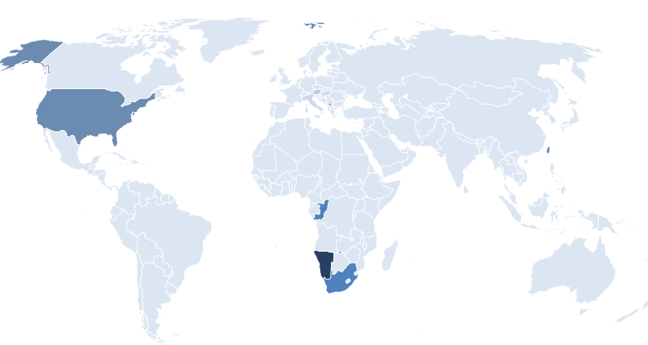
Figure 57: Destination of the Northern Cape’s CCI exports
Table 48 below gives more detail of each market and the exports from each of the CCI domains.
Table 48: Northern Cape’s top export markets for CCIs in 2020 (current rand)
 | Cultural and Natural Heritage | Performance and Celebration | Visual Art and Crafts | Books and Press | Total
Namibia | R1 071 790 | R19 432 | R152 706 | R563 824 | R1 807 752
United States | R364 827 | R- | R- | R- | R364 827
France | R 0 | R164 671 | R- | R- | R164 671
Austria | R103 097 | R- | R- | R- | R103 097
UK | R 0 | R- | R- | R79 050 | R79 050
Italy | R51 270 | R- | R- | R- | R51 270
Botswana | R 0 | R1 600 | R4 200 | R34 764 | R40 564
Hungary | R33 308 | R- | R- | R- | R33 308
Angola | R 0 | R- | R- | R10 550 | R10 550
Mozambique | R 0 | R- | R- | R300 | R300
Singapore | R 0 | R- | R- | R113 | R113
Spain | R 0 | R- | R- | R40 | R40

Western Cape
The Western Cape Province has 12% of the population of South Africa and had an annual population growth rate of 1.7% per year between 2017 and 2020 (compared to a 1.5% year-on-year growth rate for South Africa as a whole). In 2019, the Western Cape produced 14.3% of South Africa’s GVA and is one of a few provinces that generally has a faster GVA year-on-year growth rate than South Africa as a whole (Appendix 1). However, the Tress Index of Economic Diversification shows that the Western Cape has one of the more concentrated (less diversified) economies in South Africa, which makes it potentially more vulnerable to shocks or slowdowns in specific sectors (Appendix 2).

Contribution to GVA and Domain Analysis
In 2020 the Western Cape’s GVA was R563 billion (constant 2015 prices) and contributed approximately 14% to South Africa’s GVA.
The CCIs’ contribution to the province’s GVA was R16.5 billion (constant 2015 prices) and this represents 2.9% of the province’s total GVA.
The Western Cape contributes 12% to South Africa’s CCI GVA, ranking the province third in terms of its contribution to South Africa’s CCIs.
Figure 58 shows the relative size of each domain in 2020.

Figure 58: The contribution of each domain to the Western Cape’s GVA
The largest domains are Design and Creative Services (32%).and Audio-visual and Interactive Media (19%).
The Cultural and Natural Heritage and the Performance and Celebration domains contribute a relatively small GVA to the province’s CCI GVA. The Design and Creative Services domain contributes the most. Further information on the size of the CCI domains from 2015 to 2020 is provided in Table 49 below.
Table 49: GVA at basic prices for the Western Cape by CCI domain (R millions constant 2015 prices)
 | 2015 | 2016 | 2017 | 2018 | 2019 | 2020
Cultural and Natural Heritage | R547 | R561 | R563 | R566 | R571 | R537
Performance and Celebration | R642 | R660 | R671 | R666 | R674 | R651
Visual Arts and Crafts | R2 809 | R2 807 | R2 841 | R2 915 | R2 848 | R2 552
Books and Press | R3 692 | R3 624 | R3 642 | R3 566 | R3 470 | R3 013
Audio-visual and Interactive Media | R3 108 | R3 201 | R3 259 | R3 229 | R3 275 | R3 185
Design and Creative Services | R5 221 | R5 310 | R5 415 | R5 441 | R5 528 | R5 310
Transversal: Education and Training | R1 231 | R1 243 | R1 265 | R1 286 | R1 318 | R1 287
Total CCI | R17 251 | R17 405 | R17 657 | R17 670 | R17 683 | R16 536
Table 50 below shows the Western Cape’s contribution to each of South Africa’s CCI domains in percentage terms.
Table 50: Percentage contribution by CCIs in the Western Cape to the South African creative economy by domain
 | 2015 | 2016 | 2017 | 2018 | 2019 | 2020
Cultural and Natural Heritage | 11.27% | 11.25% | 11.16% | 11.14% | 11.14% | 10.92%
Performance and Celebration | 9.71% | 9.66% | 9.60% | 9.51% | 9.49% | 9.37%
Visual Arts and Crafts | 14.84% | 14.79% | 14.74% | 14.79% | 14.72% | 14.54%
Books and Press | 21.17% | 20.96% | 20.86% | 20.73% | 20.56% | 20.05%
Audio-visual and Interactive Media | 9.43% | 9.40% | 9.34% | 9.25% | 9.24% | 9.14%
Design and Creative Services | 14.61% | 14.49% | 14.44% | 14.41% | 14.38% | 14.17%
Transversal: Education and Training | 7.79% | 7.78% | 7.79% | 7.80% | 7.84% | 7.80%
Total CCI | 13.04% | 12.92% | 12.85% | 12.79% | 12.71% | 12.41%
Table 51 below shows the annual GVA growth rate of each domain in the Western Cape. The impact of COVID-19 can be seen in 2020.
Table 51: Percentage change of CCI GVA in the Western Cape
 | 2016 | 2017 | 2018 | 2019 | 2020
Cultural and Natural Heritage | 2.6% | 0.4% | 0.6% | 0.8% | -5.9%
Performance and Celebration | 2.7% | 1.8% | -0.8% | 1.1% | -3.3%
Visual Arts and Crafts | -0.1% | 1.2% | 2.6% | -2.3% | -10.4%
Books and Press | -1.8% | 0.5% | -2.1% | -2.7% | -13.2%
Audio-visual and Interactive Media | 3.0% | 1.8% | -0.9% | 1.4% | -2.7%
Design and Creative Services | 1.7% | 2.0% | 0.5% | 1.6% | -3.9%
Transversal: Education and Training | 0.9% | 1.8% | 1.6% | 2.5% | -2.4%
Total CCI | 0.9% | 1.4% | 0.1% | 0.1% | -6.5%

Cultural Employment
Overall, the creative economy accounted for 6% of all jobs in South Africa in 2019, which translates into just over 1 million jobs. This is a slight increase from 2017, when the creative economy made up 5.9% of all jobs (approximately 965 000 jobs).
Figure 59: The Cultural Trident for employment in the Western Cape (2019)
In 2017, the Western Cape accounted for 18% of all South African cultural occupations (68 500 jobs), second only to Gauteng, which accounted for 29.4% of 2017 cultural occupations. When non-cultural support occupations in the CCIs are included, the Western Cape accounted for 17.2% of all creative economy occupations in 2017.
However, in 2019, the Western Cape creative economy employment declined: people in cultural occupations decreased to 55 400 which made up 14.4% of all South African cultural occupations (behind Gauteng at 32% and KwaZulu-Natal at 18.2%). Including cultural occupations and support occupations in the creative industries, total creative economy employment in the Western Cape in 2019 accounted for 168 450 jobs (16.8% of all creative economy jobs in South Africa).

Figure 60: Percentage of cultural occupations by province 2017 and 2019
LQs are a method of identifying potential comparative advantage in a particular sector, with a score of one or more indicating that the region has a higher concentration of cultural employment than other occupations. In 2017, the cultural occupations LQ for the Western Cape was 1.2, indicating a creative economy employment cluster. However, by 2019, the LQ had declined to 0.94.

Figure 61: Percentage of cultural occupations by domain for the Western Cape and South Africa
Using the UNESCO Framework for Cultural Statistics format of grouping the CCIs into domains, the largest cultural occupation employment domain in the Western Cape (and in South Africa as a whole) is Visual Arts and Crafts, which accounted for 41.6% of cultural occupations in the Western Cape in 2019. The second largest employment domain in the Western Cape is Design and Creative Services (16.3% of all cultural occupations in the province, a considerably higher share than occupations in this domain for South Africa overall).
The film and television production cluster in Cape Town is also clear: in South Africa as a whole, cultural occupations in this domain make up 2.7% of all cultural occupations, but they make up 7.8% of cultural occupations in the Western Cape. Other domains where the Western Cape has a larger proportion of cultural occupations than the national average are Books, Information and Press (13.7%) and Performance and Celebration (6.6%).

Figure 62: Sociodemographic profile of Cultural Occupation workers in the Western Cape and South Africa
In terms of the sociodemographic characteristics of people working in cultural occupations in the Western Cape, the largest population groups are Coloured people (35%) followed by Black African and white people (32% each). Compared to people in cultural occupations in South Africa as a whole, there is a greater proportion of both Coloured (7.4% at national level) and white people (13.3% at national level). This can partly be explained by the different demographic make-up of the provinces, but it does appear to be the case that white people in cultural occupations in the Western Cape are over-represented, even in comparison to the percentage of white people in non-cultural occupations in the province (18.4%).
The distribution of age groups in cultural occupations in the Western Cape is very similar both to national cultural occupations and to non-cultural occupations in the province. There is a slightly higher percentage of youth in cultural occupations (35.4%) compared to cultural occupations nationally (32.9%). As in national cultural, and provincial non-cultural occupations, the proportion of men in cultural occupations in the Western Cape is greater than women, and the gender imbalance is somewhat higher in cultural occupations in the province (60.3% men) than in both cultural occupations at a national level (57.3%) and non-cultural occupations in the Western Cape (55.4%).
A significantly higher percentage of people in cultural occupations in the Western Cape have tertiary education (38.3%) compared to the national average for cultural occupations (25.5%), with smaller proportions falling into the lower education levels (primary school, and secondary school not completed).
In terms of employment type, it is notable that a much higher percentage of cultural workers in Western Cape are employees (78.2% working for someone else for pay) than in cultural occupations nationally (60%). While there are still a greater proportion of Western Cape cultural workers in the freelance category (19.7% own account workers with no employees), this is much lower than the national cultural occupation average (34.5%).
In line with this, cultural workers in the Western Cape are more likely to be permanently employed (83.3%) than both non-cultural workers in the province (71% permanent) and cultural workers nationally (66.9%). This is also associated with a higher proportion of formal sector work for cultural occupations in the Western Cape (67.6%) than cultural workers in South Africa as a whole (48.6%), although the percentage of formal sector cultural occupations in the Western Cape is still lower than for non-cultural occupations in the province (73%).
Table 52: Occupation type and income category for cultural workers in the Western Cape and South Africa
 |  | Western Cape |  | SA
Data | Categories | Cultural Occupations | Non-Cultural occupations | Cultural Occupations
Job Type | Working for someone else for pay | 78.2% | 87.2% | 60.0%
Job Type | An employer | 2.2% | 5.1% | 5.3%
Job Type | Own account worker | 19.7% | 7.4% | 34.5%
Job Type | Helping without pay | 0.0% | 0.3% | 0.3%
Work Status | Limited duration | 5.1% | 13.3% | 11.4%
Work Status | Permanent | 83.3% | 71.0% | 66.9%
Work Status | Unspecified | 11.6% | 15.7% | 21.7%
Formality | Formal | 67.6% | 73.1% | 48.6%
Formality | Informal | 24.7% | 20.7% | 46.3%
Formality | Other | 7.7% | 6.2% | 5.0%
Income category | R2 500 or less | 12.3% | 9.0% | 28.0%
Income category | R2 501–R6 000 | 22.8% | 29.0% | 27.3%
Income category | R6 001–R16 000 | 11.8% | 9.2% | 16.3%
Income category | R16 001–R37 500 | 5.6% | 3.9% | 9.1%
Income category | R37 501 or more | 1.6% | 1.6% | 3.8%
Income category | Refused to answer | 45.9% | 47.2% | 15.6%
With higher levels of formal sector and permanent employment and higher education levels, it is not surprising that a lower percentage of people in cultural occupations in the province fall into the lower income categories. However, the figures are not directly comparable with national statistics because of the much higher percentage of Western Cape respondents who refused to answer the question (45.9% in the Western Cape compared to 15.6% nationally).
In summary, the Western Cape has one of the highest percentages of cultural occupations in South Africa, although there was some evidence of decline between 2017 and 2019. There is also evidence of clusters in particular domains, such as Design and Creative Services and Audio-visual and Interactive Media. People in cultural occupations in the province are considerably more highly educated than the average for cultural occupations in South Africa overall. They are also more likely to be working as employees in permanent positions, although there is still a higher level of freelancer workers in cultural occupations than in other occupations in the province.

International Trade in Cultural Goods
Of South Africa’s nine provinces, in 2019 the Western Cape was the top cultural goods exports of R4.1 billion which represented of 45% of South Africa’s total cultural goods exports. In 2020 cultural goods exports for the province rose to R5.1 billion, making up 52.7% of South Africa’s total cultural goods exports.
Table 53: Western Cape’s international trade in cultural goods per domain. The data are from Quantec and are based on SARS (Customs and Excise) information. The data for the Western Cape is identified from the postal codes used by CCI exporters and importers. The data must be used with caution, especially the import data, because cultural goods brought into the Western Cape may be sold in other provinces.
Table 53: Western Cape’s international trade in cultural goods (R millions in current prices)
Domain | 2018 import | 2018 export | 2019 import | 2019 export | 2020 import | 2020 export
Cultural and Natural Heritage | R 120 | R 2 712 | R 74 | R 1 392 | R 82 | R 2 355
Performance and Celebration | R 412 | R 445 | R 409 | R 423 | R 354 | R 332
Visual Arts and Crafts | R 555 | R 1 501 | R 622 | R 2 001 | R 454 | R 2 146
Books and Press | R 449 | R 364 | R 461 | R 309 | R 384 | R 225
Audio-visual and Interactive Media | R .0.0 | R 0 | R .0.0 | R .0.0 | R .0.0 | R .0.0
Design and Creative Services | R 0 | R 1 | R 0 | R 0 | R 0 | R 0
Total | R 1 536 | R 5 024 | R 1 567 | R 4 126 | R 1 274 | R 5 060
Source: SARS (Customs and Excise)
The Western Cape’s largest cultural goods export domain is Cultural and Natural Heritage.

Figure 63: The Western Cape’s exports by domain in 2019
The map below (Figure 64) gives a graphic presentation of the markets to which the Western Cape exported cultural goods in 2019. The United States, the Netherlands, the United Kingdom and Germany are the province’s largest markets.
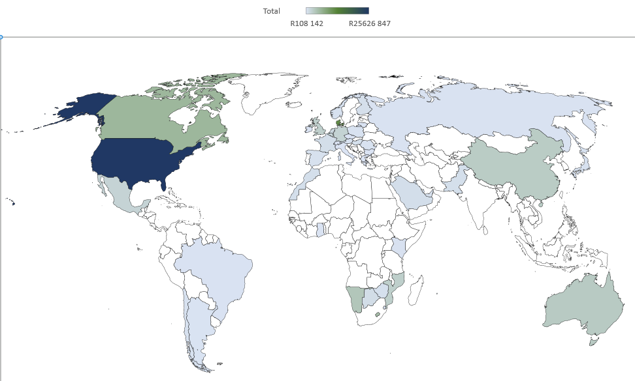
Figure 64: Destination of the Western Cape’s CCI exports
Table 54 below gives more detail of each export market and the value of cultural goods exports from the top 4 CCI domains.
Table 54: Western Cape’s top export markets for CCIs in 2020 (current rand)
 | Cultural and Natural Heritage | Performance and Celebration | Visual Art and Crafts | Books and Press | Total
United States | R7 217 186 | R94 672 299 | R1 388 782 472 | R1 867 974 | R1 492 539 931
Netherlands | R1 491 439 | R25 852 | R262 729 869 | R399 955 | R264 647 115
United Kingdom | R2 654 096 | R103 986 522 | R59 292 185 | R22 008 251 | R187 941 054
Germany | R2 412 502 | R48 686 464 | R82 254 160 | R599 708 | R133 952 834
Namibia | R5 952 965 | R5 397 986 | R26 199 630 | R76 844 638 | R114 395 219
France | R586 227 | R65 271 703 | R8 130 180 | R26 464 | R74 014 574
Nigeria | R26 572 | R52 501 | R484 935 | R48 518 401 | R49 082 409
Botswana | R206 768 | R2 780 016 | R16 090 409 | R27 377 463 | R46 455 016
Swaziland | R1 826 | R286 304 | R9 131 413 | R26 377 724 | R35 797 267
Italy | R1 326 186 | R6 166 031 | R27 058 049 | R34 016 | R34 609 282
Lesotho | R1 863 | R270 393 | R3 445 373 | R29 230 402 | R32 948 031
Zimbabwe | R 0 | R1 317 348 | R1 210 862 | R27 420 077 | R29 948 287
Canada | R343 019 | R9 930 328 | R10 364 871 | R135 193 | R20 773 411
UAE | R692 386 | R11 813 913 | R6 756 621 | R1 494 971 | R20 759 391
Sweden | R40 227 | R19 071 850 | R845 284 | R790 | R19 958 151
Belgium | R542 319 | R772 860 | R18 213 791 | R412 204 | R19 941 174
Cameroon | R 0 | R- | R4 645 | R18 488 113 | R18 492 758
Australia | R315 050 | R4 425 639 | R12 227 904 | R37 632 | R17 006 225
Zambia | R5 819 | R1 013 733 | R4 160 371 | R10 167 724 | R15 347 647
Switzerland | R2 031 241 | R91 243 | R12 818 939 | R55 873 | R14 997 296
Korea | R193 838 | R5 226 278 | R6 439 162 | R- | R11 859 278

Comparative Summary and Implications
This chapter of the CCI Mapping Study estimates the contribution that CCIs make to South Africa’s economy at a provincial level, including GVA, employment and international trade. While it is acknowledged that the cultural and creative industries also generate important intrinsic cultural, and social, values, this report focuses on the economic dimensions only.
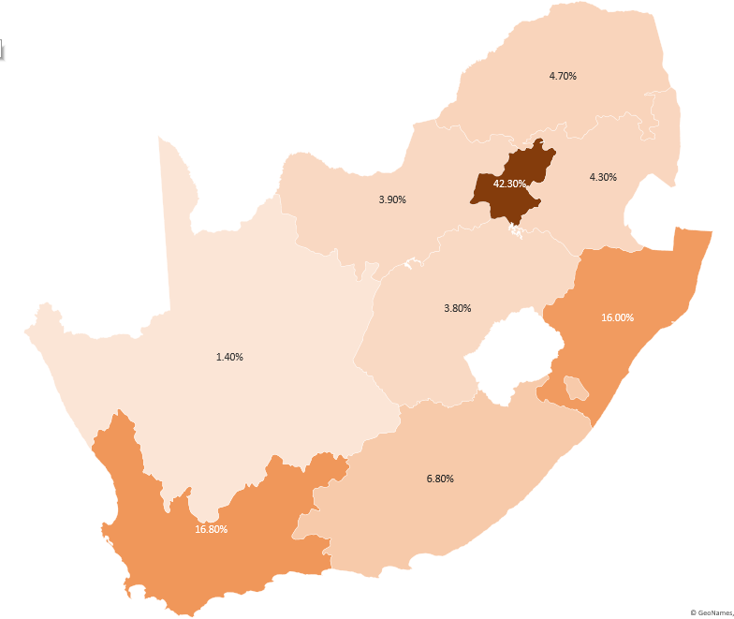
The percentage contribution of each province to South Africa’s creative economy (GVA)
The percentage contribution of each province to cultural occupations in South Africa
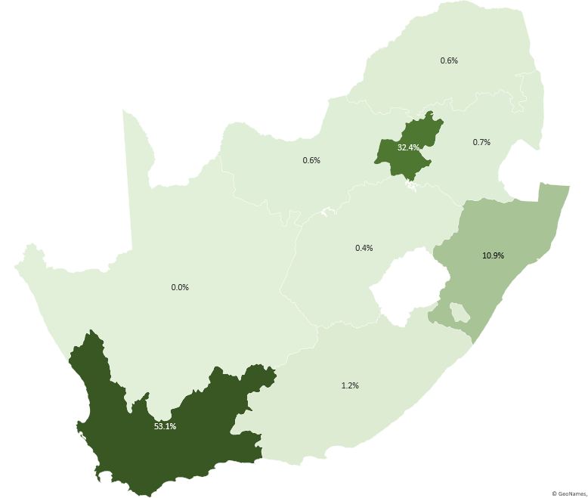
The percentage contribution of each province to South Africa’s cultural goods exports
Figure 65: Graphical comparison of provincial contributions to South Africa’s creative economy
The maps and table give a comparative overview of the percentage contribution of each province to South Africa’s creative economy, measured in terms of GVA (in Rands), the number of cultural occupations, and cultural goods exports (in Rands). To take overall economic context into account, the contribution of each province to South Africa’s overall economy (GVA) is also included.
Table 55: Comparison of provincial contributions to South Africa’s creative economy
Province | GVA  (Total) | GVA (Cultural) | Cultural Occupations | Exports
Gauteng | 34.8% | 46.5% | 32.0% | 32.4%
Western Cape | 14.4% | 12.4% | 14.4% | 53.1%
KwaZulu-Natal | 17.1% | 14.2% | 18.2% | 10.9%
Eastern Cape | 7.7% | 7.5% | 8.7% | 1.2%
Limpopo | 6.4% | 5.2% | 10.0% | 0.6%
Mpumalanga | 7.3% | 4.6% | 6.7% | 0.7%
North West | 5.4% | 4.0% | 4.2% | 0.6%
Free State | 5.0% | 4.2% | 4.3% | 0.4%
Northern Cape | 2.1% | 1.5% | 1.6% | 0.0%
As found in other countries, one region (Gauteng Province) is clearly dominant in terms of creative economy activity in the country. It contributes 46.5% of the GVA of the CCIs, and accounts for 32% of cultural occupations, and 32% of the value of cultural goods exports. However, South Africa does have two other provinces (Western Cape and KwaZulu-Natal) that also have significant shares of CCI economic activity. Two things are evident from this analysis: firstly, that the CCIs in South Africa are most likely to cluster in provinces with the larger metropolitan areas; and secondly, that South Africa has a polycentric system, like the US (Kemeny et al., 2019), with more than one creative economy hub.
Provinces with larger shares of creative economy activity are Gauteng, the Western Cape and KwaZulu-Natal. They are the top three provinces for CCI production (GVA), cultural occupations, and cultural goods exports. They had a growing cultural economy in most domains until 2019 and increased their share of cultural occupations between 2017 and 2019. Workers in cultural occupations in these provinces tend to have higher levels of education and earn higher incomes, and are less likely to be working informally.
Provinces in the next group are the Eastern Cape and Limpopo. They have the fourth and fifth largest provincial creative economies in terms of GVA share and cultural occupation share. They both increased their share of cultural occupations between 2017 and 2019. Some domains showed signs of GVA growth until 2019. However, cultural workers in these provinces tend to have lower levels of education and earnings than those in the first group. Their contributions to cultural goods exports are low.
The third group of provinces are those that have much smaller cultural economies, lower shares of cultural occupations, and lower levels of cultural goods exports: Mpumalanga, North West, Free State, and the Northern Cape. In these provinces, the percentage of CCI contribution to GDP is smaller than their overall contribution to South Africa’s GVA. The share of cultural occupations in Mpumalanga and the North West fell between 2017 and 2019. The cultural occupation workforce in all these provinces has lower levels of education than the national average and they are more likely to be working informally and as freelancers, increasing the precarity jobs in this sector. Their share of cultural goods exports is less than 1%.
All the provinces could improve their cultural economies by focusing on those domains in which there was growth (prior to 2020), and where cultural employment is highest. For provinces with large metropolitan areas, this would involve building on clusters in domains such as Audio-visual and Interactive Media, Books and Press, and Design and Creative Services. For more rural provinces with smaller cities, the cultural economy can still add value, especially in domains such as Visual Arts and Crafts, and Intangible Cultural Heritage. The important point is that regional policy design should start by assessing the current state, and potential growth areas, of the existing CCIs, which is what this chapter aims to help researchers, industry stakeholders and policy makers to do.

References
Bakhshi, H., Davies, J., Freeman, A. and Higgs, P. (2015). The geography of the UK’s creative and high-tech economies. NESTA report. [Online] Available: https://eprints.qut.edu.au/82040/1/geography_uks_creative_high-tech_economieswv20151.pdf
CCI Spillovers Report. (2015). Cultural and Creative Spillovers in Europe. Tom Flemming Creative Consultancy, produced for Arts Council England, Arts Council Ireland, Creative England, European Centre for Creative Economy, European Cultural Foundation and European Creative Business Network. [Online] Available: http://www.kulturradet.se/Documents/Kulturkontakt/EU/2015/Cultural%20and%20creative%20spillovers%20in%20Europe%20-%20full%20report.pdf
Drummond, F. and Snowball, J. (2018). Using GIS mapping to explore regional development and the cultural and creative industries: Rural development in South Africa. Paper presented at the South African Cultural Observatory Conference, 7–8 March, Port Elizabeth.
Department of Trade, Industry and Competition (DTIC). (2019). Re-imagining our Industrial Strategy to Boost Inclusion and Private Investment. Presentation at the Cabinet Lekgotla, 12–14 June. [Online] Available: http://www.thedtic.gov.za/wp-content/uploads/Re-imagining-Industrial-Strategy-FINAL-13-June-2019.pdf
Eikhof, D., and Warhurst, C. (2013). The promised land? Why social inequalities are systemic in the creative industries. Employee Relations, 35(5): 495–508.
Flew, T. (2010). Towards a cultural economic geography of creative industries and urban Development: Introduction to the Special Issue on Creative Industries and Urban Development. The Information Society, 26(2): 85–91.
Flew, T. (2014). Creative industries: a new pathway. InterMedia, 42(1): 11-13.
Flew, T. and Cunningham, S. (2010). Creative industries after the first decade of debate. The Information Society, 26(2): 113–123.
Florida, R.L. (2002). The Rise of the Creative Class: And How It’s Transforming Work, Leisure, Community, and Everyday Life. New York, NY: Basic Books.
Galloway, S. and Dunlop, S. (2007). A critique of definitions of the cultural and creative industries in public policy. International Journal of Cultural Policy, 13(1), 17–31. Available at: http://www.tandfonline.com/doi/abs/10.1080/10286630701201657 (Accessed: 26 September 2016).
Gong, H., & Hassink, R. (2017). Exploring the clustering of creative industries. European Planning Studies, 24(4), 583–600.
Higgs, P. and Cunningham, S. (2008). Creative Industries Mapping: Where have we come from and where are we going? Creative Industries Journal 1 (1):7-30.
Kemeny, T., Nathan, M. and O’Brien, D. (2019). Creative differences? Measuring creative economy employment in the United States and the UK. Regional Studies, 54(3): 377–387.DOI: 10.1080/00343404.2019.1625484
Lazzeretti, L., Boix, R. and Capone, F. (2010). On the concentration of creative industries in specialized creative local production systems in Italy and Spain: Patterns and determinants. [Online]. Available: http://www.uv.es/raboixdo/references/2010/10003.pdf
Lee, D., Hesmondhalgh, D., Oakley, K. and Nisbett, M. 2014. “Regional creative industries policy-making under New Labour” in Cultural Trends. 23,4: 217-231.
Nawa, L. (2012). Municipal Cultural Policy and Development in South Africa: A Study of the City of Tshwane Metropolitan Municipality. Submitted as a PhD Thesis: University of South Africa (UNISA).
Sacco, P., Ferilli, G. and Blessi, G. (2014). Understanding culture-led local development: A critique of alternative theoretical explanations. Urban Studies, 51(13): 2806-2821.
Snowball, J. et al. (2019). The overlaps between the digital and creative sectors: Innovation and technology in the creative economy. South African Cultural Observatory (SACO).
UNESCO. (2009). UNESCO Framework for Cultural Statistics. UNESCO, Montreal. Online [Available] http://uis.unesco.org/sites/default/files/documents/unesco-framework-for-cultural-statistics-2009-en_0.pdf
United Nations et al. (2009). System of national accounts 2008. New York: United Nations.
Van der Linde, J. C., Snowball, J. and Jooste, T. (2020). Mapping the spatial distribution of public funding for arts, culture and heritage in South Africa: Mzansi’s Golden Economy and the Cultural and Creative Industries. African Review of Economics and Finance (Special Edition: The Creative Economy). 12,2:110-132.
- GVA Statistics by Province
Table 56 below gives the year-on-year growth rates of each province’s GVA.
Table 56: Provincial economic growth rates
Growth Rates (GVA) | 2016 | 2017 | 2018 | 2019 | 2020
Gauteng | 1.2% | 1.0% | 1.8% | 0.5% | -7.1%
Western Cape | 1.1% | 1.1% | 1.6% | 0.2% | -5.9%
South Africa | 0.7% | 1.2% | 1.5% | 0.1% | -6.4%
KwaZulu-Natal | 0.8% | 1.6% | 1.5% | 0.0% | -6.6%
Limpopo | 0.0% | 1.4% | 1.1% | -0.1% | -5.4%
Eastern Cape | 0.8% | 0.5% | 1.0% | -0.1% | -5.6%
North West | -2.4% | 1.3% | 1.2% | -0.3% | -6.9%
Free State | 0.0% | 1.1% | 0.8% | -0.4% | -6.3%
Mpumalanga | 0.3% | 1.2% | 1.3% | -0.4% | -6.3%
Northern Cape | -0.5% | 2.0% | 1.3% | -0.5% | -3.9%

The map below (Figure 66) shows the relative size of each province’s total GVA as a percentage of the South Africa’s GVA.
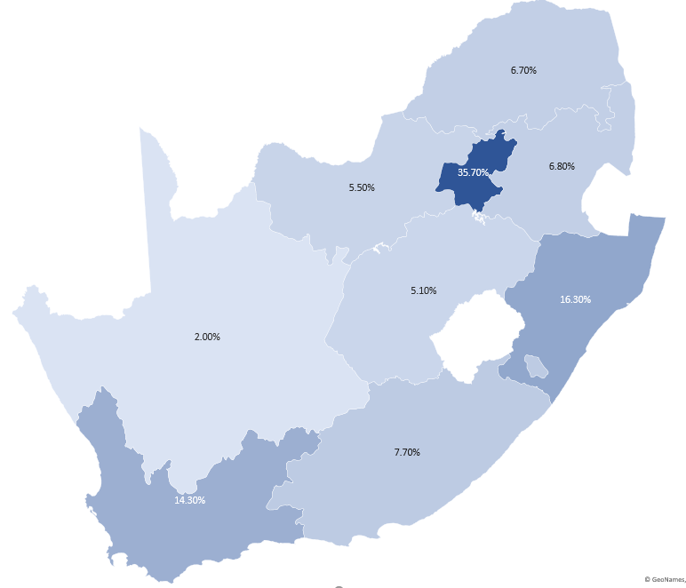
Figure 66: Percentage contribution to GVA per province in 2020

Figure 67: GVA at basic prices per sector per province
- The Tress Index of Economic Diversification
The Tress Index measures the level of economic diversification of a particular area. An index of zero represents a totally diversified economy, while the higher the index is (closer to 100), the more concentrated and vulnerable the economy of a particular area is to exogenous factors such as adverse climatic conditions, commodity fluctuations etc.

Figure 68: Provincial Tress Indices

- Population Statistics by Province
Table 57: South Africa’s population growth rates per province
Populations Growth Rate YoY | 2017 | 2018 | 2019 | 2020
Gauteng | 2.65% | 2.53% | 2.45% | 2.35%
Western Cape | 1.90% | 1.92% | 1.90% | 1.84%
North West | 1.71% | 1.75% | 1.73% | 1.68%
Mpumalanga | 1.54% | 1.62% | 1.62% | 1.53%
Total South Africa | 1.54% | 1.52% | 1.50% | 1.41%
Northern Cape | 1.26% | 1.27% | 1.25% | 1.22%
KwaZulu-Natal | 1.31% | 1.31% | 1.30% | 1.20%
Limpopo | 0.87% | 0.80% | 0.78% | 0.65%
Free State | 0.59% | 0.59% | 0.58% | 0.51%
Eastern Cape | 0.18% | 0.18% | 0.18% | 0.05%

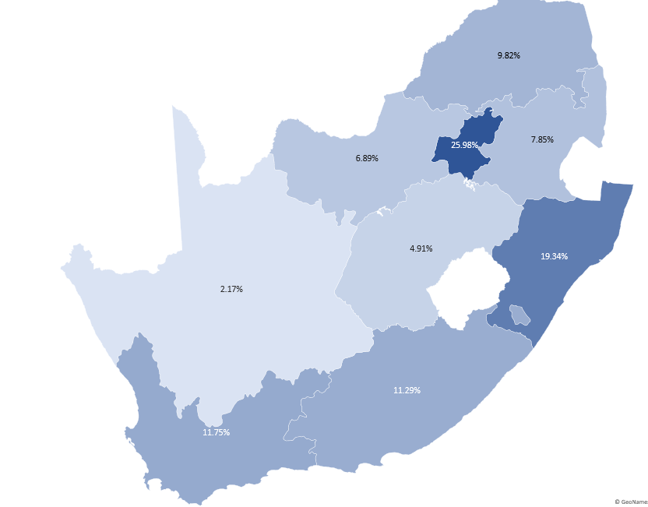
Figure 69: Distribution of South Africa’s population per province

- Gross Value Added per Province by Domain

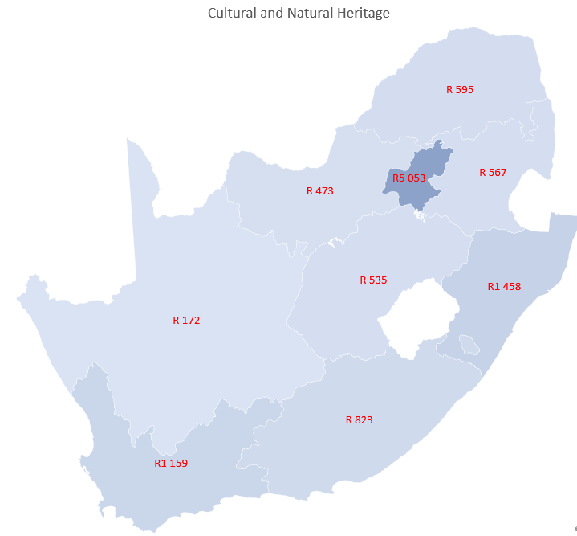 | 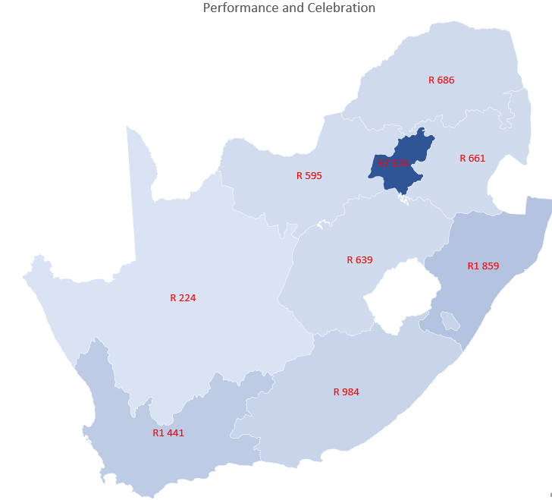
Figure 70: Cultural and Natural Heritage GVA per province | Figure 71: Performance and Celebration GVA per province
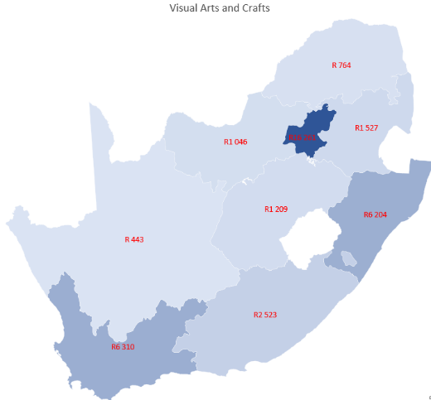 | 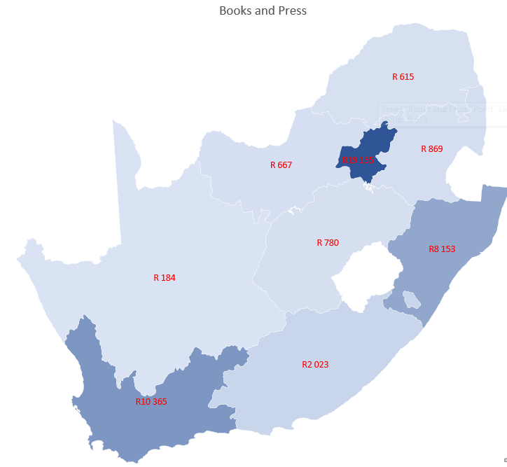
Figure 72: Visual Arts and Crafts GVA per province | Figure 73: Books and Press GVA per province
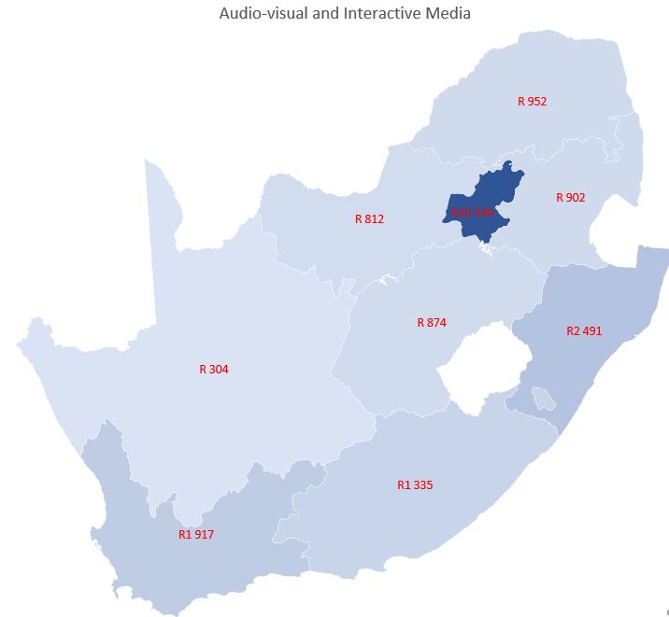 | 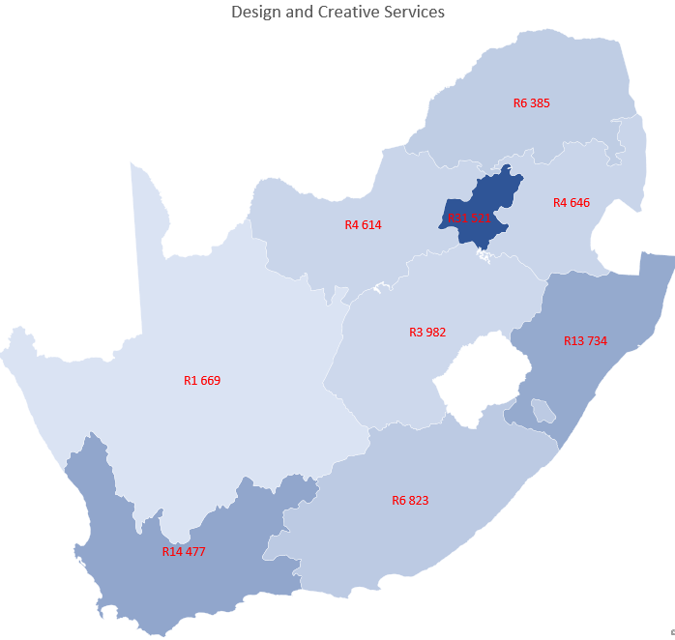
Figure 74: Audio-visual and Interactive Media  GVA per province | Figure 75: Design and Creative Services GVA per province

- Exports per Province by Domain

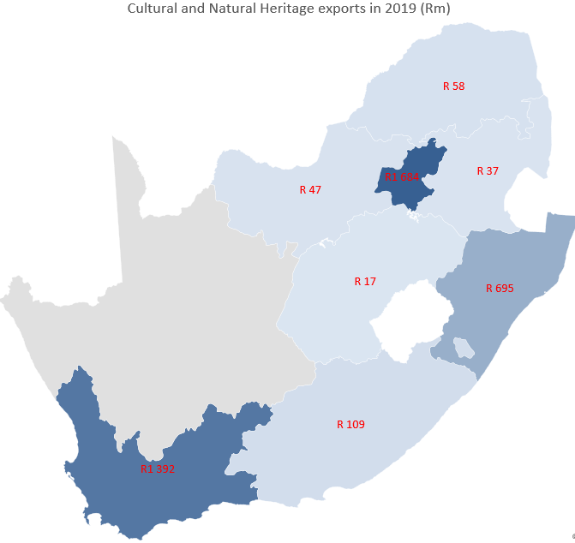 | 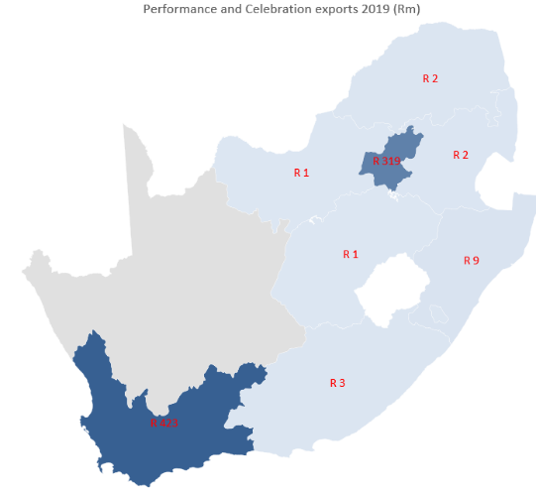
Figure 76: Cultural and Natural Heritage exports per province | Figure 77: Performance and Celebration exports per province
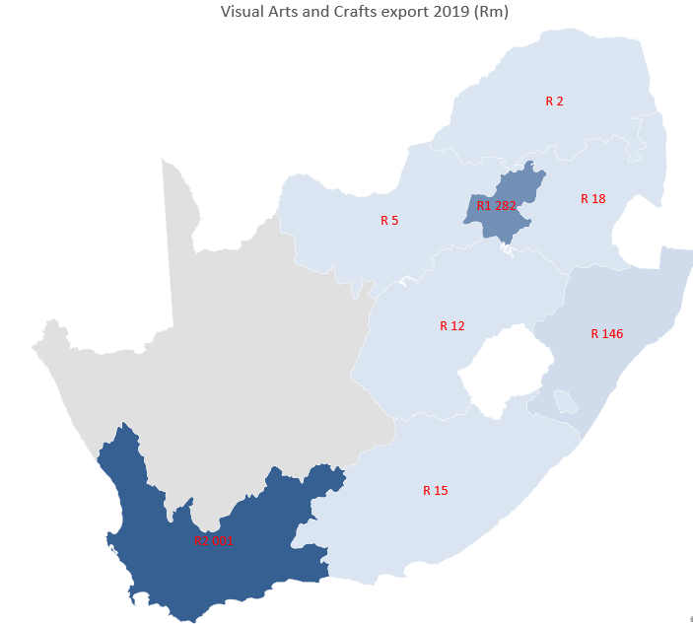 | 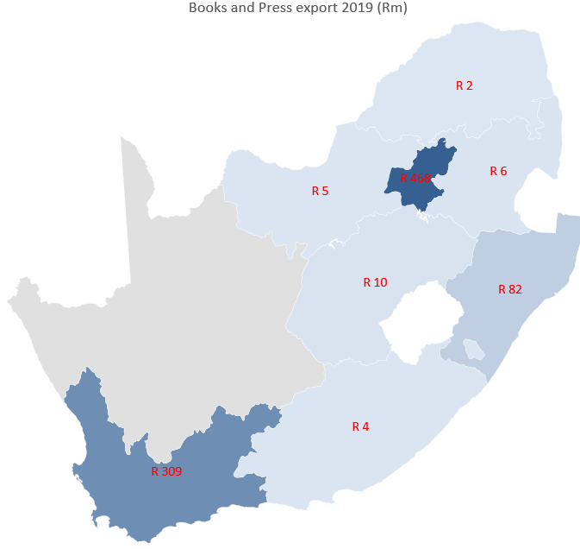
Figure 78: Visual Arts and Crafts exports per province | Figure 79: Books and Press exports per province
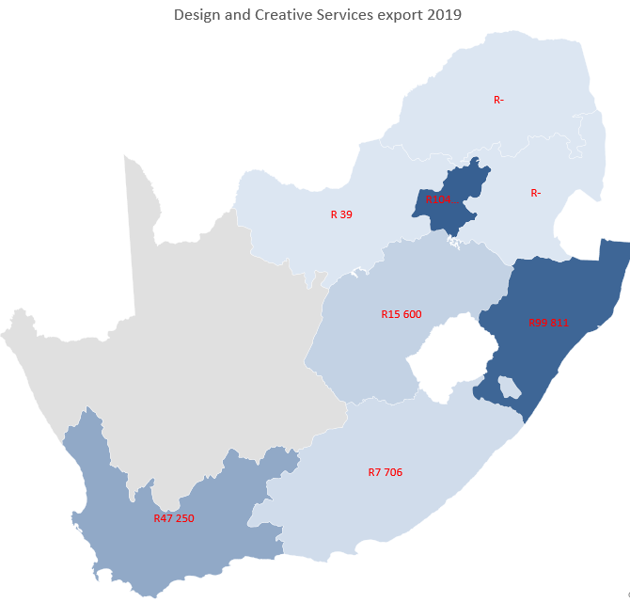
Figure 80: Design and Creative Services exports per province

GVA is the value added to all goods and services produced in a country in a time period (excluding intermediate inputs to avoid double counting). It is essentially the same as GDP, except that it does not include taxes and subsidies.
Authors’ own calculations based on mid-year population estimates sourced from Quantec.
GVA is the value added to all goods and services produced in a country in a time period (excluding intermediate uses to avoid double counting). It is essentially the same as GDP, except that it does not include taxes and subsidies.
The Gross Value Added per Province by Domain can be found in Appendix 4.
The Exports per Province by Domain can be found in Appendix 5.
Authors’ own calculations based on mid-year population estimates sourced from Quantec.
GVA is the value added to all goods and services produced in a country in a time period (excluding intermediate inputs to avoid double counting). It is essentially the same as GDP, except that it does not include taxes and subsidies.
The Gross Value Added per Province by Domain can be found in Appendix 4.
While this analysis is based on national-level data produced by Statistics South Africa, it should be noted that the sample size for cultural occupations in this province is small, and that results for sub-categories may not be very reliable.
The Exports per Province by Domain can be found in Appendix 5.
Authors’ own calculations based on mid-year population estimates sourced from Quantec.
GVA is the value added to all goods and services produced in a country in a time period (excluding intermediate inputs to avoid double counting). It is essentially the same as GDP, except that it does not include taxes and subsidies.
The Gross Value Added per Province by Domain can be found in Appendix 4.
The Exports per Province by Domain can be found in Appendix 5.
The Exports per Province by Domain can be found in Appendix 5.
Authors’ own calculations based on mid-year population estimates sourced from Quantec.
GVA is the value added to all goods and services produced in a country in a time period (excluding intermediate inputs to avoid double counting). It is essentially the same as GDP, except that it does not include taxes and subsidies.
The Gross Value Added per Province by Domain can be found in Appendix 4.
The Exports per Province by Domain can be found in Appendix 5.
Authors’ own calculations based on mid-year population estimates sourced from Quantec.
GVA is the value added to all goods and services produced in a country in a time period (excluding intermediate inputs to avoid double counting). It is essentially the same as GDP, except that it does not include taxes and subsidies.
The Gross Value Added per Province by Domain can be found in Appendix 4.
The Exports per Province by Domain can be found in Appendix 5.
Authors’ own calculations based on mid-year population estimates sourced from Quantec.
GVA is the value added to all goods and services produced in a country in a time period (excluding intermediate inputs to avoid double counting). It is essentially the same as GDP, except that it does not include taxes and subsidies.
The Gross Value Added per Province by Domain can be found in Appendix 4.
While this analysis is based on national-level data produced by Statistics South Africa, it should be noted that the sample size for cultural occupations in this province is small, and that results for sub-categories may not be very reliable.
The Exports per Province by Domain can be found in Appendix 2.
Authors’ own calculations based on mid-year population estimates sourced from Quantec.
GVA is the value added to all goods and services produced in a country in a time period (excluding intermediate inputs to avoid double counting). It is essentially the same as GDP, except that it does not include taxes and subsidies.
While this analysis is based on national-level data produced by Statistics South Africa, it should be noted that the sample size for cultural occupations in this province is small, and that results for sub-categories may not be very reliable.
The Exports per Province by Domain can be found in Appendix 5.
Authors’ own calculations based on mid-year population estimates sourced from Quantec.
GVA is the value added to all goods and services produced in a country in a time period (excluding intermediate inputs to avoid double counting). It is essentially the same as GDP, except that it does not include taxes and subsidies.
The Gross Value Added per Province by Domain can be found in Appendix 4.
While this analysis is based on national-level data produced by Statistics South Africa, it should be noted that the sample size for cultural occupations in this province is small, and that results for sub-categories may not be very reliable.
The Exports per Province by Domain can be found in Appendix 5.
Authors’ own calculations based on mid-year population estimates sourced from Quantec.
GVA is the value added to all goods and services produced in a country in a time period (excluding intermediate inputs to avoid double counting). It is essentially the same as GDP, except that it does not include taxes and subsidies.
The Gross Value Added per Province by Domain can be found in Appendix 4.
The Exports per Province by Domain can be found in Appendix 5.
Numbers do not add up to 100% because of rounding.

