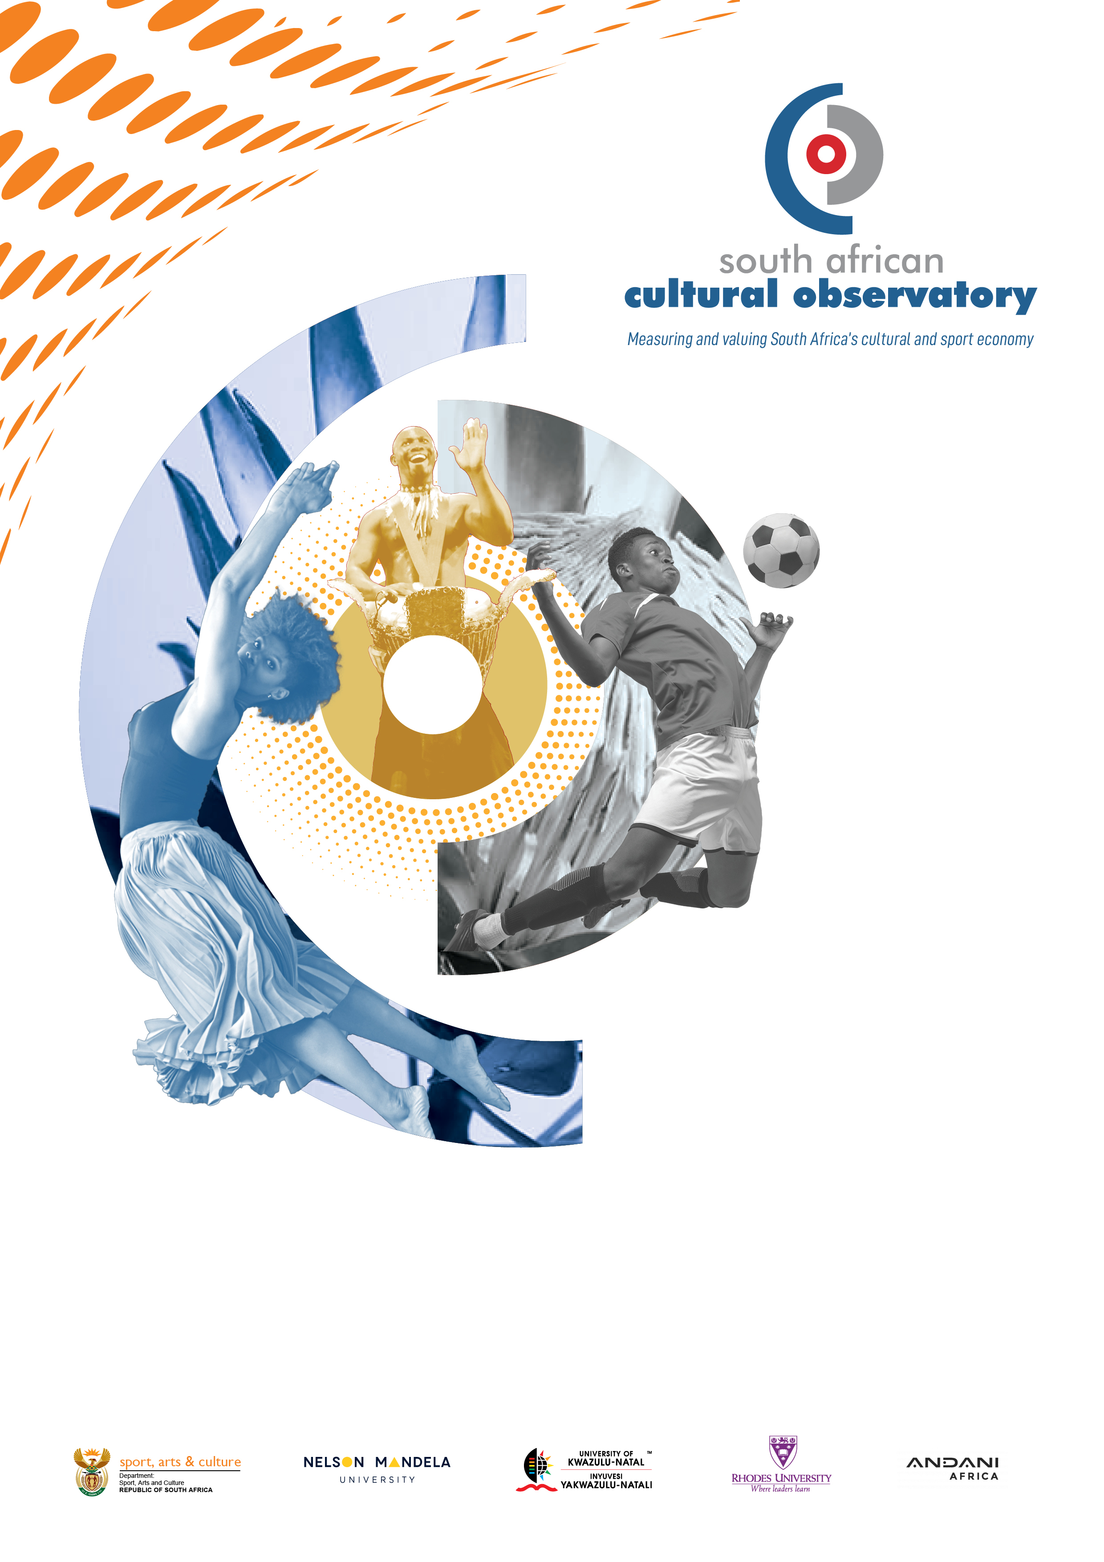
KDI Report
Research Agenda for the Creative and Sports Economy 2023 – 2024 Draft

Submitted to:
Department of Sports, Arts and Culture
Submitted by:
Nelson Mandela University

Contents
Purpose of the Research Agenda 3
Alignment with DSAC Strategic Outcomes 2020 – 2025 3
Alignment with MTSF & DSAC Contributions 3
DSAC FIVE Priorities 4
Research Agenda 4
Theme 1: Establishing a Robust Intellectual and Academic Base 8
Theme 2: Data Management and Access to Data Sources 12
Theme 3: Levels of Government Spending and Support to the Sector 15
Theme 4: Quantifying the Arts, Culture, Heritage, and Creative Sectors 25
Theme 5: Economic Analysis 33
Theme 6: Innovation and Technology 48
Theme 7: Intellectual Property 51
Theme 8: Education and Training 56
Theme 9: Social Cohesion and Nation Building 57
Theme 10: Libraries, Archives, Museums and Heritage 63
Theme 11: Management of Artifacts 67
Theme 12: Policy Development, Planning and Implementation 69
Theme 13: Living Human Treasures 87
Theme 14: International Relations and Cultural Diplomacy 88
Theme 15: Training, Skills Development and Transformation 92
Conclusion 98
Appendix 1 – DSAC Provincial Inputs 98

Purpose of the Research Agenda
The purpose of this Research Agenda is to define and focus research efforts and resources towards achieving outputs that would enhance the development of the Arts, Heritage, Cultural and Sport Sectors in South Africa as well as the policy imperatives of the South African Government and its stakeholders.
The creative and sports economy can be defined as an evolving concept based on creative assets potentially generating economic growth and development:
- It can foster income generation, job creation and expert earnings while promoting social cohesion, cultural diversity and human development.
- It embraces economic, cultural and social aspects interacting with technology, intellectual property and tourism objectives.
- It is a set of knowledge-based economic activities with a development dimension and cross-cutting linkages at macro and micro levels to the overall economy.
- It is a feasible development option calling for innovative, multidisciplinary policy responses and inter-ministerial action
The Research Agenda should be treated as a document that is – dynamic –ongoing work-in-progress, – continuously subjected to review – updating as new data and challenges emerge. This Research Agenda has been developed through several consultations starting in 2015 between with the Department of Sports, Arts and Culture, the South African Cultural Observatory, industry stakeholders and researchers.
The RA therefore aims to:
- define research requirements;
- define individual research agenda items required to address research requirements; and
- determine the alignment of proposed research agenda items with the strategic and policy imperatives of the Department of Sports, Arts and Culture (DSAC).
Research Agenda items may fall within in the scope of the Cultural Observatory, the scope of DSAC, other organs of state, civil society, tertiary and private sector entities.

Alignment with DSAC Strategic Outcomes 2020 – 2025
- The DSAC contributes to national policy agenda in a number of ways. These include general policies, such as the National Development Plan (NDP) and Industrial Policy Action Plan (IPAP), as well as specific outcomes of the Medium-Term Strategic Framework (MTSF).
- In particular, DSAC leads on MTSF Outcome 14, which relates to the development of “a diverse, socially cohesive society with a common national identity”. To this end, Social Cohesion Development Indicators have been developed using data from the Development Indicators Report and SA Social Attitudes Survey.
- More than any other sector, Arts, Culture and Heritage (ACH) play a vital role in the development of social cohesion, giving DSAC a comparative advantage in this sector. The research agenda of the Cultural Observatory needs to take this into account.

Alignment with MTSF & DSAC Contributions
- Outcome 1: Quality basic education (ACH curriculum development)
- Outcome 4: Decent employment through inclusive growth (CCI growth, Mzansi Golden Economy, labour absorbing sectors craft & music)
- Outcome 5: A skilled and capable workforce to support an inclusive growth path (skills development through bursaries and programmes to increase employment in CCI and Culture, Arts, Tourism, Hospitality & Sports Sectoral Education and Training Authority CATHSETA; planned establishment of the National Cultural Industries Skills Academy of South Africa (NaCISA)
- Outcome 7: Vibrant, equitable and sustainable rural communities contributing towards food security for all (establishment of community libraries and Community Arts Centres (CACs) development of CCIs in rural communities)
- Outcome 11: Create a better SA and contribute to a better Africa and world (Cultural diplomacy; cultural agreements, international cooperation & African Continental Cultural Seasons; multilateral engagements with BRICS
“Guide to prioritise research areas, and to produce evidence based and policy relevant research that feeds into these outcomes”

DSAC FIVE Priorities
- An enabling policy, legislative and regulatory environment: Coherent policies that guide directional planning towards the transformation of the ACH Sector, resulting in sustainable livelihoods and social cohesion.
- Inclusive economic development: An ACH Sector that is dynamic and efficient, and fosters inclusive growth.
- Nation building and social cohesion programmes: The implementation of programmes that promote nation building and social cohesion.
- Radical economic transformation: The alignment of policies and programmes with transformative outcomes.
- Effective governance and implementation institutions: The alignment of structures, authorities and systems with goals and objectives towards the implementation of the department’s mandate.

Research Agenda
This section contains the collection of research agenda items, categorised across fifteen (15) broad themes, which as a collective constitutes the Research Agenda for the 2023/24 Financial Year.
From 2015 till the current Financial Year the Research Agenda has documented a substantial increase in the number of research agenda items recorded; from an initial 24 items in 2015 to the current 334. Since the previous Financial Year, the number of topics has increase by 60.
The sustained growth in the number of research agenda items illustrates the notion that the Research Agenda is a dynamic and ongoing work-in-progress, which is continuously subjected to review and updating as new data, inputs and challenges emerge from within the sector.
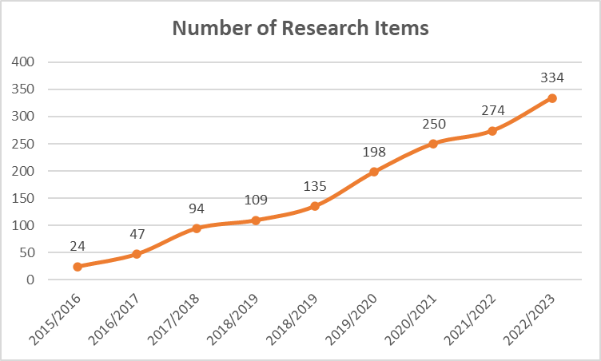
Figure 1: Growth of Research Agenda items

This is illustrated by the annual growth in the number of items that have been recorded in the various versions of the Research Agenda since 2015. In this regard, the year-on-year growth rate in research agenda items increased by 96% and 100% respectively during years two and three of operation. This could be because the development of a Research Agenda was a novel process and that the baseline was very low. As the baseline stabilized, the increase in topics appears to have stabilised after 2017/2018, as demonstrated in the graph below.
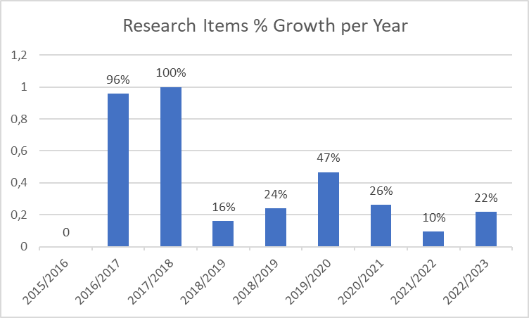
Figure 2: Growth rate of Research Agenda items
Since 2015, the format of the Research Agenda has remained consistent and consist of three (3) components. They are:
- The first component provides a very brief explanation of the research requirement that needs to be addressed.
- The second component states the Research Agenda Item that would have to be researched to address the research requirement.
- The third component aligns Research Agenda Items with the National Development Plan (NDP), the Medium-Term Strategic Framework (MTSF) and the Annual Performance Plan (APP) of the Department of Sports, Arts and Culture.
The breakdown of the Research Agenda in terms of themes, research items, DSAC APP outcomes and outputs. as well as alignment with the MTSF and the NDP is summarised in the diagrams below.
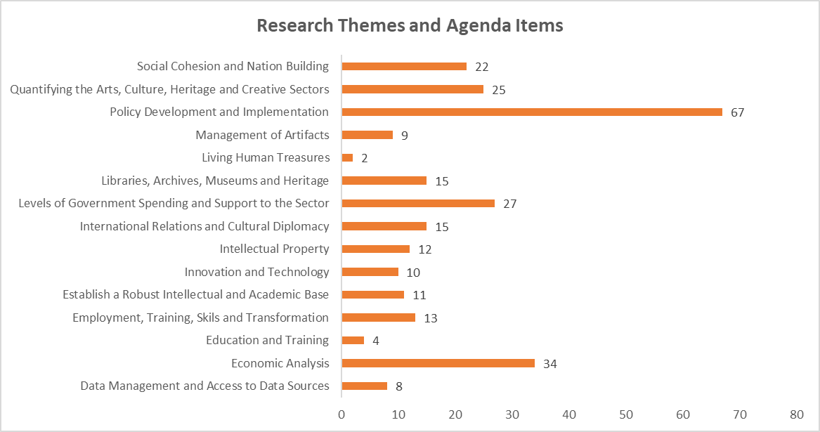
Figure 3

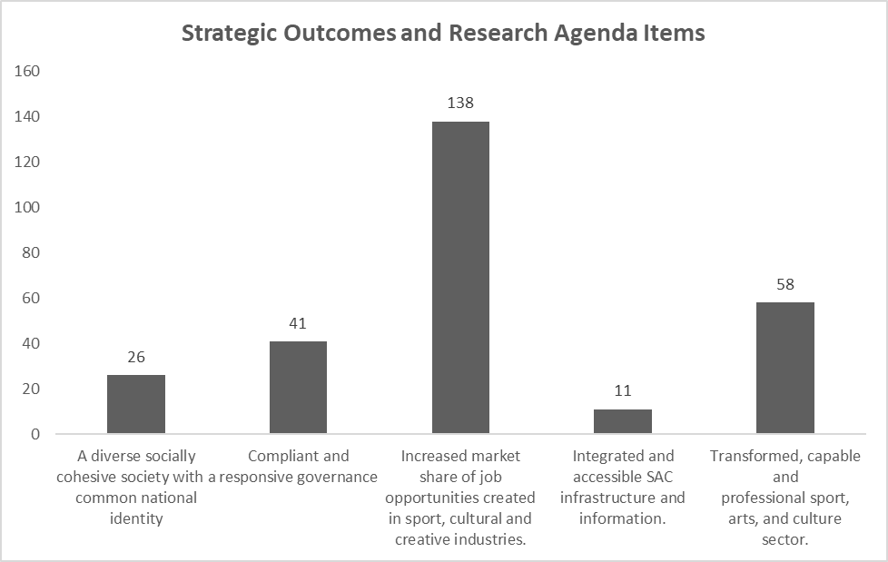
Figure 4
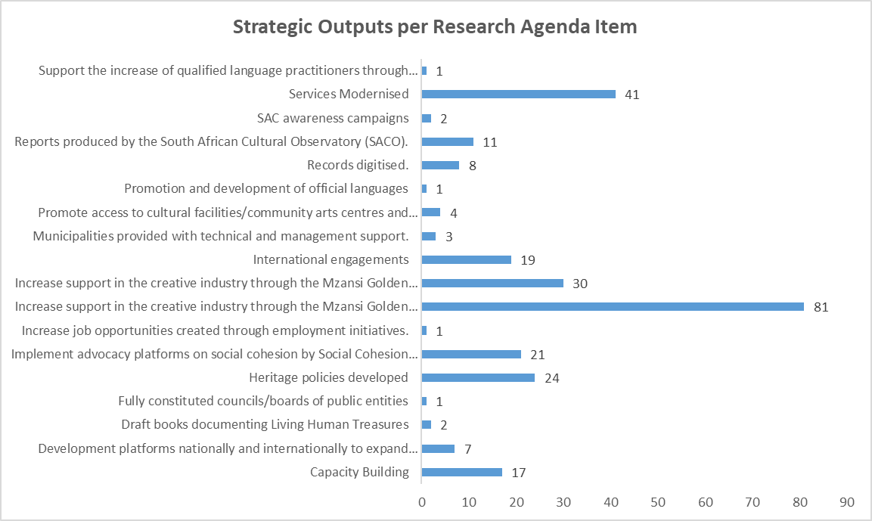
Figure 5

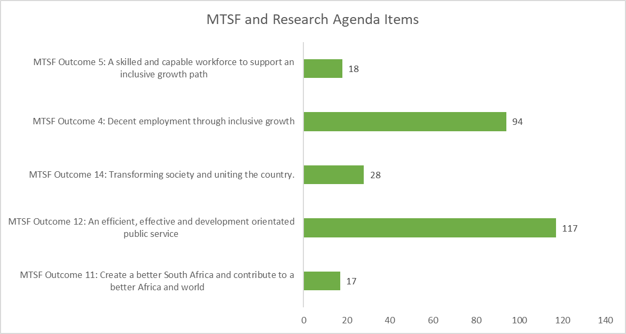
Figure 6
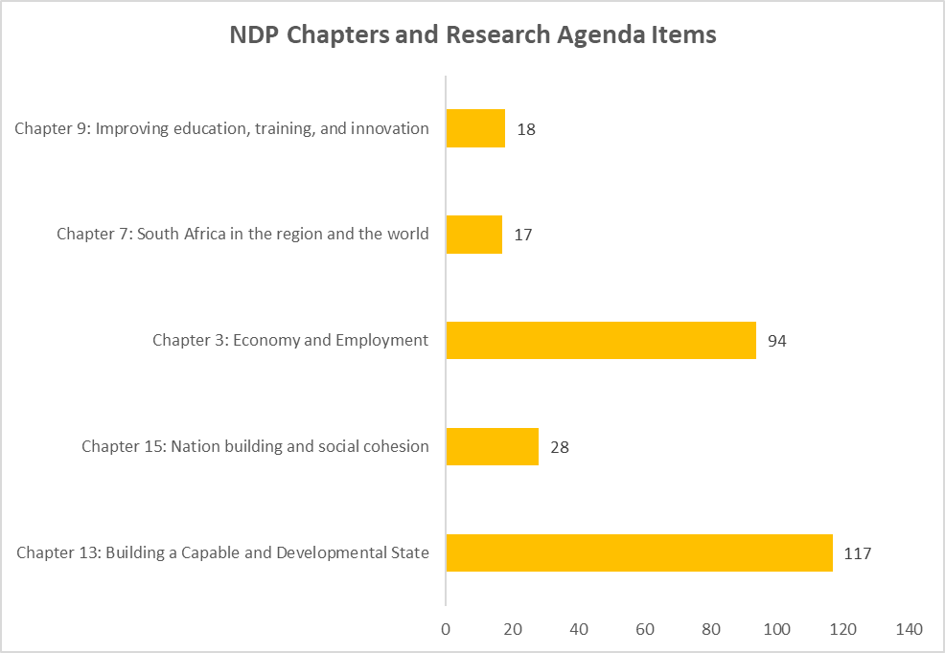
Figure 7

Theme 1: Establishing a Robust Intellectual and Academic Base - Establishing a robust intellectual and academic base is an essential research requirement for the development of evidence-based responses to inform technical design, implementation, and the monitoring of interventions within the Arts, Heritage, Cultural and Creative Sectors. The research requirement is therefore to develop a sound intellectual and academic base with the ability to generate new knowledge, advance reflection, support debate, the exchange ideas, and articulation of responses to existing and emerging intellectual, academic discourses and/or technical challenges within the sector.
All of this will require the following:
- Alignment with DSAC Strategic Outcomes 2020 – 2025
- Transformed, capable and professional sport, arts, and culture sector.
- Alignment with DSAC Outputs
- Reports produced by the South African Cultural Observatory (SACO).
- Alignment with National Development Plan 2030
- Chapter 13: Building a Capable and Developmental State
- Alignment with Medium- Term Strategic Framework 2019 – 24
- MTSF Outcome 12: An efficient, effective and development orientated public service
No | Focus/Outcome | Type of Output | Timeframes/Targets | International comparison (if any) | Risks/Assumptions | Baseline (if any) | Source of information | Contact person (if applicable to DSAC) | Progress
1. | Analysing international meta- theoretical debates about culture and creative industries.
2. | Comparative International Analysis of Cultural Observatories.
3. | Synthesize new approaches and trends within the cultural and creative space. | Cultural and Creative Industry Trends – FINAL | Three months | Adoption of the UNESCO Framework. |  | SACO previous Research agenda documents. | DSAC provincial offices and creative and sports economy stakeholders | Dr Mnguni | Completed
4. | Analyse changing narratives pertaining to culture and creative industries. | Rethinking Culture – FINAL  Realising the Economy of the Imagination and Creative and Cultural Industries: Options for South Africa | Three months | Adoption of the UNESCO Framework. |  | SACO previous Research agenda documents. | DSAC provincial offices and creative and sports economy stakeholders | Dr Mnguni | Completed
5. | Document the available Body of Knowledge pertaining to Arts, Heritage, Cultural and Creative Sectors.
6. | Analyse the degree of alignment between the “humanities” and “science” within the Arts, Heritage, Cultural and Creative Sectors.
7. | Analyse and determine the roles of the sacred and the public within the Arts, Heritage, Cultural and Creative Sectors.
8. | Develop a quantitative framework for prioritising items contained in the Research Agenda. | Publication Report: Cultural and the National Interest - Discussion Document | Six months | Adoption of the UNESCO Framework. |  | SACO previous Research publications and industry knowledge. | DSAC provincial offices and creative and sports economy stakeholders. Desktop research and document analysis. | Dr Mnguni | Completed
9. | Develop a framework for increased research collaboration in accordance with the Research Agenda. | Research agenda 2022/23  The Research Agenda for 2021/22 contains 274 research items across 15 themes  The Research Agenda for 2020/21 contains 250 research items across 15 themes  The Research Agenda for 2019/20 contains 198 research items across15 themes  The Research Agenda for 2018/19 contains 135 research items across 15 themes  The Research Agenda for 2017/18 contains 94 research items across 15 themes  The Research Agenda for 2016/17 contains 47 research items across 15 themes  The Research Agenda for 2015/16 contains 24 research items across 15 themes | Six months (comprising of two drafts and a final draft) | Adoption of the UNESCO Framework. |  | SACO previous Research agenda documents. | DSAC provincial offices and creative and sports economy stakeholders | Dr Mnguni | Completed
10. | Unpack the ideological basis of the arts in the creation of a South African identity.
11. | Quantifying the current state of research within the Arts, Heritage, Cultural and Creative Sectors.

Theme 2: Data Management and Access to Data Sources - Data resources are currently scattered across several sectors and locations, each containing individual data sets in different degrees of completeness and applicability to the research needs of the sector.
The result is a situation where the body of knowledge of the Arts, Heritage, Cultural and Creative Sectors is highly fragmented, difficult to access, incomplete and sometimes duplicated. The research requirement is therefore for the development of an integrated data eco-system where various datasets can be consolidated, verified, and accessed.
All of this will require the following:
- Alignment with DSAC Strategic Outcomes 2020 -2025
- Integrated and accessible SAC infrastructure and information.
- Increased market share of job opportunities created in sport, cultural and creative industries.
- Compliant and responsive governance
- Alignment with DSAC Outputs
- Records digitised.
- Increase job opportunities created through employment initiatives.
- Development platforms nationally and internationally to expand market access
- Alignment with National Development Plan 2030
- Chapter 3: Economy and Employment
- Chapter 13: Building a Capable and Developmental State
- Alignment with Medium- Term Strategic Framework 2019 -2024
- MTSF Outcome 4: Decent employment through inclusive growth
- MTSF Outcome 12: An efficient, effective and development orientated public service
No | Focus/Outcome | Type of Output | Timeframes/Targets | International comparison (if any) | Risks/Assumptions | Baseline (if any) | Source of information | Contact person (if applicable to DSAC) | Progress
1. | Develop an Interactive Arts, Heritage, Cultural and Creative Sectors Consolidated Database Platform. | Framework for Developing Interactive Information Platforms to Provide User-Friendly Economic Data to the Cultural and Creative Industries
2. | Develop a consolidated database of funding sources. | Commissioned Paper: How Much Funding is Available for the Cultural Sector in South Africa? | Three months | No. Only focusing on funding in South Africa | Yes. | Mzansi golden economy and funding indaba reports. | Desktop research and document analysis. | Dr Mnguni | Completed in 2018
3. | Develop an integrated database pertaining to sources of funding and technical support available to the Arts, Heritage, Cultural and Creative Sectors.
4. | Research and determine best- practices and standards for database management in the Arts, Heritage, Cultural and Creative Sectors.
5. | Develop a working paper on the use of open-source data.
6. | Create a database pertaining to failed and successful funding applications to make available data that would improve the quality of funding applications. | Criteria for “Measuring” Success in Relation to Entrepreneurship in The CCIS Which takes into Account the Different Types of Genres and Sub-sectors | Three months | Adoption of the UNESCO Framework. |  | SACO previous Research publication and existing industry knowledge. | Desktop research and document analysis. | Dr Mnguni | Completed
7. | Establish a database for collection, storage, and distribution of case studies.
8. | Develop an interactive platform for artists in rural areas that would enable artist to engage and share information with each other.
9. | Create digital platforms to advance value creation in the cultural and creative industries to benefit from the rise of the FAANGs
10. | Develop and define a methodology to develop sub-national satellite accounts for Provinces, Districts and Metros. | Methodology to develop sub-national Cultural and Creative Industries’ Satellite Accounts for Provinces, Districts and Metros | Three months | Adoption of the UNSECO Framework |  |  | Desktop research and document analysis. | Dr Mnguni | Completed

Theme 3: Levels of Government Spending and Support to the Sector - There appears to be limited data available regarding the span and scope of government and private sector spending and support within the Arts, Heritage, Cultural and Creative Sectors.
Furthermore, Arts, Heritage, Cultural and Creative Sector products are not always accurately and consistently classified in existing product indexes which makes it difficult to accurately determine spending and contribution levels within the sector. The research requirement is therefore to develop accurate data that would quantify levels of government spending and support within the sector.
All of this will require the following:
- Alignment with DSAC Strategic Outcomes 2020 – 2025
- Compliant and responsive governance
- Transformed, capable and professional sport, arts, and culture sector
- Increased market share of job opportunities created in sport, cultural and creative industries.
- Alignment with DSAC Outputs
- Development platforms nationally and internationally to expand market access
- Increase job opportunities created through employment initiatives
- Increase support in the creative industry through the Mzansi Golden Economy programme
- Services modernised
- Support the increase of qualified language practitioners through language bursaries
- Alignment with National Development Plan 2030
- Chapter 3: Economy and Employment
- Chapter 9: Improving education, training, and innovation
- Chapter 13: Building a Capable and Developmental State.
- Alignment with Medium- Term Strategic Framework 2019 -2024
- MTSF Outcome 4: Decent employment through inclusive growth
- MTSF Outcome 5: A skilled and capable workforce to support an inclusive growth path
- MTSF Outcome 12: An efficient, effective and development orientated public service
No | Focus/Outcome | Type of Output | Timeframes/Targets | International comparison (if any) | Risks/Assumptions | Baseline (if any) | Source of information | Contact person (if applicable to DSAC) | Progress
1. | Develop a Status Report on Levels of Government spending in the Arts, Heritage, Cultural and Creative Sectors employing a Cultural and Creative Industries Product Index. | SACO - Research Report - CCI Index for South Africa | twelve months | Adoption of the UNESCO Framework. |  | SACO previous Research publication and existing industry knowledge. | Desktop research and document analysis. | Dr Mnguni | Completed
2. | Determine the potential impact of access to government infrastructure in advancing the development of the South African Arts, Heritage, Cultural and Creative Sectors.
3. | Determine the optimal organisational configuration of Department of Sports, Arts and Culture (DSAC) entities to ensure the effective and efficient implementation of strategic and policy imperatives.
4. | Develop a decentralised funding model customised to the implementation realities of rural areas. | Mapping the spatial distribution of government funding FINAL | Six months | Adoption of the UNESCO Framework. |  | SACO previous Research publication and existing industry knowledge. | Desktop research and document analysis. | Dr Mnguni | Completed
5. | Develop a standardised funding model for provincial and local government spheres.
6. | Determine the degree of policy integration across all spheres of government and the requirements to increase the efficiency and effectiveness of resourcing the sector.
7. | Determine the feasibility of transforming community art centres into centres of excellence. | Determining the feasibility of establishing  South African Cultural Centres as a means of advancing South African Cultural Diplomacy | Three months | Adoption of the UNESCO Framework |  |  | Desktop research and documents from DSAC. | Dr Mnguni | Completed
8. | Reviewing the funding landscape to determine the role and impact of “middlemen” on effective and efficient service delivery.
9. | Determining the feasibility and technical requirements for establishing a Venture Capital Fund within the Arts, Heritage, Cultural and Creative Sectors. | The Role of Venture Capital in Promoting the Cultural and Creative Industry (CCI) | Three months | Adoption of the UNESCO Framework |  |  | Desktop research, interviews with various stakeholders and DSAC documents on venture capital. | Dr Mnguni | Completed
10. | Identify and quantify the financial and non-financial resources available to the craft industry.
11. | Quantifying the impact of the indigenous language bursary programme. | Impact of the  Heritage Skills & DSAC Bursary | Three months | No. Only looked at the students that were funded by DSAC. | Yes. The report only mapped the students that received funding at the Nelson Mandela University and the data was outdated as pre 2011 students couldn’t be mapped. |  | Interviews with bursary holders, Nelson Mandela University heritage bursary database and DSAC documentation of the bursary holders. | Dr Mnguni | Completed
12. | Quantify the distinction between professional and amateur sport financial investment streams, and sponsorships versus investment in in the Arts, Heritage, Cultural and Creative Sectors.
13. | Quantify the state of sponsorship in the Sport Industry
14. | Conduct a review of existing and/or “mothballed” initiatives and determine whether they can be customised to meet the operating demands emanating from the Covid-19 pandemic.
15. | Explore local social and cultural networks to establish and/or inform crowd-sourcing platforms and initiatives. | The potential of “Creative Cities” for Regional Development in Non-Metropolitan Areas: The case of the Makhanda Creative City Project | Three months | Adoption of the UNESCO Framework. |  | SACO previous Research publication and existing industry knowledge. | Desktop research and document analysis. | Dr Mnguni | Completed
16. | Identify the required legal instruments and support system requirements to allow for the use of earned royalties as a bridging finance mechanism.
17. | Identify local and international tertiary institutions that provide free-online training and develop an integrated training provision portal for the sector.
18. | Develop a prioritisation matrix to prioritise projects being implemented by DSAC within the Sport, Arts, Cultural and Creative Industries Portfolio.
19. | Identify possible revenue streams emanating from the “Covid-19 emergency response” that could be used to mitigate the loss of income in the sector.
20. | Identify opportunities such as the large-scale purchase of art works by government as a means of creating a revenue within the sector whilst simultaneously serving to showcase the sector globally and locally.
21. | Develop multi-dimensional and integrated responses which should include tax authorities and international investment attraction agencies to attract international productions to South Africa to benefit the sector.
22. | Develop new business models supporting collaborative digital platforms.
23. | Feasibility of crowdfunding instruments in supporting the sector and reducing pressure on the fiscus. | Commissioned Paper: How Much Funding is Available for the Cultural Sector in South Africa? | Three months. | Adoption of the UNESCO Framework | No. Only focusing on funding in South Africa | DSAC White Paper | Desktop, Mzansi golden economy and DSAC documents | Dr Mnguni | Completed
24. | Developing new platforms should also consider empirical testing and the development of systems, formats, and processes to scientifically confirm the safety of live venues and events.
25. | Quantify the feasibility and possible impact of developing mobile cinemas as means of bringing cinema to rural communities whilst mitigating the impact of the Covid-19 pandemic.
26. | Review of value-chains to identify areas where waivers or similar interventions could be applied without negatively impacting the sector and the fiscus in a significant manner.
27. | Conduct a review of DSAC and related departmental emergency responses and industry development plans to determine the utility of relevant initiatives contained in the Country Brief to accelerate efficiency and effectiveness in line with stated policy and operational imperatives.
28. | Determine the feasibility of leveraging funding for CCIs through crowdfunding, angel funding, and venture capital mechanisms.
29. | Quantify the impact of the “debut fund” on the sector.
30. | Measuring and quantify the sustainability of repeatedly funded projects and programmes by the DSAC. | Preliminary KDI Report - Measuring/ assessing the sustainability of repeatedly funded projects/ programs | Three months | Adoption of the UNESCO Framework |  |  | Desktop Research | Dr Mnguni | Completed
31. | Quantify the current role and define a possible future role for private sector finance within the creative economy with special reference to aspects pertaining to Return on Investment, Value Propositions offered by creatives, and Risk Mitigation. | Private Sector Support for the CCI in South Africa | Three months | Adoption of the UNESCO Framework. |  | SACO previous Research publication and existing industry knowledge. | Desktop research and document analysis. | Dr Mnguni | Completed
32. | Quantity and provide a portfolio perspective of government financial support to SMME in the CCI’s.

Theme 4: Quantifying the Arts, Culture, Heritage, and Creative Sectors - Currently limited data exists regarding the size, profile, location and contribution levels of the Arts, Heritage, Cultural and Creative Sectors towards achieving sustainable economic development and related economic policy imperatives. As a result, the research requirement is to quantity the state of the sectors to guide planning, development of policy responses and to identify future opportunities that would enhance the growth of the sector.
All of this will require the following:
- Alignment with DSAC Strategic Outcomes 2020 – 2025
- Compliant and responsive governance
- Increased market share of job opportunities created in sport, cultural and creative industries.
- Transformed, capable and professional sport, arts, and culture sector.
- Alignment with DSAC Outputs
- Heritage policies developed
- Increase job opportunities created through employment initiatives.
- Increase support in the creative industry through the Mzansi Golden Economy programme
- Services modernised
- Alignment with National Development Plan 2030
- Chapter 3: Economy and Employment
- Chapter 13: Building a Capable and Developmental State
- Alignment with Medium- Term Strategic Framework 2019 -2024
- MTSF Outcome 4: Decent employment through inclusive growth.
- MTSF Outcome 12: An efficient, effective and development orientated public service
- MTSF Outcome 14: Transforming society and uniting the country.
No | Focus/Outcome | Type of Output | Timeframes/Targets | International comparison | Risks/Assumptions | Baseline (If any) | Source of information | Contact person (if applicable to DSAC) | Progress
1. | Determine the size, profile, location and contribution levels of creative industries and audiences to the Arts, Heritage, Cultural and Creative Sectors. | The Economic Mapping of the  Cultural and Creative Industries  in South Africa 2022;  Statistical Framework | Two years | Adoption of the UNESCO Framework |  | Previous SACO mapping studies (2016 and 2018). | StatsSA, Labour Force Survey, DSAC, DSAC White paper and UNESCO | Dr Mnguni | Completed
2. | Investigate the size, shape, and significance of the Live Events Technical and Production Services Industry (LETPSI) in relation to the rest of the cultural and creative and the broader South African economy. | Mapping live event technical and production services in South Africa | Three months | Adoption of the UNESCO Framework |  | No. | Desktop research | Dr Mnguni | Completed
3. | Benchmark the Live Events Technical and Production Services Industry (LETPSI) against international trends and practices, in order to identify competitive and comparative advantages as well as opportunities which could be included in an international and continental strategy for advancing the sector.
4. | Develop a National Cultural and Creative Industries Index (NCCI) which can be used to assess the performance on the sector on an annual basis. | SACO - Research Report - CCI Index for South Africa | 12 months | Adoption of the UNESCO Framework. |  | SACO previous Research publication and existing industry knowledge. | Desktop research and document analysis. | Dr Mnguni | Completed
5. | Determine how city cultures and regional cultures articulate within the Arts, Heritage, Cultural and Creative Sectors. | Creative cities in metropolitan areas: Implications for the South African CCI's | Three months | Adoption of the UNESCO Framework |  | No. | Desktop research | Dr Mnguni | Completed
6. | Develop a working paper on the understanding of regions and local economies within the Arts, Heritage, Cultural and Creative Sectors.
7. | The relevance of the UNESCO Framework for Cultural Statistics: A guide for South African practitioners. | Towards the Development of a Framework for Cultural Statistics for South Africa | 12 months | Adoption of the UNESCO Framework. |  | SACO previous Research publication and existing industry knowledge. | Desktop research and document analysis. | Dr Mnguni | Completed
8. | Policy Paper on the potential of expanding the UNESCO Framework to include the tour guiding sector as a component of the heritage and natural science dimension.
9. | Quantify the viability of book vouchers instead of issuing cash to students on the NSFAS. | Toward a South African Book Development Policy | Three months | Adoption of the UNESCO Framework. |  | SACO previous Research publication and existing industry knowledge. | Desktop research and document analysis. | Dr Mnguni | Completed
10. | Quantify the availability of South African authored books to early school grades as the part of the youth market segment.
11. | Quantify the state of academic publishing in South Africa.
12. | Quantify the level of Afrocentrism in the South African book industry.
13. | Quantify the current state and future potential of Street Theatre within the context of the Covid-19 pandemic.
14. | Quantify how film and television incentives and other forms of support have contributed to the transformation of the Audio-Visual and Interactive Media domain.
15. | Determine the over-all satisfaction levels of stakeholders with the performance of DSAC.
16. | Develop an interactive ratio calculator of CCI location versus infrastructure which interacts with real-time data (market for monetarisation).
17. | Develop a calculator to quantify the impact of interventions | M & E KDI REPORT: FESTIVALS AND EVENTS;  M & E KDI REPORT: PUBLIC ART;  M & E KDI REPORT: MISCELLANEOUS ARTS PROJECTS AND COMMUNITY ARTS CENTRES;  M & E KDI REPORT: SUMMATIVE REPORT;  M & E KDI REPORT: FLAGSHIP EVENTS;  M & E KDI REPORT: TOURING VENTURES | Three months | Adoption of the UNESCO Framework. |  | No. | Desktop research and document analysis. | Dr Mnguni | Completed
18. | What are the levels of cultural participation in SA, and how are they changing? An analysis of the “All Media Products Survey”, 1995–2013.
19. | Quantify the state of Cultural Tourism in South Africa
20. | Animation Ecosystem Mapping and Value Chain Analysis | South Africa’s Animation Industry: Ecosystem Analysis | Three months | Adoption of the UNESCO Framework | Not being able to interview all animation stakeholders in SA. | No. | Desktop research and interviews. | Dr Mnguni | Completed.
21. | Quantify the state of the South African animation Industry
22. | Outline the current animation incentive system compared to international best practices and identify possible economic benefits for the sector and economy.
23. | Quantifying the scale of mass media coverage of the Cultural and Creative Industries (CCIs).
24. | Quantifying sport and CCI related post-schooling training programmes to assess strengths and gaps in the current training portfolio. | An audit of Cultural and Creative Industries (CCIs) post-schooling/tertiary training programmes in South Africa | Three months. | Adoption of the UNESCO Framework |  | No. | Desktop research and document analysis. | Dr Mnguni | Completed.
25. | Determining the state of Cultural Tourism in South Africa. | Determining the state of cultural tourism in South Africa | Three months | Adoption of the UNESCO Framework |  | No. | Desktop research | Dr Mnguni | Completed
26. | Develop a concordance to map CCIs according to UNESCO, UNCTAD, WIPO classifications to guide and inform for future mapping studies.
27. | Develop a Sport Satellite Account to quantify the size and scope of the South African Sports Economy. | Framework for Measuring the Sports and Recreation Economy: Moving Towards and Scoping a Satellite Account | Three months. | Adoption of the UNESCO Framework |  | No. | Desktop research and document analysis | Dr Mnguni | Completed
28. | Develop a CCI Index to benchmark and measure the state of CCIs in South Africa. | SACO - Research Report - CCI Index for South Africa
29. | Quantify the value and perceptions associated with the hosting of cultural month and heritage month interventions.
30. | Quantify and assess the performance of the visual arts sector in South Africa.
31. | Quantify the impact of Creative industries in terms of environmental sustainability.

Theme 5: Economic Analysis - A major research requirement is to enhance the ability to quantify and track the economic contribution of Arts, Heritage, Cultural and Creative Sectors to the South African Economy in accordance with relevant statistical frameworks and policy imperatives as articulated for example within the Mzansi Golden Economy intervention.
All of this will require the following:
- Alignment with DSAC Strategic Outcomes 2020 – 2025
- Compliant and responsive governance
- Increased market share of job opportunities created in sport, cultural and creative industries.
- Transformed, capable and professional sport, arts, and culture sector.
- Alignment with DSAC Outputs
- Development platforms nationally and internationally to expand market access
- Increase job opportunities created through employment initiatives.
- Increase support in the creative industry through the Mzansi Golden Economy programme
- Services modernised
- Alignment with National Development Plan 2030
- Chapter 3: Economy and Employment
- Chapter 13: Building a Capable and Developmental State
- Alignment with Medium- Term Strategic Framework 2019 – 2024
- MTSF Outcome 4: Decent employment through inclusive growth
- MTSF Outcome 11: Create a better South Africa and contribute to a better Africa and world
- MTSF Outcome 12: An efficient, effective and development orientated public service
No | Focus/Outcome | Type of Output | Timeframes/Targets | International comparison | Risks/Assumptions (if any) | Baseline (if any) | Source of information | Contact person (if applicable at DSAC) | Progress
1. | Develop a value-chain analysis of the Arts, Heritage, Cultural and Creative Sectors to assist in policy development aimed at informing the development of a clustering model that would increase the competitiveness of the sector.
2. | Determine the Contribution of the Arts, Heritage, Cultural and Creative Sectors to the South African Economy. | The Economic Mapping of the  Cultural and Creative Industries  in South Africa 2022 | Two years. | Adoption of the UNESCO Framework |  | Previous SACO mapping studies (2016 and 2018). | StatsSA, Labour Force Survey, DSAC, DSAC White paper and UNESCO | Dr Mnguni | Completed
3. | Develop an economic input- output model (or GCE model) pertaining to the Arts, Heritage, Cultural and Creative Sectors. | Publication Report - An input output model for the cultural and creative industries in South Africa and possible extensions
4. | Develop a detailed value-chain analysis of the design sector in South Africa. | Interactive Africa Design Indaba Emerging Creatives Development Programme
5. | Develop a Status Report of the Design Sector in South Africa and benchmark it against international standards and practices. | Interactive Africa Design Indaba Emerging Creatives Development Programme
6. | Develop a proposed clustering model for the Arts, Heritage, Cultural and Creative Sectors. | Mapping Study - Provincial Location and Clusters of CCIs - Report
7. | Determine the regional, continental, and global impact of the South African Arts, Heritage, Cultural and Creative Sectors. | The Economic Mapping of the  Cultural and Creative Industries  in South Africa 2022;  South African Festivals Economic Impact Calculator Guide; Macroeconomic impact assessment and analysis of Sas CCI and creative economy | Two years. | Adoption of the UNESCO Framework |  | Previous SACO mapping studies (2016 and 2018). | StatsSA, Labour Force Survey, DSAC, DSAC White paper and UNESCO | Dr Mnguni | Completed
8. | Develop a detailed longitudinal mapping study of the South African Arts, Heritage, Cultural and Creative Sectors. | The South African Creative Economy in Historical Context 2022;  Summary Report - CCI Mapping - A Baseline (1);  FULL MAPPING STUDY REPORT - Mapping of SA CCI and Creative Economy - A Baseline (1);  Mapping Study - Provincial Location and Clusters of CCIs – Report  Mapping Study 2018: Research Report 1 (of 5): Employment in the Cultural and Creative Industries in South Africa  Mapping Study 2018: Research Report 2 (of 5): South Africa's trade in cultural goods and services with a focus on cultural trade with BRICS partners  Mapping Study 2018: Research Report 3 (of 5): Macroeconomic impact assessment and analysis of South Africa’s Cultural and Creative Industry (CCI) and Creative Economy  Mapping Study 2018: Research Report 4 (of 5): Provincial Location and Clusters of the Cultural and Creative Industries Sector in South Africa  Mapping Study 2018: Research Report 5 (of 5): Transformation, Ownership and Employment in the Cultural and Creative Industries  Mapping Study 2020: Technical Research Report 1: Employment in the Cultural and Creative Industries in South Africa  Mapping Study 2020: Technical Research Report 2: Technical Research Report 2: Cultural and Creative Industries Updated Satellite Account Embedded into a Social Accounting Matrix for South Africa 2019/2020  Mapping Study 2020: Technical Research Report 3: Macroeconomic Impact Assessment Modelling System and Macroeconomic Impact Analysis of the Cultural and Creative Industries  Mapping Study 2020: Technical Research Report: South Africa's international trade in cultural products: A focus on trade with the EU in a comparative regional setting  Mapping Study 2020: Technical Research Report 4: Provincial Location and Clusters of Cultural and Creative Industries  Mapping Study 2020: Technical Research Report 5: Transformation, Ownership and Employment in the Cultural and Creative Industries in South Africa  Mapping Study 2022: Report 1: The macroeconomic impact of the Cultural and Creative Industries in South Africa 2022  Mapping Study 2022: Report 2: Employment and transformation in the Cultural and Creative Industries in South Africa 2022  Mapping Study 2022: Report 3: South Africa’s Cultural Goods Trade with a focus on the US-Mexico-Canada (USMCA) Bloc and SADC in Comparative Perspective and the Impact of the COVID-19 Pandemic 2022  Mapping Study 2022: Report 4: Provincial Profiles: Cultural and Creative Industries in South Africa 2022  Mapping Study 2022: Report 5: The South African Creative Economy in Historical Context 2022 | Two years. | Adoption of the UNESCO Framework |  | Previous SACO mapping studies and existing industry knowledge. | StatsSA, Labour Force Survey, DSAC, DSAC White paper and UNESCO | Dr Mnguni | Completed
9. | Quantify the current and future contribution of the Arts, Heritage, Cultural and Creative Sectors towards sustainable development and environmental sustainability in line with COP21.
10. | Determine how art works and creative outputs generate monetary value. | M & E KDI REPORT: PUBLIC ART | Three months | Adoption of the UNESCO Framework. |  | No. | Desktop research and document analysis. | Dr Mnguni | Completed
11. | Create a mechanism to measure economic derivatives for marginalised cultural groups. | Publication Report - The Role of Cultural and Creative Industries in Regenerating Urban and Rural Space and Economies in South Africa;  SACO Publication Report Rural Cultural Policy | Three months | Adoption of the UNESCO Framework. |  | SACO previous Research publication and existing industry knowledge. | Desktop research and document analysis. | Dr Mnguni | Completed
12. | Quantify the levels of social security provided by the Arts, Heritage, Cultural and Creative Sectors. | Short-Term Policy Options responding to Precarity and the need for Social Security Interventions in the CCS | Six months. | Adoption of the UNESCO Framework |  | No. | Desktop research, interviews with various stakeholders and DSAC documents | Dr Mnguni | Completed
13. | Develop mechanisms to encourage creativity and fostering the development of the Arts, Heritage, Cultural and Creative Sectors to alleviate poverty and promote economic and cultural development. | SACO Publication Report Rural Cultural Policy;  SACO - Research Report - Regional Development - The Cultural & Creative Industries in South Africa: A casestudy of the Sarah Baartman District | Three months | Adoption of the UNESCO Framework. |  | SACO previous Research publication and existing industry knowledge. | Desktop research and document analysis. | Dr Mnguni | Completed
14. | Define the role of Culture as a driver of sustainable tourism and cultural tourism within the South African economy. | Determining the State of Cultural Tourism in South Africa | Three months | Adoption of the UNESCO Framework. |  | No.. | Desktop research and document analysis. | Dr Mnguni | Completed
15. | Define the role of heritage as a driver for sustainable economic development. | Heritage Skills and DSAC bursary | Three months | Adoption of the UNESCO Framework. | Only focused on DSAC bursary information. | No. | Desktop research and document analysis. | Dr Mnguni | Completed
16. | Quantify employment levels within the Arts, Heritage, Cultural and Creative Sectors. | Employment and transformation in the Cultural and Creative Industries in South Africa 2022 | Two years. | Adoption of the UNESCO Framework |  | Previous SACO mapping studies (2016 and 2018). | StatsSA, Labour Force Survey, DSAC, DSAC White paper and UNESCO | Dr Mnguni | Completed
17. | Analysis of the value chain of materials used in the production of craft. | Youths in the Craft Sector: Socio-economic Opportunities and Challenges in the Eastern and Western Cape | Three months | Adoption of the UNESCO Framework. |  | SACO previous Research publication and existing industry knowledge. | Desktop research and document analysis. | Dr Mnguni | Completed
18. | Status Report: National Archives and the Profession. | The Value of The Repatriation of South Africa Museum Artefacts: Debates, Case Studies and a Way Forward | Three months | Adoption of the UNESCO Framework. |  | SACO previous Research publication and existing industry knowledge. | Desktop research and document analysis. | Dr Mnguni | Completed
19. | Quantify the value and impact of national symbols. | The Value of The Repatriation of South Africa Museum Artefacts: Debates, Case Studies and a Way Forward | Three months | Adoption of the UNESCO Framework. |  | SACO previous Research publication and existing industry knowledge. | Desktop research and document analysis. | Dr Mnguni | Completed
20. | Quantify the value and impact of library services. | Quantifying the State of South African Museums from a Supply Side Perspective | Three months | Adoption of the UNESCO Framework. |  | SACO previous Research publication and existing industry knowledge. | Desktop research and document analysis. | Dr Mnguni | Completed
21. | Quantify the impact and value of the National Oral History Programme.
22. | Quantify the impact and value of heritage infrastructure.
23. | Quantifying the demand for Performing Arts.
24. | Quantify the medium-term impact of the Covid-19 Pandemic on the Arts, Heritage, Cultural and Creative Sectors. | Measuring the impact of Covid-19 Crisis on the Cultural and Creative Industries in South Africa: An early assessment | Three months | Adoption of the UNESCO Framework |  | Previous SACO mapping studies (2016 and 2018). | StatsSA, Labour Force Survey, DSAC, DSAC White paper, surveys and UNESCO | Dr Mnguni | Completed
25. | Quantifying the impact of Covid-19 on the “smaller” domains of the Arts, Heritage, Cultural and Creative Sectors. | Measuring the impact of Covid-19 Crisis on the Cultural and Creative Industries in South Africa: An early assessment | Three months | Adoption of the UNESCO Framework |  | Previous SACO mapping studies (2016 and 2018). | StatsSA, Labour Force Survey, DSAC, DSAC White paper, surveys and UNESCO | Dr Mnguni | Completed
26. | Develop economic scenarios for the cultural and creative economy. | Economic Scenarios for the CCI’s | Three months | Adoption of the UNESCO Framework |  |  | Desktop research, focus groups, interviews and UNESCO framework | Dr Mnguni | Completed
27. | Identify international best-practice to increase local content and expand employment duration and job opportunities.
28. | Quantifying the contribution of Sports Tourism to the CCI and South African Economy.
29. | Produce a time series review all CCI domains.
30. | Quantify the State of Cultural Tourism and its contribution to the Cultural and Creative Economy.
31 | Quantify the value of national online video gaming competitions. | Unlocking the Growth Potential of the Online Gaming Industry in South Africa: Challenges and Opportunities | Three months | Adoption of the UNESCO Framework |  |  | Desktop research | Dr Mnguni | Completed
32. | Eco-system mapping of the CCI.
33. | Develop a South African Cultural and Creative Industries Product Index (SACCIP). | SACO - Research Report - CCI Index for South Africa | 12 months | Adoption of the UNESCO Framework. |  | SACO previous Research publication and existing industry knowledge. | Desktop research and document analysis. | Dr Mnguni | Completed
34. | Develop Cultural Satellite Account, based on relevant statistical frameworks. | SACO - A position paper on the nature, requirements and operationalisation of a Satellite Cultural Account for South Africa 2016 | Six months | Adoption of the UNESCO Framework. |  | SACO previous Research publication and existing industry knowledge. | Desktop research and document analysis. | Dr Mnguni | Completed
35. | Economic Analysis of the South African fine art market, with a special focus on the role of auction houses in promoting and cataloguing South African fine art.
36. | Measuring the economic and social impact of social media on value chains and ecosystems pertaining to Design and Creative services since the outbreak of the Covid-19 pandemic.
37. | Identify the barriers to transformation of the commercial art gallery sector in South Africa.
38. | Quantifying the size and scope of audiences and user of animation and related products in South Africa. | Gaming in South Africa: Producers and Consumers | Three months | Adoption of the UNESCO Framework |  | SACO research publication and existing industry knowledge. | Desktop research, interviews and focus group. | Dr Mnguni | Completed
39. | Develop a guide for CCI mapping in the African context, to assist countries in efforts to map their cultural and creative economies.
40 | Quantify the economic and commercial viability of SA having its own textile signature and how this could potentially advance national pride and nation building.
41. | Quantity the measurement of income distribution within the CCI with special reference to the Gini coefficient and vulnerability index. | CCI Consumption in South Africa: Equality of access and the expenditure Gini Coefficient | Three months | Adoption of the UNESCO Framework |  | SACO research publication and existing industry knowledge | Desktop research, StatsSA, National Treasury, DTI and SARS. | Dr Mnguni | Completed
42. | Identify future requirements and implications pertaining to the realisation of the full potential of the SA gaming industry through linkages with the animation, design, and other related sectors. | Unlocking the growth potential of the online gaming industry in South Africa: challenges and opportunities | Three months | Adoption of the UNESCO Framework |  | SACO research publication and existing industry knowledge | StatsSA, National Treasury, DTI and SARS. Desktop research, interviews and focus group. | Dr Mnguni | Completed
43. | Quantifying the size and economic contribution of language to the South African Economy and CCI. | Economics of Languages | Three months | Adoption of the UNESCO Framework |  | SACO research publication and existing industry knowledge | Desktop research | Dr Mnguni | Completed
44. | Develop Economic Scenarios for the CCI's. | Scenarios for the Cultural and Creative Industries | Three months | Adoption of the UNESCO Framework |  | SACO research publication and existing industry knowledge | Desktop research, focus group and interviews. | Dr Mnguni | Completed
45. | Review and quantify the size and scope of impact produced through the Mzansi Golden Economy (MGE) initiative. | KDI Report: Review/Evaluation of the Mzansi Golden Economy (MGE) Program | Three months | Adoption of the UNESCO Framework |  |  | DSAC Mzansi golden economy document, various ACH stakeholders, interviews and focus groups. | Dr Mnguni | Completed

Theme 6: Innovation and Technology - Innovation and the development of new technologies exponentially contributes towards the increase in both the competitive and comparative advantages of the South African economy. Accordingly, to the research requirement is to identify ways to increase the competitive and comparative advantages of the Arts, Heritage, Cultural and Creative Sectors, through the establishment of a competitive innovation eco-system within the sector.
All of this will require the following:
- Alignment with DSAC Strategic Outcomes 2020 – 2025
- Compliant and responsive governance
- Increased market share of job opportunities created in sport, cultural and creative industries.
- Alignment with DSAC Outputs
- Development platforms nationally and internationally to expand market access.
- Increase support in the creative industry through the Mzansi Golden Economy programme
- Reports produced by the South African Cultural Observatory (SACO).
- Alignment with National Development Plan 2030
- Chapter 3: Economy and Employment
- Chapter 13: Building a Capable and Developmental State
- Alignment with Medium- Term Strategic Framework 2019 – 2024
- MTSF Outcome 4: Decent employment through inclusive growth
- MTSF Outcome 12: An efficient, effective and development orientated public service
No | Focus/Outcome | Type of Output | Timeframes/Targets | International comparison | Risks/Assumptions | Baseline (if any) | Source of information | Contact person if applicable at DSAC | Progress
1. | Determine the role of innovation in advancing the development of the South African Arts, Heritage, Cultural and Creative Sectors. | The Overlaps Between the Digital and Creative Sectors: Innovation and Technology In The Creative Economy | Three months | Adoption of the UNESCO Framework |  |  | Desktop research | Dr Mnguni | Completed
2. | Define and determine the requirements to establish a “culture of innovation” and the ingredients required to make such a culture to thrive.
3. | Assess the feasibility of alternative technologies in producing beads for the crafting industry.
4. | Identify support mechanisms that are required to drive innovation.
5. | Draft a Position Paper on the role of social media and networking innovations and technologies in advancing the development of the Arts, Heritage, Cultural and Creative Sectors.
6. | Define the role of culture within the context of emerging new Technologies. | Policy Implications of the 4th Industrial Revolution for the Cultural and Creative Economy | Three months | Adoption of the UNESCO Framework |  |  | Desktop research | Dr Mnguni | Completed
7. | Determine the implications of digitalisation for the Arts, Heritage, Cultural and Creative Sectors. | Policy Implications of the 4th Industrial Revolution for the Cultural and Creative Economy | Three months | Adoption of the UNESCO Framework |  |  | Desktop research | Dr Mnguni | Completed
8. | Quantifying the state of digital translation: A case study of the South African National Language services.
9. | Appraisal of the skill profile of the Arts, Heritage, Cultural and Creative Sectors to contribute towards the 4IR.
10. | Determine the ability of CCI domains to migrate to the digital space. | The Challenges of Pivoting to Digital: The COVID-19 Shut Down and Cultural Festivals and Events  The overlaps between the Digital and Creative Sectors: Innovation and Technology in the Creative Economy | Three months | Adoption of the UNESCO Framework |  | SACO research publications and existing industry knowledge. | Desktop research | Dr Mnguni | Completed
11. | Determine how interactive gaming can interfaces with animation and design in South Africa.
12. | Develop a consolidated reference bibliography and catalogue of SACO and Related Research pertaining to CCIs from 2015 to 2022. | SACO Bibliography of CCI Publications | Three months | Adoption of the UNESCO Framework | No. | No. | SACO research database | Dr Mnguni | Completed

Theme 7: Intellectual Property - Maintaining and enforcing Intellectual Property Rights is a critical success factor in ensuring the viability and competitiveness of the sector. Recent global and national legislative processes have emphasised the importance of Intellectual Property Rights for the sector. The research requirement is therefor to obtain accurate data regarding the state and value of Intellectual Property within the Arts, Heritage, Cultural and Creative Sectors for both policy and implementation purposes.
All of this will require the following:
- Alignment with DSAC Strategic Outcomes 2020 – 2025
- Compliant and responsive governance
- Increased market share of job opportunities created in sport, cultural and creative industries.
- Alignment with DSAC Outputs
- Increase support in the creative industry through the Mzansi Golden Economy programme.
- Services modernised
- Alignment with National Development Plan 2030
- Chapter 3: Economy and Employment
- Chapter 13: Building a Capable and Developmental State
- Alignment with Medium- Term Strategic Framework 2019 – 2025
- MTSF Outcome 4: Decent employment through inclusive growth
- MTSF Outcome 12: An efficient, effective and development orientated public service
No | Focus/Outcome | Type of Output | Timeframes | International comparison | Risks/Assumptions | Baseline (if any) | Source of information | Contact person (if applicable at DSAC) | Progress
1. | Quantify the value of Intellectual Property in the South African Economy. | Publication Report - Intellectual Property in the Cultural and Creative Industries | Six months | Adoption of the UNESCO Framework |  |  | Desktop research | Dr Mnguni | Completed
2. | Develop a strategic and policy framework for protecting and expanding the value of intellectual property within the South African Arts, Heritage, Cultural and Creative Sectors.
3. | Develop a position  paper on how to protect Intellectual Property within the Design Sector in South Africa. | Copyright: Public and stakeholder perceptions and concerns on current copyright and performers legislation and proposed amendments | Three months | Adoption of the UNESCO Framework |  |  | Desktop research | Dr Mnguni | Completed
4. | Determine best practice for managing Intellectual Property Rights within the context of developing countries. | Fair Use Versus Fair Dealing: Implications for the Cultural and Creative industries | Three months | Adoption of the UNESCO Framework |  |  | Desktop research | Dr Mnguni | Completed
5. | Determine and  quantify the impact of new Intellectual Property legislation on the sector and the operations of DSAC. | Policy Implications of Changes in the Intellectual Property (IP) Legislative Environment and the Possible Impact Thereof on the Emerging 4th Industrial Revolution | Three months | Adoption of the UNESCO Framework |  |  | Desktop research | Dr Mnguni | Completed
6. | Develop a working  paper on the role and  inclusion of indigenous  knowledge systems within the context of intellectual property rights. | Indigenous Knowledge as Content for the Cultural and Creative Industries | Three months | Adoption of the UNESCO Framework |  | SACO research publications and existing industry knowledge. | Desktop research | Dr Mnguni | Completed
7. | Analyse modern-day patronage systems within the Arts, Heritage, Cultural and Creative Sectors and determine its role in developing Intellectual Property.
8. | Copyright and the  Micro-creative industries in South Africa: A case study of micro-enterprises using shweshwe as an input.
9. | Determine the implications of the Performers’ Protection Amendment Bill for the South Africa film and television industry.
10. | Develop interactive training materials and platforms pertaining to Intellectual Property Rights; with special reference to design, patents, copyright, trademarks, and the available mechanisms to protect, confirm the duration of validity periods, remedies available and identify possible infringements.
11. | Define mechanism for incorporating Intellectual Property Rights into university curriculum.
12. | Intellectual Property Rights Framework for informal SMME’s in the cultural and creative sector.
13. | Identify potential operational and policy measures to protect South African Content and South African Ownership of creative material and platforms.

Theme 8: Education and Training - The research requirement is to quantify the current and potential impact of cultural and creative education in enhancing capacity and thus contributing towards increased economic growth and competitiveness.
All of this will require the following:
- Alignment with DSAC Strategic Outcomes 2020 – 2025
- Transformed, capable and professional sport, arts, and culture sector.
- Alignment with DSAC Outputs
- Capacity Building
- Alignment with National Development Plan 2030
- Chapter 9: Improving education, training, and innovation NDP Chapter
- Chapter 13: Building a Capable and Developmental State
- Alignment with Medium- Term Strategic Framework 2019 -24
- MTSF Outcome 5: A skilled and capable workforce to support an inclusive growth path
- MTSF Outcome 12: An efficient, effective and development orientated public service
No | Focus/Outcome | Type of Output | Timeframes/Targets | International comparison | Risks/Assumptions | Baseline (if any) | Source of information | Contact person (if applicable to DSAC) | Progress
1. | Determine the impact of Arts, Heritage, Cultural and Creative Sectors education on learners and determine its potential contribution towards increasing the competitiveness of the South African economy.
2. | Determine how Arts, Heritage, Cultural and Creative Sectors can be advanced within the South African education system. | Artists in Schools | Three months | Adoption of the UNESCO Framework | Only focused on artists that were funded by DSAC. | No. | Desktop research | Dr Mnguni | Completed
3. | Provide a detailed mapping and database of training institutions within the Arts, Heritage, Cultural and Creative Sectors.
4. | Conduct a skills audit and develop a skills development plan that would assist in increasing the competitive and comparative advantages of the South African Arts, Heritage, Cultural and Creative Sectors.

Theme 9: Social Cohesion and Nation Building - The research requirement is for the generation of data and methodologies to quantify and track Social Cohesion and its impact on nation building.
All of this will require the following:
- Alignment with DSAC Strategic Outcomes 2020 – 2025
- A diverse socially cohesive society with a common national identity.
- Alignment with DSAC Outputs
- Implement advocacy platforms on social cohesion by Social Cohesion Advocates
- Services modernised
- Alignment with National Development Plan 2030
- NDP Chapter 15: Nation building and Social Cohesion.
- Alignment with Medium- Term Strategic Framework 2019 – 2024
- MTSF Outcome 14: Transforming society and uniting the country.
No | Focus/Outcome | Type of Output | Timeframes/Targets | International comparison | Risks/Assumptions | Baseline (if any) | Source of information | Contact person (if applicable to DSAC) | Progress
1. | Develop a Social Cohesion Statistical Index. | Social Cohesion Indicator – Report | Six months | Adoption of the UNESCO Framework |  | SACO research publications and existing knowledge. | Desktop research | Dr Mnguni | Completed
2. | Determine the degree of cultural diversity in South Africa, as set out in the UNESCO guidelines (Technical Paper 6, 2011) for the measurement of the "diversity of cultural expression". | Measuring cultural employment in South Africa – A comparison between the UNESCO Guidelines and the South African Standard Occupational and Industrial Classification Code | 12 months | Adoption of the UNESCO Framework |  | SACO research publications on CCI mapping. | Desktop research | Dr Mnguni | Completed
3. | Identify requirements for deracialising the Arts, Heritage, Cultural and Creative Sectors.
4. | Conduct research on the need to decolonise cultural and creative institutions, curriculums and public spaced whilst considering local influence.
5. | Determine the role of Social Cohesion in  driving the Arts, Heritage, Cultural and Creative Sectors, by focusing on place-making, and the develop multilingualism.
6. | Determine the  impact of how social  cohesion can increase  collaborations, increase  capacity and insights  within the Arts, Heritage, Cultural and Creative Sectors.
7. | Determine how  access to information can change Social Cohesion as opposed to only serving a central ideology.
8. | Determine how  access to resources can advance Social Cohesion.
9. | Quantify the impact of the Arts, Heritage, Cultural and Creative Sectors in mitigating and/or advancing social protest by communities.
10. | Create a policy  framework to balance  economic and social  interests.
11. | Define the role of culture in conflict prevention.
12. | Determine the acquisition rates for language in support of advancing Social Cohesion.
13. | The state of Social Cohesion: Post-colonial assimilation and containment.
14. | Create a baseline dataset by applying the proposed statistical index for measuring social- cohesion to existing and/or available data. | Social Cohesion Indicator - Report | Six months | Adoption of the UNESCO Framework |  | SACO research publications and existing knowledge. | Desktop research | Dr Mnguni | Completed
15. | Review of Social Cohesion interventions being implemented by the DSAC | Presidential Employment Stimulus Programme Survey Report (PESP) | Six months | Adoption of the UNESCO Framework |  | No. | Interaction with the 899 creatives that were part of the programme. | Dr Mnguni | Completed
16. | Fake news and changes in the newspaper consumption habits of South Africans: An analysis of the “All Media Products Survey”, 1995 – 2013 and it impact on Social Cohesion.
17. | Measuring and quantifying the value of Social Cohesion.
18. | Early warning and Rapid Response Capability for measuring Social Cohesion: A concept.
19. | Review of the DSAC Social Cohesion Strategy.
20. | Determine whether South African emigrants living abroad have been assimilated into their host country's culture: A Case study of South African Expats living in Australia.
21. | Quantifying inclusivity levels of South African languages; inclusive of the Khoi and San languages.
22. | Measuring perceptions of National Symbols.
23. | Determine how cultural, creativity and heritage could be applied as a positive force in address the consequences of the Covid-19 pandemic with reference to promoting social cohesion based on the ability of CCI’s to leverage economic opportunities.
24. | Identify and define the potential contribution towards nation building by so-called “Big flag” interventions (such as the Donkin flag).
25. | Quantify and define public perception of Government’s role in advancing social cohesion since 1994.

Theme 10: Libraries, Archives, Museums and Heritage - South Africa is a signatory to a range of international agreements which requires it to advance collaboration between libraries and archives on the African continent. This entails the development of an African Union (AU) Library integration Protocol and proposed implementation framework based on a detailed assessment of the state of relevant libraries in Africa; the degree of legislative, policy and systems compatibility across the continent. Additionally, limited information exists regarding the full spectrum, use, location and content of libraries and archives. A need also exists to develop mechanisms that would make access and the use of archives and libraries easier for users and beneficiaries. The final focus of this theme is the relevance, scope, and impact of heritage.
All of this will require the following:
- Alignment with DSAC Strategic Outcomes 2020 – 2025
- Compliant and responsive governance
- Transformation of heritage landscape.
- A diverse socially cohesive society with a common national identity
- Alignment with DSAC Outputs
- Heritage policies developed
- Alignment with National Development Plan 2030
- Chapter 13: Building a capable and developmental state.
- Alignment with Medium Term Strategic Framework 2019 – 2024
- MTSF Outcome 12: An efficient, effective and development orientated public service
- MTSF Outcome 14: Transforming society and uniting the country.
No. | Focus/Outcome | Type of Output | Timeframes | International comparison | Risks/Assumption | Baseline (if any) | Source of information | Contact person (if applicable to DSAC) | Progress
1. | Develop a proposed AU Library Integration Protocol.
2. | Develop an AU Library Status Report and supporting Policy and Implementation Framework pertaining to achieving continental library integration and cooperation.
3. | Articulate a continental view of libraries and the possible integration of libraries across the continent.
4. | Determine the requirements for ensuring that library and archive related outputs are produced based on existing protocols and agreements that are in place.
5. | Determine the feasibility of establishing an All African or Pan African University or Library.
6. | Determine the requirements to collate and provide universal access to archival platforms.
7. | Address the ideology legacy and historical rationale which underpinned the establishment of museums and identify possible policy implications for the DSAC.
8. | Determining the feasibility of establishing new museums in South Africa.
9. | Quantify the state and relevance of Liberation Heritage.
10. | Quantify the capability of new museums in Africa to house repatriated artefacts.
11. | Quantify the state, impact, and use of innovation by smaller locally owned and managed museums.
12. | Quantifying South Africa’s progress with repatriating artefacts within the context of the Charter for African Cultural Renaissance, and Agenda 2063.
13. | Identify current research and best practice pertaining to the repatriation of artifacts. | The value of the Repatriation of South African Museum Artefacts: Debates, Case Studies and a Way Forward | Three months | Adoption of the UNESCO Framework |  | SACO research publications and existing knowledge. | Desktop research, focus groups, interviews and a survey. | Dr Mnguni | Completed
14. | Determining whether repatriated artifacts should be distributed to national museums or communities.
15. | Mapping the South African Museums Landscape: Supporting Cultural Tourism Development. | Quantifying the State of South African Museums from a Supply Side Perspective | Three months | UNESCO Framework | Vote 37 document only focuses on DSAC funded museums. SA has 327 museums and only 13 museums were funded in the Vote 37 document. |  | Desktop research, DSAC vote 37 document and interviews of museum professionals. | Dr Mnguni | Completed
16. | Develop a GIS- based database of CCIs and heritage sites to locate the sector within the broader spatial economy of South Africa. | Quantifying the State of South African Museums from a Supply Side Perspective | Three months | UNESCO Framework | Vote 37 document only focuses on DSAC funded museums. SA has 327 museums and only 13 museums were funded in the Vote 37 document. |  | Desktop research, DSAC vote 37 document and interviews of museum professionals. | Dr Mnguni | Completed
17. | South African Cultural Heritage databases: A review of the SA Heritage Resources Agency Information System (SAHRIS) and how this data could be used to inform evidence-based heritage policy development and analysis
18. | South African Place Names: Policy and implementation implications for addressing colonial and apartheid legacies. | Place Name Fact Sheets | Three months | No. Report focused on South African Place Names that were identified by DSAC. | Yes. Not all place names were identified. Only those selected by DSAC. |  | Desktop research | Dr Mnguni | Completed
Theme 11: Management of Artifacts - Currently several cultural and historical artefacts of significance to South African heritage are located abroad under the custodianship of external heritage and/or historical institutions. The requirement is to catalogue all these artefacts and engage through bi- and multi- lateral agreements and institutions to return these artefacts to South Africa. Additionally, a need exists to consolidate and increase the effective and efficient management of artifacts.
All of this will require the following:
- Alignment with DSAC Strategic Outcomes 2020 – 2025
- Transformation of heritage landscape.
- Alignment with DSAC Outputs
- Heritage policies developed.
- Alignment with National Development Plan 2030
- Chapter 13: Building a capable and developmental state.
- Alignment with Medium Term Strategic Framework 2019 – 2024
- MTSF Outcome 12: An efficient, effective and development orientated public service.
No. | Focus/Outcome | Type of Output | Timeframes | International comparison | Risks/Assumption | Baseline (if any) | Source of information | Contact person (if applicable to DSAC) | Progress
1. | Develop a catalogue of significant artefacts which should be returned to South Africa.
2. | Determine the status quo of artefacts and what needs to be done to access and preserve them.
3. | Determine the requirements for global, regional, national, provincial, local, and municipal, level alignment pertaining to the management of artefacts.
4. | Catalogue corporate archives and private collections.
5. | Determine a standard naming convention for artefacts and cataloguing of artefacts to assist in determining where they are located.
6. | Define best practice regarding the precedents and requirements for returning artefacts.
7. | Catalogue all government acquisitions.
8. | Document the value of artefacts without putting objects at risk. | The Value of the Repatriation of South African museum artefacts: Debates, Case Studies and a way forward | Three months | UNESCO Framework |  |  | Desktop research, document analysis and interviews of museum stakeholders. | Dr Mnguni | Completed
9. | Identify protocols to manage high risk collections and artifacts.
Theme 12: Policy Development, Planning and Implementation - major research requirement exists to ensure optimal alignment of the development of evidence-based policy, planning and implementation interventions across the Arts, Heritage, Cultural and Creative Sectors across the public and private sectors.
All of this will require the following:
- Alignment with DSAC Strategic Outcomes 2020 – 2025
- A diverse socially cohesive society with a common national identity.
- Compliant and responsive governance.
- Increased market share of, and job opportunities created in sport, cultural and creative industries.
- Integrated and accessible SAC infrastructure and information.
- Transformation of heritage landscape.
- Transformed, capable and professional sport, arts, and culture sector.
- Alignment with DSAC Outputs
- Development platforms nationally and internationally to expand market access.
- Fully constituted councils/boards of public entities.
- Heritage policies developed
- Increase job opportunities created through employment initiatives.
- Increase support in the creative industry through the Mzansi Golden Economy programme
- International engagements.
- Municipalities provided with technical and management support.
- SAC awareness campaigns.
- Services modernised
- Alignment with National Development Plan 2030
- Chapter 3: Economy and Employment.
- Chapter 7: South Africa in the region and the world.
- Chapter 13: Building a capable and developmental state.
- Chapter 15: Nation building and Social Cohesion.
- Alignment with Medium Term Strategic Framework 2019 – 2024
- MTSF Outcome 4: Decent employment through inclusive growth
- MTSF Outcome 11: Create a better South Africa and contribute to a better Africa and world.
- MTSF Outcome 12: An efficient, effective and development orientated public service
- MTSF Outcome 14: Transforming society and uniting the country.
No. | Focus/Outcome | Type of Output | Timeframes/Target | International comparison | Risks/Assumptions | Baseline (if any) | Source of information | Contact person | Progress
1. | Conduct a policy review to determine optimal policy and strategic alignment across the Arts, Heritage, Cultural and Creative Sectors. | Policy Implications of the 4th Industrial Revolution for the Cultural and Creative Economy
2. | Repositioning the Bureau of Heraldry: Policy Implications.
3. | Transforming museums into centres of creativity and sites of culture: A Policy position Paper.
4. | Determine how to ensure inclusion of the Arts, Heritage, Cultural and Creative Sectors into main- stream policy  and strategy development.
5. | Develop a White Paper for the Arts, Heritage, Cultural and Creative Sectors in South Africa. | Review of the current White Paper on Arts, Culture and Heritage | Three months | UNESCO Framework |  | 1996 White paper | Document analysis of previous white papers. | Dr Mnguni | Completed
6. | Conduct a comparative study between the formal and informal elements of the South African Cultural and Creative Industries and determine the policy and implementation implications for the various sectors.
7. | Ensuring the sustainability of DSAC entities: Policy Implications and best practices.
8. | Determine levels of policy compliance by Provincial and Local Government with national policy and legislative prescripts pertaining to the development of the South African Arts, Heritage, Cultural and Creative Sectors.
9. | Determine the feasibility of employing DORA and/or Conditional Grants to fund provincial and local government interventions within the Arts, Culture, Heritage, and Creative sectors.
10. | Identify possible mechanisms that would allow for the inclusion of Arts, Heritage, Cultural and Creative Sector interventions at local government level.
11. | Quantify the policy contribution of Culture in implementing the policy imperatives of the AU Agenda 2063.
12. | Develop policies for the graphic, textile, ceramics, jewellery, architecture, and industrial design sectors.
13. | Define the role of Culture in achieving the policy imperatives of the 2030 Agenda on Sustainable  Development.
14. | Develop a business case for the relocation of DSAC within a newly restructured Public Sector.
15. | Repositioning the State Theatre: Policy and implementation options.
16. | Policy implications to consider in developing a national Animation Policy.
17. | Defining and quantifying the provision of film technical support services: Policy and implementation implications for the DSAC. | The Establishment of the Film Sector as a Catalyst for Economic Growth in South Africa: Toward a Sallywood – Framework | Six months | UNESCO Framework |  |  | Desktop research and existing industry knowledge in the film industry. | Dr Mnguni | Completed
18. | Integrated strategy and policy for the development of the craft industry.
19. | Determine the linkages between Arts, Heritage, Cultural and Creative Sectors with the tourism industry: Policy implications.
20. | The linkage between the Arts, Heritage, Cultural and Creative Sectors with the Sports Sector: Policy implications. | The Nexus Between Arts, Culture, Heritage, Tourism and Sports – Policy Implications | Three months | UNESCO Framework |  | SACO research publications and existing industry knowledge. | Desktop research and document analysis. | Dr Mnguni | Completed
21. | Framing Arts, Heritage, Cultural and Creative Sectors within the framework of the South African National Interest: Policy implications.
22. | The Policy implications of Arts, Heritage, Cultural and Creative Sectors in advancing sustainable human development.
23. | Policy options for mainstreaming the cultural and creative economy into provincial economic planning processes.
24. | Can the “creative cities” development strategy be applied to smaller towns in more rural areas? A case study of Makhanda Creative City. | The potential of “Creative Cities” for regional Development in non - metropolitan areas: The case of the Makhanda  Creative City project | Three months | Yes. An analysis of creative city case studies and theory drawn from published sources |  |  | Desktop research | Dr Mnguni | Completed
25. | The impact of the Industrial Policy Action Plan (IPAP) on international trade in Visual Arts and Crafts: Focus on the jewellery production IPAP investment strategy.
26. | Policy Framework: Alignment and integration across the full spectrum of the arts, culture, heritage and sports portfolio of the Department of Sports, Arts and Culture (DSAC).
30. | Policy Paper: Expanding the new integrated arts, culture, heritage, and sports portfolio of DSAC to provincial and local government.
31. | Baseline Report: Demographic disparities between urban and rural areas as it pertains to inbound domestic travel.
32. | Policy Paper: Impact of the sports/arts nexus on Social Cohesion and nation-building. | The Nexus Between Arts, Culture, Heritage, Tourism and Sports – Policy Implications | Three months | UNESCO Framework |  | SACO research publications and existing industry knowledge. | Desktop research and document analysis. | Dr Mnguni | Completed
33. | Integrating cultural and creative industries into the district development model.
33. | National Spatial Develop Framework: Implications for the development of the CCIs.
34. | Integrating the CCI into Local Economic Development Planning.
35. | Integrating the CCI into Rural Development Planning and Practice.
36. | Assess the performance of the Department of Sports Arts and Culture (DSAC) over the Medium-Term Strategic Framework (MTSF) period, to determine optimal policy alignment.
37. | Implementation options for the establishment of mini film studies and public screening capacity.
38. | Implementation options for touring ventures: A DSAC perspective.
39. | Implementation options for author ventures: A DSAC perspective.
40. | Determine the role of cultural and creative industries in countering de-industrialisation within the South African Spatial Economy
41. | Determine the role of Arts, Heritage, Cultural and Creative Sectors in the regeneration of urban and rural spaces and economies.
42. | Determine the impact of identity and place- making in creating an enabling environment for the development of cultural and creative industries.
43. | Research the alternative forms of expression and entertainment in the arts and what the youth are doing to redefine the arts and culture space they occupy; and determine how this is fundamentally changing the arts environment.
44. | Determine the capacity and future requirements of municipalities to advance the development of the South African Cultural and Creative Industry.
47. | Identify and/or develop mechanism within the recycled-, beading-, corporate gift- and souvenir crafts sectors that would increase the competitive and comparative advantage of these sectors.
48. | Develop a design sector strategy and implementation plan.
49. | Draft a position paper to determine the degree of compatibility between the evaluation frameworks of the Department of Sports Arts and Culture (DSAC), the Department of Monitoring and Evaluation (DME) and UNESCO. | A Framework for the Monitoring and Evaluation of Publically Funded Arts, Culture and Heritage  Refining the SACO (2016) Monitoring and Evaluation Framework to Align with the Policy Framework for the Government-Wide Monitoring and Evaluation System  A Position Report on a Forecasting Model in regard to the Cultural and Creative Industries of South Africa | Six months | UNESCO Framework |  | SACO research publications and existing industry knowledge. | Desktop research and document analysis. | Dr Mnguni | Completed
50. | Identify best- practices that would assist in the effective and efficient commercialisation of indigenous knowledge systems within the South African Cultural and Creative Industry. | Indigenous Knowledge as Content for the Cultural and Creative Industries | Three months | UNESCO Framework |  | SACO research publications and existing industry knowledge. | Desktop research and document analysis. | Dr Mnguni | Completed
51. | Determine the “state of creatives” in South Africa that would assist in the identification of needs and requirements of creatives within the Cultural and Creative Industry.
52. | Quantify the impact of culture in achieving the UN Sustainable Development Goals.
53. | Identify modalities of culture in sustainable development.
54. | The Environmental Sustainability of cultural events: A study of the National Arts Festival (NAF).
55. | Policy Paper on how to expand the gaming industry using smart phone platforms
56. | Policy Paper: Measures to unlock the full economic potential of the gaming industry in South Africa.
57. | Baseline Study: Licencing of online gaming international and local best-practice
58. | Baseline Study: Identification and  dismantling of barriers to entry in the gaming industry.
59. | Identifying strategies and coping mechanisms that CCI’s have adapted to mitigate the impact of the Covid-19 pandemic
60. | Determining the implications of the Personal Information Act (POPIA) for the CCI. | The implications of the Protection of  Personal Information Act (POPIA) on the Cultural and Creative Industries (CCIs) in South Africa | Three months | UNESCO Framework |  |  | Desktop research and document analysis | Dr Mnguni | Completed
61. | GIS mapping and creative clustering in cities
62. | The role of sports celebrities in promoting the sports, arts, culture, and heritage sectors
63. | Policy and planning nexus between tourism, the CCIs and  Rural Development | The Nexus Between Arts, Culture, Heritage, Tourism and Sports - Policy Implications | Three months | UNESCO Framework |  |  | Desktop research and document analysis | Dr Mnguni | Completed
64. | Policy and planning implications of Informal work in the creative economy
65. | A Post-COVID-19 Cultural Tourism Strategy
66. | Options to Brand South African Crafts
67. | Positioning Architects (Design & Creative Services) to increase exports to Africa under AfCFTA
68. | Medium to long- term adaption strategies resulting from the Covid-19 pandemic: Policy and Planning Implications
69. | Applying a gravity model to identify export potential: Policy and Regulatory Implications | The Development of a South African Cultural Export Strategy | Three months | UNESCO Framework |  | SACO research publications and existing industry knowledge. | Desktop research and document analysis. | Dr Mnguni | Completed
70. | Production of public benefit through social entrepreneurship in the CCI: Policy Implications
71. | Regulatory impact and policy responses to global digital distribution platforms.
72. | Identify and define cultural and sports events as policy instruments to contribute towards recovery and resilience in the sector after the Covid-19 pandemic.
73. | Develop an ecosystem-based operational model to advance resilience and recovery within the CCIs.
74. | Assess the scope and impact of mental health issues in the CCIs.
75. | Define the role of the CCIs in positioning South Africa mitigate the impact of the COVID-19 pandemic and possible future disruptions.
76. | Assess the role and potential of South Africa’s natural environment as cultural and heritage resources
77. | Policy and implementation mechanisms to advance entrepreneurship for creatives based on best practice.
78. | Decent work in the CCIs: Policy instruments to regulate and support precarious, non-traditional forms of employment.
79. | Policy and Implementation options for the establishment of platforms to support youth within the CCIs.
80. | Music Sector Policy. | The role of Live Music Venues in Promoting and Developing South African Artists | Three months | UNESCO Framework |  | SACO research publications and existing industry knowledge. | Desktop research, interviews, survey and document analysis | Dr Mnguni | Completed
81. | A critical assessment of the State of the Visual Arts in South Africa: 2010-  2022.
82. | The current state and contribution of the Cultural and Creative Sector toward addressing Gender- Based Violence in South Africa.
83. | Towards Integrated Youth Development and Employment: Creating a transversal platform to coordinate and leverage muti-sectoral policy instruments to the benefit of the CCI. | KDI Report: Indoni Youth Empowerment National Culture and Heritage Celebration Festival  KDI Report: Royal Heritage Festival Vhembe  KDI Indicator: Mahika Mahikeng Festival  KDI Indicator Report: Summative Report on Year 2 Impact Studies of a Sample of Live Events using the SACO Framework  KDI Indicator Report: 2016 MACUFE Festival  Socio-Economic Impact of the 2017 Cape Town Carnival  KDI Report: Miscellaneous Arts Projects and Community Arts Centres  KDI Report: Public Art  KDI Report: Flagship Events  KDI Report: Touring Ventures (December 2017)  KDI Report: Festivals and Events  KDI Report: Udomo Entertainers – Youth Dance Event  KDI Report: N. M. Mabote Craft and Development Project  KDI Report: National Arts Festival  KDI Report: South African Music Awards  KDI Report: Evaluation of the 2018 National Book Week  KDI Report: uMaskandi Festival  KDI Report: COVID-19 Impacts on the Sports Sector: - Business survey responses  KDI Report: Impact Study of the DSAC Funded BASA Supporting Grant Programme  Interactive Africa: Design Indaba - Emerging Creatives Development Programme | Three months | UNESCO Framework | Yes. Only focused on the individual event. | SACO research publication on Monitoring and Evaluation. | Interviews and surveys with the event organisers, DSAC and participates. | Dr Mnguni | Completed
Theme 13: Living Human Treasures - Data and knowledge associated with Living Human Treasures (LHT) is under threat of not being secured for future generations. The research requirement is therefore to identify such data and knowledge sources and to develop means of securing it for future generations.
All of this will require the following:
- Alignment with DSAC Strategic Outcomes 2020 – 2025
- Transformed, capable and professional sport, arts, and culture sector.
- Alignment with DSAC Outputs
- Draft books documenting Living Human Treasures.
- Alignment with National Development Plan 2030
- Chapter 15: Nation building and Social Cohesion.
- Alignment with Medium Term Strategic Framework 2019 – 2024
- MTSF Outcome 14: Transforming society and uniting the country.
No. | Focus/Outcome | Type of Output | Timeframes/Targets | International comparison | Risks/Assumptions | Baseline (if any) | Source of information | Contact person (if applicable to DSAC) | Progress
1. | Develop and populate a Consolidated National Living Human Treasure Database.
2. | Develop methods and platforms that would allow communities, civil society, and all spheres of government to identify potential LHT that could be considered for inclusion onto the  database.
Theme 14: International Relations and Cultural Diplomacy - To develop focused high- impact international engagements with multi- and bi- lateral partners a detailed analysis of relevant trends and potential growth and collaboration points within the Arts, Heritage, Cultural and Creative Sectors must be developed, implemented, and tracked. The research require is therefore to create an implementation an integrated policy perspective pertaining to cultural diplomacy and international engagements.
All of this will require the following:
- Alignment with DSAC Strategic Outcomes 2020 – 2025
- Compliant and responsive governance
- Increased market share of, and job opportunities created in sport, cultural and creative industries.
- Alignment with DSAC Outputs
- International engagements.
- Alignment with National Development Plan 2030
- Chapter 7: South Africa in the region and the world
- Alignment with Medium Term Strategic Framework 2019 – 2024
- MTSF Outcome 11: Create a better South Africa and contribute to a better Africa and world.
No. | Focus/Outcome | Type of Output | Timeframes/Target | International comparison | Risks/Assumptions | Baseline (if any) | Source of information | Contact person (if applicable to DSAC) | Progress
1. | Develop and maintain a digitised and hard copy repository of all relevant international agreements, protocols, and policy documents.
2. | Develop Cultural and Creative Industry Country Briefings to inform Cultural Diplomacy efforts aimed  at accelerating economic development.
3. | Quantify the impact of international protocols in advancing the Arts, Heritage, Cultural and Creative Sectors in South Africa.
4. | Develop a baseline paper on the role of Cultural Diplomacy within the broader Foreign Policy portfolio and identify possible policy mechanisms that could support the practice of Cultural Diplomacy. | Publication Report - Cultural Diplomacy Policy Framework | Three months | UNESCO Framework |  | SACO research publications and existing industry knowledge. | Desktop research and document analysis. | Dr Mnguni | Completed
6. | Develop a mechanism that would be able to track and share data pertaining to developments within the cultural diplomacy domain.
7. | Develop a position paper on the CCI in terms of the South African National Interest.
8. | Develop policy and negotiating positions to assist international negotiations within the CCI and Cultural Diplomacy domains.
9. | Determine the impact of Cultural Seasons on international  trade within the CCI. | Quantifying The Value and Impact of Cultural Seasons  South Africa's cultural goods trade with Africa: policies and trade potentials in the context of the African Continental Free Trade Area Agreement  Research Report - Cultural and Creative Industries Trade Report 2017  SAs trade in cultural goods and services with a focus on cultural trade with BRICS partners FNL | Three months | UNESCO Framework |  |  | Desktop research and DSAC documents on cultural seasons | Dr Mnguni | Completed
10. | Create an integrated policy  framework to manage cultural seasons.
11. | Review the impact of Cultural Centres in South Africa as instruments of international cultural  diplomacy.
12. | Determine the feasibility of the establishment of South African Cultural Centres as a means of advancing South African cultural  diplomacy. | Determining the feasibility of establishing  South African Cultural Centres as a means of advancing South African Cultural Diplomacy | Three months | UNESCO Framework |  |  | Desktop and DSAC documents on Cultural Centres in SA. | Dr Mnguni | Completed
13. | Establishment of a Cultural Centre in China:  A prefeasibility study.
14. | Determine the feasibility of the establishment of cultural fora too advance policy development and  implementation.
15. | Quantifying the Return-on-Investment (RIO) of International Cultural Events
16. | Assessing the implications of Co- production Treaties: Current and future  Implications
17. | Determining the feasibility of establishing a Cultural Diplomacy Forum: A Concept Document.
Theme 15: Training, Skills Development and Transformation - There is a major research requirement for accurate data pertaining to employment, training, skills, and the state of transformation within the Arts, Heritage, Cultural and Creative Sectors.
All of this will require the following:
- Alignment with DSAC Strategic Outcomes 2020 – 2025
- Transformed, capable and professional sport, arts, and culture sector.
- Alignment with DSAC Outputs
- Capacity Building.
- Alignment with National Development Plan 2030
- Chapter 9: Improving education, training, and innovation.
- Alignment with Medium Term Strategic Framework 2019 – 2024
- MTSF Outcome 5: A skilled and capable workforce to support an inclusive growth path.

No. | Focus/Outcome | Type of Output | Timeframes/Targets | International comparison | Risks/Assumptions | Baseline (if any) | Source of information | Contact person (if applicable to DSAC) | Progress
1. | Define the scope and size of the labour market in the Arts, Heritage, Cultural and  Creative Sectors. | Employment and transformation in the Cultural and Creative Industries in South Africa 2022  The Employment of Youth and Women in Cultural Occupations in South Africa  Research Report - Employment in the Cultural and Creative Industries in South Africa  Employment in South Africa's CCI and Creative Economy  Snowball J and Hadisi S, 2016, Cultural Employment in SA using Labour Force Data, SACO  Employment in South Africa's CCI and Creative Economy | Two years | UNESCO Framework |  | Previous SACO mapping studies and existing industry knowledge. | StatsSA, Labour Force Survey and DSAC. | Dr Mnguni | Completed.
2. | Develop a skills profile and develop a framework for skills development within the Arts, Heritage, Cultural and Creative Sectors. | A Framework for Measuring Cultural Employment in South Africa FINAL  Hadisi S and Snowball J, 2016, Measuring Cultural Employment in South Africa, SACO | Two years | UNESCO Framework |  | Previous SACO mapping studies and existing industry knowledge. | StatsSA, Labour Force Survey and DSAC. | Dr Mnguni | Completed.
3. | Determine empowerment and transformation levels within the Arts, Heritage, Cultural and  Creative Sectors. | Transformation Ownership and Employment in South Africas CCIs and Creative Economy  Snowball, Collins and Tarentaal, 2016, Transformation and job creation in the cultural and creative industry in SA, SACO | Two years | UNESCO Framework |  | Previous SACO mapping studies and existing industry knowledge. | StatsSA, Labour Force Survey and DSAC. | Dr Mnguni | Completed.
4. | Determine the number of graduates within the Arts, Heritage, Cultural and Creative Sectors, that  exit from the sector; why they exit; and where are they now?
5. | Develop impact indicators related to training, health and well-being within the Arts, Heritage, Cultural  and Creative Sectors.
6. | Determine minimum  occupational and labour standards for the South African Arts, Heritage, Cultural and Creative  Sectors
7. | Determine the viability of social security elements for the Arts, Heritage, Cultural and Creative  Sectors.
8. | Quantifying the skills requirements in the heritage industry.
9. | Review the impact and relevance of the current heritage bursary scheme against the future  requirements of the  Fourth Industrial Revolution. | Impact of the  Heritage Skills & DSAC Bursary | Three months | No. Only looked at the students that were funded by DSAC. | Yes. The report only mapped the students that received funding at the Nelson Mandela University and the data was outdated as pre 2011 students couldn’t be mapped. |  | Interviews with bursary holders, Nelson Mandela University heritage bursary database and DSAC documentation of the bursary holders. | Dr Mnguni | Completed
10. | Determine the viability of establishing an Unemployment Insurance Fund (UIF) for freelancers within the  CCI.
11. | Assessing the Project Management Maturity of the Public  Sector to serve the CCI.
12. | Cultural Occupations in the Visual Arts and Crafts Domain in South Africa: Challenges and  opportunities.
13. | Determine the viability of  professionalising the Cultural and Creative Industry.

Conclusion

Research across arts, culture and heritage sectors including sport is intermittent, disjointed, uncoordinated and uncharted. Every year the South African Cultural Observatory (SACO) project will issue an updated version of the Research Agenda, which will contain all new inputs and additions. The aim through the research agenda is to bring coherence and unity in the field of research and to make sense of all the current research underway so that it, in turn, informs policy and practice.
While there is valuable research undertaken, we need to understand how it relates to the policies, strategies and projects of our sector and government at large. It is envisaged that a range of engagements and interactions will be held over the coming years, during which new inputs will be collected and recorded in the Research Agenda.

Appendix 1 – DSAC Provincial Inputs
As part of disseminating its research and expanding knowledge, the South African Cultural Observatory engages with various industry stakeholders. In meeting that took place earlier this year, SACO engaged with DSAC provincial officials who asked SACO to consider the following inputs for their upcoming research publications.
- South African Social Cohesion Index
- How can culture be accelerated
- National Sport and Recreation Plan Implementation Status to be fast tracked.
- Impact of school programs in the cultural and sport sector
- How can schools sports be measured? Are there indicators that can be developed.
- Study on Universities that teach in African languages
- Professionalization and accreditation of Museums
- Skills report on heritage, headcount of heritage professionals and human resources development strategy amongst others (last report was in 2008).
- Impact and value of Museums towards tourism.
- Assistance with expression of culture in the Khoi-San community
- Animation value chain analysis
- Skills audit of the current animation workforce (accurate accounting of how many people technically qualified: how many of them continue to work in the industry or have actively found work in other industries or immigrated).
- Legally circumvent Popia
- The influence of gender on sports participation and achievement in South Africa
- The role of sports in promoting gender equality and women’s empowerment
- The impact of COVID-19 on the sports industry
- The role of sports in promoting social innovation and entrepreneurship among youth
- Cultural tourism value chain
- Sourcing of different funding from non-DSAC departments at local, provincial and national government to select DSAC research
- The role of the private sector in promoting arts, culture and heritage in South Africa.
- The role of government in Public-Private partnerships as these are more likely to gain local and international support.

APPROVALS FOR THE SOUTH AFRICAN CULTURAL OBSERVATORY – Research Agenda 2023-24 draft – 30 September 2023
 | NAME | TITLE | SIGNATURE | DATE
Prepared and recommended by: | Ms. Unathi Lutshaba | SACO  Executive Director | 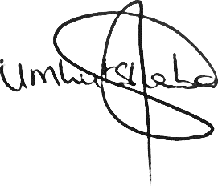 | 30 September 2023
Approved by: | Dr. Mphikeleli Mnguni | DSAC SACO  Project Manager
Approved by: | Dr Stella (CN)  Khumalo | DSAC Acting DDG: Arts and Culture Promotion and Development

